Title:
Metagenomics of respiratory microbiota of an ostrich
Authors:
Muhammad Zubair Shabbir^{1*}, JiHye Park², Masood Rabbani¹, ³Khushi Muhammad, Muhammad Younus Rana⁴, Arfan Ahmad¹ and Eric Thomas Harvill²
Affiliations:
¹University Diagnostic Laboratory, University of Veterinary and Animal Sciences, Lahore 54600 Pakistan; ²Department of Veterinary and Biomedical Sciences, Pennsylvania State University, State College, PA 16801, USA; ³Department of Microbiology, University of Veterinary and Animal Sciences, Lahore 54600 Pakistan; ⁴College of Veterinary and Animal Sciences (Jhang Campus), Jhang.
Corresponding author:
Muhammad Zubair Shabbir
Lecturer at University Diagnostic Laboratory
University of Veterinary and Animal Sciences, Lahore
E. mail: vetvains@uvas.edu.pk
Cell: 03214264480
Novelty Statement:
First culture independent analysis of respiratory microbiome of ostrich chick with identification of number of genera previously not associated with birds in health or disease. Furthermore, first molecular identification of specie Myroides sp. MY15, a novel strain isolated in 2012 from human saliva, indicate the zoonotic potential of ostrich and necessitate further isolation and molecular epidemiological surveys as a potential bird’s pathogen as well. We hope that the study’s outcome will be of much concern for those involved in ostrich farming, a newly emerged industry in Pakistan.

ABSTRACT
Respiratory diseases caused by bacteria are common to all ages of ostrich. Young chicks however are more susceptible, and respiratory diseases are considered a major hindrance in successful ostrich farming. Culture dependent techniques have provided little success in identification of bacterial pathogens and corresponding diseases. Here we report the first culture independent analysis of the respiratory microbiota of a diseased ostrich; a metagenomic analysis of the tracheo broncho alveolar lavage (T-BAL) of a young chick that died of respiratory disease. The 16S rRNA sequences showed diversity corresponding to 2 phyla, 7 families and 8 genera. Both of the identified bacterial phyla were gram negative; Proteobacteria (97.3 %) and Bacteroidetes (2.7 %). The single species identified, Myroides spp. MY15, has previously been examined as a human opportunistic pathogen. The lack of assignment of the majority of reads to lowest taxa indicates the presence of multiple yet uncharacterized organisms. This analysis provides important information that can guide the exploration of the roles of Myroides spp. MY15 and various previously unknown pathogens in respiratory diseases of ostriches and/or other animals.
Key words: Culture independent analysis, Myroides Spp. MY15, Ostrich, Respiratory microbiota

INTRODUCTION
Ostriches belong to a clan of flightless birds called the ratites that also include cassowaries, kiwis, moas and emus. There exist a long history of ostrich domestication and farming as a source of meat, leather, feathers and oil (Huchzermeyer, 2002). With the increase in protein demand and subsequent commercial farming worldwide, there is likely to increase contact between ostrich and commercial poultry and subsequent diseases. Respiratory diseases are common to all ages of ostriches. However, high chick mortalities below three months of age are considered as one of the major obstacles in successful ostrich farming. Together, improper ventilation, cold stress, high ammonia level in indoor pens augments respiratory problems and subsequent mortalities due to poor prognosis (Samson, 1997). Compared to isolation and identification of numerous bacterial infectious agents and consequent diseases in poultry industry worldwide (Byrum and Selmons, 1995; Glisson, 1998), respiratory microbiota of ostriches is not well revealed (Samson, 1997; Elfaki et al., 2002). While concerns exist about bird’s health in relation to globalized trade, reservoir of number of infectious organisms and disease control, yet unknown culturing facilities for most of microbiota provides a diminutive prospect of respiratory microbiome and subsequent diseases in ostriches. Using 454-pyrosequencing, culture independent molecular analysis of respiratory microbiota of 37 day old ostrich died recently of symptoms clinically suggestive of respiratory disease has been described. Unbiased exploration of the respiratory system will be of help to improve ostrich’s health care through understanding the susceptibility to wide range of environment load, disease diagnostics and future clinico-pathological studies.

MATERIALS AND METHODS
Of the total 90 ostrich in the farm located in Punjab (30°48’29”N 73°36’00”E), during winter, a 37 day old ostrich was presented to laboratory for necropsy examination. The bird died recently showing clinical symptoms suggestive of respiratory disease such as swollen head, nasal and lacrimal discharge and high body temperature. Within three days of clinical symptoms, a total of 11 birds were died. Hemorrhages on trachea mucosa were evident, whereas, rest of respiratory airways particularly lungs were devoid of any typical gross lesion. As sterile as possible, tracheo-broncho alveolar lavage (T-BAL) was collected and processed for genome extraction (BiOstic® FFPE Tissue DNA Isolation Kit; Mobio, USA).
Using bar-coded fusion with 16S rRNA primers, 27F (5´AGAGTTTGATCMTGGCTCAG 3´) and 907R (5´TACGGGAGGCAGCAG 3´), one-way read amplicons (Lib-L) were prepared. The PCR reactions was carried out with ds DNA (5 to 10ng in total), forward and reverse primers (5 pmoles each), dNTPs (5 nmoles each), 0.25 uL of TAQ (Fast Start High Fidelity PCR system, Roche, Indianapolis, IN), and 10X buffer solution supplied with the enzyme (2.5uL). The samples were denatured at 94ºC for 3 minutes followed by 35 cycles of 94ºC for 15 sec, 55ºC for 45 seconds and 72ºC for 60 seconds each with a final extension at 72ºC for 8 min (Gene AMP PCR System 9700; Applied Biosystems, Foster City, CA). Product (~ 1000bp) was separated on 1% agarose gel and purified (AgencourtAMPure technology, Beckman Coulter, Brea, CA). After clean-up (QIAquick PCR Purification kit, Qiagen,Valencia, CA), quality and quantity was assessed using a DNA 7500 LabChip on the Agilent 2100 Bioanalyzer (Agilent Technologies, Santa Clara, CA) and Qubit quantification. Using the 454/Roche GS FLX+ Titanium chemistry (Roche Diagnostics, Indianapolis, IN), pyrosequencing was carried out according to the manufacturer’s instruction.
Primer sequences and barcodes were removed from GS-FLX-Titatium sequencer data (.sff file). Using MOTHUR, sequences were screened for read shorter than 100 nucleotides in length, have more than 1 mismatched barcodes and 8 bases in a row, and the average quality score lower than 25 (Schloss et al., 2009). High quality sequence reads were aligned to closest relative sequence, using BLASTn, against “Bacteria + Archeaea (isolates only)”database (www.microgator.org/taxcollector/). Finally, the aligned sequence data was analyzed through MetaGenomeANalyzer, MEGAN (Version 4.22, built February 22, 2011) using a default setting (MinSupport: 5, Min score: 35, Top percent: 10) (Huson et al., 2011).
RESULTS
A total of 9,821 readwere obtained from extracted gDNA (19.0 ng/uL) and were designated to bacteria domain and its descendents. Taxonomic diversity within T-BAL has been captured as indicated by rarefaction analysis between sequence retrieved and associated taxonomy leaves at the level of genera (Figure 1). Collapsing sequence file (.rma) to taxonomic node identified reads corresponding to 2 phyla, 6 order,7 families and 8 genera. Of the total read, 8253 were found to match two phyla: Proteobacteria (8028, 97.3%) and Bacteroidetes (225, 2.7%). Based upon sequences summarized at family node (1263), the dominant family was Shewanellaceae (531, 42.0%) followed by Morexallaceae (196, 15.5%), Aeromonadaceae (179, 14.2%) and Pseudomonacae (153, 12.1%). Similarly, among the sequence reads summarized at genera node (1231), the abundance of reads were found for Shewanella (531, 43.1%) followed by Acinetobacter (196, 15.9%), Aeromonas (179, 14.5%), Pseudomonas (153, 12.4%) and Sphingobacterium (89, 7.2%) (Figure 2).Because top BLAST hits have heterogeneous taxonomic lineages, among the reads assigned to species level, only one bacterial species named Myroides spp. MY15 (44) belonging to phyla Bacteroidetes was identified (Figure 3)
DISCUSSION
This is the first metagenomic examination of bacterial communities of the trachea and lower respiratory tract of a young ostrich. Given the nature and cost of bird involved, farm owner did not agree to contribute additional birds, either healthy or diseased. Although both gram positive and gram negative bacterial species of phylum Proteobacteria, Firmicutes, Actinobacteria and Bacteroidetes have been reported in domestic and wild birds (Byrum and Selmons, 1995; Poorniya and Upadhey, 1995; Glisson, 1998), the respiratory system of this sick young ostrich appeared to harbor less diversity, with only to two gram negative bacterial phyla, Proteobacteria and Bacteroidetes. Low biodiversity may be ascribed to the fact that this young ostrich has been kept in indoor pens and not exposed to environment outside. Though the majority of sequences read were not assigned to species level, genera and species belonging to Proteobacteria, such as Klebsiella spp., Pseudomonas spp., Escherichia spp. and Pastuerella spp., have been isolated from the respiratory tract of ostrich (Samson, 1997; Elfaki et al, 2002). To best of our knowledge, nothing is known of species of genus Sphingobacterium, Shewanella, Myroides, Flavobacterium, Chrysobacterium, Aeromonas and Acinetobacter in relation to health and disease in ostrich. Our identification of number of phylotypes at different taxonomic nodes may be simply due to the limitation of prior studies using conventional culturing procedures that are likely to isolate less than 1% of the organism present, leaving a large proportion of bacteria in a given clinical samples unknown. Although conventional culturing procedures have claimed the lower respiratory tract is a sterile compartment; recent molecular studies have reported a characteristic distribution of organisms in the human respiratory tract. For example, BAL of patients with pneumonia has revealed Tropheryma whipplei as a lung inhabitant (Bousbia et al., 2010).
Identification in birds of bacterial species previously associated with infectious diseases in humans indicates the potential to carry organism of public health significance. Myroides spp.MY15 is a gram negative bacterium within the family Flavobacteriaceae that has been recovered from clinical sources, soil, and seawater. It is considered an opportunistic pathogen that has been recently isolated from human saliva (Yan et al., 2012). Identification of Myroides spp. MY15in similar studies of T-BAL of other diseased birds (unpublished) highlight its potential as a respiratory pathogen of birds, and potential zoonoses. Further studies involving molecular epidemiological survey, isolation and experimental analysis will be required to determine its role as a commensal or a potential bird pathogen.
Acknowledgment
This work was supported by the Defense Threat Reduction Agency,
Basic Research Award # HDTRA1-10-1-0081 to the Pennsylvania State University, USA (Prime Awardees) and University of Veterinary and Animal Sciences, Lahore Pakistan (Subcontract Awardees). Thanks to genomic core facility of the Huck Institute of the Life Sciences at Pennsylvania State University, USA in sequencing facility.
References

Byrum BR and RD Slemons, 1995. Detection of proteolytic bacteria in the upper respiratory tract flora of poultry. Avian Dis, 39(3): 622 – 626.

Bousbia S, L Papazian, JP Auffray, F Fehollar, C Martin, W Li, L Chiche, B LaScola and D Roult, 2010. Tropheryma whipplei in patients with pneumonia. Emerg Infect Dis, 16: 258 – 263.
Elfaki MG, B Abbas, OM Mahmoud, EM Haroun and EM Abdel-Magied, 2002. Septicaemic pasteurellosis in ostriches (Struthio camelus) in central Saudi Arabia. Vet J, 163: 218 – 221.
Glisson JR, 1998. Bacterial respiratory diseases of poultry. Poult Sci, 77: 1139 – 1142.
Huchzermeyer FW, 2002. Diseased of farmed Crocodiles and Ostriches. Rev Sci Tech Off Int Epi, 21(2): 265 – 276.
Huson DH, S Mitra, HJ Ruscheweyh, N Weber and SC Schuster, 2011. Integrative analysis of environmental sequences using MEGAN 4. Genome Res, 21: 1552 – 1560.
Poornima M and S Upadhye, 1995. Bacterial flora of respiratory tract of poultry in health and disease. Mysore J Agric Sci, 29: 68 – 72.
Samson J, 1997. Prevalent diseases of Ostrich chicks farmed in Canada. Can Vet J, 38: 425 – 428.

Schloss PD, SL Westcott, T Ryabin, JR Hall, M Hartmann, EB Hollister, RA Lesniewski, BB Oakley, DH Parks, CJ Robinson, JW Sahl, B Stress, GG Thallinger, DJ Van Horn and CF Weber, 2009. Introducing mothur: open-source, platform-independent, community-supported software for describing and comparing microbial communities. Appl Environ Microbiol, 75(23): 7537 – 7541.

Yan S, N Zhao and XH Zhang, 2012. Myroides phaeus sp. nov., isolated from human saliva, and emended descriptions of the genus Myroides and the species Myroides profundi Zhang et al. 2009 and Myroides marinus Cho et al.2011. Int J Syst Evol Microbiol, 62: 770 – 775.



Figure 1: Taxonomy rarefaction plot for the T-BAL analyzed from ostrich. The plot is made with percentage of reads present in a given sample to corresponding leaves in taxonomy database.

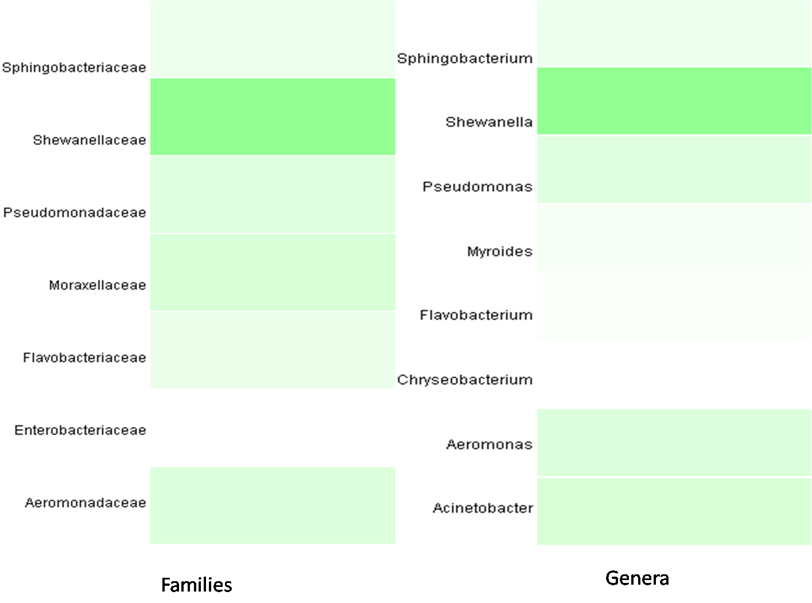

Figure 2: Relative abundance of phyla, families and genera identified in ostrich

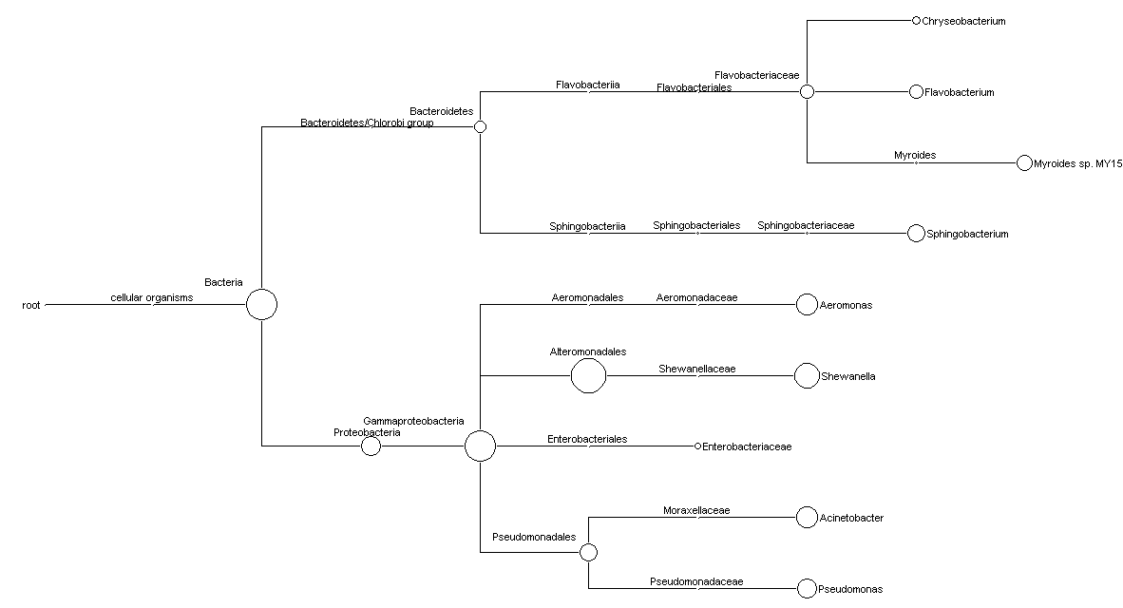

Figure 3: Phylogeny of 16S rRNA gene sequences derived from ostrich. The number of reads assigned to each node in NCBI taxonomic tree is scaled logarithmically.

