ANTIMICROBIAL SENSITIVITY PATTERN OF METHICILLIN RESISTANT STAPHYLOCOCCUS AUREUS ISOLATED FROM HOSPITALS OF KOHAT DISTRICT, PAKISTAN

Antimicrobial sensitivity Pattern of Methicillin Resistant Staphylococcus aureus Isolated from Hospitals of Kohat District, Pakistan

Mubbashir Hussain *1, Samina Ashiq 2, Abdul Basit 1, Abdullah Khan 1, Asif Junaid 1 and Muhammad Shahid 3
*1. Department of Microbiology, Kohat University of Science and Technology, Pakistan
2. Center of Biotechnology and Microbiology, University of Peshawar, Pakistan
3. Veterinary Research Institute, Peshawar
*Corresponding author: mubashirbangash@gmail.com , 00923334380950

Abstract

The study was conducted to analyze antibiotic susceptibility patterns of Methicillin Resistant Staphylococcus aureus (MRSA) isolates. A total of 552 different samples were collected from two hospitals of District Kohat, Khyber Pakhtunkhwa, Pakistan. Total 434 Staphylococcus strains containing 191 (44 %) MRSA and 243 (56 %) coagulase negative Staphylococcus strains were isolated and identified by using selective media and biochemical tests including catalase, coagulase and DNase tests. Maximum numbers of samples (15.55%) were belonging to surgical ward followed by 14.70 % of total samples from Outdoor Patient Department (OPD). The highest number of MRSA were isolated form wound swabs (24.08 %) followed by pus samples (21.46 %) while the lowest percentage of MRSA was from High Vaginal Swab (3.14 %). Kirby-Bauer disc diffusion method was used for antimicrobial susceptibility testing. All the 191 MRSA strains isolated from two hospitals of Kohat were resistant to amoxycillin (100%), followed by cefotaxime (76.43 %), ofloxacin (74 %), levofloxacin (70.15 %), erythromycin (69.10 %) and chloramphenicol (34.03 %). Highest sensitivity was found against Vancomycin (99.55 %). Thus, high prevalence and multi drug resistance pattern was found in MRSA isolates from two different hospitals of Kohat district, Pakistan, thus presenting a major health concern.

Introduction
Staphylococcus aureus is well known for its pathogenecity for humans and other animals (Persoons et al., 2009, Milyani and Ashy, 2012). S. aureus causes infections ranging from minor skin infections and abscesses to life threatening cases including toxic shock syndrome, meningitis, endocarditis, pneumonia and septicemia (Enright et al., 2002; Ho et al., 1989). The resistance pattern of S. aureus against a number of antimicrobial agents also varies. Methicillin Resistant Staphylococcus aureus (MRSA) is usually resistant to methicillin while strains of S. aureus show resistance to multiple antibiotics as gentamicin, norfloxacin, fucidic acid, erythromycin and clindamycin (Shai et al., 2004). Initially, penicillin was used against S. aureus but it became resistant to penicillin due to the production of enzyme ß-lactamase. Strains of MRSA emerged soon after using ß-lactamase-stable penicillin-derived methicillin for S. aureus (Samia et al., 2007). Infections caused by resistant MRSA is a prominent threat to animal’s and human’s health (Yao et al., 2010; Persoons et al., 2009, Shai et al., 2004). MRSA infection has also been reported in different animal species; sheep, goat, cows, dogs (Bassim and El-Maghraby, 2005) and hospitalized horses (Hartmann et al., 1997)
Hospital associated-methicillin resistant Staphylococcus aureus (HA-MRSA) and community associated-Methicillin-Resistant Staphylococcus aureus (CA-MRSA) are two broad categories of MRSA that present a persistent challenge to clinicians recently. Strains of CA-MRSA developed from a community (population or habitat) while the HA-MRSA include emergence of MRSA from the patient having current or recent hospitalization, receives dialysis, or resides in a long-term care facility (Milyani and Ashy, 2012). MRSA has become a leading cause of nosocomial infections worldwide since the first European isolate of MRSA, detected in 1960s (Lowy, 1998; Tristan et al., 2007). During the period 1970 to 2010, MRSA strains were increasingly responsible for outbreaks of hospital acquired infections around the world, like in Saudi Arabia (Madani et al., 2001), Austria (Krziwanek et al., 2009), Argentina (Reyes et al., 2009), South Africa (Shittu et al., 2009), Italy (Soavi et al., 2010). These outbreaks were frequently associated with neonatal, intensive care and burns units (Liu et al., 2011).
In developing countries like Pakistan antibiotic resistant bacteria are persistent challenge and difficult to control because of irrational use of antibiotics. There was scarce data regarding MRSA in Khyber Pakhtunkhwa province of Pakistan. The present study was conducted for the first time to investigate the antibiotic susceptibility profiles of MRSA in two Government hospitals of a remote district Kohat that are Liaqat Memorial hospital and District Head Quarter (DHQ) hospital, Kohat Developmental Authority (KDA) hospital of district Kohat, Pakistan.
Materials and methods

Sampling
The study was carried out from January 2012 to December 2012. Total 552 samples were collected from Liaqat Memorial hospital and DHQ hospital KDA district Kohat (Khyber Pakhtunkhwa) Pakistan. These samples were collected from different wards (OPD, ENT, Medical, Burns, Orthopedic, Surgical, Children, Gynaecological ward and Main Operation Theater). These samples included the samples of blood, pus, wound swabs, throat swabs, sputum, High Vaginal Swab (HVS) and urine samples. The samples were labeled accordingly and were subjected to screening of Staphylococcus aureus in Microbiology Laboratory at Department of Microbiology, Kohat University of Science and Technology, Kohat, Pakistan.

Isolation of S. aureus from clinical samples
Mannitol Salt Agar (MSA) (Oxoid, UK) was used for inoculation of samples. Media was prepared according to manufacturer’s standard protocol. Media along with all required glassware were autoclaved at 121ºC for 20 minutes at 15 psi. The identification of S. aureus was performed on the basis of tests like Gram staining reaction, catalase, coagulase and Dnase tests according to standard protocols as described earlier. Isolates positive for these tests were considered as S. aureus.

MRSA screening
Oxacillin was used to screen S. aureus isolates for presence of methicillin resistance. Briefly, each isolate was streaked on surface of Muller-Hinton agar (Oxoid UK) containing 6 µg/ml of oxacillin and incubated at 37 °C for 24 hours. Isolates showing growth on this media were preserved and labelled as MRSA for further studies.

Anti-biogram Assay
The Kirby-Bauer disc diffusion method was adopted to evaluate the antimicrobial susceptibility pattern of the MRSA isolates against different commonly used antibiotics. Amoxicillin (60 µg), cefotaxime (20 µg), cephradin (30 µg), chloramphenicol (30 µg), ciprofloxacin (5 µg), doxycycline (1µg), gentamicin (10 µg), levofloxacin (5µg), ofloxacin (10 µg), sparfloxacin (20 µg), norfloxacin (5 µg) and vancomycin (30 µg), Oxoid UK, were used in the present study. The antibiotic discs were used in Muller-Hinton agar (Figure 1) and the results were interpreted by measuring zone of inhibitions according to standard guidelines as described by Perveen et al. (2013).

Results
MRSA is a major issue of public health concern in recent times. In the present study out of 552 samples we isolated 434 Staphylococcus strains containing 191 (44 %) MRSA and 243 other non methicillin resistant Staphylococcus strains, and the rest of samples (109) were negative for Staphylococci. Thus a prevalence of MRSA was 44 % in present study. 51.79% of these positive Staphylococcus samples were from male patients while remaining 48.21% were from female patients. All the samples were collected from different wards. Maximum numbers of samples (15.55%) were belonging to surgical ward followed by OPD with 14.70 % of total samples. From the total samples, the samples containing S. aureus were categorized as positive samples. These positive samples were further checked for their resistance pattern against methicillin. The highest number of MRSA were isolated form wound swabs (24.08 %) followed by pus samples (21.46 %) while the lowest percentage of MRSA was from HSV (3.14 %). Incidence of MRSA in other samples is shown in the table 1.
The antibiotic sensitivity patterns of MRSA isolated from clinical specimens was found to be highly variable in present study. All the 191 MRSA strains isolated from two hospitals of Kohat were resistant to oxacillin (used for screening) and penicillin (100%), followed by cefotaxime (76.43 %), ofloxacin (74 %), levofloxacin (70.15 %), erythromycin (69.10 %) and chloramphenicol (34.03 %). Highest sensitivity was found against vancomycin (99.55 %). The antimicrobial susceptibility pattern of MRSA isolates against different classes of antibiotics is shown in table 2. Thus, we found all isolates of MRSA resistant to multiple antibiotics tested.

Discussion
In the present study the prevalence of MRSA from clinical samples was 44 %. Highest percentage of MRSA (24.08 %) was isolated from wound samples and lowest percentage (3.14%) in HVS samples as shown in Table 1. The results of the present study showed that the prevalence of methicillin resistance is higher in district Kohat than previous reports in Pakistan. Ahmed et al. (2000) reported 35% MRSA prevalence in Pakistan whereas Qureshi et al. (2004) reported a 28.4% occurrence of MRSA in Rawalpindi. In another multicenter study conducted by Hafiz et al. (2002) reported the prevalence of MRSA strains in various cities of Pakistan was highest 61% in Lahore, 57% in Karachi, 46% in Rawalpindi Islamabad and 36% in Peshawar. Similar study conducted by Siddique et al. (1999) at Sargodha, Pakistan isolated 23% MRSA, Samia et al. (2007) at Karachi, Pakistan isolated 43% MRSA, and then Khatoon et al. (2002) at Karachi, Pakistan isolated 38.5% MRSA. Similar study was also conducted in India by Shagufta and Jayaraj (2010) who isolated 77.9% MRSA, while Helena et al. (2010) in Brazil isolated 61% MRSA. This shows an increase in MRSA percentage with time. This increase is due to transfer of resistance genes between bacterial cell and persistence of bacteria in hospital environment due to antibiotic resistance. Absence of control program for antibiotics usage pattern is another factor which facilitates MRSA to increase in concentration (Hacek et al., 1999).
In the present study all the 191 MRSA strains isolated from two hospitals of Kohat were resistant to oxacillin and amoxycillin (100%), followed by cefotaxime (76.43 %), ofloxacin (74 %), levofloxacin (70.15 %), erythromycin (69.10 %) and chloramphenicol (34.03 %) as shown in figure 2. Highest sensitivity was found against vancomycin (99.55 %). James and Reeves (1996) found MRSA strains resistant to first, second, third and fourth generation of cephalosporins. In a study conducted by Perveen et al. (2013), 83% of the MRSA showed resistance against cephradine. Mahmood et al. (2001) reported 29% resistance of generation cephalosporins. Gentamicin is an aminoglycoside and is most often prescribed because of its low cost and synergistic activity with ß-lactum antibiotics. In present study MRSA showed 67.01 % resistance against gentamicin which is lower than shown by Perveen et al. (2013) who reported 76.35% of MRSA resistance towards gentamicin. In this study 69.10 % of MRSA were resistant to erythromycin, which is in accordance with previous reports conducted by Perveen et al. (2013). Among quinolones the percentage resistance found in MRSA in present study was quite higher. Previously reported resistance of ciprofloxacin and other quinolones also showed higher pattern as reported by Auckenthaler et al. (2000). In the present study all the MRSA isolates gave 99.55 % sensitivity to vancomycin. There was only one isolate that was found to be resistant to vancomycin. These results coincide with the findings of multi-drug resistance in the study conducted by Perveen et al. (2013). The results of present study clearly showed high prevalence of MRSA in hospitals of district Kohat. All these antibiotics are frequently prescribed by clinicians without carrying out antibiogram assays on samples of their patients. Moreover, common people have easy access to these antibiotics available to them at local pharmacies without any prescriptions from doctors. Therefore, the rise in resistance is clearly due to irrational use of antibiotics and non existence of protocols and guidelines for safe practice in terms of treatment of MRSA.

Conclusion
MRSA were isolated in high concentration from clinical samples in present study which showed a high risk to the patients and staff working in the hospital. The over-crowding in hospital, lack of facilities and lack of knowledge about HA-MRSA leads to the presence of nosocomial pathogen in such a high concentration. MRSA strains isolated showed resistance to multiple antibiotics. This study suggests implementation of preventive measure in order to minimize the bacterial resistance to antibiotics. An electronic record of antibiotic usage should be made to prevent unnecessary usage of broad spectrum antibiotics and increase recommended usage of antibiotics. All the health care personnel should strictly follow the preventive guideline for patient as well as for their own safety. Proper antibiotics susceptibility test should be made for all suspected infection caused by MRSA. Vancomycin showed good results against MRSA in the present study. But the prescription of this antibiotic should be limited and subjected to presentation of proper antimicrobial sensitivity assay reports.

Ethical Consideration
The samples were obtained from patients with prior informed consent and explaining to them the importance of this study. The study was finally approved by Research and ethical committee, Department of Microbiology, Kohat University of Science and Technology, Pakistan.

Conflict of Interest
The authors declare no conflict of interest of any type.

Acknowledgements
We are grateful to Dr. Younas Nadeem and Dr Sami, DHQ hospital Kohat for their technical help in obtaining clinical samples from patients. We also express our thanks to laboratory staff department of Microbiology, Kohat University for facilitating us in providing sterilized glassware and other requirements during the study period. Lastly, we are thankful to all patients for providing the clinical samples for present study.

References
Ahmed A, Qureshi SF and Ansari N (2000). Prevalence and antibiotic sensitivity pattern of methicillin resistant Staphylococcus aureus (MRSA) infection in a tertiary care hospital. Karachi: Liaquat National Hospital Symposium.
Auckenthaler R, Courvalin P, Feger C and Roche G (2000). In vitro activity of quinupristin/ dalfopristin in comparison with five antibiotics against worldwide clinical isolates of staphylococci. Clin. Microbiol. Infect. 6: 608 - 612.
Bassim H and El-Maghraby M (2005). Methicillin-resistant Staphylococcus aureus (MRSA) a challenge for infection control. ASJOG. 2: 277 - 279.
Boyce JM (1990). Increasing prevalence of methicillin-resistant Staphylococcus aureus in the United States. Infect. Contr. Hosp. Epidemiol. 11: 639 - 642.
Enright MC, Robinson DA, Randle G, Feil EJ, Grundmann H and Spratt BG (2002). The evolutionary history of methicillin-resistant Staphylococcus aureus (MRSA). PNAS. 99: 7687 - 7692.
Hacek DM, Suriano T, Noskin G, Kruszynski J, Reisberg B and Peterson L (1999). Medical and economic benefit of a comprehensive infection control program that includes routine determination of microbial clonality. Am. J. Clin. Pathol. 111: 647 - 654.
Hafiz S, Hafiz AN, Ali L, Chughtai AS, Memon B, Ahmed A, et al. (2002). Methicillin resistant Staphylococcus aureus: a multicentre study. JPMA. 52: 31 - 32.
Hartmann FA, Trostle SS and Klohnen AAO (1997). Isolation of methicillin-resistant Staphylococcus aureus from a postoperative wound infection in a horse. J. Am. Vet. Med. Assoc. 211: 590 - 592.
Helena BS, Machado DP, Camey SA, Uchenbecker RS, Barth AL and Wagner MB (2010). Prevalence and acquisition of MRSA amongst patients admitted to a tertiary-care hospital in Brazil. BMC Infect. Dis. 328(10): 1 - 7.
Ho G, Campbell MS, Bergdoll MS and Carlson E (1989). Production of toxic shock syndrome toxin variant by Staphylococcus aureus strains associated with sheep, goats and cows. J. Clin. Microbiol. 72: 1946 - 1948.
James PA and Reeves DS (1996). Bacterial resistance to cephalosporins as a function of outer memberane permeability and access to their target. J Chemother. 8: 37 - 47.
Khatoon N, Bukhari H, Riaz JR and Sheikh AS (2002). Prevalence of methicillin resistant staphylococcus aureus (MRSA) infection laboratory study at Mayo Hospital Lahore. Biomedica. 18: 49 - 52.
Krziwanek K, Metz-Gercek S and Mittermayer H (2009). Methicillin-resistant Staphylococcus aureus ST398 from human patients, upper Austria. Emerg. Infect. Dis. 15(5): 766 - 769.
Liu C, Bayer A, Cosgrove S, Daum RS, Fridkin S, Gorwitz R, Kaplan S, Karchmer A, Levine D, Murray B, Rybak M, Talan D and Chambers H (2011). Clinical practice guidelines by the infectious diseases society of America for the treatment of methicillin-resistant Staphylococcus aureus. Infections in Adults and Children. Downloaded from cid.oxfordjournals.org by guest on November 4.
Lowy FD (1998). Staphylococcus aureus infections. New. Eng. J. Med. 339: 520 - 532.
Ma SH, Lee YS, Lee SH, Kim HK, Jin JS, Shin EK and Lee JC (2007). Methicillin-resistant Staphylococcus aureus clones with distinct clinical and microbiological features in Korean community. J. Med. Microbiol. 56(6): 866 - 868.
Madani TA, Al-Abdullah NA, Al-Sanousi AA, Ghabrah TM, Afandi SZ and Bajunid HA (2001). Methicillin-resistant Staphylococcus aureus in two tertiary care centers in Jeddah, Saudi Arabia. Infect. Cont. Hosp. Epidemiol. 22: 211 - 216.
Mahmood A, Rafique S, Qayyum M and Qazilbash AA (2001). Prevalence of nosocomial and community-based methicillin-resistant Staphylococcus aureus (MRSA). Pak. J. Med. Res. 40: 86 - 89.
Mandell GL, Bennett JE and Dolin R (2005). Eds. Principles and practice of infectious diseases. 6th ed. Churchill Livingstone, London.
Milyani R and Ashy N (2012). Inhibitory effect of some plant extracts on clinical isolates of Staphylococcus aureus. Afr. J. Microbiol. Res. 6(40): 6822 - 6829.
Persoons D, Hoorebeke SV, Hermans K, Butaye P, Kruif AD, Haesebrouck F and Dewulf J (2009). Methicillin-resistant Staphylococcus aureus in poultry. Emerg. Infect. Dis. 15(3): 452 - 453.
Perveen I, Majid, A, Kanwal S, Naz I, Sehr S, Safia A and Muhammad AR (2013). Prevalence and antimicrobial Pattern of Methacillin resistant Staphylococcus aureus and Coagulase negative Staphylococcus in Rawalpindi, Pakistan. British J. of Med & Med. Res. 3(1): 198 - 209.
Qureshi A, Rafi HS, Qureshi SM and Ali AM (2004) The current susceptibility patterns of methicillin resistant Staphylococcus aureus to conventional anti staphylococcus antimicrobials at Rawalpindi. Pak. J Med Sci. 20(4): 361 - 364.
Reyes J, Rincon S, Diaz L, Panesso D, Contreras GA, Zurita J, Carrillo C, Rizzi A, Guzman M, Adachi J, Chowdhury S, Murray BE and Arias CA (2009). Dissemination of methicillin-resistant Staphylococcus aureus USA300 sequence type 8 lineage in Latin America. Clin. Infect. Dis. 49: 1861 - 1877.
Samia P, Barakzi Q, Farooqi BJ, Nazia K and Sabir N (2007). Antimicrobial susceptibility pattern of clinical isolates of methicillin resistant Staphylococcus aureus. J. Pak. Med. Asso. 57(1): 2 - 4.
Shagufta N and Jayaraj YM (2010). Nasal carriage of methicillin-resistant staphylococcus aureus isolated from intensive care unit patient. Res. J. Boil. Sci. 5(2): 150 - 154.
Shai A, Natalya MD, Bilenko MD, Zeev RB and Halevy MD (2004). Use of infection control procedures in an out-patient clinic for leg ulcers and the rate of contamination with methicillin-resistant Staphylococcus aureus. Wounds. 16(6): 15 - 25.
Shittu A, Nubel U, Udo E, Lin J and Gaogakwe S (2009). Characterization of meticillin-resistant Staphylococcus aureus isolates from hospitals in Kwazulu-Natal province, Republic of South Africa. J. Med. Microbiol. 58: 1219 - 1226.
Siddique GM, Karamat KA and Hannan A (1999). Prevalence of methicillin resistant staphylococcus aureus: a study at PAF Hospital Sargodha. Pak. J. Pathol. 10: 26 - 28.
Soavi L, Stellini R, Signorini L, Antonini B, Pedroni P, Zanetti L, Annalisa M, Alberto P, Angelo P and Carosi G (2010). Methicillin-resistant Staphylococcus aureus ST398, Italy. Letters, Emerg. Infect. Dis. 16(2): 346 - 348.
Tristan A, Bes M, Meugnier H, Lina G, Bozdogan B, Courvalin P, Reverdy ME, Enright MC, Vandenesch F and Etienne J (2007). Global distribution of Panton-Valentine leukocidin-positive methicillin-resistant Staphylococcus aureus. Emerg. Infect. Dis. 13(4): 594 - 600.
Yao D, Yu FY, Qin ZQ, Chen C, He SS, Chen ZQ, Zhang XQ and Wang L (2010). Molecular characterization of Staphylococcus aureus isolates causing skin and soft tissue infections (SSTIs). BMC Infect. Dis. 10: 133 - 137.

Table 1: MRSA isolated from different clinical samples of hospitals of Kohat
Clinical Samples | Number of MRSA isolates |  | Total (%)
Clinical Samples | KDA Hospital | Liaqat Hospital | Total (%)
Blood | 19 | 8 | 27 (14.13)
Urine | 15 | 12 | 27 (14.13)
Pus | 23 | 18 | 41 (21.46)
HVS | 6 | 0 | 6 (3.14)
Throat | 13 | 13 | 26 (13.61)
Wound | 26 | 20 | 46 (24.08)
Sputum | 11 | 7 | 18 (9.42)
Total | 113 | 78 | 191 (100)

Table 2. Antibiotic sensitivity pattern of Methicillin Resistant Staphylococcus aureus
Antibiotic | DHQ, Hospital KDA  n=113 |  |  | Liaqat Mem. Hospital  n=78 |  |  |  | n=191
Antibiotic | **S | *R | Percent Sensitive (%) | S | R | Percent Sensitive  (%) | Total (%)
Amoxicillin | 0 | 113 | 100 | 0 | 100 | 100 | 100
Cefotaxime | 25 | 88 | 78 | 20 | 58 | 74.35 | 76.43
Cephradine | 37 | 76 | 67.25 | 23 | 55 | 70.51 | 68.58
Erythromycin | 32 | 81 | 71.68 | 27 | 51 | 65.38 | 69.10
Chloramphenicol | 69 | 44 | 39 | 57 | 21 | 27 | 34.03
Ciprofloxacin | 47 | 66 | 58.40 | 31 | 47 | 41.59 | 59.16
Doxycyclin | 45 | 68 | 60.17 | 25 | 53 | 68 | 63.35
Gentamicin | 37 | 76 | 67.25 | 26 | 52 | 66.66 | 67.01
Levofloxacin | 41 | 72 | 64 | 16 | 62 | 79.48 | 70.15
Norfloxacin | 49 | 64 | 56.63 | 20 | 58 | 74.35 | 64
Ofloxacin | 36 | 77 | 68.14 | 14 | 64 | 82.05 | 74
Sparfloxacin | 55 | 58 | 51.32 | 23 | 55 | 70.51 | 59.16
Vancomycin | 112 | 01 | 99.1 | 78 | 0 | 100 | 99.55
*R: Resistant, **S: Sensitive

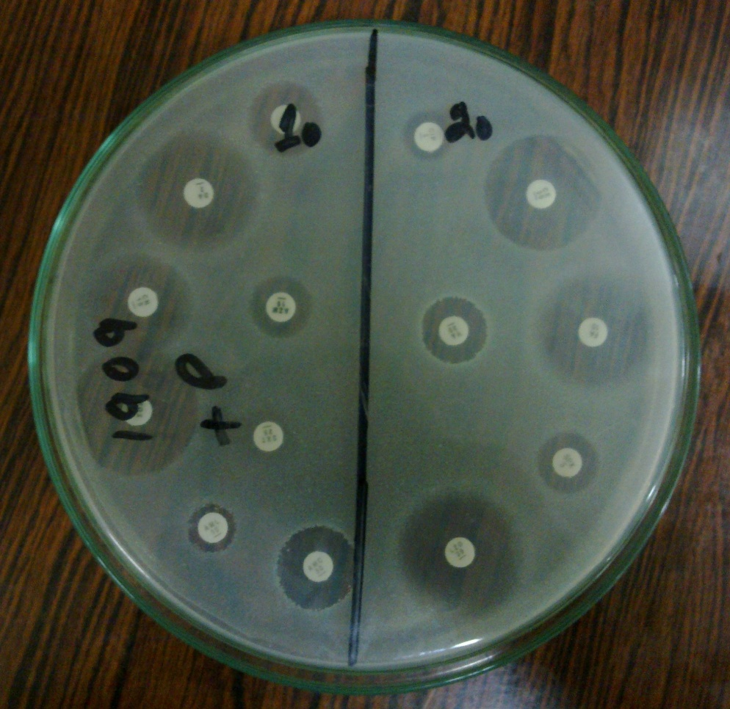
Figure 1 Antimicrobial sensitivity pattern results on Petri plate
Figure 2. Antimicrobial sensitivity pattern shown by multi drug resistant MRSA

