Seroepidemiological Pattern of Salmonellosis in Animals of Rohilkhand Region, Uttar Pradesh, India

N. Sachan¹, Binita Nautiyal¹, R. K. Agarwal³, V. P. Singh²and Amit KumarVerma²

¹Department of Animal Science, Faculty of Applied Sciences, M.J.P. Rohilkhand University, Bareilly, U.P.-243122; ²Uttar Pradesh Pandit Deen Dayal Upadhayay Pashu Chikitsa Vigyan Vishwavidyalaya Ewam Go-Anusandhan Sansthan (DUVASU), Mathura (U.P.) – 281001, India; ³Indian Veterinary Research Institute, Izatnagar, Bareilly, U.P. 243122, INDIA
Corresponding author: Dr Neelam Sachan, Assistant Professor, Department of Veterinary Public Health, U.P. Pt. Deen Dayal Upadhyay Veterinary University and Go Anusandhan Sansthan, Mathura, U.P. 281001, INDIA. Email: neelamvet@rediffmail.com

Abstract
During the period under study (2008-10), a total of 1500 serum samples of cattle, buffalo, goats and dogs from five districts of Rohilkhand region, Uttar Pradesh, India were screened for presence of Salmonella agglutinins employing slide micro-agglutination test using two coloured antigens of Salmonella Typhimurium (O-4,5,12) and S. Gallinarum (O-9,12). An overall sero-prevalence of Salmonella agglutinin against O-4,5,12 and O-9,12 antigens in animals were 15.53% and 13.6%, respectively, while overall sero-prevalence of Salmonella agglutinins against both the antigen was 11.4%. Species wise distribution of positive agglutinin against both the antigen were highest in dogs (25.2%), followed by cattle (11%), buffalo (9.2%) and goats (2.8%). The prevalence of agglutinin in sera of animals was highest in animals of district Bareilly (13%). In all the animal species, seropositivity was highest during winter season. Sex of animal had no significant effect on sero-prevalence of agglutinin against both Salmonella antigen. Age wise prevalence of positive agglutinin was found to decrease with age in Buffalo and goats, while showed an increasing trend in dogs.
Keywords: Salmonella, seroprevalence, slide microagglutination test, animal, cattle, buffalo, goat, dog

Introduction
More than 60% diseases of human are zoonotic in nature and animals are important source of these diseases including campylobacteriosis, salmonellosis colibacillosis etc (Verma et al., 2007; Kumar et al., 2012). Among these, salmonellosis is one of the most common zoonotic diseases affecting man, animals (Verma et al., 2011a and 2011b) and wide variety of hosts including reptiles, insects, birds etc. The bacteria may cause a spectrum of disease occurrence ranging from sub-clinical, impaired productivity, clinical manifestations that may become often fatal. The infection spread through contaminated feed and water (Verma et al., 2007) and infected animals tend to shed the organisms in their faeces and secretions (Verma et al., 2008). The isolation of Salmonella from the faecal sample is quite difficult and takes approximately 4-7 days (Carter and Chengappa, 1991; Verma et al., 2011b). Animal owners, handlers, veterinary health professionals, abattoir workers etc may have chances to get the infection. Salmonellosis, is hyper endemic in India affecting man and animals, alike (Raichowdhuri, et al., 1983) but the actual magnitude of disease is not well documented (Niyogi et al., 1999). Therefore, it is very necessary to keep watch on salmonellosis in animals. As the isolation of Salmonella is tedious and time consuming, so use of simple, rapid serological tests like slide micro-agglutination test is convenient method for detecting the prevalence of Salmonella infection in animals.

Material and methods:
Samples: During the period of 2008-10, a total of 1500 blood samples of cattle (725), buffalo (393), goats (180) and dogs (202) attending veterinary hospitals in different districts of Rohilkhand region viz., Moradabad, Rampur, Bareilly, Shahjahanpur and Pillibhit were collected. About 5.0ml of blood were collected aseptically using hypodermic syringe (Dispovan) and allowed to clot and kept at room temperature for 3hrs. Serum was separated and kept at -20ºC till use. During collection of samples, epidemiological data like age, sex of animal and season was also collected to understand the epidemiological pattern of the disease.
Slide micro agglutination test: Slide micro agglutination test was employed to assess the sero-prevalence of Salmonella agglutinins in different animals. For this purpose, two coloured Salmonella antigens O-4,5,12 and O-9,12 were used. Antigen O-4,5,12 belonged to S. Typhimurium group O:4(B) whereas antigen O-9,12 belonged to S. Gallinarum group O: 9(D1). The test was performed as per the method described by Muktaruzzaman et al. (2010). For performance of the test, about 2-3 drops of coloured antigen were placed on a clean greasefree glass slide. Then 2-3 drops of test serum were placed adjacent to the antigen. By using a match stick or toothpick, antigen and serum were mixed and observed for 2-3 minutes. Appearance of thick clump of cells (agglutination) was taken as a positive result whereas absence of clump formation was indicative of negative test.
Statistical analysis: The epidemiological data obtained from the study were statistically analyzed by the methods described by Snedecor and Cochran, 1980.

Results and discussion:
A total of 1500 serum samples from different species of animals were screened for presence of Salmonella agglutinin against Salmonella antigen O-4,5,12 and O-9,12. Species wise sero-prevalence of Salmonella agglutinin against Salmonella antigens (O-4,5,12 and O-4,12) were shown in table 1. From the table 1, it can be seen that the overall sero-prevalence of Salmonella agglutinin against O-4,5,12 and O-9,12 antigens in animals were 15.53% and 13.6%, respectively, while an overall sero-prevalence of Salmonella agglutinins against both the antigens was 11.4%.
Table 1: Species wise sero-prevalence of Salmonella agglutinins against Salmonella antigen in animals
Species | Total Samples | Samples positive against O-4,5,12 antigen | Samples positive against O-9,12 antigen | Samples positive by both of the antigens
Cattle | 725 | 104  (14.3) | 93  (12.8) | 80  (11.0)
Buffalo | 393 | 52  (13.2) | 44  (11.1) | 36  (9.2)
Goat | 180 | 11  (6.1) | 9  (5.0) | 5  (2.8)
Dog | 202 | 66  (32.6) | 59  (29.2) | 51  (25.2)
Total | 1500 | 233  (15.5) | 205  (13.6) | 172  (11.4)
* Figures written in parentheses are value in percentage

The higher sero-prevalence of Salmonella agglutinin against Salmonella antigen O-4,5,12, which belongs to Salmonella Typhimurium group, showed the higher circulation of this serovar in Rohilkhand region, Uttar Pradesh, India. In a sixteen year study, Basu et al. (1975) also reported that S. typhimurium was the most common serotype in animals in India. Verma et al., 2007 also reported the isolation of Salmonella Typhimurium from apparently healthy dogs of district Bareilly, which is under Rohilkhand region. Since S. typhimurium can infect man and animals equally, interspecies sharing of this serovar have also been observed (Singh et al., 2010).
Species wise distribution of positive agglutinin against both the antigen were highest in dogs (25.2%), followed by cattle (11%), buffalo (9.2%) and goats (2.8%). The possible reasons for higher seroprevalence of Salmonella agglutinins in dogs is there habit of roaming here and thereand preferably outside; close association with human beings; and thus increased chances of interspecies transmission (Verma et al., 2008). The effect of species on Salmonella infection has also been reported earlier in various studies. Singh et al. (2010) have also reported higher seroprevalence of salmonellosis in pet dogs than other animals. Contrary to our findings, Chandra et al. (2007) reported 40% seroprevalence of Salmonella antibodies among goats in Bareilly district using MAT ‘O’ test. But the reason for higher seroprevalence could be attributed to higher sensitivity of MAT.
Place wise distribution of Salmonella agglutinins against Salmonella antigen in animals is given in table 2 and figure 1. From the table 2, it can be seen that the overall sero-prevalence of agglutinins in animal sera were highest in district Bareilly (13.0%), followed by Rampur (11.4%), Shahjahanpur (11%), Pilibhit and Budaun (10% each), and Moradabad (8.6%).
Table 2: Place wise sero-prevalence of Salmonella agglutinins against Salmonella antigen in animals
Host species | Bareilly |  | Pilibhit |  | Shahjahanpur |  | Badaun |  | Rampur |  | Moradabad
Host species | Total | Positive | Total | Positive | Total | Positive | Total | Positive | Total | Positive | Total | Positive
Cattle | 250 | 27  (10.8) | 100 | 9  (9.0) | 150 | 18  (12.0) | 95 | 10  (10.5) | 75 | 11  (14.6) | 55 | 5  (9.1)
Buffalo | 152 | 18  (11.8) | 56 | 5  (8.2) | 65 | 4  (6.1) | 61 | 4  (6.5) | 37 | 3  (8.1) | 22 | 2  (9.1)
Goat | 50 | 2  (4.0) | 25 | 1  (4.0) | 40 | 1  (29.0) | 29 | 1  (3.4) | 18 | 0  (0.0) | 18 | 0  (0.0)
Dogs | 100 | 25  (25.0) | 22 | 7  (31.8) | 35 | 9  (25.7) | 25 | 6  (24.0) | 10 | 2  (20.0) | 10 | 2  (20.0)
Total | 552 | 72  (13.0) | 203 | 22  (10.8) | 290 | 32  (11.0) | 210 | 21  (10.0) | 140 | 16  (11.4) | 105 | 9  (8.6)
* Figures written in parentheses are value in percentage
From the table 2, it can also be seen that percentage positive in different animals varied with districts. The possible reason for this variation in different animals might be due to difference in the number of samples in different areas and prevalence of different serotypes in different areas. Verma et al. (2008) have also reported that place wise difference was very much expected as different serovars are prevalent in different areas.
Seasonal distribution of Salmonella agglutinins in different animal species was compared as depicted in table 3 and figure 2. Results show that, seroprevalence of salmonellosis was highest during winter season in all the animal species. Similar pattern was seen in all the species of animals but highest seroprevalence was recorded in dogs (34.2%) during winter season. During winters, animals have low immunity and overcrowding of the animals facilitates the spread of infection.
Table 3: Seasonal distribution of Salmonella agglutinins against Salmonella antigen in animals
Seasons | Cattle |  | Buffalo |  | Goat |  | Dog
Seasons | Total | Positive | Total | Positive | Total | Positive | Total | Positive
Summer | 225 | 26  (11.5) | 95 | 9  (9.4) | 50 | 1  (2.0) | 55 | 14  (25.4)
Rainy | 225 | 22  (9.7) | 103 | 9  (8.7) | 35 | 1  (2.8) | 56 | 12  (21.4)
Autumn | 110 | 8  (7.2) | 75 | 4  (5.3) | 35 | 0  (0.0) | 36 | 7  (19.4)
Winter | 85 | 14  (16.4) | 65 | 8  (12.3) | 30 | 2  (6.6) | 35 | 12  (34.2)
Spring | 80 | 10  (12.5) | 55 | 6  (10.9) | 30 | 1  (3.3) | 20 | 6  (30.0)
Total | 725 | 80  (11.1) | 393 | 36  (9.2) | 180 | 5  (2.8) | 202 | 51  (25.4)
* Figures written in parentheses are value in percentage
Sex wise sero-prevalence of Salmonella agglutinins was almost similar in both the sexes of all animal species with minor differences. In agreement to our findings, Verma et al. (2008) also reported non-significant difference in sero-prevalence of Salmonella agglutinins between male and females dogs.
Age wise distribution of seroprevalence of Salmonella agglutinins is shown in table 4 and figure 3. Data obtained in the study showed that in cattle, young (below 3 yrs) as well as adult cattle (>3 yrs) had almost similar sero-prevalence. Young buffaloes had higher sero-prevalence (15.3%) in comparison to that of adult buffaloes (8.4%). Similarly, young goats also had higher seroprevalence (5.2%) in comparison to that of adult (>1 yrs) goats (2.1%).
Table 4: Age-wise distribution of Salmonella agglutinins against Salmonella antigen in animals
District | Cattle |  |  |  | Buffalo |  |  |  | Goats |  |  |  | Dogs
District | < 3 yrs |  | >3yrs |  | < 3 yrs |  | >3yrs |  | < 1 yrs |  | >1yrs |  | < 6 months |  | >6 months
District | Total | Postitive | Total | Postitive | Total | Postitive | Total | Postitive | Total | Postitive | Total | Postitive | Total | Postitive | Total | Postitive
Bareilly | 45 | 4 | 205 | 23 | 12 | 2 | 140 | 16 | 11 | 1 | 39 | 1 | 35 | 8 | 65 | 17
Pilibhit | 7 | 1 | 93 | 8 | 5 | 1 | 51 | 4 | 6 | 0 | 19 | 1 | 5 | 2 | 17 | 5
Shahjahnpur | 10 | 2 | 140 | 16 | 8 | 1 | 57 | 3 | 8 | 0 | 32 | 1 | 10 | 2 | 25 | 7
Badaun | 8 | 2 | 87 | 8 | 9 | 1 | 52 | 3 | 7 | 1 | 22 | 0 | 10 | 1 | 15 | 5
Rampur | 2 | 0 | 73 | 11 | 3 | 1 | 34 | 2 | 3 | 0 | 15 | 0 | 4 | 1 | 6 | 1
Moradabad | 2 | 0 | 53 | 8 | 2 | 0 | 20 | 2 | 3 | 0 | 15 | 0 | 3 | 1 | 7 | 1
Total | 74 | 9  (12.1) | 651 | 74  (11.3) | 39 | 6  (15.3) | 354 | 30  (8.4) | 38 | 2  (5.2) | 142 | 3  (2.1) | 67 | 15  (22.3) | 135 | 36  (26.6)
* Figures written in parentheses are value in percentage
The reason for this may be that young ones acquire the infection more easily due to their low immunity. In contrast, adult dogs had higher sero-prevalence (26.6%) in comparison to that of young dogs (22.3%). In agrrement of our findings, Verma et al. (2008) have also reported high seroprevalence of Salmonella agglutinins in dogs with the increasing age, which might be either due to increase in susceptibility of dogs with age as in humans (Cherian et al., 1990; Wray and Wray, 2000; Deborah et al., 2001) or repeated subclinical infection increased the antibodies detected by the test.
Conclusion: Present study has indicated the presence of Salmonella agglutinins in all the animal species tested. Dogs have shown the highest rate of seroprevalence of salmonellosis which further necessitates the control of disease among pets because of its zoonotic potential. Further studies employing large number of antigens and more specific tests would help in understanding the distribution pattern of salmonella agglutinins in different regions of the country.
References:
Basu, S., Dewan, M.L. and Suri, J.C. (1975). Prevalence of Salmonella serotypes in India: a 16-year study. Bull. World Health Organ., 52(3):331-336.
Chandra, M., Singh, B.R., Shankar, H., Agarwal, M., Agarwal, R.K., Sharma, G. and Babu, N. (2007). Prevalence of Salmonella antibodies among goats slaughtered for chevon in Bareilly (Northern India). Prev. Vet. Med.,15 (1) :1-8.
Kumar, R., Verma, A. K., Kumar, A., Srivastava, M. and Lal, H. P. (2012). Prevalence and antibiogram of campylobacter infections in dogs of Mathura, India. Asian Journal of Animal and Veterinary Advances 7(5): 734-740.
Muktaruzzaman, M., Haider, M.G., Ahmed, A.K.M., Alam, K.J., Rahman, M.M., Khatun, M.B., Rahman M.H. and Hossain, M.M. (2010). Validation and refinement of Salmonella pullorum (SP) colored antigen for diagnosis of Salmonella infections in the field. International Journal of Poultry Science, 9 (8): 801-808.
Niyogi,S.K., Dutta, D., Bhattacharya, M.K. and Bhattacharya, C.K. (1999). Multi-drug resistant non-typhoidal Salmonella spp. associated with acute diarrheal disease. Indian J. Med. Res. 110:183-185.
Raichowdhuri, A.N., Agarwal, P., Singh, M. and Anand ,B.R. (1983). Salmonella etiology of acute diarrhoea. J.Commun. Dis., 15: 8-13.
Singh, S., Agarwal, R.K., Tiwari, S.C., Kumar, K. and Nambiar, K. (2010). Predominance of Paratyphi B var Java serotype among human and animals clinical isolates of Salmonella in North India. J. Vet.Pub. Hlth., 8(2): 73-81.
Snedecor, G.W. and Cochran, W.G. (1980). Statistical Methods. Oxford and IBH publishing Co. Calcutta.
Verma, A. K., Sinha, D. K. and Singh, B. R. (2007). Salmonella in apparently healthy dogs. Journal of Veterinary Public Health. 5(1):37-39.
Verma, A. K., Sinha, D. K. and Singh, B. R. (2008) Micro-agglutination test (MAT) based seroepidemiological study of salmonellosis in dogs. Journal of Immunology & Immunopathology, 10(1):29-35.
Verma, A. K., Sinha, D. K. and Singh, B. R. (2011a). Seroprevalence study on salmonellosis in apparently healthy dogs by enzyme linked immunosobent assay. Indian Journal of Animal Science, 81(1): 3-5.
Verma, A. K., Sinha, D. K. and Singh, B. R. (2011b). Detection of Salmonella from clinical samples of dogs by PCR. Indian Journal of Animal Science, 81(6): 552-555. (NAAS 6.6)

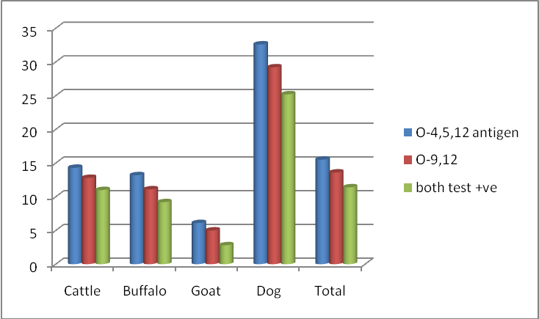
Figure 1: Percent sero-positivity of Salmonella infection in animals using slide micro agglutination test
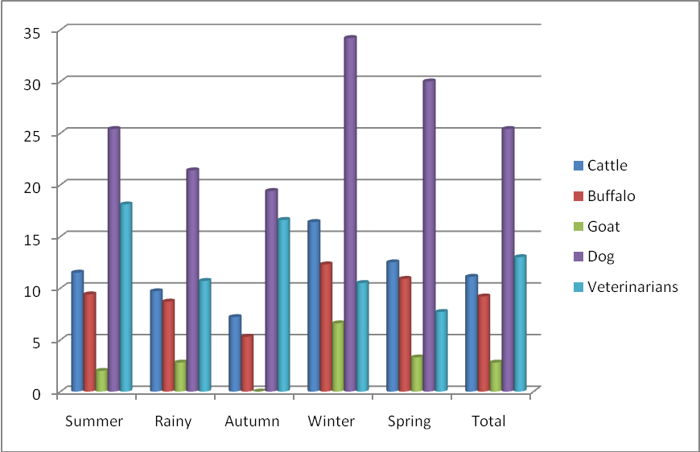
Figure 2: Seasonal distribution of Salmonella agglutinins in different host species

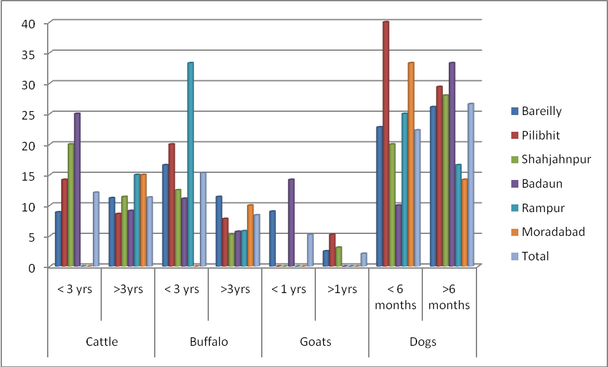
Figure 3: Age-wise and districts wise distribution of Salmonella agglutinins in different animal species

