COMPARATIVE POTENTIAL OF TRADITIONAL VERSUS MODERN DIAGNOSTIC TESTS IN ESTIMATING INCIDENCE OF CAPRINE JOHNE’S DISEASE
Running title: Incidence of Caprine Johne’s disease
D.B. Barad¹, B.S. Chandel¹, A.I. Dadawala¹, H.C. Chauhan¹, H.N. Kher¹, S. Shroff¹, A.G. Bhagat¹,
S.V. Singh^{2*}, P.K. Singh², A.V. Singh², J.S. Sohal², S. Gupta² and K.K. Chaubey²

¹Department of Microbiology, College of Veterinary Science and A.H., Sardarkrushinagar
Dantiwada Agricultural University, Sardarkrushinagar - 385 506, Dist. Banaskantha, Gujarat

²Microbiology Laboratory, Animal Health Division, Central Institute for Research on Goats,
Makhdoom, PO -Farah, Dist.- Mathura, 281 122, Uttar Pradesh, India

*Corresponding author: shoorvir.singh@gmail.com; shoorvir_singh@rediffmail.com
Phone No. +91 565 2763260; +91 9719072856; Fax: +91 565 2763246

Abstract
Study aimed to compare easy to perform field based conventional tests {(faecal smear examination, Delayed Type Hypersensitivity (DTH), AGID} with respect to modern laboratory tests (IS900 PCR and Indigenous ELISA kit) in estimating incidence of Mycobacterium avium subspecies paratuberculosis (MAP) in two important breeds of goats (Mehsani and Surti) from Gujarat (Western India) in the year 2009. A total of 219 goats screened were categorized as Group-I (123 Mehsani goats), Group-II (76 Surti goats) and Group-III, (20 Non-descript goats). Percent positivity by faecal smear examination (fecal microscopy), Delayed Type Hypersensitivity (DTH), AGID, IS900 PCR and Indigenous ELISA kit was 9.2 (7/76), 21.9 (27/123), 10.9 (24/219), 12.5% (5/40) and 43.3 (95/219), respectively. Rectal pinch smear examination was carried out in 27 DTH positive goats and all smears were negative for the presence of acid fast bacilli. Screening tests (Indigenous ELISA and Delayed Type Hypersensitivity) showed very high incidence of MAP infection in the goat population.

Key words: Johne’s disease, Mycobacterium avium subspecies paratuberculosis, Microscopy, ELISA, IS900 PCR, AGID

1. Introduction

Mycobacterium avium subspecies paratuberculosis (MAP) is the cause of chronic granulomatous inflammation in animals and is known as Johne’s disease (JD) or Paratuberculosis (Chiodini et al., 1984). It causes entero-colitis, lymphadenitis and lymphangitis in domestic and wild ruminants (Perez et al., 1996, Clarke, 1997, Manning and Collins, 2001, Singh et al., 2012). The disease is endemic worldwide including India and in herds where investigated. In India, limited studies (Pande, 1940; Singh et al., 1996, Tripathi et al., 2002, Singh et al., 2007a) reported variable incidence (2-18%) in domestic livestock. Animals may either receive infection from infected parents through semen, in-utero, milk and colostrums (Shankar et al., 2008) or pick up infection from contaminated environment soon after birth and then follows a protracted incubation period which may last few months to few years. Sharing of MAP between species (inter-species transmission) has been frequently reported (Singh et al., 2012). Clinical symptom being non-specific (weight loss and diarrhea) are not visible before disease gets fully established in the body (clinical) and progressive weakness ultimately leads to either un-timely death or culling. In small ruminants disease is clinically characterized by progressive weight loss and emaciation, soft pelleted faeces with occasional immunea (may be absent) in the terminal stages. Internally granulomatous enteritis leads to thickening of intestinal mucosa and regional lymphangitis and lymphadenitis (Chiodini et al., 1984), however, corrugations are rare as animals goes out much before from the production system.
Johne’s disease (JD) being spectral in nature presents variable bacteriological, immunological and pathological spectra leading to variable efficacy of diagnostic methods at different points of time during the course of infection (Chiodini et al., 1984). Cultivation of MAP from faeces and tissues (ileo-caecal lymph nodes and small intestines) though specific but is time consuming and may require up to 12 weeks (Cocito et al., 1994) and poor in sensitivity (Sockett et al., 1992). PCR is a rapid diagnostic test for the detection of MAP from faeces, blood and tissues with sensitivity comparable with bacterial culture (Tripathi et al., 2002, Singh et al., 2010). Infected animals elicit strong cell-mediated immune (CMI) response in early stages of the infection and strong humoral immune response in the later stages (Clarke, 1997). CMI based test such as cutaneous testing with johnin PPD, gamma-interferon assay and lymphocyte stimulation test, although reported to be sensitive, have been less frequently evaluated for the detection of early stages of MAP infection in sheep and goats (Molina et al., 1991; Storset et al., 2001; Kurade et al., 2004). Antibody assays for JD include complement fixation test (CFT), agar gel immunodiffusion (AGID) and enzyme-linked immunosorbent assay (ELISA) tests. The latter is sensitive in clinical infection but performs poorly in sub-clinical stages of infection (Stewart et al., 2006). The study aimed to evaluate the efficacy of easy to perform field based conventional tests {(faecal smear examination, Delayed Type Hypersensitivity (DTH), AGID)} with respect to modern laboratory tests (IS900 PCR and Indigenous ELISA kit) in estimating incidence of Mycobacterium avium subspecies paratuberculosis (MAP) in two important breeds of goats (Mehsani and Surti) from Gujarat (Western India) in the year 2009.

2. Materials and methods

2.1 Faecal smear

About 2-3 grams of faecal sample was collected from each of the goats directly from rectum, brought to the laboratory on the same day and processed. One gram of faecal sample was properly crushed with the help of sterilized pestle and mortar in sterilized distilled water. Mixture was then centrifuged at 2600 rpm for 45 minutes. After centrifugation, supernatant was discarded and from the semisolid middle layer smear was prepared on a clean slide. Smear was air dried, heat fixed and stained with Ziehl-Neelsen (ZN) method and examined under microscope. Positive faecal samples were stored at -20⁰ C for DNA extraction and culture.

2.2 Rectal pinch smear
Rectal pinch smear were examined in goats positive in Johnin test. Rectal pinch was collected with a sterilized Artificial Insemination sheath and smears were prepared. Smears were air dried, heat fixed, stained with ZN method and observed under microscope. Smears exhibiting presence of short acid fast bacilli were considered positive in smear.

2.3 Delayed Type Hypersensitivity (DTH) / Johnin test
Single intra-dermal (DTH) test was performed on 123 goats of group-I by inoculation of 100 µg of Johnin PPD, obtained from Division of Biological Products, IVRI, Izatnagar (India) in the form of heat concentrated synthetic medium (HCSM) of Mycobacterium paratuberculosis. Test was carried out as per the instructions of manufacturer on the side of neck. Skin thickness was measured with Vernier Calipers at pre, 24, 48 and 72 hours post inoculation. Animals showing hot, edematous, painful skin thickness of more than 3 mm after 48 hours were considered positive.

2.4 Post mortem and histopathology
Goats died of natural infection were subjected to post mortem examination. Tissues (Ileocaecal junction of intestine, ileum and mesenteric lymph nodes) exhibiting gross lesions were collected and stored at –20⁰C without adding any preservative for DNA isolation and PCR, whereas, for histopathology tissues were stored in 10% formalin at room temperature. Formalin fixed tissues were cut into thin (2-3 mm) pieces and wash thoroughly with water for several hours before putting in ascending grades of alcohol for dehydration. Dehydrated tissues were cleared in xylene, embedded in paraffin blocks and 5 micron thick sections were prepared (Luna, 1968). Sections were stained with haematoxylin and eosin (H and E) and Ziehl Neelsen method. Smears made from tissues (Ileocaecal junction, mesenteric lymph nodes), heat fixed and stained with ZN method for the presence of acid fast bacilli indistinguishable to MAP.

2.7 Agar Gel Immunodiffusion (agid) test
The protocol of AGID was followed as per Ferreira et al. (2002). Agarose was dissolved at 0.75% in 0.85% NaCl solution and buffered to pH 9.0 with 0.01 mol tris (hydroxymethyl) - aminomethane and sodium azide 0.02%. Gel was poured in plates on a 4-mm thick layer and wells of 5 mm diameter, in a hexagonal pattern of six peripheral wells for serum samples and a central well for antigen were made. Protoplasmic Antigen (PPA) (Allied Monitor, USA) was used as antigen at the concentration of 10 mg/ml. Positive serum was placed into wells adjacent to test sera. Diameter between the centers of all the adjacent wells was 8 mm. After the wells were filled plates were incubated in covered, moistened glass dishes to avoid drying. Plates were examined after 24 and 48 h of incubation at room temperature. Appearance of one or more clearly definable precipitation lines before or at 48 h constituted a positive test result. Absence of any precipitation lines was recorded as a negative test result. Serum from clinically infected animals was used as positive control.

2.5 DNA Isolation

2.5.1 From tissues

After collection of tissues (mesenteric lymph nodes and intestines) were grounded and treated with 0.9% HPC (Hexadecyl pyridinium chloride) overnight. The sediment (0.5-1.0 ml) was taken in 2.0 ml capacity eppendorf tubes and washed with PBS, 3-4 times by spinning and vortexing. Pellet was subjected to DNA isolation as per van Embeden et al. (1993) method with some modification. Briefly, washed pellet was suspended in 1.0 ml 1X TE buffer (pH 8.0) and centrifuged at 8000 rpm for 15 minutes. Pellet was re-suspended in 450 µl 1X TE buffer and subjected to freezing and thawing (heating to boiling and snap cooling at -20⁰C) repeat the process 3-4 times. Then, 40 µl of lysozyme was added to tubes and incubated at 37⁰C for 2 hours. Proteinase K (6 µl) and 10% SDS (56 µl) were added and incubated at 65⁰C for 30 minutes. After that 64 µl of CTAB + 80 µl 5M NaCl were added and incubated at 65⁰C for 30 minutes. Equal volume of Chloroform + Isoamyl alcohol (24:1) was added, mixed properly and centrifuged at 10,000 rpm for 10 minutes. DNA was precipitated by chilled absolute ethanol and washed with 70% chilled ethanol. DNA Pellet was re-suspended in 30 µl 1X TE buffer and stored at -20⁰C until further use.

2.5.2 From faeces

Faecal samples were centrifuged at 2600 rpm for 45 minutes and bacilli were concentrated in the interface of solid and watery layers. After discarding the top layer, semi-solid middle layer was collected by sterilized swab and stirred in tubes containing 40 ml 0.9% HPC for decontamination (18-24 hours) at room temperature. For DNA isolation, 0.5-1.0 ml of sediment after discarding the decontaminated layer was kept into a 2.0 ml capacity sterilized eppendorf tubes. Sediment was washed with PBS, 3-4 times by spinning and vortexing. Pellet was subjected to DNA isolation as per method described by Van Embeden et al. (1993) with some modification.

2.6 Polymerase Chain Reaction (PCR)

DNA was isolated from decontaminated fecal and tissue samples were subjected to specific IS900 PCR as per Green et al. (1989) and Vary et al. (1990). Briefly, PCR was set in volume of 25 µl, using 1.0-5.0 ng template DNA, 12.5 µl of 2X PCR Master Mix (Genei, Banglore) and 1.0 µl of each primer (10 pmole). Total of 35 cycles were performed in a thermocycler (MJ research) for complete ampliﬁcation reaction (Table 1). Thermal cycling conditions for primer 1 were: initial denaturation at 94⁰C for 3 min, followed by 35 cycles of denaturation at 94⁰C for 10 sec, annealing at 50⁰C for 10sec, extension at 72⁰C for 10 sec, and final extension at 72⁰C for 3 min. Thermal cycling conditions for primer 2 were: initial denaturation at 94⁰C for 4 min, followed by 35 cycles of denaturation at 94⁰C for 30 sec, annealing at 64⁰C for 30sec, extension at 72⁰C for 30 sec, and final extension at 72⁰C for 5 min. Presence and yield of speciﬁc PCR product was analyzed by 1.5% agarose gel electrophoresis.

2.5 Indigenous ELISA kit

Serum samples were screened by ‘indigenous ELISA kit’ as per the method of Singh et al (2007b). Briefly, 10µg per plate of MAP ‘Indian Bison type’ protoplasmic antigen was taken in 10 ml of carbonate-bicarbonate buffer (pH 9.6) and coated in duplicate wells of flat bottom 96 well ELISA plates. Plates were incubated at 4⁰C overnight, washed thrice with washing buffer (PBS + 0.05% Tween-20, pH 7.4- PBST), blocked (3% skimmed milk powder in PBS) and incubated at 37⁰C for 1 hour. Plates were washed thrice (PBST) and stored at 4⁰C till further use. M. phlei (Allied Monitor Inc., USA) was mixed in serum dilution buffer before dilution of each test serum sample and plate used for serum dilution was incubated for one hour at 37⁰C. After incubation, 100 µl of each adsorbed test serum was transferred to duplicate wells of ELISA plate incubated for two hours at 37⁰C. Plates were washed thrice with PBST. After washing, 100µl of optimally diluted (1:8000) rabbit anti-goat horse radish peroxidase conjugate was added to wells and incubated at 37⁰C for one hour. Plates were washed thrice with PBST and 200 µl of freshly prepared substrate (OPD, 5 mg/ plate in substrate buffer, pH- 5.0) was added to each well and incubated in dark for 30 minutes at room temperature. Absorbance was read at 450 nm.

2.6 Data analysis

Data were managed in tables created using Microsoft Office Excel; Microsoft Corp., Redmond, Washington, USA. Positive and strong positive samples were considered positive for MAP infection in ELISA, as per Collins (2002) by converting OD values into sample-to-positive (S/P) ratio (using formulae; Sample OD - Negative OD / Positive OD - Negative OD in Excel cells).

3. Results and Discussion

In the faecal smear examination of 56 goats of Group-I, 5 (8.9%) goats were positive, whereas, in Group-III, of 20 goats, 2 (10.0%) goats were positive. Of total 76 goats screened, 7 (9.2%) were positive (Table 2). Of 5 faecal positive goats of Group-I, 3 died during study. Clinical signs were observed in all the 7 faecal smear positive goats and were also positive in ELISA and AGID. Tripathi et al. (2006) showed that of 36 known cases of caprine paratuberculosis diagnosed by clinical and faecal smear examination, 72.2% goats were shedding MAP bacilli (Figure 2). Faecal smear examination with acid-fast staining detected more goats as positive as compared to bacterial culture and PCR (Munjal et al., 2007). Screening of 71 animals (55 goats and 16 sheep) belonging to Central Institute for Research on Goat (CIRG) located at Makhdoom (India) revealed that 40% goats and 31.2% sheep were shedding MAP in faeces (Singh et al., 2007a, Singh et al., 2007b).
Rectal pinch smear examination was carried out in 27 DTH/Johnin positive goats. All rectal pinch smears were negative for the presence of MAP (Table 2). In accordance to this it was described in Ohio State University Fact Sheet for Johne’s disease in sheep and goats that the smears of rectal mucosa biopsies are difficult to get and may not be very helpful because the disease process is less likely to involve the rectum in sheep and goats (http://ohioline.osu.edu/vme-fact/0003.html). Of the 123 goats of Group-I, 27 (21.9%) were positive in DTH test. Of 5 faecal positive goats which also showed clinical signs, 2 (3.5%) goats died during study were negative by Johnin (Table 3). Similar to these findings, Paliwal and Rajya (1982) and Rajukumar (1998) stated that sensitivity of Johnin test in goats ranged between 18-30% with least specificity in both preclinical and advanced stage of disease. Tripathi et al. (2006) reported that of 34 cases of caprine paratuberculosis, 73.5% goats were positive for Johnin test. In the present study, of 5 infected goats, 3 (60%) were positive in Johnin test.
Of the 219 goats tested, 95 (43.3%) were positive by ELISA. Of 123 Mehsani goat breed (Group-I), positive reactors were higher 57 (46.3%) and had history of recurrent diarrhea (Table 4). Sweeney et al. (1995) reported that sensitivity of ELISA is only 15.0% in animals excreting low quantities of MAP bacilli in their faeces as compared to 87.0% in animals with clinical signs of Johne's disease. In this study similar results were obtained i.e. all the 7 goats showing clinical signs as well as faecal smear positivity were also positive by ELISA. Paolicchi et al. (2003) and Singh et al. (2009) observed that absorbed ELISA was useful to detect positive animals and those goats shedding MAP in faeces. Similarly in the present study all animals shedding MAP in feces were positive in the ELISA test also. ELISA has been described as most sensitive and specific test for the detection of MAP infection (OIE manual, 2000). In our study also Indigenous ELISA kit developed by CIRG, Makhdoom was most sensitive and specific test for the detection of MAP infection.
Of 219 goats tested, 24 (10.9%) were positive by AGID. Group-III consisting of 20 non-descript goats showed higher number (4 or 20%) of goats as positive reactors. All the 7 goats showed clinical signs and were positive in smear examination and AGID (Table 5). Similarly, Sherman et al. (1984) recorded that of 33 AGID positive cattle, 32 (96.9%) were confirmed for MAP infection by culture or necropsy. Similarly, Ferreira et al. (2002) found AGID specificity was 92.5% and sensitivity 57%. Raul et al. (1998) recorded 11.7% (64 of 546) sero-prevalence of MAP in sheep and goat flocks using AGID test.

PCR was carried out on faecal samples of suspected animals of Group-I and III with history of recurrent diarrhoea or pasty faeces and tissue samples of three goats died in Group-I. Of 40 goats, 7 showed clinical signs and were also positive by faecal smear examination (Figure 1). Among these 7 goats faecal PCR detected 5 goats as positive while 2 were negative (Table 6). Munjal et al. (2007) observed that faecal smear examination with acid fast staining detected more goats positive than bacterial culture and PCR. Previous studies also reported higher prevalence of MAP in farm herds as compared to farmer’s herds (Kumar et al., 2007). Tissue samples of all 3 goats died during study were positive by PCR. Similarly, Stabel (1997) reported that IS900 based PCR could be more sensitive in tissue samples in confirming diagnosis at necropsy.

All three goats died during study in Group-I were subjected to post mortem examination, revealed enlargement of mesenteric and ileocecal lymph nodes and thickening of ileum and ileocecal junction wall (Figure 3 and 4). In one goat slight corrugation of ileal mucosa was observed. Carcass showed depletion of fat depots. Rajukumar (1998) observed similar lesions with enlarged, edematous and congested mesenteric and ileocecal lymph nodes. Corrugation of ileal mucosa observed in only one goat as described in to Ohio State University Fact Sheet for Johne’s disease that sheep and goats may exhibit some gross and microscopic lesions not typical of those seen in cattle. Ridges and thickening of the small intestine and cecum are not always seen as is common in cattle.

Storset et al. (2001) observed more number of goats with lesions in jejunum as compared to ileum while the lesions in ileum were detected in only one goat. In contrast to this lesions in jejunum were not observed in present study. Histopathological changes in goats died of JD revealed slightly congested intestinal mucosa with infiltration of mononuclear cells consisting of lymphocytes and macrophages in lamina propria. Villi were thickened and blunt at some places. Mesenteric lymph nodes exhibited infiltration of lymphocytes and macrophages. Munjal et al. (2005) observed similar lesions such as thickening of the intestinal villi with flat and wide tips, infiltration of lymphocytes, macrophages and epithelioid cells in lamina propria of intestine and inter-follicular area of mesenteric lymph nodes. Similar Histopathological changes observed by Paliwal and Rajya, (1982) and Rajkumar, (1998).
4. Acknowledgement
Authors are thankful to Council of Science & Industrial Research, New Delhi for financial assistance and Head, Animal Health Division and Director, CIRG, Makhdoom for the technical assistance.
5. Conflict of Interest
No conflict of interest to declare
6. References

- Chiodini RJ, Van Kruiningen HJ and Merkal RS (1984). Ruminant paratuberculosis (Johne's disease): The current status and future prospects. Cornell Vet., 74: 218-262.
- Clarke CJ (1997). The pathology and pathogenesis of paratuberculosis in ruminants and other species. J. Comp. Path., 116: 217-261.
- Cocito C, Gilot P, Coene M, de Kesel M, Poupart P and Vannuffel P (1994). Paratuberculosis. Clin. Microbial. Rev., 7(3): 328-345.
- Collins MT (2002). Interpretation of a commercial bovine paratuberculosis enzyme-linked immunosorbent assay by using likelihood ratios. Clinical and Diagnostic Laboratory Immunology, 9(6): 1367-1371.
- Ferreira R, Fonseca LS and Lilenbaum W (2002). Agar gel immunodiffusion test (AGID) evaluation for detection of bovine paratuberculosis in Rio de Janeiro, Brazil. Letters in Applied Microbiology, 35: 173-175.
- Green EP, Tizzard MLV, Moss MT, Thompson J, Winterbourne DJ, Mc Fadden JJ and Hermon-Taylor J (1989). Sequence and characteristics of IS900, an insertion element identified in a human Crohn’s disease isolate of Mycobacterium avium subsp. paratuberculosis. Nucleic acid research, 17: 9063-9073.
- Kumar P, Singh SV, Bhatiya AK, Sevilla I, Singh AV, Whittington RJ, Juste RA, Gupta VK, Singh PK, Sohal JS and Vihan VS (2007). Juvenile Capri-Paratuberculosis in India; Incidence and characterization of by six diagnostic tests. Small Ruminant Research. 73: 45-53
- Kurade NP, Tripathi BN, Rajukumar K and Parihar NS (2004). Sequential development of histologiclesions and theirrelationship with bacterial isolation, fecal shedding, and immune responses during progressive stages of experimental infection of lambs with Mycobacterium avium subsp. paratuberculosis. Vet Pathol. 41: 378–387.
- Luna LG (1968). Manual of Histological Staining Methods of the Armed Forces Institute of Pathology. 3rd Edn. McGraw Hill Book Company, New York.
- Manning EJB and Collins MT (2001). Mycobacterium avium subsp. paratuberculosis: pathogen, pathogenesis and diagnosis. Rev. Sci. Tech. off. Int. Epiz., 20: 133-150.
- Molina A, Morere L and Lianes D (1991). Enzyme-linked immunosorbent assay for detection of antibodies against Mycobacterium paratuberculosis in goats. Am. J Vet. Res., 52: 863-868.
- Munjal SK Tripathi BN and Paliwal OP (2005). Progressive immunopathological changes during early stages of experimental infection of goats with Mycobacterium avium subspecies paratuberculosis. Vet. Pathol. 42: 427-436.
- Munjal SK, Tripathi BN, Paliwal OP, Boehmer J and Homuth M (2007). Application of different methods for the diagnosis of experimental paratuberculosis in goats. Zoonosis and Public Health, 54: 140-146.
- Ohio State University Fact Sheet for Johne’s disease. (http://ohioline.osu.edu/vme-fact/0003.html).
- OIE Manual (2000). Johne's disease. pp. 30-35.
- Paliwal OP and Rajya BS (1982). Evaluation of paratuberculosis in goats: Pathomorphological studies. Indian J. Vet. Path., 6: 29-34.
- Pande P G (1940). Paratuberculosis (Johne 's disease) of cattle in Assam. Its invidence and epizootiology. Ind. J. Vet. Sci., 10: 40.
- Paolicchi FA, Zumarraga MJ, Gioffre A, Zamorano P, Morsella C, Verna A, Cataldi A, Alito A and Romano M (2003). Application of different methods for the diagnosis of paratuberculosis in a dairy cattle herd in Argentina. J. Vet. Med. B. Infect. Dis. Vet. Public Health, 50: 20-26.
- Perez V, Garcia-Marin JF and Badiola JJ (1996). Description and classification of different types of lesions associated with natural paratuberculosis infection in sheep. J. Comp. Path., 114: 107-122.
- Rajukumar K (1998). Pathology and diagnosis of caprine paratuberculosis. M.V.Sc. thesis. Deemed Unjversity. IVRI, Izatnagar.
- Raul C, Mainar-Jaime and Vazquez-Boland JA (1998). Factors associated with seroprevalence to Mycobacterium paratuberculosis in small-ruminant farms in the Madrid region (Spain). Preventive Veterinary Medicine, 34 (4): 317-327.
- Shankar H, Singh SV, Singh PK, Singh AV, Sohal JS and Greenstein RJ (2008). Presence, characterization, and genotype profiles of Mycobacterium avium subspecies paratuberculosis from unpasteurized individual and pooled milk, commercial pasteurized milk, and milk products in India by culture, PCR, and PCR-REA methods. International Journal of Infectious Diseases., 14: e126-e126.
- Sherman DM, Markham RJF and Bates F (1984). Agar gel immunodiffusion test for diagnosis of clinical paratuberculosis in cattle. J. Am. Vet. Med. Assoc., 185: 179-182.
- Singh AV, Singh SV, Sohal JS and Singh PK (2009). Comparative potential of modified indigenous, indigenous and commercial ELISA kits for diagnosis of Mycobacterium avium subspecies paratuberculosis in goat and sheep. Indian Journal of Experimental Biology., 47(5): 379-382.
- Singh N, Singh SV, Gupta VK, Sharma VD, Sharma RK and Katoch VM (1996). Isolation and identification of Mycobacterium avium subsp. paratuberculosis from naturally infected goatherds in India. Indian Journal of Veterinary Pathology., 20: 104-108.
- Singh PK, Singh SV, Kumar H, Sohal JS and Singh AV (2010). Diagnostic Application of IS900 PCR Using Blood as a Source Sample for the Detection of Mycobacterium avium subspecies paratuberculosis in Early and Subclinical Cases of Caprine Paratuberculosis. Veterinary Medicine International., doi:10.4061/2010/748621.
- Singh SV, Singh AV, Gupta S, Rajindran AS, Swain N, Singh PK, Singh H, Sohal JS and Kumar N (2012). Interspecies Sharing of ‘Indian Bison Type’ A Novel Predominant Genotype of Mycobacterium avium subspecies paratuberculosis between Naturally Infected and Endemic Flocks of Bharat Merino Sheep and a Colony of Rabbits (Oryctolagus Cuniculus) Raised on the Same Ecosystem in South India. Research and Reviews: A Journal of Life Sciences, 2(3): 1-8.
- Singh SV, Singh AV, Singh PK, Sohal JS and Singh NP (2007b). Evaluation of an indigenous ELISA for diagnosis of Johne's disease and its comparison with commercial kits. Indian J. Microbiol., 46: 251-258.
- Singh SV, Singh AV, Singh PK, Sohal JS, Vikram Y and Kharche SD (2007a). Sero-prevalence of Mycobacterium avium subspecies paratuberculosis infection in Barbari and Sirohi breeds of goats in their respective home tracts in semi-arid regions of North India. Haryana Vet., 46: 104-106.
- Sockett DC, Carr DJ and Collins MT (1992). Evaluation of conventional and radiometric faecal culture and a commercial DNA probe for diagnosis of M. paratuberculosis infections in cattle. Can. J. Vet. Res., 56: 148-153.
- Stabel JR (1997). Johne's disease - A hidden threat. J. Dairy Sci., 81: 283-288.
- Stewart DJ, Vaughan JA, Stiles PL, Noske PJ, Tizard MLV, Prowse SJ, Michalski WP, Butler KL and Jones SL (2006). A long-term study in Angora goats experimentally infected with Mycobacterium avium subsp. paratuberculosis: Clinical disease, faecal culture and immunological studies. Vet. Microbiol., 113: 13-24.
- Storset AK, Hasvold HJ, Valheim M, Brun-Hansen H, Bernstsen G, Whist SK, Djonne B, Press CM, Holstad G and Larsen HJ (2001). Subclinical paratuberculosis in goats following experimental infection. An immunological and microbiological study. Vet. lmmunol. Immunopathol., 80: 271-287.
- Sweeney RW, Whitlock RH, Buckley CL and Spencer PA (1995). Evaluation of a commercial enzyme-linked imunosorbant assay for the diagnosis of paratuberculosis in dairy cattle. J. Vet. Diagn. Invest., 7: 488-493.
- Tripathi BN, Munjal SK and Paliwal OP (2002). An overview of paratuberculosis (Johne's disease) in animals. Ind. J. Vet. Pathol., 26(1-2): 1-10.
- Tripathi BN, Sivakumar P, Paliwal OP and Singh N (2006). Comparison of IS900 tissue PCR, bacterial culture, Johnin and serological tests for diagnosis of naturally occurring paratuberculosis in goats. Vet. Microbiol., 116: 129-137.
- Van Embden JDA, Cave D, Crawford JT, Dale JW, Eisenach KD and Gicquel B (1993). Strain identiﬁcation of Mycobacterium tuberculosis by DNA ﬁngerprinting: recommendations for a standardized methodology. J Clin Microbiol., 31(2): 406-9.
- Vary PH, Andersen PR and Green E, Hermon Talyor J and McFadden JJ (1990). Use of highly specific DNA probes and the polymerase chain reaction to detect Mycobacterium paratuberculosis in Johne’s disease. J. Clin. Microbiol., 28: 933-937.

Tables (1-6)

Table 1: Details of primers used for PCR

Sequence 5` to 3` | Amplicon size | Reference
Primer 1  NT 05 (F) GAT CGC CTT GCT CAT CGC TGC CG  NT 06 (R) GAT CGG AAC GTC GGC TGG TCA GG | 218 bp | Green et al.,1989
Primer 2  (F) CCG CTA CTT GAG AGA TGC GAT TGG  (R) AAT CAA CTC CAG CAG CGC GGC CTC G | 229 bp | Vary et al., 1990

Table 2. Faecal and rectal pinch smear examination

Group | Tested n |  |  | Positives n (%)
Group | Male | Female | Total | Male | Female | Total
I | 4 | 52 | 56 | 1^{D} (25.0) | 2^{D}+2*= 4 (7.6) | 5 (8.9)
III | 2 | 18 | 20 | 1 (50.0) | 1 (5.5) | 2 (10.0)
Total | 6 | 70 | 76 | 2 (33.3) | 5 (7.1) | 7 (9.2)
^{D}- Goats died during study, * Two goats found negative by PCR, n- number of animals

Table 3. Delayed Type Hypersensitivity (DTH) /Johnin test

 | Tested n |  |  | Positives n (%)
Age (year) | Male | Female | Total | Male | Female | Total
0.5-1 | 2 | 23 | 25 | 0 (0.0) | 2 (8.7) | 2 (8.0)
1-3 | 5 | 64 | 69 | 1 (20) | 17 (26.5) | 18 (26.0)
> 3 | 3 | 26 | 29 | 1 (33.3) | 6 (23.0) | 7 (24.1)
Total | 10 | 113 | 123 | 2 (20) | 25 (22.1) | 27 (21.9)
n- number of animals

Table 4. Enzyme Linked Immuno Sorbent Assay (ELISA)

Group | Tested n |  |  | Positives n (%)
Group | Male | Female | Total | Male | Female | Total
I | 10 | 113 | 123 | 4 (40) | 53 (46.9) | 57 (46.3)
II | 5 | 71 | 76 | 1 (20) | 29 (38.1) | 30 (39.4)
III | 2 | 18 | 20 | 1 (50) | 7 (38.8) | 8 (40)
Total | 17 | 202 | 219 | 6 (35.2) | 89 (44.0) | 95(43.3)
n- number of animals

Table 5. Agar Gel Immuno Diffusion (AGID)

Group | Tested n |  |  | Positives n (%)
Group | Male | Female | Total | Male | Female | Total
I | 10 | 113 | 123 | 1 (10) | 14 (12.3) | 15 (12.2)
II | 5 | 71 | 76 | 0 (0.0) | 5 (7.0) | 5 (6.5)
III | 2 | 18 | 20 | 1 (50) | 3 (16.6) | 4 (20)
Total | 17 | 202 | 219 | 2 (11.7) | 22 (10.8) | 24 (10.9)
n- number of animals

Table 6. IS 900 Polymerase Chain Reaction (PCR)

Group | Tested (n) |  |  | Positives n (%)
Group | Male | Female | Total | Male | Female | Total
I | 4 | 24 | 28 | 1 (25) | 2 (8.3) | 3 (10.7)
III | 2 | 10 | 12 | 1 (50) | 1 (10) | 2 (16.6)
Total | 6 | 34 | 40 | 2 (33.3) | 3 (8.8) | 5 (12.5)
n- number of animals

Figures (1-6)

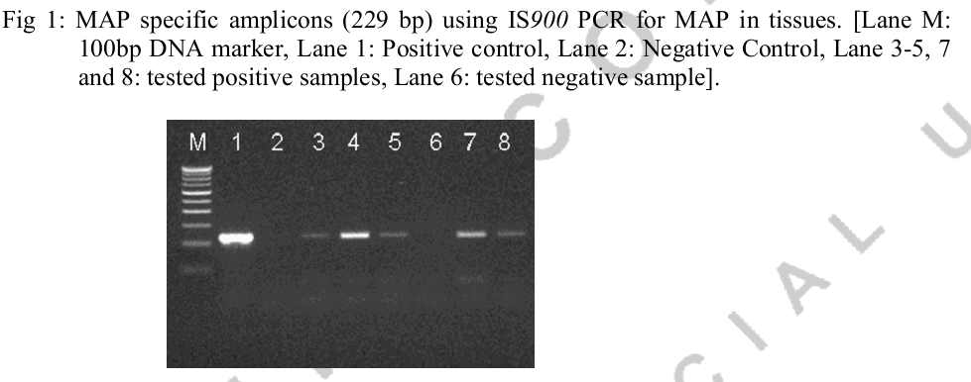
300 bp
100 bp
229 bp
Figure 1. MAP specific amplicons (229 bp) using IS900 PCR. Lane M: 10 bp DNA marker, Lane 1: Postive control (MAP DNA), Lane 2: Negative control (MiliQ water),
Lane 3-5: Tested DNA samples

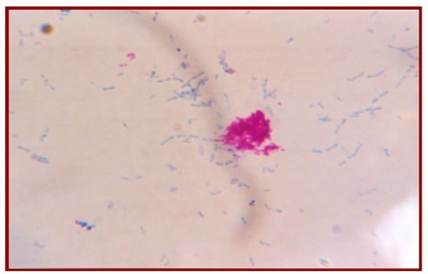

Figure 2. Microscopic view of acid fast bacilli (indistinguishable to MAP)

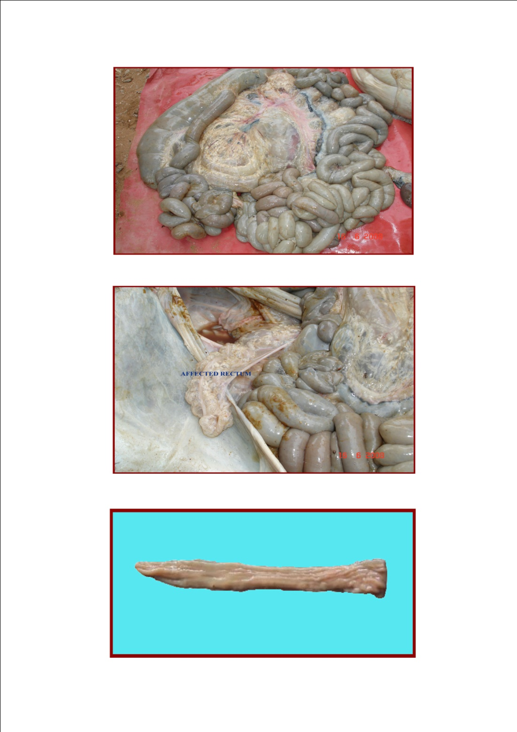
Figure 3. Histopathological changes showing enlargement of mesenteric
and ileocecal lymph nodes

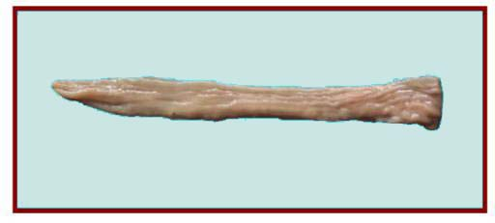
Figure 4. Histopathological changes showing corrugation and
thickening of intestinal mucosa

