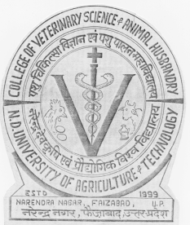 | Department of Veterinary Microbiology  College of Veterinary Science and Animal Husbandry  N. D. UNIVERSITY OF AGRICULTURE AND TECHNOLOGY  Kumarganj-224 229, Faizabad (U.P.), India  Phone: 05270-262847 (R)  09451663077 (M)  e-mail: rkjoshivet26@gmail.com |  |  |  | 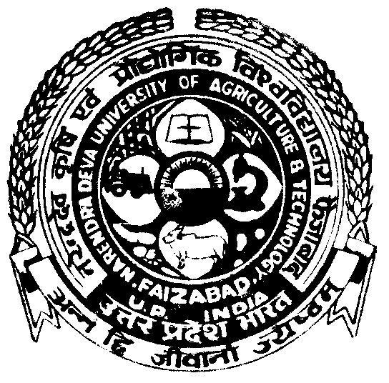
Dr. R. K. Joshi
M.V.Sc., Ph. D.
Professor and Head
 |  |  |  | Dated: 12-04-2013

To

The Chief Editor
Journal of Animal Health and Production

Sir,
Please find attached herewith the research article entitled “Detection and characterization of Staphylococcus aureus from the cases of Sub clinical bovine mastitis”. You are very kindly requested to consider it for the publication in Journal of Animal Health and production.

Kindly acknowledge the receipt.

Yours Sincerely

(R.K. Joshi)

