To,
The Editor-in-Chief
Advances in Animal and Veterinary Sciences

Sub: Submission of Manuscript for publication

Dear Sir,

We intend to publish an article entitled “Sequence and phylogenetic analysis of bovine rotavirus isolates (G6 genotypes) from India” in your journal.

On behalf of all the contributors I will act and guarantor and will correspond with the journal from this point onward.
We hereby transfer, assign, or otherwise convey all copyright ownership, including any and all rights incidental thereto, exclusively to the journal, in the event that such work is published by the journal.
Thanking you,

Yours’ sincerely,
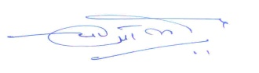
[YPS Malik]
Corresponding contributor
Dr. Y.P.S. Malik, Senior Scientist,
Indian Veterinary Research Institute (IVRI)

