Biogram of Wild Carnivores of Pakistan,

Edited By
Dr. Haroon Rashid Chaudhry
DVM, M. Sc. (Hons) Microbiology
PhD Scholar, UVAS, Lahore- Pakistan
The Islamia University of Bahawalpur, Pakistan
&
Dr. Tariq Jamil,
DVM (UCV&AS, IUB)
M. Phil Scholar, UVAS, Lahore-Pakistan

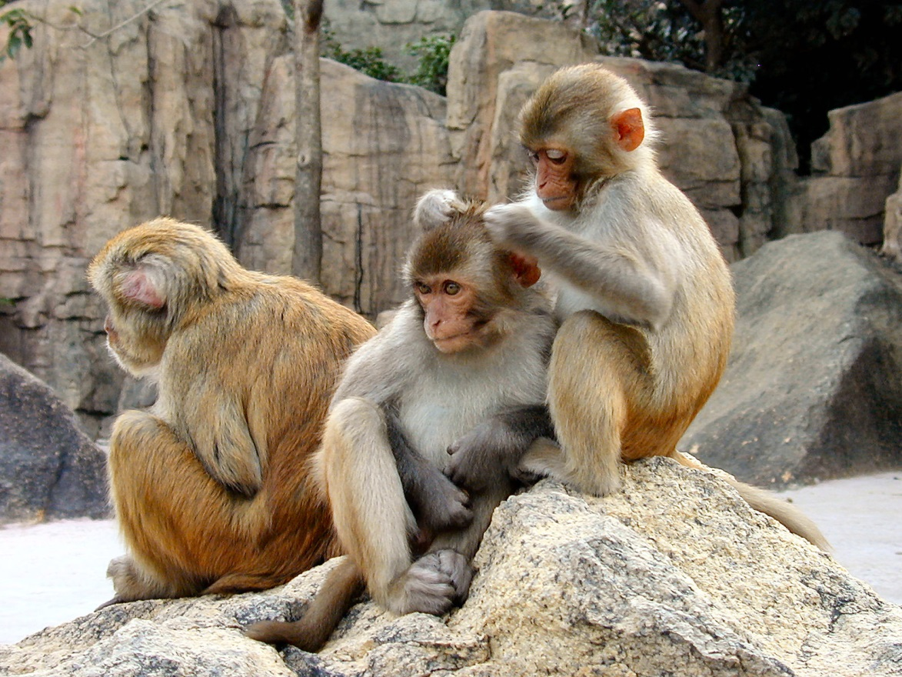

PHOTO CREDIT: http://www.redorbit.com/education/reference_library/science_1/mammalia/2577882/rhesus_macaque/

English Name | Rhesus Macaque
Scientific Name | Macaca Mulatta
Local Name | Bandar
Appearance | Brown, red face and rump, light brown ventrally, medium length tail and quadrupedal locomotion.
Weight | Male: 5.6-10.9 kg  Female: 4-10.9 kg
Length | Males: 48-63 cm  Female: 47-53 cm
Reproduction | Mating season: March to June  Sexual Maturity: 48-72 Months  Gestation Period: 164 Days
Diet | The main diet is fruits, seeds, leaves, gums, buds, grass, clover, roots, bark, resin, and small invertebrates. Rhesus monkeys raid crops. In the dry season they drink 3-4 times per day
Habitat | This species of primate can live in a variety of habitats. This animal mostly inhabits mountainous regions of the moist temperate forest and also found in dry temperate forest.
Distribution | Rhesus monkeys are mainly found in the northern hill regions of Murree, Swat, Khagan, Azad Kashmir and Chitral. This animal occurs throughout the high hills of Hazara and Malakand civil divisions. It is also found in Sakra mountain range in Mardan civil division. They are also found in the Margalla Hills.

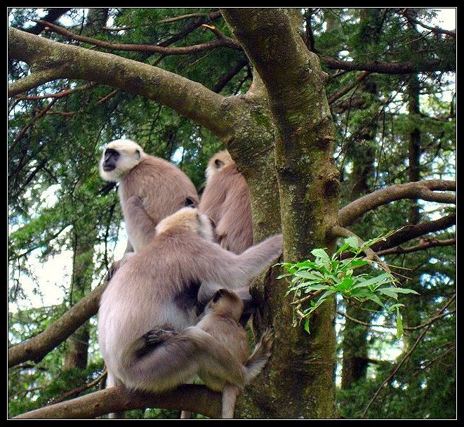
PHOTO CREDIT: http://www.treknature.com/gallery/Asia/India/North//photo93313.htm

English Name | Hanuman Langur/Grey Langur
Scientific Name | Semnopithecus Entellus
Local Name | Langur
Appearance | The Hanuman Langur's coloration varies across subspecies, from gray to dark brown to golden, with varying amounts of black. The locomotion is quadrupedal.
Weight | Male: 18.3 kg  Female: 11.2 kg
Length | Males: 51-78 cm  Female: 40-68 cm
Reproduction | Mating season: March to June  Sexual Maturity: 46.5-47 Months  Gestation Period: 168-200 Days
Diet | The Hanuman Langur eats mature leaves, fruit, buds, flowers, young leaves, animal prey, exudates, bark, soil, herbs. The Himalayan subspecies rely on pinecones, bark and twigs during snowy winter months These langurs will raid gardens and crops
Habitat | The Hanuman Langur prefers tropical, subtropical, pine, alpine forests and urban areas.
Distribution | This animal is very adaptable species and is distributed in dry savannah country and tropical rain forests in different parts of the sub-continent. In Pakistan, however, it is confined to Azad Kashmir and Siran Valleys of Mansehra and Kohistan districts

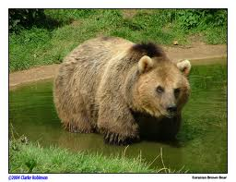
PHOTO CREDIT: www.accentsdailleurs.com

English Name | Eurasian Brown Bear
Scientific Name | Ursus Arctos
Local Name | Bhora Reech, Bhora Bhallu
Appearance | The brown bear is a large animal, usually dark brown in color, though it can vary from a light creamy shade through to black. The long guard hairs over the shoulders and back are often tipped with white which, from a distance, gives a grizzled appearance. The brown bear is characterized by a distinctive hump on the shoulders, a slightly dished profile to the face, and long claws on the front paws.
Weight | Male: 135-390 kg  Female: 95-205 kg  Baby at Birth: 11-12 ounces stay with mother for 2.5 years
Length | Males: Female:
Reproduction | Mating season: May-June  Sexual Maturity: 4.5-7 Years  Pregnancy termination: January to March (females breed fter 3 years)
Diet | Brown bears mainly eat vegetation such as grasses, sedges, bulbs, and roots. They also eat insects such as ants, fish, and small mammals. In some areas they have become significant predators of large hoofed mammals such as Marcopole Sheep, Ibex and Bharal
Habitat | Their preferred habitat includes mountain forests, open meadows and large river.
Distribution | This bear inhabits the remote northern regions of Pakistan. It is found in baltistan, Hunza, Gilgit, the slopes of Nanga Parbat, Khunjerab National Park and the Deosai Pleatue near Skardu.

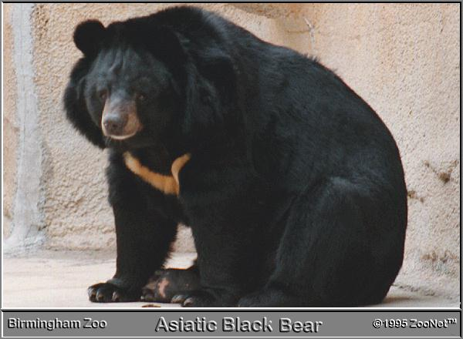
PHOTO CREDIT: Brimingham Zoo

English Name | Asiatic Black Bear
Scientific Name | Ursus Thibetanus
Local Name | Kala Reech, Kala Bhallu
Appearance | This medium-sized, black-colored bear has a lightish muzzle and ears which appear large in proportion to the rest of its head, especially when compared with other species of bears. There is a distinct white patch on the chest , which is sometimes in the shape of a V, and white on the chin. A brown color phase also occurs.
Weight | Male: 100-200 kg Female: 50-125 kg
Length | Males: 130-190 cm Female: 130-190 cm
Reproduction | Mating season: October  Sexual Maturity: 3-4 years  Termination of Gestation: February (Weaned after 6 months stay with mother for 2.5 years)
Diet | Fruits, bees' nests, insects, invertebrates, small vertebrates, and carrion. They occasionally kill domestic livestock. The Baluchistan bear prefers to (Olea ferruginea), Ber (Zizyphus nummularia) as well as the starchy rhizomes and fruits of the dwarf palm, insects and lizards.
Habitat | Asiatic black bears live predominantly in forested areas, especially in hills and mountainous areas. In summer, they have been reported at altitudes over 3,000 meters (9,900 feet), descending to lower elevations during winter. Apparently, they den for winter sleep in the northern parts of their range.
Distribution | In Pakistan the Himalayan Black Bear is found in the mountains of Azad Kashmir, Khagan, Swat Kohistan and Southern Chitral, in Chitral Gol National Park. It is also found in Ayubia National Park. The subspecie, Baluchistan Bear is found in the higher hill ranges of Baluchistan, such as Takht-e-Suliman and Toba Kakar. It is also found in Ziarat, Kalat and Khuzdar.

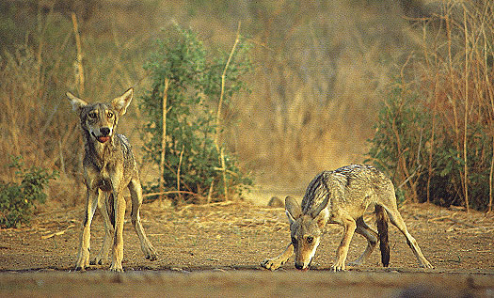
PHOTO CREDIT: Rajpal Singh

English Name | Grey Wolf
Scientific Name | Canis lupus
Local Name | Bhagyar
Appearance | The largest wild canid. Fur is thick and usually grey, but can vary from nearly pure white, red, or brown to black.
Weight | Male: 16-60 kg Female: Lighter
Length | Males: 100-150 cm Female: 100-150 cm  Height: 66-81 cm. at shoulder Tail Length: 31-51 cm.
Reproduction | Time of mating: January-April. Gestation: 6 1 63 days. Litter size: 1-1 1, mean 6. Duration of lactation: 8-10 weeks. Age at sexual maturity: 22-46 months, occasionally 10 months. Longevity: up to 13 years in the wild, 16 years in captivity.
Diet | Extremely variable, but the majority of the diet is large ungulates. Grey wolves will also eat smaller prey items, livestock, carrion, and garbage.
Habitat & Distribution
 | There are two subspecies of the Grey Wolf in Pakistan. In the northern mountanious regions, the Tibetan Wolf (Canis Lupus Campestris) is found. The Tibetan Wolf inhabits the barren rocky mountanious valleys of Baltistan, Gilgit, Hunza, Chitral, Upper Swat and Khunjerab National Park. In the south of the country the Indian Wolf (Canis Lupus Pallipes) is found. Here the wolf inhabits the deserts of Cholistan and Thar. Further West the wolf inhabits the lower hills of the Baluchistan pleatue where it is widespread. The wolf is also found in N.W.F.P, but it is rare in this region.

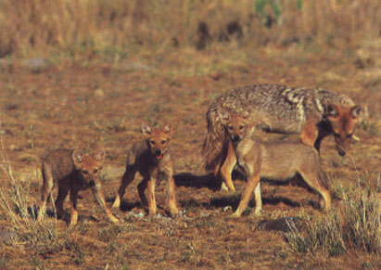
PHOTO CREDIT: Bedi

English Name | Golden Jackal or Asiatic Jackal
Scientific Name | Canis Aureus
Local Name | Gheedar
Appearance | Coat varies with season and region, but is usually a pale gold-brown, or brown tipped yellow. Fur is coarse, and not very long. Dorsal area is black and grey; head, ears, and sides can be rufous. Underside is frequently ginger or nearly white. The tip of the tail is black.
Weight | Male: 7-15 kg Female: Lighter
Length | Males: 60-106 cm Female: 100-150 cm  Height: 38-50 cm. at shoulder Tail Length: 20-30 cm.
Reproduction | Unavailable
Diet | Omnivorous: fruits; invertebrates; reptiles; amphibia; birds; small mammals; carrion. Opportunistic foragers, but cooperation between mated pairs can greatly increase hunting success. In areas around human habitation, it can subsist on garbage
Habitat & Distribution
 | The Golden Jackal is found in open country with trees and brush, grass and copse. This is a very common animal in Pakistan and is usually seen around human settlements. It is widespread and is found throughout much of the country, except the northern most mountanious regions.

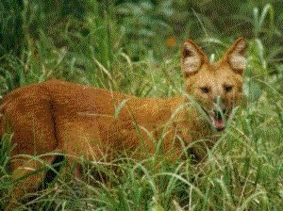
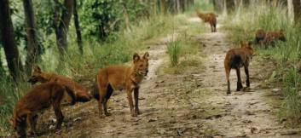

PHOTO CREDIT: http://www.cuon.net/dholes/dholinfo.htm
English Name | Dhole
Scientific Name | Cuon Alpinus
Local Name | Jungli Kutta
Appearance | A fairly large, doglike canid, with rounded ears and a long, moderately bushy tail. Legs are rather short, pelage is evenly tawny or dark red with a slightly darker tail and lighter underparts.
Weight | Male: 15-20 kg Female: 10-15 kg
Length | Males: 90 cm Female: 90 cm  Height: 50 cm. at shoulder Tail Length: 40-45 cm.
Reproduction | Litter size: 8-9, but 3-4 common. Lactation: At least 8 weeks. Age at sexual maturity: 1 year. Longevity: 10 years, up to 16 years in captivity.
Diet | The primary component of the diet is other vertebrates, particularly medium-sized ungulates. The dhole will also include berries and reptiles in its diet
Habitat & Distribution
 | Unavailable

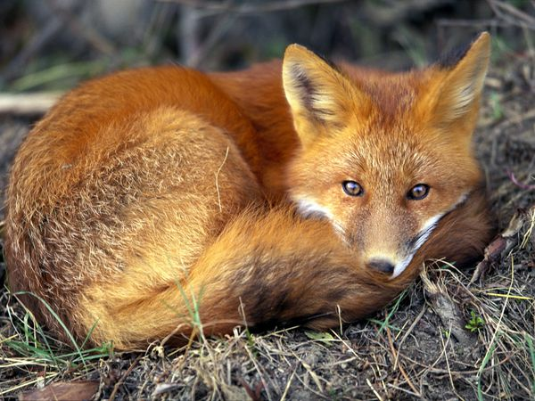
PHOTO CREDIT: http://animals.nationalgeographic.com/animals/mammals/red-fox/

English Name | Red Fox
Scientific Name | Vulpes Vulpes
Local Name | Lal Loomari
Appearance | A medium-sized canid, the largest fox in the genus Vulpes. Large bushy tail, often tipped in white. Ranges in colour from greyish and rust red to a flame red, usually reddish-brown. Black backs to ears; lower limbs often black.
Weight | Male: Female: .
Length | Males: 67 cm Female: 63 cm  Height: 35-40 cm. at shoulder Tail Length: 32-49 cm.
Reproduction | Time of mating: variable with latitude and habitat, usually in late winter/early spring. Gestation: 49-55 days, usually 51-52. Litter size: 3-12. Lactation: 4 weeks, completely weaned at 6-8 weeks. Age at sexual maturity: 9-10 months. Longevity: 10- 12 years in captivity.
Diet | Extremely varied, including invertebrates (particularly beetles and earthworms), small mammals (rodents and lagomorphs), birds (including game species), and fruit along with garbage and carrion. Generally caches food surplus to requirements, and has highly developed memory for locations of hoards
Habitat & Distribution
 | The natural habitat of the Red Fox is dry, mixed landscape, with abundant 'edge' of scrub and woodland. It is also found in uplands, mountains (crosses alpine passes), deserts, sand dunes, and farmland. The Red Fox flourishes especially in affluent suburbs and, in many habitats, appears to be closely associated with humans. In Pakistan the Red Fox is widespread and common throughout most of the country. In the hill ranges like Murree and Azad Kashmir, is found a subspecie of the Red Fox, the Kashmir Hill Fox. Further north in the high mountanious regions such as the Karakoram and Hindukush is found another subspecie the Tibetan Red Fox. The Red Fox is killed in enormous numbers each year for its valuable pelt and because it is considered destructive to poultry, but it has survived this persecution and still survives in good numbers where ever it is found.

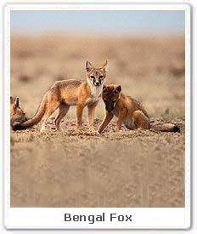

CREDITS: www.ecoindia.com

English Name | Bengal Fox
Scientific Name | Vulpes bengalensis
Local Name | Loomari
Appearance | Sandy-orange coat with black-tipped tail. Skull typically foxlike with long sharply pointed canines and well-developed molar teeth.
Weight | Male: Female:
Length | Males: 45-60 cm Female: same  Height: unknown Tail Length: 25-35 cm
Reproduction | Time of mating: unknown. Gestation: 53 days, equivalent to average for vulpine foxes. Litter size: 2-4. Lactation: unknown. Age at sexual maturity: unknown. Longevity: unknown.
Diet | The Bengal fox feeds opportunistically on insects, ground nesting birds, and smaller mammals. When in season, melons, shoots, and pods of Cicer arietum are eaten. V. bengalensis also eats winged termites, grasshoppers, crabs, and rodents
Habitat & Distribution
 | The Bengal Fox inhabits open country, thorny scrub or semi-desert, up to 1,350 m. It has a very local distribution in Pakistan. The Bengal Fox is found in Lahore district and Cholistan deserts in Punjab. It si also found in Kasur. Futher south it is found in the Thar desert in Sind and the Dadu and Thatta districts. It has not been recorded in Baluchistan or N.W.F.P. The major threat is killing for sport and for the alleged medicinal properties of its flesh. The great majority of foxes are killed for sport and not because they pose any threat to domestic livestock.

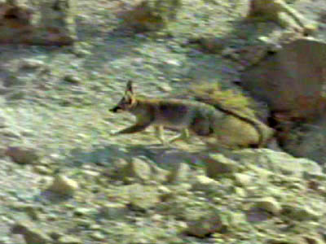
PHOTO CREDIT: BBC (Wild Facts)

English Name | Bradford’s Fox
Scientific Name | Vulpes cana
Local Name | Sia Rubah
Appearance | A small fox with very large ears and long tail which appears very bushy due to long dark guard hairs. Its appearance is very cat-like and its gait and demeanour are also rather feline. The colouring is variable, usually blotchy black, grey and white. The tail often has a dark tip, but is sometimes white. Some skins examined in the British Museum have white tips as do specimens in the wild. It has an almost black mid-dorsal line; the hind legs may be dark and the underparts are almost white. In Israel, colouring is light brown, grey, and yellow, and mid-dorsal line is sometimes absent.
Weight | Male: 0.9-1.3 kg Female: Lighter
Length | Males: 42 cm Female: same  Height: 28-30 cm. at shoulder Tail Length: 30 cm
Reproduction | Time of mating: Dec.-Jan. Gestation: 50-60 days. Litter size: 1-3 pups. Lactation: 60 days. Age at sexual maturity: 8-12 months. Longevity: 4-5 years.
Diet | Time of mating: Dec.-Jan. Gestation: 50-60 days. Litter size: 1-3 pups. Lactation: 60 days. Age at sexual maturity: 8-12 months. Longevity: 4-5 years.
Social Behaviour | Monogamous, solitary hunter. Strictly nocturnal. Diet: Reportedly more frugivorous than other foxes. When eating domestic crops, the fox appears to prefer ripe melons, seedless grapes. It has also been observed eating insects, including locusts
Habitat & Distribution | Blanford's fox is usually found in mountainous regions and prefers cliffs. The species is known from barren mountain steppes and rocky hills bordering low valleys, cultivation and plains. The species is found to an altitude of approximately 2,000 m. This canid is found only in western Baluchistan. The Blandford's Fox is found in the hill ranges around Quetta, where it appears to be uncommon. It is also found in Chaman and the Chagai desert. Despite its being rare it is hunted for its valuable fur.

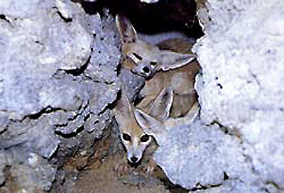
PHOTO CREDIT: Dubai Zoo

English Name | Ruppell’s Fox
Scientific Name | Vulpes ruepcana
Local Name | Loomri
Appearance | A pale sandy coloured coat with black patches on the face. The tip of the tail tip is conspicuously white. The fur is soft and dense, and the animal's frame is slighter than the red fox with short legs and broad ears.
Weight | Male: 1.2-3.6 kg Female: Lighter
Length | Males: 40-52 cm Female: same  Height: 30 cm. at shoulder Tail Length: 25-39 sm
Reproduction | Time of mating: unknown. Gestation: unknown. Litter size: 2-3. Lactation: unknown. Age at sexual maturity: unknown. Longevity: 6.5 years in captivity.
Diet | Reports suggest an omnivorous diet with a substantial insectivorous component
Social Behaviour | Little is known, but reports indicate that the species may be gregarious, having been sighted in groups of 3-15 . These may represent extended family groups. Grouping may be incidental, caused by close aggregation of dens in the few areas where denning sites are available. The species is crepuscular/nocturnal.
Habitat & Distribution | The Ruppells Fox inhabits deserts, either stony or sandy. This is the rarest Vulpes in Pakistan. It has only been recorded from two places in Baluchistan. One sighting was in Southern Mekran and the other was in western Baluchistan, near Chaman (T.J Roberts, "Mammals of Pakistan). Other than these two records it has not been sighted anywhere else in Pakistan.

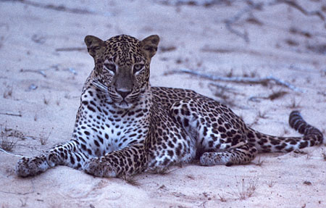

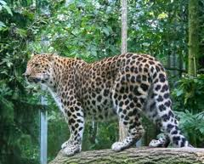
English Name | Common Leopard
Scientific Name | Panthera Pardus
Local Name | Guldar, Teendwa, Chita (Urdu)
Appearance | The leopard is most easily recognised by its rosette patterned coat and extremely long, darker tail. This large cat is sometimes confused in appearance with the South American Jaguar - the leopard though is less stocky and unlike the jaguar, its rosette markings are generally smaller and have no internal spots.
Weight | Male: -- kg Female: Lighter
Length | Males: 5 ft Female: 20-40% smaller  Height: -- cm. at shoulder Tail Length: 3 ft
Reproduction | Time of mating: unknown. Gestation: unknown. Litter size: 2-3. Lactation: unknown. Age at sexual maturity: unknown. Gestation length: 4 months
Diet | The main prey in Pakistan is Rhesus Monkey, Wild boar, Chinkara, Urial, Sind Wild Goat and Porcupines.
Social Behaviour | True to large Cats., The common leopard frequents Himalayan mountains upto the tree limit in the forest of chir, kail, deodar and fir. It also inhabits broken arid mountainous country in association with scrub and thorn forest.
Habitat & Distribution | The Leopards in Pakistan are mainly found in the highlands of Baluchistan and Sind, and the mountain forests of Punjab, N.W.F.P and Azad Kashmir. The leopard is found in the Kirthar Mountain Range of Sind and the Toba Kakar, the Mekran and the Sulaiman Range of Baluchistan. In the northern mountanious region it is found in the Murree Hills, Swat Kohistan, Dir, Chitral, Abbotabad and Lower Gilgit. It is also found in the Kaghan valley and the Margalla Hills. In Azad Kaashmir it is found around the hill ranges of Muzaffarabad and the Neelum Valley. Its survival in the Salt Range in Punjab is not clear, though they still do exist in very small numbers. The leopard sparsely inhabits the Kala Chita hills as well.
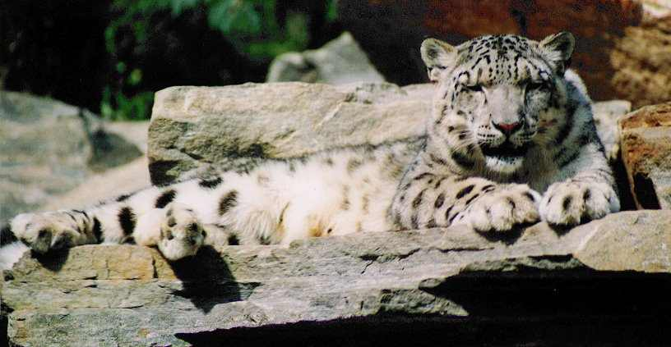
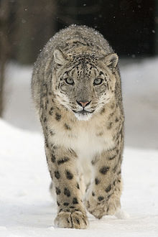www.wikipedia.org
English Name | Snow Leopard/Ounce
Scientific Name | Uncia Uncia
Local Name | Barfani Chita (Urdu), Ikar (Balti: Baltistan)
Appearance | Although sharing its name with the common leopard, the snow leopard is not believed to be closely related to the Leopard or the other members of the Pantherine group and is classified as the sole member of the genus Uncia uncia. Due to the under-development of the fibro-elastic tissue that forms part of the vocal apparatus the snow leopard cannot give a full, deep roar and this along with differences in skull characteristics help to separate it from its fellow ‘big cats’. In appearance, the snow leopard is strikingly different from the common leopard. Although it has similar rosettes and broken-spot markings, they appear less well defined and are spaced further apart. The fur is long and woolly and helps protect the cat from the extreme cold of its generally mountainous habitat. The general ground coloration of the cat is predominantly grey with brownish/yellow tinges on its flanks and lighter, often white fur on its belly, chest and chin. The head, which sports small ears and a distinctive heavy brow, is rounded and comparatively small for its body size
Weight | Male: 70 kg Female: Lighter
Length | Males: 1.3meters Female: 20-40% smaller  Height: cm. at shoulder Tail Length: 900 cm.
Reproduction | Time of mating: unknown. Gestation: unknown. Litter size: 1-4 Lactation: 18 months . Age at sexual maturity: unknown. Gestation length: 98 days
Diet | Generally crepuscular in its hunting activities, the snow leopards main prey is that of wild sheep such as Bharal (Blue Sheep) and Argali, goats, including Markhor and Ibex. Other prey taken includes Musk Deer, marmots, various species of hare and birds. The cat often uses the natural protection of the terrain to stalk its prey, keeping low below the skyline and pouncing down onto its victim. Commonly the animal is a solitary hunter but may share the task with its mate during its breeding season. It has been know that one animal will stalk the prey while the other lies in wait to make the kill. With larger prey, it is common that the snow leopard will remain close to its kill and return over a period of three to four days to feed. his well built, muscular cat can bring down prey more than two to three times its size, as is the case with the native Yak. However, unlike its distant neighbours the Tiger and Leopard, the snow leopard is generally not aggressive toward man.
Social Behaviour | True to large Cats.
Habitat & Distribution | The snow leopard generally inhabits elevations between 2000-4000 meters although it can occasionally be found at lower altitudes to the north of its range and as high as 5500 meters in Himalayan regions. The cat is generally associated with generally rocky terrain such as high valley ridges, rocky outcrops and mountain passes. As summer gives way to winter, the snow leopard will follow its migrating prey down below the tree line to the lowland forests that cover much of its habitat-however the cat is rarely associated with dense forestation.  In summer it is found in alpine pastures upto 5100 m, evelation while in winter it descends to lower altitudes. In the alpine pasture snow the following vegetation characterizes snow leopard habitat:  In Pakistan the Snow Leopard is found in the high mountains of the Karakoram and the Hindukush. There are mainly found in Baltistan, Chitral, Gilgit, Upper Swat Valley, the Slopes of Nanga Parbat, Khunjerab National Park and the Chitral Gol National Park.
)
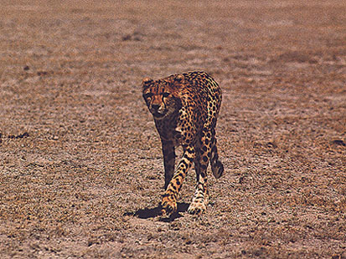
PHOTO CREDIT: Unknown

English Name | Asiatic Cheetah
Scientific Name | Acinonyx jubatus Venaticus
Local Name | Yeoz (Brahui: Baluchistan) , Gurk (Mekrani: Baluchistan)
Appearance | Cheetahs are pale yellow with white underbellies, covered all over with small round black spots. They are readily distinguished from theispotted relatives by their "tear lines": heavy black lines extending fromthe inner corner of each eye to the outer corner of the mouth.
Weight | Male: 45-65 kg Female: Lighter
Length | Males: -- cm Female: 20-40% smaller  Height: cm. at shoulder Tail Length: -- cm.
Reproduction | Time of mating: unknown. Gestation: unknown. Litter size: 3-5 Lactation: unknown Age at sexual maturity: unknown. Gestation length: Average Life span: 12-14 years
Diet | Gazelles are generally indicated as the main prey species. In India, cheetahs took primarily blackbuck antelopes and chinkara gazelles, but were also known to attack nilgai antelope and domestic goats and sheep. In Turkmenistan, cheetahs primarily took goitered gazelles
Social Behaviour | There is little information available on the ecology of Asiatic cheetahs.
Habitat & Distribution | It was long thought that Asiatic cheetahs were extinct in the Indian sub-continent. However there is increasing evidence that there are still few cheetahs found in south western Baluchistan along the Iranian border. During this decade there have been some sightings in Kharan district of Baluchistan and on some ocassions fresh tracks have been seen. Recently, four cheetah skins believed to be of the Asiatic cheetah have materialized from Baluchistan

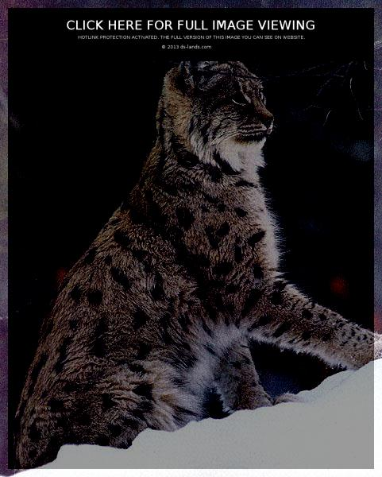
ds-lands.com

English Name | Eurasian Lynx
Scientific Name | Lynx lynx
Local Name | tsogde (Balti: Baltistan)
Appearance | The Eurasian lynx has relatively long legs, and large feet which provide a “snowshoe effect”, allowing for more efficient travel through deep snow. In winter, the fur grows very densely on the bottom of the feet . The coat is greyish, with tint varying from rusty to yellowish. A bright reddish tint, with profuse spotting. Eurasian lynx have long, prominent black ear tufts, and short black-tipped tails.
Weight | Male: 21.6 kg Female: Lighter
Length | Males: -- cm Female: 20-40% smaller  Height: cm. at shoulder Tail Length: -- cm.
Reproduction | Time of mating: unknown. Gestation: unknown. Litter size: 3-5 Lactation: unknown Age at sexual maturity: unknown. Gestation length: Average Life span: 12-14 years
Diet | Lynx activity peaks in the evening and morning hours, with resting mainly around mid-day and midnight. Eurasian Lynx are capable of killing prey 3-4 times the size of their own weight. In pakistan the main prey of Lynx is the young of Ibex, Markhor and the Marcopolo Sheep, Musk deer, Marmots, Red Fox, Pikas and ground birds.
Social Behaviour | There is little information available on the ecology of Lynx.
Habitat & Distribution | Lynx are probably found throughout the northern slopes of the Himalayas, and have been reported both from thick scrub woodland and barren, rocky areas above the treeline (Roberts 1977). In Pakistan the Eurasian Lynx is found in remote mountanious regions of the North. It is found in Baltistan, Gilgit, Northern Hunza and Chitral. It is relatively common in Baltistan, elsewhere is is rare.
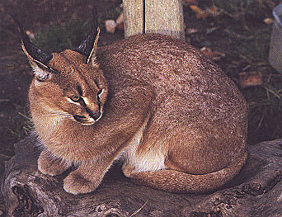
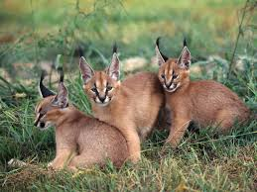
earthsendangered.blogspot.com

English Name | Caracal
Scientific Name | Caracal caracal
Local Name | Siah Goosh (Urdu), Caracal (Farsi)
Appearance | The Caracal in appearance resembles the Lynx in having characteristic dark tufts on its large, pointed ears and is indeed often referred to as the African Lynx or Desert Lynx, however the caracal is not closely related to the true lynx species. Extending the visual comparison, the body of the caracal is slimmer and less stocky, its legs are thinner and its tail longer than the Lynx. Its coloration is generally yellowish brown to a darker red/brown, with the undersides of the cat, areas around the eyes and under the chin being white. The backs of its ears are black – the name Caracal is derived from the Turkish word ‘karakulak’, meaning ‘black ear’.
Weight | Male: 21.6 kg Female: Lighter
Length | Males: 3 ft. Female: 20-40% smaller  Height: cm. at shoulder Tail Length: 6 ft.
Reproduction | Time of mating: unknown. Gestation: unknown. Litter size: 1-7 Lactation: unknown Age at sexual maturity: 16-18 months Gestation length: 71 days Average Life span: unknown
Diet | In hunting, the caracal is mainly nocturnal, but will also use the twilight hours to search out its prey. Diurnal activity has also been observed, specially in the hunting of bird. For its size the caracal is strong and fast, and as well as taking smaller prey such as jerboas, sand rat, ground squirrel and rock hyrax, it can also bring down the larger reedbuck and duiker. Much in the way of the Leopard, the caracal will sometimes cache its larger prey up in the lower limbs of trees and return to feed on its kill over several days. The caracal is also well known for using its agility and superior jumping ability to catch birds just after take-off – here prey species include pidgeons and guineafowl.
Social Behaviour | There is little information available on the ecology of Caracal.
Habitat & Distribution | The cat is found in dry savanna and woodland areas, scrubland and rugged terrain in mountainous regions, where it is known to live up to 3000 metres. In Pakistan the Caracal is rarely seen, because it is rare and nocturnal. The caracal inhabits the broken hills of Baluchistan and the Deserts of Sind and Punjab. It is found in the Thal desert, the Cholistan desert in Punjab and the Thar desert in Sind. It is found in the lower hill ranges of Baluchistan. The Caracal is also found in Attock and might still be found in Kala Chita hills and the Salt Range.
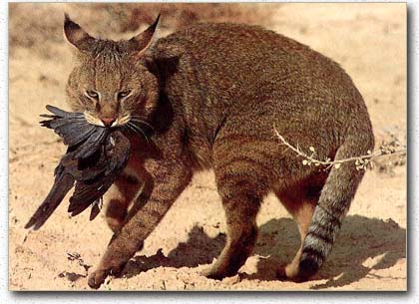
English Name | Jungle Cat
Scientific Name | Felis chaus
Local Name | Jungli Billi
Appearance | The jungle cat has long legs and a slender build. The fur is generally sandy brown, reddish or grey, and is unpatterned except for stripes on the legs and occasionally the throat, which are very light in the south of its range and darker in the north. The winter coat is darker and denser than in summer. Melanistic individuals are occasionally reported. Jungle cats have black ear tufts. The tail is relatively short
Weight | Male: -- kg Female: Lighter
Length | Males: -- ft. Female: 20-40% smaller  Height: cm. at shoulder Tail Length: --.
Reproduction | Time of mating: unknown. Gestation: unknown. Litter size: 1-7 Lactation: unknown Age at sexual maturity: -- months Gestation length: -- days Average Life span: unknown
Diet | Jungle cats are frequently observed in the daytime. They feed primarily on rodents, including large rodents. Jungle cats also take hares, birds, reptiles, amphibians, insects, and the young of larger mammals such as wild pig . They are strong swimmers, and will dive to catch fish, or to escape when chased by man or dog.
Social Behaviour | Males protective of youngones.
Habitat & Distribution | The jungle cat, despite its name, is not strongly associated with closed forest, but rather with water and dense vegetative cover, especially reed swamps, marsh, and littoral and riparian environments. It is able to satisfy these requirements in a variety of habitats across a wide geographic area. In sandy and stony desert country (sometimes with only very sparse shrub cover:Roberts 1977), it occurs along riverbeds.  Jungle cats have adapted well to irrigated cultivation, having been observed in many different types of agricultural and forest plantations throughout their range, with sugarcane frequently mentioned in Tropical Asia. Jungle cats are often spotted amidst human settlement (and are frequently reported to take chickens). Jungle cats have adapted well to irrigated cultivation, having been observed in many different types of agricultural and forest plantations in Pakistan. This cat is found through out the riverine tracts of the Indus and the cultivated and irrigated lands of Punjab and Sind. This is the most common wild cat in Pakistan.
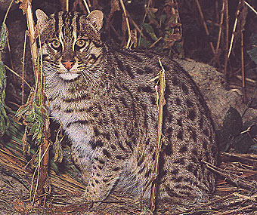
English Name | Fishing Cat
Scientific Name | Prionailurus Viverrinus
Local Name | Mach Billi (Sindhi)
Appearance | The fishing cat, with its stocky, powerful build and short legs, was given its Latin name on account of its rather viverrine or civet-like appearance. Its pelt is olive grey, and is patterned with rows of parallel solid black spots which often form stripes along the spine. Its tail is very short for a felid, less than half the body length
Weight | Male: 11-12 kg Female: 6-7 kg
Length | Males: -- ft. Female: 20-40% smaller  Height: cm. at shoulder Tail Length: --.
Reproduction | Time of mating: unknown. Gestation: unknown. Litter size: 2-3 Lactation: unknown Age at sexual maturity: -- months Gestation length: --days Average Life span: unknown
Diet | Fishing cats are good swimmers, and have been observed to dive into water after fish, as well as attempt to scoop them out of water with their paws. Other water-associated prey are probably taken as well, ranging from crustaceans and molluscs to frogs and snakes. Fishing cats also prey on rodents, small Indian civet, and wild pig, as well as domestic goats, calves, dogs and poultry. Roberts (1977) reports that in Pakistan fishing cats have been seen to catch waterfowl by swimming up to them while fully submerged and seizing their legs from underneath
Social Behaviour | Males protective of youngones.
Habitat & Distribution | Fishing cats are strongly associated with wetlands. They are typically found in swamps and marshy areas, oxbow lakes, reed beds, tidal creeks and mangrove areas. In Pakistan, it is mainly found along the lower reaches of the Indus River, although a few stragglers penetrate the northeast of the country along the Ravi and and Sutlej rivers (Roberts 1977). It is found around the swamps and reed beds of Haleji and Kalri lakes in Lower Sind. In the Indus river basin in Pakistan, fishing cats are probably on the verge of extinction.
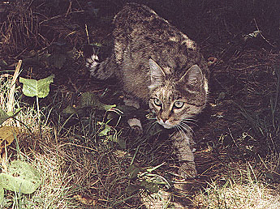
English Name | Indian Desert Cat or Wild Cat
Scientific Name | Felis Silvestris Ornata
Local Name | Cholistani Billi
Appearance | The Asiatic Wildcat - also commonly known as the Indian Desert or Asiatic Steppe Cat - is often thought a closer relation to the African wildcat than to its eastern neighbour the European wildcat. In coloration the Asiatic cat resembles its African relation in having lighter coloured greyish yellow fur, although depending on its location it can sometimes take on more of a sandy/red appearance. The markings, which usually consist of small dark brown or muddy red spots, sometimes coalescing into stripes along the back and flanks, are more distinct. In common with other wildcat species the chin and chest are often white and the tail banded with dark rings and tipped with black. In size, the Asiatic wildcat is similar to the African species, although in some areas notably to the east of its range, it is often smaller than its relatives. . (all above information from Big Cat's Online).
Weight | Male: -- kg Female: --kg
Length | Males: -- ft. Female: 20-40% smaller  Height: cm. at shoulder Tail Length: --.
Reproduction | Time of mating: unknown. Gestation: unknown. Litter size: 2-6 Lactation: unknown Age at sexual maturity: -- months Gestation length: --days Average Life span: unknown
Diet | In common with the African wildcat the Asiatic species depends on rodents to supply the largest proportion of its diet - sand rat and desert gerbil are a common source of prey which is supplemented by Tolai hare, birds such as sandgrouse and peafowl. The diet also includes hares, young ungulates, birds, insects, lizards and snakes. Asiatic wildcats rest and den in burrows. They are frequently observed in the daytime.
Social Behaviour | Males protective of youngones.
Habitat & Distribution | Asiatic wildcats are most typically associated with scrub desert. They range up to 2,000-3,000 m in mountain areas with sufficient dense vegetation. Wildcats can be found near cultivated areas and human settlement. They usually occur in close proximity to water sources, but are also able to live year-round in waterless desert.  In Pakistan this cat is found in the dry zones of Lower Sind, such as Dadu and Thatta districts. Further west it is found in Lasbela and Merkan areas. This cat is very rare in Pakistan. The main threat to this cat is hybridization with domestic cats.
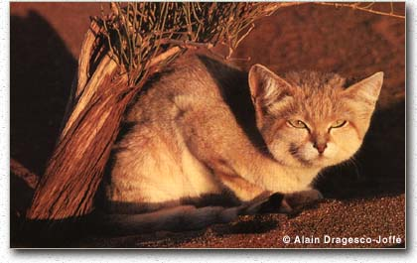
English Name | Pakistani Sand Cat
Scientific Name | Felis Margarita Scheffeli
Local Name | Gorbeh Sheni (Farsi)
Appearance | The Sand cat is one of the smallest of all the wild cat species. Its body which is about the size of a small domestic cat. The coat varies in colour from grey to sandy yellow and is marked irregularly with indistinct stripy markings - the legs are often banded with horizontal dark stripes. Characteristic dark reddish/drown markings appear on the cheeks and to the side of the eyes as well as covering the rear of the ears - the chin and throat of the sand cat are white. The distinctive triangular ears of the sand cat, which are large in proportion to the rest of the cats head are particularly sensitive.
Weight | Male: 3 kg Female: --kg
Length | Males: 57 cm. Female: 20-40% smaller  Height: cm. at shoulder Tail Length: --.
Reproduction | Time of mating: unknown. Gestation: unknown. Litter size: 1-8 Lactation: unknown Age at sexual maturity: 14 months Gestation length: 68days Average Life span: unknown
Diet | Unknown. The diet also includes hares, birds, insects, lizards and snakes. They are frequently observed in the daytime.
Social Behaviour | Males protective of youngones.
Habitat & Distribution | As its name implies the sand cat is commonly found in sandy desert areas. Despite early reports that the sand cat population of Baluchistan’s Chagai desert was devastated by commercial collectors within 10 years after foreign collectors became aware of its existence (Roberts 1977, Hemmer 1977), more recent information indicates that the sand cat still occurs widely in the area (above information from Iucn). But, still the Sand Cat is rare in Pakistan and is only found in the Chagai desert in South west Baluchistan. The Pakistan Sand Cat is considered endangered and will not survive until stronger wildlife laws are put in to place to stop it's export from Pakistan.
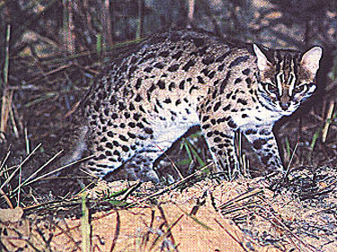
PHOTO CREDIT: Shigeki Yasuma
English Name | Leopard Cat
Scientific Name | Prionailurus bengalensis
Local Name | Chita billi (Urdu)
Appearance | Broadly speaking the leopard cat is a little larger than a big domestic cat and has a base fur colour that ranges from yellow/brown to grey/brown, found mostly in the north of its range. The underparts, chest and lower head are usually white as is a large spot which is commonly found on the back of the otherwise black ears. In varying intensity, depending on the sub-species the leopard cat is covered with medium to large dark brown to black spots which often coalesce into solid stripes on the top of the back and thin stripe markings on the top and side of the head ( all above information from Big Cats Online).
Weight | Male: -- kg Female: --kg
Length | Males: -- cm. Female: 20-40% smaller  Height: cm. at shoulder Tail Length: --.
Reproduction | Time of mating: unknown. Gestation: unknown. Litter size: 2-3 Lactation: unknown Age at sexual maturity: -- months  Gestation length: --days Average Life span: unknown
Diet | Rodents form the principal prey. The diet also includes young ungulates, hares, birds, reptiles, insects, eels and fish, as well as occasional carrion. Although often described as primarily nocturnal, Leopard Cats are active in the day time as well (all above information from Iucn's Cats Specialist Group).
Social Behaviour | Males protective of youngones.
Habitat & Distribution | The Leopard Cat occurs in a broad spectrum of habitats, from tropical rainforest to temperate broadleaf and, marginally, coniferous forest, as well as shrub forest and successional grasslands. The northern boundaries of its range are limited by snow cover; the leopard cat avoids areas where snow is more than 10 cm deep. It is not found in the cold steppe grasslands, and generally does not occur in arid zones, although there are a few records from relatively dry and treeless areas in Pakistan (Roberts 1977). Leopard cats usually live in proximity to a water source, and can occupy refuge strips of riverine forest in areas. Leopard cats can live close to rural settlements, occasionally raiding poultry.  In Pakistan this cat is found in the Murree hills and the Kaghan valley. It is also found in Azad Kashmir. Further West it is found in Swat, Dir, and lower Gilgit. It might be found in Chitral as well.
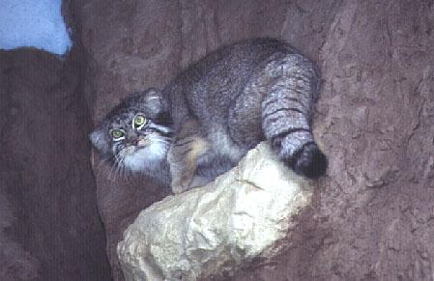
English Name | Pallas Cat
Scientific Name | Otocolobus Manul
Local Name | psk kuhey (Dari: Afghanistan)
Appearance | Peter Pallas, who first described the manul, erroneously suggested that it was the ancestor of the long-haired Persian breeds of domestic cat, because of its long fur, stocky build and flattened face. The hair on its underparts and tail is nearly twice as long as on the top and sides. Like the snow leopard, this presumably helps keep the animal warm when it hunts on snow, cold rock or frozen ground. The background color of its fur varies from grey in the north of its range to fox-red in some parts of the south (Roberts 1977), although greyish animals are also found in the south. The hairs have white tips, producing a silvery, frosted appearance in all but the reddest specimens. The body is compact, with short legs marked with indistinct black bands, and a thick, short, black-tipped tail. Weight ranges from 2-4.5 kg. The forehead is patterned with small black spots. Its ears are small and rounded and set low on the sides of the head. The auditory bullae are enlarged, similar to those of the sand cat. The barking call of the manul is similar also to that of the sand cat and, likewise, the low profile of its head is an adaptation to hunting in open country where there is little cover.
Weight | Male: -- kg Female: --kg
Length | Males: -- cm. Female: 20-40% smaller  Height: cm. at shoulder Tail Length: --.
Reproduction | Time of mating: unknown. Gestation: unknown. Litter size: -- Lactation: unknown Age at sexual maturity: -- months  Gestation length: --days Average Life span: unknown
Diet | One cat in Baluchistan, Pakistan, was found feeding on chukor partridge (Roberts 1977). Other prey includes Gerbils, Voles, Pikas and small birds. Manuls are generally crepuscular, being most frequently encountered at dusk or in early morning,. They den in small caves and rock crevices, and may take refuge in the burrows of other animals such as marmots, foxes and badgers. Tame manuls hunting for rodents caught not only animals running on the surface, but also successfully ambushed them by hiding near exits of burrows, using their paws to fish out the inhabitants when the holes were shallow enough (all above information from Iucn's Cats Specialist Group).
Social Behaviour | Males protective of youngones.
Habitat & Distribution | The manul is adapted to cold arid environments, but is relatively specialized in its habitat requirements. It is found in stony alpine desert and grassland habitats, but is generally absent from lowland sandy desert basins, although it may penetrate these areas along river courses. The small southern populations in Baluchistan, isolated from the main population, occur in montane juniper steppe (Roberts 1977). This cat is also found in Baltistan, but there is no information about its status there. This cat is rare in Pakistan.

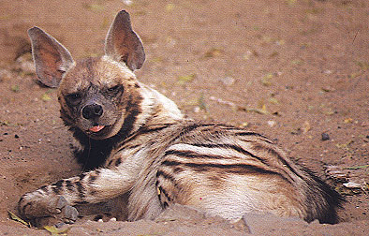
PHOTO CREDIT: Nirmal Gosh
English Name | Stripped Hyenna
Scientific Name | Hyaena Hyaena
Local Name | Laghar Bhagar, Charagh (Urdu)
Appearance | Stripped Hyena are a long-haired hyena with large, pointed ears. They are gray to straw-colored with a black muzzle and black stripes on their head, torso, and legs. The striped hyena can erect the long hair on its mane and appear 38% bigger, which it does when it feels threatened. Males and females do not differ in average height or length, but males do tend to be slightly heavier.
Weight | Male: 25-45kg Female: --kg
Length | Body Length: 1 meter  Shoulder Height: 65-80 cm Female: 20-40% smaller.
Reproduction | Breeding is nonseasonal, beginning at two to three years. One to six cubs are born per litter, after a 88-92 day gestation. No detailed studies of sexual behavior in the striped hyena have been published. Based on observations in captivity, estrus lasts one day, with the female mating several times at 15-25 minute intervals throughout the day. The mother brings food to the den for her cubs after they are one month old, but continues to nurse for approximately 12 months.
Diet | The striped hyena is predominantly a scavenger; its diet consisting mainly of carrion and human refuse. It scavenges large and medium-sized mammals, such as zebras, wildebeests, gazelles, and impalas, even eating bones from carcasses if the meat has been picked off. It supplements its diet with fruit, insects, and occasionally by killing small animals like hare, rodents, reptiles, and birds. The striped hyena forages principally at night,individually travelling throughout its home range searching for food in no apparent pattern. Travelling speeds average 2-4 km/h, occasionall increasing to 8 km/h when trotting.
Social Behaviour | The striped hyena is generally considered solitary, but has some social organization. It forages individually and is rarely seen in groups. It does, however, associate in small family groups at the den. Immature family members will help feed younger siblings by bringing food back to the den. Vocal communication is not highly developed. It consists mainly of soft growls and other sounds used during intraspecific encounters.
Habitat & Distribution | The Stripped Hyena lives in arid, mountainous regions with scrub woodland. It dens in rocky hills, ravines, and crevices. In Pakistan the Stripped Hyena is mainly found in all the major hill ranges of Baluchistan and Sind Kohistan. It appears to be uncommon in Baluchistan and rare in Sind. The Stripped Hyena definitely occurs in the Kirthar mountain range in Sind, but is is considered rare. It is considered common around the hill ranges surrounding Quetta city in Baluchistan. The Stripped Hyena is extremely rare in Punjab, with only a couple of sightings around Lahore and the border with India. It was considered common in Dera Ghazi Khan and Dera Ismail Khan, but is now very rare in these regions. In N.W.F.P, the Stripped Hyena occurs in Attock district and is also found in Mardan

Note: All above information from IUCN, WWF, net browsing

