BACTERIOLOGICAL AND CHEMICAL ANALYSIS OF DRINKING WATER IN KHYBER PAKHTUNKHWA PROVINCE, PAKISTAN.
Running Title: Analysis of drinking water in Khyber Pakhtunkhwa.
Authors:
1. Sajid Iqbal ¹
2. Ghazi Rehman¹
3. Iqbal Ahmad¹
4. Baharullah Khattak¹
5. Nighat Sultana²
6. Saiqa Sardar¹
7. Muhammad Muddassir Ali ³
8. Furqan Awan⁴
9. Sulaiman Qadir Afridi⁵
10. Hassaan Bin Aslam⁵
No. of Tables: 2
No. of Illustrations: 2
No. of Graphs: 1
Addresses and affiliations
¹ Department of Microbiology, Kohat University of Science and Technology, Kohat.
² Food Analysis Laboratory, Peshawar.
³ Institute of Biochemistry and Biotechnology, University of Veterinary and Animal Sciences, Lahore.
⁴ Department of Epidemiology and Public Health, University of Veterinary and Animal Sciences, Lahore.
⁵ Department of Microbiology, University of Veterinary and Animal Sciences, Lahore.
Correspondence:
Muhammad Muddassir Ali
Lecturer, Institute of Biochemistry and Biotechnology, Faculty of Biosciences; University of Veterinary and Animal Sciences Lahore, 54000, Punjab, Pakistan. Mobile: +923336252189. Email: muddassir.ali@uvas.edu.pk.

ABSTRACT
Water is an essential part of life on earth. Today millions of people around the world are facing water shortage. For meeting their water needs, people use different sources for getting drinking water. Sometimes people neglect the quality of water and just concentrate on the quantity. This trifle can lead them to different diseases and even death. This study examined the chemical and bacteriological analysis of water from different sources in Khyber Pakhtunkhwa (KP) province, Pakistan. Water samples were collected from bore, wells, bottle, hotels and tape water. These samples were analysed for Sulphates, Nitrates, Nitrites, Chlorides and Total soluble solids and faecal coli form. Results indicated that majority of the water sources had unacceptable Total coli form count and all the water sources which were positive for presumptive Coli form count had E.coli showing faecal contamination of water sources. Besides this the water sources were chemically contaminated as well.

1. INTRODUCTION
In old times, access to clean drinking water was considered as luxury. With the advancement this water supply shortage has meliorated in developed parts of the world. This condition is improving day by day but nearly one billion people are still unable to access clean and hygienic water (Salaam-Blyther, 2012). Over the years, there has been increase in frequency of disease outbreaks resulted from poor water distribution system (Moe and Rheingans, 2006). Agricultural wastes such as pesticides, fungicides and fertilizers, human and animal faeces, seepage from pit latrines and septic tanks, refuse dump, industrial, domestic and municipal wastes released into water bodies are often responsible for water contamination.
Contaminated water is associated with health risks. When comparing to deep well water, less costly shallow pumping well water can easily acquire impurities from the surface. Hence pose a greater risk of contamination as well as of disease outbreak. It leads to the spread of many deadly diseases. Most of the contaminating bacteria, viruses, parasites, and fungi come from faecal material of humans and other animals. Common bacterial contaminants include E. coli, Salmonella, Shigella, and Campylobacter jejuni. On the other hand, viral contaminants are norovirus, rotavirus, enteroviruses, sapovirus, hepatitis A Virus, hepatitis E virus etc. Parasitic agents which are mostly involved in water contamination include Giardia lamblia, Cryptosporidium, Cyclospora cayetanensis, and microsporidia etc. (Leclerc et al., 2002).
Among all infectious contaminant, Coli form is considered as most prevalent infectious agent which is highly associated with the human and animal intestinal infections. This is a group of bacteria comprised of gram negative non spore forming aerobic and facultative anaerobic rods and are classified in the genera Escherichia ,Enterobacter, klebsiella etc (Khan, 2001). Total coli forms are divided into subgroups, one of which is faecal coli forms or E .coli (Yalcin et al., 2001). These bacteria are released to the environment through human and animal faeces and able to grow well at body temperature.
In spite of bacterial and viral Contaminants, heavy metals such as nitrates, nitrites, sulphates and other salts also cause serious threat to human and animal health by contaminating the water. These heavy metals are present in inadequately treated water and waste material (human and livestock), industrial discharges, and over-used water resources (Singh and Mosley, 2003). When natural water comes in contact with these sources, it gets contaminated. Apart from these artificial sources of heavy metals, there are natural potential levels of heavy metals and other chemicals which are harmful for human health. The natural water analyses for physical and chemical properties including trace element contents are very important for public health studies. (Soylak. et al., 2002). Pakistan is considered among those countries that have low sanitary conditions (Salaam-Blyther, 2012). Keeping in view all this the present study was designed to investigate the detailed bacteriological and chemical analysis of drinking water in Khyber Pakhtunkhwa (KP) Pakistan.

2. MATERIALS AND METHODS
For both bacteriological and chemical analysis, water samples were collected in sterile bottles from 5 different sources i.e. bottles, wells, bore, taps, and hotels in a sterile manner. Twenty samples of each source were collected from different districts of Khyber Pakhtunkhwa province. These samples were stored at a temperature between 0 to 10 ⁰C before processing.
Coliform test
Oxoid broth was used as a medium in presumptive coliform test. Three sets of tubes were inoculated with 10ml, 1ml and 0.1ml of water samples. The tubes were incubated at 37 cº to 44 cº for 24 to 48 hours and examined for acid and gas production. Acid production was determined by color change of the broth from reddish purple to yellow and gas production confirmed by gas entrapment in the tube.
Coliform confirmative test
The confirmatory test was performed by using Brilliant Green Lactose Bile. A loop containing culture was used to transfer the culture into a tube of Brilliant Green Lactose Bile (BGLB) with Durham tubes. For total coliform, these inoculated tubes were incubated at 37 Cº for 24 to 48 hours. For faecal coliform these tubes were incubated at 44 Cº and kept under observation for gas production. After the confirmation of E.coli presence, Eosin Methylene Blue (EMB) agar plates were streaked by a loop dipped in the broth from a positive tube. Based on morphological characteristics and biochemical tests, the colonies were identified as coliform or faecal coliforms (E.coli).
Morphological identification of bacteria
Gram staining was used to identify bacteria based on morphological characteristics. A smear of culture was prepared on slide and air dried. After fixing on low flame, this smear was flooded with crystal violet, and kept for one minute then washed with tap water. Iodine solution was poured on smear and after one minute washed with tap water. Smear was decolorized with alcohol until a purple colour no longer comes from the smear. Counter staining was done with safranin (secondary dye) for 45 sec and washed with tap water and air dried. The stained smear was observed under oil immersion lens of microscope.
Chemical analysis
Different chemical tests for water analysis were performed as following.
Chlorides in water
To find out various chlorides in water 50 ml of sample was taken in a 100cc conical flask and titrated against 0.01N AgNO₃ using Potassium chromate as neutralization indicator amount of Ag NO₃ used at neutralization point was noted for simple calculation each ml of Ag NO₃ was multiplied 7.1 (constant) which was equal to mgs /liter chloride, for e.g. if 1cc of Ag NO₃ was used for neutralization it means 7.1x 1 which equals 7.1./liter.
Nitrites in water
Nitrite is very dangerous and its minute amount is injurious to health. Nitrite itself is in gaseous state which is produced by nitrifying bacteria. For qualitative tests of Nitrite 50cc of the sample was taken in beaker or conical flask, 1cc of a solution or Aliosy A (a chemical) was added to the sample and 1cc of Alisoy B to the same sample. We waited for 15 minutes and pink color was developed which meant that the sample contained Nitrite.
Nitrates in water
Nitrates generally occur in trace quantities in surface waters but may attain high levels in some ground waters. For the purpose 50cc of water sample was taken in a china dish and put on water bath to evaporate all the water. The residue remained below was then treated with Brucine in the presence of an inorganic acid, which gave red chili color of positive reaction.
Total soluble solids
Total soluble solid should not be more than 500 mg /liter in a good sample of water. For the purpose 50cc water sample was taken in a china dish and put on a steam bath or hot air oven till all the sample was evaporated. Weight of the empty china dish and weight of the china dish after sample evaporation was noted and the difference between the two weights was found out and calculated as total solids contained in water.
Sulphate in water
To point out Sulphate in water sample 50cc of the sample was taken in a conical flask of 100cc. 5cc of 5 percent barium chloride solution was added to the contents of the flask. If Sulphate was present the solution became turbid .Baso4 is produced in the form of ppt. Now the sample was filtered and dried in a hot air oven at 105cº and weighed as barium Sulphate .Now Sulphate was calculated as.
Formula weight of barium Sulphate as suppose it is A and A contains SO₄ is equal to B and Sulphate in a residue dried in oven = C contained in 50cc sample .Now the Sulphate was pointed out in 1 liter. Suppose 50cc contained Sulphate =x
1cc contains Sulphate =x/50
1000cc contains Sulphate as x/50 x 1000
This gives grams/liter to convert into mg divide it by 1000.
RESULTS
Our study analysed water of Khyber Pakhtunkhwa collected from different sources, where the highly contaminated source was the hotels and restaurants which were all contaminated for fecal contamination, while Water sample from bottled water were least contaminated with coliform. Table 1 shows bacteriological analysis of drinking water. The highest faecal coliform positive samples are of hotel water (95%) followed by tap water (60%), wells water (55%), Bore water (30%) and the lowest positive samples are of Bottled water (20%) (Table 1).
From Chemical analysis, the highest values of sulphates were observed in bore water followed by well water. On the other hand, the highest value of nitrates was observed in well water along with highest value of Total soluble solids. Hotel water was declared to possess the highest value of nitrite and chloride. Bottle water had the least value of TSS and tap water had the lowest value of sulphate ions (Graphical Representation 1, Table 2).
Discussion:
Recently, UNICEF and WHO declared that about 1.1 billion people needs improved water supplies and 2.6 billion people has the deficiency of adequate sanitation (Moe and Rheingans, 2006). In our study, Total Coli form counts in most cases were > 34 CFU/100mL. This was far above the accepted WHO standard. The effects of drinking contaminated water results in thousands of deaths every day, mostly in children under five years, in developing countries (WHO, 2004). For analysed water of Khyber Pakhtunkhwa this was observed from the results on plate counts on media inoculated with borehole water and bottled water where in most cases no bacteria were observed to grow. This was similar to the work done by Zvidzai (Zvidzai et al. 2007). On the other hand, water supplied through pipes i.e. tap water and hotel water was more contaminated. These results are similar to the study from Lahore (Anwar et al.2010). Pipelines are potential source of bacterial contamination as the distribution network of water supply comes in contact with waste water and faeces (Moe and Rheingans, 2006). But these results are in contradiction with results from study in Kenya. That study discussed tap water as good source of drinking water and considered well water contaminated source (Kimani-Murage and Ngindu, 2007).
Chemical analysis of this study reveals that the water of Khyber Pakhtunkhwa is chemically safe for drinking. Most of the harmful ions are in permissible ranges which is not a health risk. The nitrates are within the safe limits according to the EPA and WHO in Khyber Pakhtunkhwa drinking water. The value recommended by WHO is between 40 - 50 mg/l. For the analysed water of Khyber Pakhtunkhwa the values ranged from 0-8 mg/L. This value is much lower than the values from India (Rafi et al. 2011). High Nitrates in water have been known to cause blue baby syndrome. Nitrite is in very minute amount for health. In our study it is range from 0 to 0.56 mg/L (Table 2).
The level of chloride is just below the safe drinking standard. The standard is 250 mg/L. In water of Khyber Pakhtunkhwa, the values obtained were between 0 to 54 mg/L. This water is thus low in chlorides and of good quality with respect to chlorides. The excessive intake of drinking-water containing sodium chloride at concentrations above 250 mg/litre has been reported to produce hypertension (Anonymous WHO, 1996).
Water containing magnesium sulphate at levels above 600 mg/L acts as a purgative in humans. The presence of sulphate in drinking water can also result in a noticeable taste. The value allowed by the USEPA is ≤ 250 mg/l. For water of the Khyber Pakhtunkhwa, the values of sulphates were between 0 and 9.10 mg/l, with the high values reported coming from well water source. In all the cases, water of Khyber Pakhtunkhwa is not polluted according to their Sulphates content. These results were similar to the results from Indian district Andhra Pradesh (Rafi et al. 2011).
Allowable Slandered values of Total Soluble Solid (TSS) range between 500 and 1500 mg/L. For analysed water of Khyber Pakhtunkhwa, the values of TSS were between 0 to 654 mg/l for the majority of sources examined.
REFERENCES
- Anawar HM, Akai J, Mostofa KM, Safiullah S and Tareq SM (2002). Arsenic poisoning in groundwater: health risk and geochemical sources in Bangladesh. Environ Int. 27(7):597-604.
- Anwar MS, Lateef S and Siddiqi GM (2010). Bacteriological quality of drinking water in Lahore. Biomedica. 26 (23): 66 – 69.
- Kimani-Murage EW and Ngindu AM (2007). Quality of Water the Slum Dwellers Use: The Case of a Kenyan Slum. J. Urban Health. 84(6):829-838.

Khan R, Israeli SH, Ahmad H and Mohan A (2005). Heavy Metal Pollution Assessment in Surface Water Bodies and its Suitability for Irrigation around the Neyevli Lignite Mines and Associated Industrial Complex, Tamil Nadu, India. Mine Water Environ. 24:155-161.
- Leclerc H, Schwartzbrod L, Dei-Cas E (2002). Microbial agents associated with waterborne diseases. Crit. Rev. Microbiol. 28(4):371-409.
- Moe CL and Rheingans RD (2006). Global challenges in water, sanitation and health. J. Water Health 4:41-57.
- Rafi KM, Rmachar T, Umamahesh M (2011). A study on chemical analysis of drinking water from some communities in Nandyal rural areas of Kurnool district, Andhra Pradesh, India. Int J Civil and Structural Engineering. 2(1): 351-358.
- Salaam-Blyther T (2012). Global Access to Clean Drinking Water and Sanitation: U.S. and International Programs (R42717). CRS Reports.
- Singh S and Mosley LM (2003). Trace metal levels in drinking water on Viti Levu, Fiji Islands. S. Pac. J. Nat. Sci. 21:31- 34.

Soylak M, Aydin FA, Saracoglu S, Elci L, Dogan M (2002). Chemical analysis of drinking water samples from Yozgat, Turkey. Pol. J. Environ. Stud. 11(2): 151-156.
- Zvidzai C (2007). Microbial community analysis of drinking water sources from rural areas of Zimbabwe. Afr. J. Microbiol. Res. 1(6): 100 - 103.
- United States Environmental Protection Agency (USEPA) (2003).Chemical contaminants in drinking water. Technical fast sheet on microbes. EPA 816-03-016.
- WHO (1996). Guidelines for drinking water quality. World Health Organization. 2: 231.
Tables:
S.no | Source of water | Total samples | Fecal coli form +ive
1 | Bore | 20 | 6
2 | Well | 20 | 11
3 | Bottled | 20 | 4
4 | Hotels | 20 | 19
5 | Tap water | 20 | 12
Table 1; Showes the total samples and the samples of water which were fecally contaminated and were viable count positive.
Sample sources | sulphate (mg/L) | nitrate (mg/L) | Nitrite (mg/L) | chloride (mg/L) | TSS (mg/L)
bore water | 5.313 | 0.3035 | 0.0243 | 2.073 | 140.45
well water | 4.424 | 0.6713 | 0.0347 | 2.838 | 190.3
bottled water | 0.0005 | 0.5355 | 0.0369 | 4.3 | 11.1
hotel water | 0.06 | 0.124 | 0.0496 | 14.5 | 11.35
tap water | 0 | 0.124 | 0.0496 | 14.45 | 20.85

Table 2; shows chemical analysis of water samples taken from all over khyber pakhtunkhwa.

Figures:
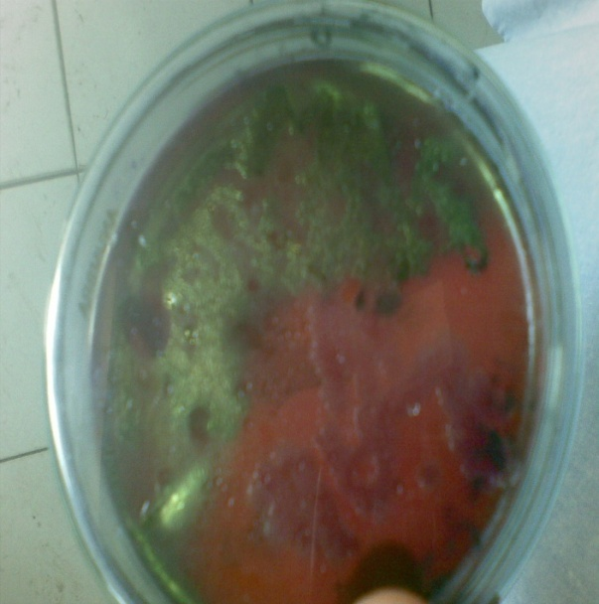

Fig 1. Plate of water sample showing green Metallic sheen formed by E.coli.
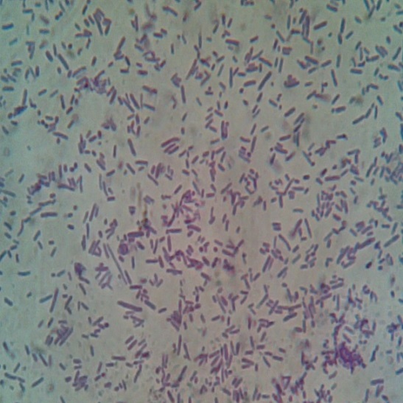

Fig 2. Microscopy of culture taken from water Samples.

Graphical Representation 1; The graphical representation of all the water samples tested for chemical analysis taken from all over Khyber Pakhtunkhwa.

