Characterization and evaluation on the impact of BL41 microsatellite marker associated with milk fat and protein percentage among Frieswal (HF x Sahiwal ) cattle of Indian origin
Rajib Deb*, Umesh Singh, Sushil Kumar, S. Tyagi, Arjava Sharma, Arun Kumar, G. Sengar, Sandeep Mann, Rani Singh
Project Directorate on cattle, ICAR, Meerut, Uttar Pradesh-250 001, India
*corresponding author: drrajibdeb@gmail.com
ABSTRACT
BL41 is an autosomal microsatellite marker located at the region of bovine chromosome 3 (BTA3) which are well known for its lactogenic trait QTL property. In the present study we have amplified the BL41 gene of Frieswal (HFx Sahiwal) crossbred cattle of India. Genotyping of the BL41 was done by outsourcing. Analysis revealed that Frieswal cow genome has seven allelic pattern of BL41 microsatellite marker and among them 245 bp allele is most frequently distributed in this bred. Direct count heterozygosity, Unbiased heterozygosity and Polymorphic information content of BL41 studied were 0.78, 0.79 and 0.76 respectively. A higher level of fat (4.45±0.05) and protein (3.09±0.09) percentage were observed among 238 and 234 allele of Frieswal BL41 microsatellite marker respectively.

Key Words: BL41, Frieswal, Milk, Fat, Protein
Running title: BL41 marker and their association with milk fat and protein

INTRODUCTION
Microsatellites, alternatively known as simple sequence repeats (SSRs), short tandem repeats (STRs) or simple sequence length polymorphisms (SSLPs) are tandem repeats of sequence units generally less than 5 bp in length (Bruford and Wayne 1993). These markers appear to be hypervariable, in addition to which their co‐dominance and reproducibility make them ideal for genome mapping, as well as for population genetic studies (Dayanandan et al., 1998).
Identification of molecular marker in modern genetics is an important challenge in modern genetics. Heyen et al., 1999 performed a microsatellite-based genome scan to detected QTL associated with milk production and milk composition. Studies reported that, quantitative trait loci affecting milk yield (MY) and milk composition were localized to a region of bovine chromosome 3 (BTA3) are linked to a microsatellite marker BL41, which are located at 42 cM on the cattle linkage map (Rodriguez et al., 2002, Ihara et al.,2004).Thomas et al., 2012 also reported that BL41 microsatellite marker are BL41 microsatellite marker are informative as their PIC were 0.85 and are associated with milk fat percentage among Indian cross breed cattle developed in Kerala (Thomas et al., 2012).
The goal of the present study was to identify, characterize the BL41 microsatellite marker of an indian cross breed Frieswal (HFx Sahiwal) cattle genome and further to evaluate the association ship of this candidate with milk fat and protein percentage.

MATERIALS AND METHODS
Cattle resource population and genomic DNA extraction
The cattle resource population of this study consisted of randomly selected 93 lactating Frieswal (HF x Sahiwal) cross- bred cow herd maintained at Military Farm, Meerut, Uttar Pradesh, India. Blood samples were collected and gDNA was isolated using standard phenol chloroform method (Sambrook and Russel 2001).
Primer designing and PCR amplification
For the amplification of BL41 microsatellite marker gene from genomic DNA , primer sequences as were taken from Thomas et al., 2012 (Table1). At the 5’ end of the forward primer we have added 6, FAM (Golbia, Bioserver, India ) . The polymerase chain reactions (PCR) were carried out in a total volume of 25 μl solution containing 50 ng/μl of template DNA, 1X buffer (Tris-HCl 100 mmol/l, pH 8.3; KCl 500 mmol/l), 0.25 μmol/l primers, 2.0 mmol/l MgCl2, 0.25 mmol/l dNTPs, and 0.5U Taq DNA polymerase (Sigma-aldrich, USA). The polymerase chain reaction (PCR) protocol was 94°C for 5 min, followed by 35 cycles of 94°C for 30 s, annealing at 55⁰C for 30 s and 72°C for 30 s, and a final extension at 72°C for 8 min. The PCR products were separated on 1.0% agarose gel (Sigma-aldrich, USA) including 0.5 μg/ml of ethidium bromide, photographed under Gel Documentation system (Alpha imager® EP) (Figure 1).
Genotyping of BL41
Amplified PCR products were gel purified and sent for genotyping from outsourcing (Customer Support Team, SciGenom Labs Pvt Ltd,India). After analysis of the results we have genotyped the animals and each genotype were run in 6% denaturation polyacrylamide gel electrophoresis (Figure 2).
Statistical analysis
Allele frequency
Estimation of allele frequency was done manually by direct counting. Finally allele size, number of alleles, allele frequency and heterozygosity was calculated.
Estimation of heterozygosity
The direct count heterozygosity was measured (Nei, 1973) by the formula,
H = 1-Σ Pi²
Where, Pi - is the frequency of i^{th} allele
The unbiased heterozygosity was estimated (Pandey et al., 2002) by the formula
H= [2n/(2n-1)] [1-Σ Pi²]
Where, Pi - is the frequency of i^{th} allele and n is number of observation.
Estimation of polymorphic information content (PIC)
PIC of BL41 microsatellite marker was estimated by the following formula (Botstein et al., 1980).
n n-1 n
PIC= 1-[1-Σ Pi²] – [ Σ Σ 2 Pi² Pj²]
i=1 i=1 j= i-1
Where, Pi and Pj - is the frequency of i^{th} and j^{th} allele respectively , n is number of observation.
Analysis of milk fat and protein percentage associated with each allele
Average and standard error were calculated as normal procedure and each data were represented as Average± SE.
RESULTS AND DISCUSSION
Our results show that Frieswal cow genome having seven different kinds of alleles for BL41 microsatellite markers. Their distribution has been shown in Figure 1. 245 base pair is most frequent compare to other seven allele identified among Frieswal cow genome.
Allele frequency, direct heterozygosity, unbiased heterozygosity and PIC were calculated by the above formulas and data has shown in table 2. Different haplotypes identified after genotyping shown in figure 3.
Association analysis with milk fat and protein percentage revealed that allele 238 showing a comparatively highest fat percentage (4.45±0.05) compare to others where as allele 234 having highest protein percentage (3.09±0.09) compare to other counterparts (Table 3).
Microsatellite DNA markers have been well studied that they are useful for identification of QTL and Marker assisted selection (MAS). According to the selective standards of microsatellite DNA loci, microsatellite loci ought to have at least four alleles to be an effective marker (Pandey et al., 2002). Heterozygosity is an appropriate measure of genetic variability within a population when populations are expanding (Hanslik et al., 2000). Again according to FAO, 1995, Markers were classified as informative when PIC was ≥ 0.5 . Our results revealed that BL41 of Frieswal are informative as it’s PIC is more than ≥ 0.5 as well more than four allele as and thus it may be further useful marker for analysis the genetic diversity.
Previously many others reported that microsatellite alleles are associated with some QTLs, for example 136 bp allele of BM1500 associate with weight gain in beef cattle and live weight in Holestein Friesian cattle (Almeida et al., 2007), 138 bp of allele of BM1500 are associated with fat deposition in beef cattle (Fitzsimmons et al.,. 1998). Liefers et al., 2002 could not find any positive correlation between BM1500 polymorphism and milk production traits in Holestein Friesan cattle. Thomas et al., 2012, reported that BL41 microsatellite are informative marker which are associated with milk fat percentage among Indian cross breed cattle developed in Kerala. In the present study we observed that BL41 alleles may be associated with both fat and protein percentage among Frieswal crossbred cattle developed in India.
Further for effective microsatellite based MAS it need to be analyzed in large number of DNA samples and also need to evaluate other autosomal microsatellite associated with milk production traits among Frieswal cattle genome.
Conclusion
Our present findings revealed that Frieswal (HFx Sahiwal) having seven allelic patterns of BL41 microsatellite marker and 245 bp allele is most frequently present. Direct count heterozygosity, Unbiased heterozygosity and Polymorphic information content of BL41 studied were 0.78, 0.79 and 0.76 respectively. A higher level of fat (4.45±0.05) and protein (3.09±0.09) percentage were observed among 238 and 234 allele of Frieswal BL41 microsatellite marker respectively. These piece of information can attract researchers to evaluate different kind of microsatellite markers for association analysis with milk production and other QTL traits .

Table 1: List of primer used for the present study
Primer | Sequence | Amplicons Size range (bp)
BL41 F | 5’6 FAM CCTCTGCCATCTTTATTCCG 3’ | 232-258
BL41 R | 5’ AAGATCAACTTATTCCTCACAGTG3’ | 232-258

Table 2: Parameters of BL41 characterized in Frieswal genome
Parameters | Values
Number of alleles observed | 7
Most frequent allele | 245 bp
Lowest frequent allele | 257 bp
Values of allele frequency | 238 (0.13), 245 (0.41), 243 (0.06), 240 (0.08), 234 (0.08) , 253 (0.17) , 257(0.04).
Direct count heterozygosity | 0.78
Unbiased heterozygosity | 0.79
Polymorphic information content | 0.76

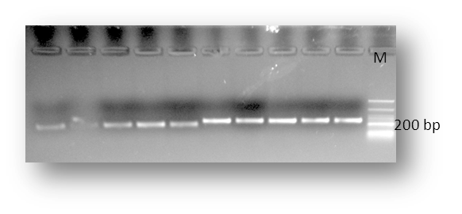

Figure 1: PCR amplification of BL41 microsatellite marker of Frieswal

Allele
Frequency

Figure 2: Distribution of BL41 alleles in Frieswal cow genome
A1(Allele 1): 238, A2(Allele 2): 245, A3(Allele 3): 243, A4(Allele 4): 240, A5(Allele 5): 234, A6(Allele 6): 253, A7(Allele 7): 257
Table 3: Analysis of allelic average for milk fat and protein percentage for BL41 microsatellite marker in Frieswal cattle
Allele  (bp) | Fat %  (Average± SE) | Protein%  (Average± SE)
238 (n=12) | 4.45±0.05 | 2.97±0.03
245 (n=39) | 4.09±0.04 | 3.03 ±0.02
243 (n=06) | 3.82±0.13 | 2.99±0.05
240 (n=08) | 3.74±0.13 | 3.02±0.02
234 (n=08) | 3.83±0.10 | 3.09±0.09
253 (n=16) | 4.02±0.05 | 2.97±0.02
257 (n=04) | 3.52±0.16 | 2.87±0.08

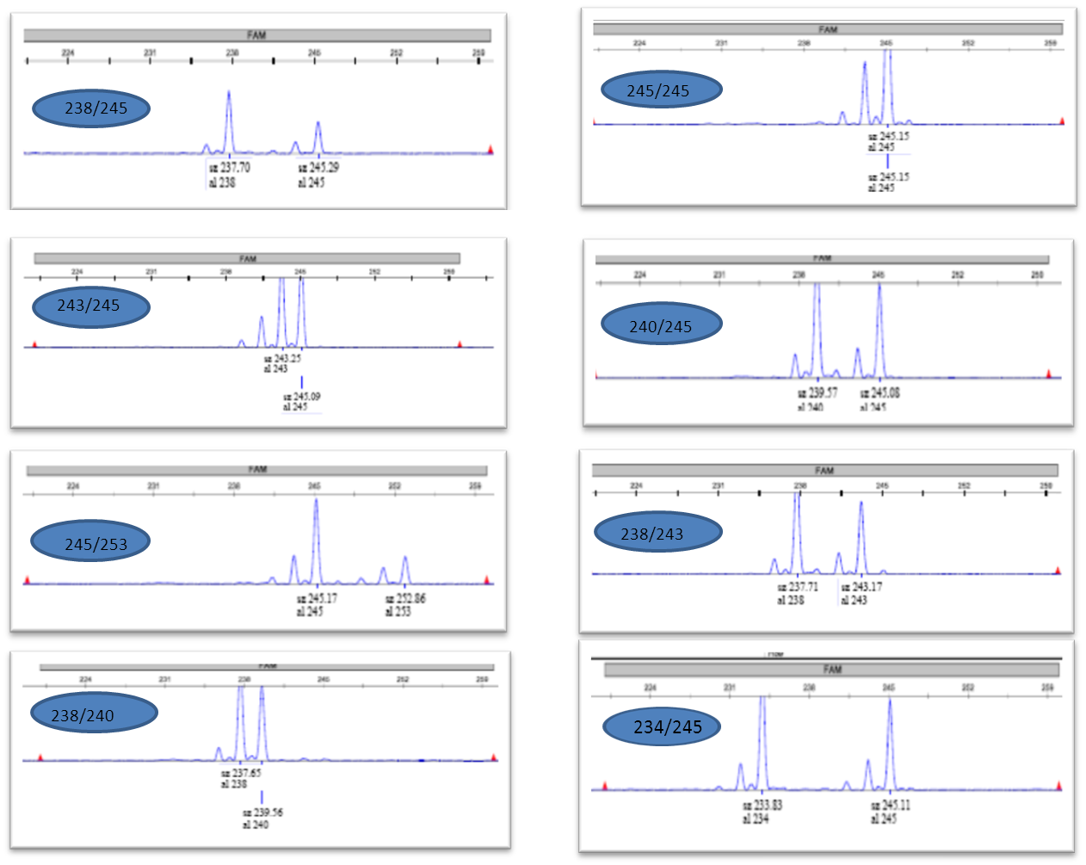
Figure 3: Haplotypes of BL41 identified after genotyping
ACKNOWLEDGEMENT
The authors are thankful to the Directorate to provide all the necessary facilities to conduct the present work. Authors are also thankful to the Incharge Military Farm for providing the blood samples.

REFERENCES
ALMEIDA, S. E. M., E. A. DE ALMEIDA, G. TERRA, J. P. NEVES, P. B. D. CONCALVES, W.T. DE AZEVEDO (2007): Association between molecular markers linked to leptin gene and weight gain in postpartum beef cows. Cien. Rural 37, 206-211.
BOTSTEIN, D., R. L. WHITE, M. SKOLNICK AND R. W. DAVIS. (1980) Construction of a genetic linkage map in man using restriction fragment length polymorphisms. Am. J. Hum. Genet. 32:314- 331.
BRUFORD, M. W. AND WAYNE, R. K. (1993) Microsatellites and their application to population genetic studies. Curr. Opinion Gen. Dev. 3(6): 939-943.
DAYANANDAN, S., O. P. RAJORA AND K. S. BAWA. (1998) Isolation and characterisation of microsatellites in trembling aspen (Populus tremuloides). Theor. Appl. Genet. 96: 950‐956.
FOOD AND AGRICULTURAL ORGANIZATION OF THE UNITED NATIONS (FAO). (1995) World Watch List.
HANSLIK, S., B. HARR, G. BREM AND C. SCHLOTTERER. (2000) Microsatellite analysis reveals substantial genetic differentiation between contemporary New World and Old World Holstein-Friesian populations. Anim. Genet. 31:31-38.
FITZSIMMONS, C. J., S. M. SCHMUTZ, R. D. BERGEN, J. J. McKINNON (1998): A potential association between the BM1500 microsatellite and fat deposition in beef cattle. Mamm. Genome 9, 432-434.
HEYEN D. W., J.I.WELLER, M. RON, M. BAND, J.E. BEEVER, E. FELDMESSER, Y. DA, G. R. WIGGANS, P. M. VANRADEN, AND H. A. LEWIN(1999) A genome scan for QTL influencing milk production and health traits in dairy cattle. Physiol Genomics 1: 165-175.
IHARA N., A. TAKASUGA, K. MIZOSHITA, H. TAKEDA, M. SUGIMOTO, Y. MIZOGUCHI, T. HIRANO, T. ITOH, T. WATANABE, K. M. REED, W. M. SNELLING, S. M. KAPPES, C.W. BEATTIE, G.L. BENNETT, AND Y. SUGIMOTO (2004) A comprehensive genetic map of the cattle genome based on 3802 microsatellites. Genome Res 14: 1987-1998.
LIEFERS, S. C., M. F. W. TE PAS, R. F. VEERKAMP, T. VAN DER LENDE (2002): Associations between leptin gene polymorphisms and production, live weight, energy balance, feed intake, and fertility in Holstein heifers. J. Dairy Sci. 85, 1633-1638.
NEI, M. (1973) The Theory and Estimation of Genetic Distance. In: Genetic Structure of populations (Ed. N. E. Morton). University of Hawaii Press, Honolulu. pp. 45-54.
PANDEY, A. K., M. S. TANTIA, D. KUMAR, B. MISHRA, P. CHAUDHARY, AND R. K. VIJH. (2002) Microsatellite analysis of three poultry breeds of India. Asian-Aust. J. Anim. Sci. 15:1536-1542.
RODRIGUEZ-ZAS S. L., B. R. SOUTHEY, D. W. HEYEN, AND H. A. LEWIN ( 2002)Interval and composite interval mapping of somatic cell score, yield, and components of milk in dairy cattle. J Dairy Sci 85: 3081-3091.
SAMBROOK J., D. W. RUSSEL. (2001)Molecular Cloning: A Laboratory Manual. 3rd edition. Cold Spring Harbor, New York, USA: Cold Spring Harbor Laboratory Press.
THOMAS, N., K. ANIL KUMAR, AND A. P. USHA. (2012) Study on the association of three microsatellite DNA markers with milk fat percentage in crossbred dairy cattle of kerala. Indian Journal of Animal Science., 46(1): 46-50.

