Nodular Vasculitis caused by Chlamydophila pneumoniae
Abdul Majid*^{, 1}, Nadia Jabeen¹, Azam Hayyat¹, Junaid Ali Shah¹, Abdus Salam², Muhammad Amjid Ali¹, Zakir Ullah¹
1Department of Microbiology, Hazara University, Mansehra Pakistan
2Department of Pathology and histology, Mardan Medical Complex Mardan
*Corresponding author: Abdul Majid E-mail: Microbiologistic99@yahoo.com
Phone number: 0092-301 5396009
Abstract
We present a 22-year Pakistanis female patient case history who developed a nodular vasculitis which induced by a bacteria named Chlamydophila pneumoniae. She developed a cutaneous vasculitis with the onset of respiratory symptoms. Chlamydophila pneumoniae infection diagnosis was based on serology. Since this infection is very common although this term use often asymptomatic, but it must be considered as systematically for the causative agent of nodular vasculitis.
Key Words: Chlamydia pneumoniae Erythema induratum Erythema nodosum
Introduction
Panniculitis most common type of Erythema nodosum; it may be due to a variety of primary infectious or else antigenic stimuli. Nodular vasculitis is a related but definitely different clinicopathologic reaction pattern of the subcutaneous fat. It is characteristically caused by an antigenic stimulus from Mycobacterium tuberculosis but may be linked with more than a few other primary disorders. To our familiarity, there are only a few preceding case reports of manifestations of nodular vasculitis in connection with Chlamydophila pneumoniae infection.
Case Report
22-year Pakistanis female skin eruptions on her extremities that she first noticed one month before to his access to DHQ hospital, Mardan. A week after the appearance of the eruptions, she developed generalized malaise and a further week after that, she developed fever. She was diagnosed as having fungal infection in DHQ hospital, Mardan and treated with antimicrobial agents, including Amphotericin B for about 10 days, but without effect. The bluster spreading is increased on skin. Thus, she visited the department of Dermatology of Mardan Medical Complex and Teaching Hospital Mardan about 1 month ago. On admission (day 1), body temperature was 37.4°C, blood pressure was 121/85 mm Hg, and pulse was regular, 109 beats/min. Laboratory data on that day were as follows.
HEMATOLOGY
ESR: 00-20 normal mm 1st Hr. Units 50.00 Results
G-6-PD: G-6-PD depolarization time 15 Min G-6-PD Enzyme not Deficient
ICT TB: Negative
WBC Count: 8400/cmm 4000-11000/cmm Reference Range
RBC Count: 5.2 mil/cmm 3.8-5.8 (Female Range)
Hemoglobin: 12.8 g/dl 12-16 g/dl (Female Range)
Hematocrit: 49.8 % 40-50 %
MCV: 84.7 fl 82-98 fl
MCH: 28.6 Pg 27-31 Pg
MCHC: 33.7g/dl 32-36 g/dl
Platelets: 392000/cmm 140000-42500 g/dl
Differential count:
Neutrophil: 61 % 55-70 %
Lymphocytes: 32 % 25-40 %
Monocytes: 04 % 02-04 %
Esinophils: 03 % 02-04 %
LFT’s:
SBR Total: 0.3 mg/dl 0.1-1.2
SGPT: 21 U/L 05-40 U/L
ALK-Phos.: 85 U/L < 250 U/L
Urine RE:
Colour: Pale Yellow
Sp Gravity: 1016
Reaction: Acidic
Protein: Nil
Sugar: Nil
WBCs: 2-3/HPF
Epithelial Cell: A few
In Urine Legionella and Streptococcus pneumoniae antigen were negative. Serum Mycoplasma antibody was negative (complement-fixation test). Anti-C. Pneumoniae IgA 1.61 C.O.I. (negative <0.80), anti-C. Pneumoniae IgG 2.82 C.O.I. (negative <0.89).
BT/CT
BT: 5.0 min 3.0-0.7
CT: 8.0 min 5.0-11.0
Chest computed tomography (CT) showed interstitial pneumonia and alveolar pneumonia was intermingled. Physical examination exposed crops of tender, violaceous nodules on her extremities, and their sizes ranged from 5 to 8 mm in diameter.
Histopathology
Spc Nature: BIOPSY
History: Discharging wound at ankle joint.
Micro: HISTOCHEMICAL STRAIN
Ziehl-Neelsen: Negative for acid fast bacilli
PAS/GMS Fugal hype are not seen
Diagnosis: ANKLE JOINT, BIOPSY
Skin with vasculitis, ulceration, granulation tissue formation and focal granulomatous reaction. There is no evidence of malignancy.
Immunofluorescent Study:
No immunoglobulin deposition is shown on direct immunofluorescent studies. She was diagnosed with C. pneumoniae infectivity, and this infection induced nodular vasculitis. From the 4th to the 15th day, she was treated with pazufloxacin/Ciprofloxacin, 1 g daily. The serum CRP fell gradually to become 0.57 mg/dl on the 18th day, and return to normal range by one month. After the 24th day, the indurate erythema began to improve, and seemed to run parallel with the improvement of the serum CRP. We measured it again 40 days after the first time: anti-C. pneumoniae IgA 0.90 C.O.I., anti-C. pneumoniae IgG 3.18 C.O.I.
Discussion
Finally summarizing the case, our patient showed the signs and symptoms of pneumonia with an interstitial shadow and thorough shadow on chest CT. Cephems were unproductive, whereas the newer quinolones were effective. Changes in the blood antibody titers in addition to these observations and results suggested that this infection is C. pneumoniae. Following antibiotic administration, Nodular vasculitis subsided along with improvement of the pneumonia, suggesting that its causative agent was C. pneumoniae. Literature survey showed that C. pneumoniae infection could be involved in the pathogenesis of glomerulonephritis, reactive arthritis, and adult onset of Still’s disease (Fujita et al., 2009). The pathogenesis of C. pneumoniae is much less known about the role in systemic diseases. One other explanation is molecular impressions (Blank et al., 2007). C. pneumoniae antigen might cross-react with several body tissues/organ such as the kidney, blood vessels, skin, joint, and muscle, Immune responses and or antibodies against it are unknown. On the other hand, C. pneumoniae can survive and replicate inside the macrophages, neutrophil, and epithelial cells. Infected cells by C. pneumoniae may then trigger abnormal signal transduction, follow-on in changes of the cytokine profiles and activation and deactivation of certain immunocytes such as macrophages, T cells, B cells, and NK cells (Herrath et al., 2003). Nodular vasculitis has been related with infectious tuberculosis and nontuberculous and noninfectious disorders. Infectious nontuberculous cases have been related with Nocardia, Fusarium, and Pseudomonas (Patterson et al., 1989). Hepatitis B virus and hepatitis C virus they may also be an association with it (Sequra et al., 2008). Previous episodes of superficial thrombophlebitis of the lower legs, hypothyroidism, chronic lymphocytic leukemia, rheumatoid arthritis, and Crohn’s disease which are Noninfectious associations with it may include (Sequra et al., 2008). Some case reports in the past literature survey have shown that all cases of exanthema caused by C. pneumoniae are of the erythema nodosum nature [6–13] (table 1). On the other hand, the histopathological findings in 3 [6, 11, 12] of the 7 exanthema cases have been reported previously, and these 3 cases showed skin texture of vasculitis. It is therefore possible that the eruption reported cases as erythema nodosum is actually nodular vasculitis.
Acknowledgements
We are thankful to Mardan Medical complex Mardan, for providing laboratories for this research work. We cordially appreciate the participation of medical and paramedical staff of clinical laboratories of all hospitals chosen for present study. We are also grateful to the Department of Microbiology Hazara University, Mansehra for approving and facilitating this study.
List of abbreviations
CF: Complement fixation; antigen; MIF: micro-immunofluorescence. NK: Natural Killer Cells; CT: Chest computed tomography.
Competing interests
The authors declare that they have no competing interests.
References
Bergler-Czop B, Lis-Swięty A, Kaminska WG and Brzezinska WL (2009). Erythema nodosum caused by ascariasis and Chlamydophila pneumoniae pulmonary infection – a case report. FEMS Immunol Med Microbiol; 57: pp: 236–238.
Blank M, Barzilai O and Shoenfeld Y (2007). Molecular mimicry and auto-immunity. Clin Rev Allergy Immunol; 32: pp: 111–118.
Cascina A, Marone Bianco A, Mangiarotti P, Montecucco CM and Meloni F (2002). Cutaneous vasculitis and reactive arthritis following respiratory infection due to Chlamydia pneumoniae: report of a case. Clin Exp Rheumatol; 20: pp: 845–847.
Erntell M, Ljunggren K, Gadd T and Persson K (1989). Erythema nodosum – a manifestation of Chlamydia pneumoniae (strain TWAR) infection. Scand J Infect Dis; 21: pp: 693–696.
Fujita M, Hatachi S and Yagita M (2009). Acute Chlamydia pneumoniae infection in the pathogenesis of autoimmune diseases. Lupus; 18: pp: 164–168.
Gran JT, Hjetland R and Andreassen AH (1993). Pneumonia, myocarditis and reactive arthritis due to Chlamydia pneumoniae. Scand J Rheumatol; 22: pp: 43–44.
Kousa M, Saikku P and Kanerva L (1980). Erythema nodosum in chlamydial infections. Acta Dermatovener (Stockholm); 60: pp: 319–322.
Marie I, Lecomte F, Levesque H, Janvresse C, Kerleau M, Cailleux N and Courtois H (1999). Lofgren’s syndrome as the first manifestation of acute infection due to Chlamydia pneumoniae: a prospective study. Clin Infect Dis; 28: pp: 691–692.
Patterson JW, Brown PC and Broecker AH (1989). Infection-induced panniculitis. J Cutan Pathol; 16: pp: 183–193.
Sakuma H, Niiyama S, Amoh Y and Katsuoka K (2011). Chlamydophila pneumoniae Infection Induced Nodular Vasculitis - a case report. Case Rep Dermatol; 3: pp: 263–267
Sequra S, Pujol RM, Trindade F and Requena L (2008). Vasculitis in erythema induratum of Bazin: a histopathologic study of 101 biopsy specimens from 86 patients. J Am Acad Dermatol; 59: pp: 839–851.
Sundelof B, Gnarpe H and Gnarpe J (1993). An unusual manifestation of Chlamydia pneumoniae infection: meningitis, hepatitis, iritis and atypical erythema nodosum. Scand J Infect Dis; 25: pp: 259–261.
Von Herrath MG, Fujinami RS and Whitton JL (2003). Microorganisms and autoimmunitiy: making the barren field fertile. Nat Rev Microbiol; 1: pp: 151–157.
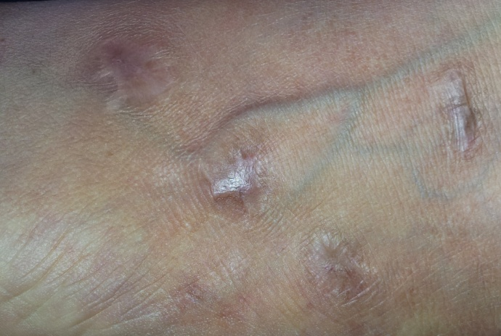
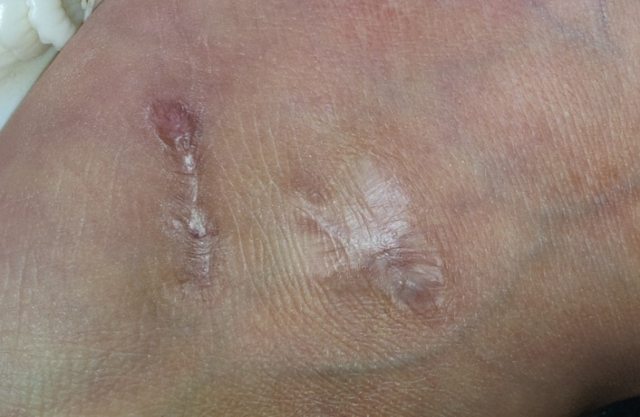

Figure 1: heeling position of the infection of Nodular Vasculitis on foot.
Table 1. The literature survey with reference to the association of C. pneumoniae infection with erythema nodosum
Reference  Number | Age/sex | nature of infection | Associated  disease(s) | Diagnostic criteria | Other findings
[6] | 48/F | Lower respiratory | Episcleritis | CF | Histology: vasculitis
[7] | 17/M  11/F | Lower respiratory  Lower respiratory | None  None | MIF  MIF
[8] | 37/M | Lower respiratory | Myocarditis,  reactive arthritis | MIF
[9] | 37/M | Meningitis | Hepatitis, iritis | MIF | Erythema  Nodosum or vasculitis
[10] | Not specified |  | Lofgren’s syndrome | MIF
[11] | 45/M | Upper and lower  Respiratory | Reactive arthritis,  conjunctivitis | MIF | Histology: vasculitis
[12] | 42/F | None | None |  | Histology: infiltrations  around the vessels
[13] | 48/M | Lower respiratory | None |  | Histology: vasculitis
Present study | 22/F | Lower respiratory | None | MIF | Histology: vasculitis
CF = Complement fixation; MIF = micro-immunofluorescence.

