MULTIPLE CUTANEOUS MELANOMAS IN A DOG: A CASE REPORT
M. Palanivelu,^{1*} A.W. Lakkawar², K.C. Varshney² and M. Asok kumar¹
1Division of Pathology, Indian Veterinary Research Institute, Izatnagar -243 122
2Department of Veterinary Pathology, Rajiv Gandhi College of Veterinary and Animal Sciences, Puducherry
* Corresponding author
Address of corresponding author:
Dr. Palanivelu M, M.V.Sc
Scientist,
Division of Pathology
Indian Veterinary Research Institute,
Izatnagar, Bareilly – 243 122
Uttar Pradesh.
ABSTRACT
A 1 year old Great Dane bitch was presented with multiple, pedunculated masses of varying sizes. On clinical examination, the masses were soft, pliable and revealed both pigmented as well asun-pigmented skin coat.Histopathologically, all the tumour masses were characterized by mild epidermal hyperplasia along withaggregates of melanin pigmentsin the dermis. The dermal collagen was moderately hyperplastic and arranged as wavy bundles often containing focal aggregates of melanin.
Keywords:cutaneous, cytology, Great Dane, hyperplastic, melanoma,
Melanomas are one of the commonly diagnosed tumours in dogs that originate from melanin producing cells. The benign cutaneous melanomas that arise on the haired skin usually display very little cytologic or nuclear atypia and a few mitotic figures. The lesions are solitary, and occur most commonly on the head, limbs, digits, scrotum, lip and trunk. These are variably circumscribed and are gray, brown or black in color, ranging from 0.5 to 10 cm in diameter. Histopathologically, characterized by the presence of atypical melanocytes arranged in sheets (packets or mesh) or in cords and are exhibited as epithelioid, spindle cell or combination of these two forms^{1, 2}. Among the skin tumours, melanocytic neoplasm accounts to 5 percent³.
A one year old Great Dane bitch was presented for evaluation of multiple cutaneous masses in the skin of different body regions. It was reported that, the masses were first noticed by the owner 3 months prior to evaluation and since then the masses have gradually increased in size. On clinical examination, the masses were soft, pliable and revealed both pigmented as well as un-pigmented skin coat. The size of tumour masses in the present case ranged from 1 cm to 6 cm in diameter. The cut surface was dark brown in color with little apparently normal tissues. Fine needle aspiration cytology (FNAC) showed presence of varying sizes of dark brown to jet black granules often masking the cellular details.Histopathologically, all the tumour masses were characterized by moderate degree of orthokeratosis, hyper pigmentation of epidermal cell layer. The dermis revealed aggregates of melanin pigments interspersed between the dermal collagen.The collagens were severely hyperplastic and were arranged as wavy bundles without any adnexal structures.Based on these features, the case was diagnosed as multiple cutaneous melanomas.
The cases of melanoma in dogs have been reported by many earlier workers^{4, 5}but the unusual occurrence of multiple cutaneous melanomas in a one year old dog as in the present case appears to have not been reported earlier.
AKNOWLEDGEMENT
The authors are thankful to the Dean and faculty of Veterinary Surgery and Radiology division for extending their help.
REFERENCES
- Moulton JE (1990). Tumours of the skin and soft tissue. In: Tumours in Domestic Animals. 3rd ed., Moulton JE. Berkely, University of California press, USA.
- Goldschmidt MH and Schofer FS (1992). Skin Tumours in Dogs and Cats. ButerworthHeinemann , Oxford, UK. J. Vet. Diagn. Invest.,17: 403–411.
- Scott DW; Miller WH and Griffin CE (2001). Muller and Kirk’s Small Animal Dermatology. 6th ed. W.B. Saunders Company, Philadelphia, USA.
- Schultheiss PC (2006). Histologic features and clinical outcomes of melanomas of lip, haired region, and nail bed locations of dogs. J. Vet Diagn Invest.,18: 422-425.
- Bidur P; Min-Soo K; Il-Hong B; Mi-Sun P; Hyang J; Mi-Hyeon Y; Jae-Hoon K; Byung-Il Y; Yang-Kyu C and Dae-Yong K (2007). Retrospective study of canine cutaneous tumours in Korea. J. Vet. Sci., 8: 229–236.
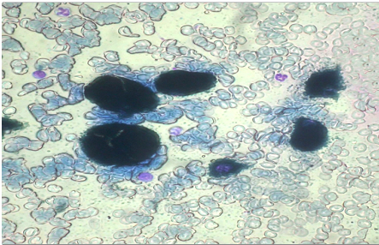
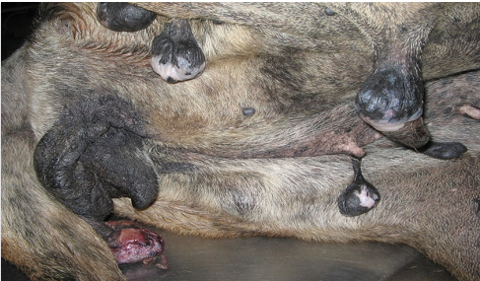

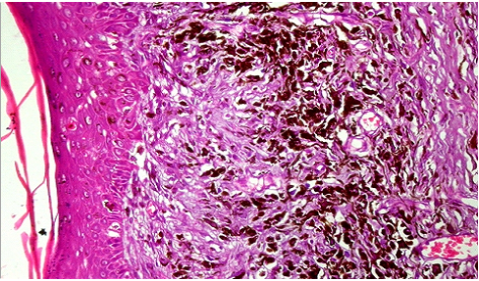

LIST OF FIGURES
- Melanoma from a female Great Dane showing multiple pedunculated growths in the hind quarters and abdominal region.
- Aspirate from melanoma showing varying sizes of melanin granules. Leishman& Giemsa x400.
- Melanoma showing nests of melanocytes within the dermis. H&E x100.

