Serum progesterone level of camel (Camelus dromedarius) according to the physiological status

Kamoun Mounir and Jemmali Borni.
ADIPARA Lab, Department of Animal Production, School of Higher Education in Agriculture of Mateur

Abstract
The present work was planned in the Department of Animal Production, Higher School of Agriculture, Mateur. Analysis of progesterone level in blood samples can be a pathway to define the physiological status of females. The progesterone level measurement can indicate an early pregnancy. 13 females and 01 male were included in this study, out of which primiparous, multiparous and heifers. In total 364 blood samples were collected, along one year, every 10 days. The blood samples were used to establish the pregnancy diagnosis. serum progesterone levels were determined by radioimmunoassay. For all animals, the average of serum progesterone was about 2.03 ± 1.14 g/L. for growing female (category 1), young pregnant females (category 2), empty multiparous females (category 3) and pregnant multiparious females (category 4) were respectively 0.14 ± 0.08 g/L, 4.11 ± 1.43 g/l, 0.06 ± 0.10 g/L and 3.5 ± 1.00 g/L. Progesterone hormone is even in growing females, and its concentration started to rise after successful mating. Statistical analysis, with General Linear Model procedure and Multiple linear regression models, indicates a significant effect (P<0.001) of age, physiological status, pregnancy status on serum progesterone level and significant differences in serum progesterone levels between category (p < 0.001). The reproductive variables means value for serum progesterone in analyzed individuals, were significantly higher in the young pregnant females, pregnant multiparious females than those for growing female and empty multiparous females. Progesterone level for all analyzed empty female always low for all experimental period. It started to rise again after successful mating and remained high until the end of the pregnancy. Monitoring serum progesterone level can be a useful pathway to monitor pregnancy in camels.

INTRODUCTION

The level of fertility in domestic animals results from a number of interacting factors, some of which have a genetic basis while others are environmental in origin. The systems reproductive physiology of some animals has attracted considerable studies, although certain aspects of reproductive performance for males and females, especially fertility, are inadequately understood. For camel, it is known that the female is an induced ovulation. Adult camel male is characterized by an intermediate penis type, between the vascular and fibrous types. Generally, dromedaries give one calf per birth (Kamoun and Wilson, 1994; Tibary et al., 1997; Nikjou et al., 2008). The reproductive physiology of camel has been incompletely characterized. Most literature describe general characteristic such as occurrence, growth, maturation, diets and pregnancy rate (Hammadi et al., 2001; Ayoub et al., 2003; Deen, 2008; Babiker et al. 2011; Kamoun and Jemmali, 2012 ). The dromadaries reproductive efficiency is generally characterized that low under natural conditions. The short breeding season, the long prepubertal period, the long gestation period, the prolonged period of lactation (anestrous of 8–10 months) and the long inter-calving interval are the principal causes for these low performances. (Babiker et al., 2011; Kamoun and Jemmali, 2012).
FAO statistics (2004), reported that the number of camel in world was about 19 million, this number was founded essentially in Africa and Asia with 15 million and 4 million respectively. African populations represent 79% of world camels. all of these animals were one humped and are concentrated in Nord-East of Africa. In Egypt, their numbers were previously estimated as 230,000 camels. In Tunisia, there are about 100.000 camels (Camelus dromedarius). This estimated number was distributed especially in southern and center of Tunisia (figure 1). Despite this important number, there is a little information on genetic diversity of this population and no clear classification for camels exists.

Figure 1. Localization of principal camel breeds in Tunisia.

Camel known as a beast of burden in the desert is presently being transformed into a multi-utility animal providing draft power, patrolling international borders, production of commodities like hair, meat and milk. Study of low fertility level of camel can be a way to improve reproductive performances for this animal. The objective of this study is to estimate the serum progesterone level according to physiological status of Maghrebi She-camels.

MATERIAL AND METHODS
Animals:
Total of 13 females and one fertile male camel were used in the experiment to study the variation of serum progesterone level. Progesterone was determined in three hundred sixty-four sample of blood serum taken from thirteen non-pregnant, early, mid-, and late pregnant, as well as Pre-Pubertal she-camels, at regular intervals throughout one year. Four groups were formed: growing female (category 1), young pregnant females (category 2), empty multiparous females (category 3) and pregnant multiparious females (category 4). At startup (9 July) there were six pregnant females, who gave birth during the experiment, five females had a successful mating amid of experience (in winter) and the remaining were 16 months old at the sampling end (July 7). For pregnant females, eight were in first-pregnancy, mated at 25.0±4.0 months old which corresponded to 68.8±7.5% of mature weight and three in the second pregnancy mated at 56.3±8.8 months old which corresponded to 90.7±4.5 % of mature weight. Thus the samples belong to she-camels in different pregnancy stages, to young female (pre-pubertal or pubertal), but also nursing females.
Blood sampling:
Blood samples (10 ml) were collected individually from the jugular vein of all animals in the experiment morning before feeding every week. Blood samples were placed on ice during collection and stored at + 4 °C for 6 hours in refrigerator, then serum was separated by centrifugation at 3000 rpm for 20 minutes and stored frozen at - 20 °C till analysis.
Serum Progesterone RIA:
Progesterone assay was performed using kits supplied by the Joint FAO/IAEA through the CRP D31017 titled "INTER-REGIONAL RESEARCH NETWORK FOR IMPROVING THE PRODUCTIVITY OF CAMELIDS". The sensitivity of this method was 0.09 ng/mL and the inter- and intra-assay coefficients of variation were 9.2 and 11.0%, respectively.
Statistical analysis:
The means procedure in SAS (Version 9.1; SAS Institute, 2003) was used to determinate average serum progesterone level for each category. The multiple linear regression models was used to estimate difference if exist between level progesterone by category. The GLM procedure was used for statistical analysis. Differences in serum concentrations of progesterone were examined between she-camel females the by General Linear Model (GLM) procedures of the SAS. The effect of a probability value of 0.05 was used as an indicator of statistical significance among comparisons.

RESULTS AND DISCUSSION

The average concentration of progesterone hormone for analyzed individuals and for each category of age is shown in table 1. For all animals, the average of serum progesterone was about 3.99 ± 1.14 g/L. for growing female (category 1), young pregnant females (category 2), empty multiparous females (category 3) and pregnant multiparious females (category 4) were respectively 0.14 ± 0.08 g/L, 3.24 ± 0.45 g/l, 0.11 ± 0.10 g/L and 3.5 ± 1.00 g/L.

Table 1. Serum progesterone levels and average age for analyzed category of age.
Category | Characters | obervation | Mean | Std Dev | Min | Max
All individuals | Progesterone (g/L) | 343 | 2.03 | 1.14 | 1.56 | 9.78
All individuals | Age (month) | 364 | 36.13 | 18.85 | 4 | 76.27
Category 1 | Progesterone (g/L) | 113 | 0.14 | 0.08 | 0.05 | 0.38
Category 1 | Age (month) | 113 | 16.25 | 5.88 | 4 | 251
Category 2 | Progesterone (g/L) | 115 | 4.11 | 1.43 | 0.35 | 9.78
Category 2 | Age (month) | 115 | 32.14 | 6.6 | 23.67 | 52.96
Category 3 | Progesterone (g/L) | 56 | 0.06 | 0.10 | 0 | 0. 4
Category 3 | Age (month) | 77 | 49.54 | 11.46 | 33.8 | 76.27
Category 4 | Progesterone (g/L) | 59 | 3.5 | 1.00 | 0.08 | 5.27
Category 4 | Age (month) | 59 | 64.48 | 6.42 | 52.6 | 74.83

Serum progesterone level change during ovulatory cycle and pregnancy in camel. Table 2 showed the variation of progesterone level according to physiological status for all analyzed females. This study showed that the average levels of progesterone in analyzed she-camel during the period of pregnancy ranged from 3.5 ± 0.89 to 4.34 ± 1.3 ng/ml (Table 2).

Table 2. Variation of progesterone level according pregnancy status of analyzed females.
status | Number | Means | Std dev | Min | Max
1 | 56 | 4.34 | 1.30 | 1.56 | 7.97
2 | 52 | 4.19 | 1.04 | 2.39 | 6.56
3 | 65 | 3.5 | 0.89 | 2.03 | 5.91
Status: 1= first 1/3 of pregnancy; 2= middle second 1/3 of pregnancy; end last 1/3 of pregnancy

The pregnancy status have a significant effect on serum progesterone level (P<0.01). The measurement of progesterone levels is still the most reliable method to detect estrus, ovulation and the ovarian function in animals. Figure 2 showed the general profile of serum progesterone level for analyzed individuals.

Progesterone serum levels for all studied dromedaries’ were separately analyzed by category. Regarding the startup day (9 July), the progesterone level remained low during the period from the end of August to the end of January. Recording data, of serum progesterone level, indicate a gradual increase during this study. The serum progesterone level started to increase at March and continue high during July (Babiker et al., 2011). The corpus luteum represents the primary source of progesterone in dromedaries. Ovulation in camel is induced by mating stimulus. If successful mating exists, serum progesterone level started to rise, else blood progesterone quantity still low (Ayoub et al., 2003; Skidmore, 2005; Ghazi, 2007). In this study testosterone level in male is high between Marsh and August. Sexual behavior of male can explain serum progesterone level variation in camel during this period. The present findings are similar to those of Musa and Abusineina (1978). Camel’s species have seasonal sexual behavior affected by long daylight of the year (Chen and Yuen 1979; Sumar, 2000).

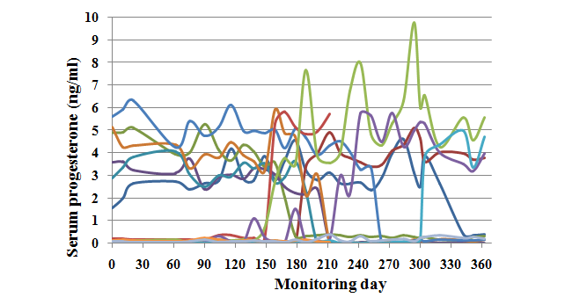

Figure 2. General profile of serum progesterone level during monitoring days

Statistical analysis, with General Linear Model procedure, indicates a significant effect (P<0.001) of age on serum progesterone level. These results were confirmed by regression procedure. The use of multiple linear regression models showed significant differences between category for the serum progesterone levels (F₉,₁₇₈ = 5.05, P < 0.001, SEM = 0.32; adjusted R² = 0.16). The reproductive variables means value for serum progesterone in analyzed individuals, were significantly higher in the young pregnant females, pregnant multiparious females than those for growing female and empty multiparous females.

Figure 3 showed the evolution in serum progesterone following a successful mating of she-camel. These studies confirm that serum progesterone level increase after a successful mating. This high level of progesterone is successful tool for succeed pregnancy process. Concentrations increase faster from day 3, reaching higher levels during the pregnancy (around 5 ng/ml).

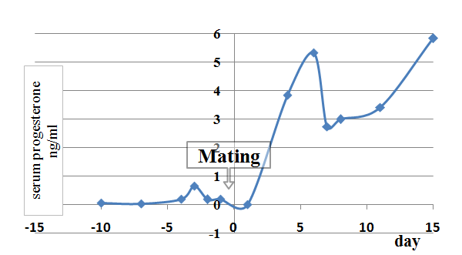

Figure 3. Evolution in serum progesterone following a successful mating of she-camel

During pregnancy level of progesterone recorded a highest level. This level decrease to the low quantities just after parturition. Recording serum progesterone level is a very useful pathway to monitor pregnancy in dromedaries. During pregnancy progesterone hormone is found to be high and declined just after parturition (Alfuraiji, 1998; Skidmore, 2005). In empty female, progesterone level remained low and it increase again after successful mating. The progesterone hormone level continues high until the end of the pregnancy (Figure 4).

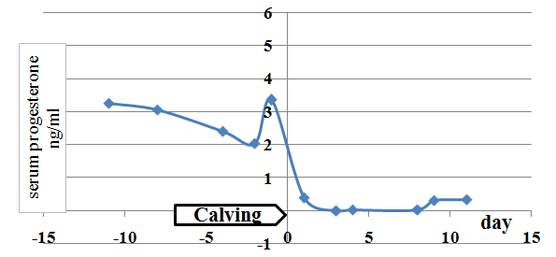

Figure 4. Evolution in serum progesterone after calving of she-camel

The figure (5 and 6) showed the significant effect on progesterone concentration respectively for multiparous during pregnancy and young she-camels during pregnancy. As demonstrate by different studies ovulation in camel is induced by mating stimuli (Ayoub et al., 2003; Skidmore, 2005; Ghazi, 2007).

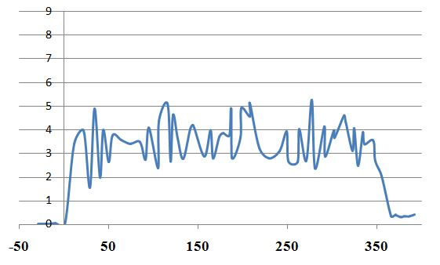

Figure 5. Serum progesterone profile of she-camels multiparous during pregnancy

Progesterone level indicated a significant rise (>5 ng/ml) in progesterone 2 days after successful mating in all female (Abdel Rahim et El-Nazier , 1993).

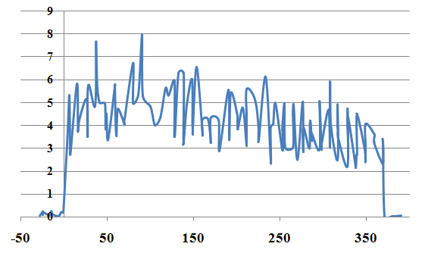

Figure 6. Serum progesterone profile in young she-camels during pregnancy

After mating stimulus and if the dromedary is not pregnant (figure 7) progesterone level rapidly decrease to low concentration of <1ng/ml by days 10 - 12, however, if she is pregnant the serum progesterone level are maintained between 3 and 5 ng/ml for the first 90-100 pregnancy days. During period between 100-300 pregnancy day progesterone concentration is 2 - 4 ng/ml. This second period is characterized by a slight decrease of progesterone level. These slight decreases continue over the next 70 - 80 days. A Rapid drop of the progesterone concentration, to values of < 1 ng/ml on the day before, or the day of parturition, is recorded (Fig. 7) (Skidmore et al., 1996). Mobarak and El-Wishy (1971) reported that from 5 pregnancy months until parturition there to be a gradual decrease for this hormone. These results indicate a significant rise in progesterone the day after successful mating of all young she-camel.

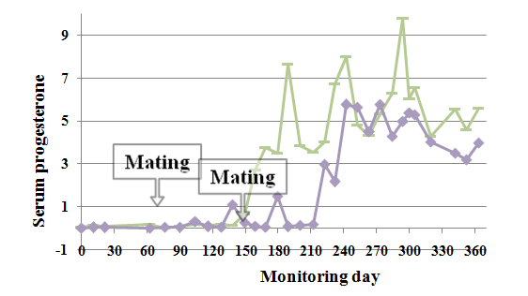

Figure 7. Progesterone the day after successful mating of young she-camel

CONCLUSIONS
The average concentration of progesterone hormone for analyzed individuals and for each category is shown in table1. For all animals, the average of serum progesterone was about 3.99 ± 1.14 g/L. for growing female (category 1), young pregnant females (category 2), empty multiparous females (category 3) and pregnant multiparious females (category 4) were respectively 0.14 ± 0.08 g/L, 3.24 ± 0.45 g/l, 0.11 ± 0.10 g/L and 3.5 ± 1.00 g/L.
Statistical analysis, with General Linear Model procedure, indicates a significant effect (P<0.001) of age on serum progesterone level. These results were confirmed by regression procedure. The use of multiple linear regression models showed significant differences between category for the serum progesterone levels (F₉,₁₇₈ = 5.05, P < 0.001, SEM = 0.32; adjusted R² = 0.16).
The reproductive variables means value for serum progesterone in analyzed individuals, were significantly higher in the young pregnant females, pregnant multiparious females than those for growing female and empty multiparous females.
Progesterone level of for all studied dromedaries is low in empty female. It started to increase if successful mating exist and continue to be high until the end of the pregnancy.
Progesterone hormone level is a very useful tool to monitor pregnancy in camels.

REFERENCES
Ayoub, M.A., El-Khouly, A.A. and Mohamed, T.M. 2003. Some hematological and biochemical parameters and steroid hormone levels in the onehumped camel during different physiological conditions. Emirates Journal of Agricultural Science, 15(1): 44 – 45.
Ayoub, M.A., El-Khouly, A.A. and Mohamed, T.M. 2003. Some hematological and biochemical parameters and steroid hormone levels in the onehumped camel during different physiological conditions. Emirates Journal of Agricultural Science, 15(1): 44 – 45.
Babiker, E. A1, Ahmed, A. I1, Husna M. E2 and Abdel-Aziz B. E2, 2011. Serum testosterone and progesterone levels and ovarian activity as indicators for seasonal breeding in dromedary camels in Sudan. roavs, 2011, 1(5), 309-312.
Chen, B.X. and Yuen, Z.X. 1979. Reproductive pattern of the Bactrian camel. The Camelid: All Purpose Animal. Cockrill, W.R. (ed.), Scandinavian Institute of African Studies, Uppsala, Sweden, 1: 364 – 396.
Deen, A. 2008. Estradiol and testosterone profiles, their correlation with sexual libido in male camels. Proceedings of the WBC/ICAR Satellite Meeting on Camelid Reproduction, Budapest, Hungary.
Eman Hamed and Aisha Elattar. 2013. Identification and Some Probiotic Potential of Lactic Acid Bacteria Isolated From Egyptian Camels Milk. Life Science Journal 2013;10(1).
Ghazi, F.B. 2007. Follicular wave pattern, folliculogenesis and assisted reproductive techniques in the non-pregnant female dromedary camel. Journal of Biological Sciences, 7(6): 1038–1045.
Hammadi M., Khorchani T., Khaldi G., Majdoub A., Abdouli H., Slimane N., Portetelle D., Renaville R., 2001. Effect of diet supplementation on growth and reproduction in camels under arid range conditions. Biotechnol. Agron. Soc. Environ., 5: 69-72.
Kamoun M and Jemmali B. 2012. Reproductive performance Improvement of Maghreby negga by zootechnic practices. 3rd Conf. ISOCARD. Muscat, Oman 29 Januay -1February, 48: 129-130.
Kamoun M, Wilson RT. Improving early reproductive characteristics of Tunisian camels by nutritional and management interventions. J Arid Environ 1994; 26:89-94.
Mobarak AM, El-Wishy AB. Uterus of the one-humped camel (Camelus dromedarius) with reference to rectal palpation. Indian J Anim Sci 1971; 41:846-855.
Musa, B. and Abusineina, M.E. 1978. The estrus cycle of the camel. Veterinary Record, 103: 556 – 557.
Nikjou D, Niasari-Naslaji A, Skidmore JA, Mogheiseh A, Razavi K. Synchronization of follicular wave emergence prior to superovulation in Bactrian camel (Camelus bactrianus). Theriogenology. 2008;69:491–500.
Skidmore, J.A. 2005. Reproduction in dromedary camels: an update. Animal Reproduction, 2(3): 161– 171.
Skidmore JA., Billah M, Allen WR. Patterns of hormone secretion throughout pregnancy in the one-humped camel (Camelus dromedarius). Reprod Fertil Dev 1996; 8:863-869.
Sumar J. Removal of the ovaries or ablation of the corpus luteum andits effect on the maintenance of gestation in the alpaca and llama. Acta Vet Scand 1988; 83:133-141.
Sumar, J.B. 2000. Llama and Alpacas. In: Hafez (editor), Reproduction in Farm Animals, 7th edn. Philadelphia: Lippincott Williams and Wilkins, 218 – 233.
Tibary A, Anouassi A. Taxonomy and Evolution. In: A. Tibary, ed. Theriogenology in Camelidae: anatomy, physiology, BSE, pathology and artificial breeding. Actes Editions: Institut Agronomique et Vétérinaire Hassan II, 1997;1-16.

