OUTBREAKS OF INCLUSION BODY HEPATITIS (IBH) IN CHICKENS: PATHOLOGICAL STUDIES AND ISOLATION OF FOWL ADENOVIRUS
Running Title: Histopathology of IBH affected birds
Vipan Kumar¹, Rajesh Kumar^{2*}, Rajesh Chandra³, Prakash Bhatt⁴ and Kuldeep Dhama⁵
No. of Tables: Nil, No. of Figures: 06

¹Department of Veterinary Microbiology, College of Veterinary & Animal Sciences, Khalsa college of Veterinary and Animal Sciences, Amritsar, Punjab
Departments of ²Veterinary Microbiology, ⁴Veterinary Clinics, College of Veterinary and Animal Sciences, G. B. Pant University of Agriculture & Technology, Pantnagar – 263 145, Uttarakhand
³Department of Veterinary Microbiology, College of Veterinary & Animal Sciences, Central Agricultural University, Selseih, Aizawal
⁵ Principal Scientist, Division of Pathology, Indian Veterinary Research Institute, Izatnagar
*Corresponding Author: rajeshvet@rediffmail.com, Tel: +91-5944-233065,
Fax: +91-5944-233473
Abstract:
Fowl adenoviruses (FAV) are known to cause many disease conditions in birds including poultry and wild birds. The disease has worldwide presence. In India, disease is endemic in many states e.g. Uttarakhand, Uttar Pradesh, Punjab, Haryana and Maharashtra. Present study reports the two disease outbreaks of inclusion body hepatitis (IBH) in poultry farms of Uttar Pradesh and Uttarakhand, India on the basis of disease investigation carried out including clinical and histopathological examination of affected birds, isolation of causative virus and its detection by immunofluorescent test. Clinically, the birds showed depression and greenish diarrhea. Postmortem lesions consisted of jaundice, enlargement of kidneys and grayish white area of necrosis on livers. Histopathology of liver revealed large intracellular inclusion bodies in hepatocyte, degeneration and congestion of sinusoids,; and kidneys revealed degeneration of tubules,; Atrophy of bursa of Fabricius was also recorded. Virus was isolated from the clinical samples of both the disease outbreaks using chicken embryo liver (CEL) cell culture and the viral antigen was demonstrated in cell culture by indirect fluorescent antibody test (IFAT) using FAV specific antisera. Present study demonstrates the involvement of Fowl adenovirus in Inclusion hepatitis outbreaks and adds to the epidemiological data available. Findings of the study also suggest that IFAT can be a valuable tool for detection of FAVs.
Introduction:
Fowl adenoviruses are known to cause many disease conditions in poultry birds like Inclusion body hepatitis (IBH), hydropericardium syndrome (HPS), and respiratory infections in chickens and quail bronchitis. All eleven serotypes of fowl adenovirus (FAV) have been isolated from natural infections of poultry birds (Kim et al. 2008; Choi et al. 2012; Asthana et al. 2013) and wild birds like Wild black kites (Kumar et al., 2010) and pigeons (Schrenzel et al. 2005; Catroxo et al. 2011). The disease causes high morbidity among broiler birds leading to production losses (Young et al., 1972, Palya et al., 1977, Singh et al., 1996), although average mortality is low (5-10%) but 30% mortality has been reported from Australia (McFerran and Smyth, 2000). Recently, some of FAVs have been implicated in immunosuppression (Hussain et al., 2012). The disease was first reported from USA as a necrotizing hepatitis in 7-weeks-old chickens (Helmboldt and Frazier, 1963). Since then, the disease has been reported from all continents. In India, many outbreaks of this disease have been investigated by earlier workers (Garewal et al., 1981; Bhattacharya et al., 1983; Nayak et al., 1990; Mishra and Grewal, 1994; Sandhu et al., 1994, Deshmukh et al., 2000, Kumar et al., 2003).
In domestic poultry, the disease usually affects birds at the age of 2 to 6 weeks (Kumar et al. 1997; Asthana et al. 2013). The onset of disease occurs in hot and humid weather [Shah et al. 2011; Shahzad et al. 2011]. The disease, inclusion body hepatitis is characterized by sudden onset of mortality, severe anemia and necrotic hepatitis with basophilic or eosinophillic intranuclear inclusion bodies in hepatocytes (Kim et al. 2008; Shahzad et al. 2011; Saifuddin and Wilkis, 1991; Dar et al., 2012).
Present study deals with investigation of outbreaks of Inclusion body hepatitis, histopathology of naturally infected birds and isolation of causative agent and its identification by IFAT.
Materials and Methods:
Disease investigation and Collection of samples:
Disease outbreaks of Inclusion body hepatitis (IBH) were suspected in broiler poultry birds in two private poultry farms of Bilaspur region of Rampur district, Uttar ptadesh and Kashipur of Uttarakhand on the basis of clinical signs and post mortem examination carried out in dead and sacrificed birds. The mortality rates recorded in both the farms were 10% and 3%, respectively, whereas morbidity was around 80%. Clinical samples of liver, kidneys and bursa of Fabricius were collected from dead and necropsied birds for histopathological and isolation studies. The liver samples were collected in 50% glycerol saline for virus isolation. Tissue samples of liver, kidneys and bursa of Fabricius were collected in 10% formal saline for histopathological examination.
Histopathologcal examination:
The tissues (liver, kidneys and bursa of fabricius) were processed for histopathological examination as per standard protocol, fixed in 10% formal saline, washed in running tap water overnight and then dehydrated for one hour in different concentrations of ethanol, 50%, 60%, 70%, 80%, 90% and absolute alcohol for dehydration of tissues in same order. Then the tissues were cleared in xylene and embedded in paraffin wax. Sections of 4-5 µ thickness were cut and stained with Haemotoxylin and Eosin (H & E) staining procedure as described by Kumar et al. (2003).
Isolation of virus on chicken embryo liver (CEL) cell culture:
Twenty percent (w/v) liver homogenates of both isolates were prepared in Phosphate buffered saline (PBS) from the clinical samples collected from both the outbreaks and virus isolation was attempted on 14 day-old chicken embryo liver (CEL) cell culture. Embryonated chicken eggs for this purpose were procured from Instructional Poultry Farm, Pantnagar and CEL cell cultures were prepared using standard procedure (Kumar and Chandra, 2009) and a total of six passages were done for isolation of the virus and the virus was identified by observing characteristic cytopathic effects in CEL cell cultures and its demonstration by immunofluorescence staining.
Immunofluorescence staining
The presence of fowl adenovirus (FAV) during isolation in cell cultures was detected by indirect immunofluorescent antibody technique. Briefly, CEL cells were grown on cover slips and infected with both the virus isolates obtained from the two disease outbreaks. After 48 hrs. of infection cover slips were flooded with chilled acetone for 30 min for fixing of cells of monolayers. Then the cells were rehydrated with PBS (pH 7.2). Single washing of infected cells was done with wash buffer (Triton X-100 0.01% v/v in PBS). After 5 min. of incubation, the detergent was removed and blocking buffer (10% foetal calf serum in wash buffer) was added to block unreactive sites on monolayers. Then, after three washings with wash buffer, FAV specific antiserum was added and incubated for 30 min at 37˚C again after three washings with PBS, rabbit anti-chicken FITC conjugate (Sigma) was added to detect the binding of anti adenoviral antibodies with adenoviral antigens present in infected cell cultures. The coverslips were washed thrice as mentioned above with wash buffer, air-dried and mounted in glycerol. The stained coverslips were examined under U. V. light in fluorescent microscope. The un-infected CEL cell culture monolayer was kept as negative control and processed in similar way.
Results:
Clinical signs in affected birds:
During the disease investigation, the clinically affected birds at both the poultry farms showed signs of depression, greenish watery yellow diarrhea and sluggish movement. At the terminal stages of disease, birds were dull and depressed, reluctant to move and showed characteristic posture with their chest and beak resting on ground and closed eye lids. Feathers around vent were soiled with faecal material.
Postmortem lesions:
Postmortem examination of dead and moribund birds at both the farms showed enlarged livers with petchial and ecchymotic haemorrhages. Livers were pale yellow in color and in some cases appeared friable and contained large areas of focal necrosis (Fig. 1).
The kidneys were pale yellow, swollen, congested and contained haemorrhagic patches on the surface (Fig. 2). The lungs were congested and odematous. Haemorrhages were also present on the thigh muscles of affected birds. A few birds also showed slight enlargement of bursa of Fabricius. The carcasses of all the dead birds were anaemic.
Histopathology:
The histopathological examination of liver from affected birds revealed focal hepatic necrosis, vacuoler degenratiuon of hepatocytes and sinusoidal congestion along with mononuclear cell infiltration. Many hepatocytes revealed large basophilic intranuclear inclusion bodies, which were round and compact and occupied almost entire nucleus, sometimes leaving a thin layer of chromatin around periphery. Fatty and vacuolar degeneration was also evident (Fig. 3). Birds examined from both the farms revealed similar histopathological lesions of IBH.
The microscopic examination of kidneys showed hyperemia and focal areas of haemorrhages in between tubular epithelium. The kidney tubules revealed moderate degree of degenerative changes with focal necrosis along with mononuclear cell infiltration. Large basophilic inclusion bodies were occasionally present in renal epithelium (Fig. 4).
Bursa of Fabricus also had varying degree of degenerative changes, reduction in number of follicles, hyperemia, necrotic foci and intrabursal fibrosis. However, inclusion bodies were not seen in bursal tissues (Fig. 5). Birds examined from both the farms revealed similar histopathological lesions of IBH.
Isolation of virus:
On CEL cell cultures, the cytopathic effects (CPE) were characterized by rounding and degeneration of cells from first passage itself. Microplaques were evident after 72 hrs. post infection (PI). By second passage, the CPE appeared in 24 hrs. After 72 hrs., almost 80% of the cell layer detached from its surface. On successive passaging, CPE were more distinct and stable.
Immunofluorescence antibody technique:
Intense intranuclear immunofluorescence was observed in the virus infected CEL cell cultures at 7th passage for both the virus isolates, which indicated the presence of FAV antigens in cell cultures tested (Fig. 6).
Discussion :
. Inclusion body hepatitis has a worldwide distribution, and there are indications that its incidence is increasing in many poultry industries (Mase, 2012). Findings of present study adds to epidemiology of disease and virus isolates obtained can be used for further molecular characterization, phylogenetic analysis, immunological and virological studies etc. In the present disease investigation naturally affected birds did not show any clinical signs at initial stages, except greenish watery diarrhea. However at terminal stages birds were dull depressed and reluctant to move and showed typical changes in posture. Kumar et al (2009) also reported varying degree of dullness, depression and diarrhea leading to prostration and death. Wang et al (1995) and Grgic et al. (2006) also had similar observations. Absence of clinical signs and sudden mortality may be attributed to relatively short course of disease and acute damage to vital organs like liver and kidney. In this investigation, the mortality rate was about 3-10%. Earlier workers have also reported low mortality rates in adult broiler birds in IBH infections (McFerran and Smyth, 2000,; Palya et al., 1977 and Kumar et al., 2003).
The predominant post mortem lesions included enlarged livers with friable texture and pin point or white necrotic foci. In some cases, petechial and ecchymotic haemorrhages were also present. Kidneys were congested and contained haemorrhagic patches on the surface. Haemorrhages were also evident on thigh muscles. Lungs were congested and odematous. Previously many investigators have noticed these findings (Azab et al. 1992; Sandhu et al., 1994, Dar et al., 2012). In some cases, livers were also covered with a fibrinous mass of exudates as reported by other workers (Sandhu et al., 1994,; Nayak et al., 1990,; Mitra et al., 1996].
Randell et al. (1986) reported cholecystitis, acites and cholangitis. Pilkington (1997) reported haemorrhages and discoloration of pancreas and enlargement of spleen in some cases. Okuda et al (2004) observed gizzard erosions. However, these lesions were not noticed in any of the affected birds in the present disease investigation. That may be due to the difference in the serotypes of the virus involved.
The histopathological examination of liver revealed necrosis of hepatocytes, vacuolar degeneration and infiltration of mono nuclear cells. Large ‘bird eye’ basophilic intranuclear inclusion bodies and sinusoidal congestion were also observed in this study. Theses findings are in accordance with those observed by earlier workers (Nayak et al., 1990,; Azab et al., 1992,; Sandhu et al., 1994,; Kaur et al., 2003,; Kim et al. 2008).
Kidneys showed congestion and haemorrhages, degeneration of renal epithelium and infiltration of mononuclear cells. Large basophilic intranuclear inclusions were occasionally observed. These findings were also reported by many earlier workers viz Nayak et al., 1990, Sandhu et al., Singh et al., 1996 and Kaur et al., 2003.
Bursa of Fabricius also had varying degree of degenerative changes and reduction in number of follicles. Inclusion bodies were not demonstrated in the bursal tissues. These findings are in agreement with earlier findings of Nayak et al., 1990 and Sandhu et al., 1994.
The lesions in different organs were suggestive of acute extensive damage in the liver, kidneys and bursa of Fabricius. Increased vascular permeability may be attributed to deposition of serofibrinous exudates in the parenchyma of liver and kidney.
Chicken embryo liver cell culture and chicken kidney cell culture are reported to support the growth of adenoviruses (Oberoi et al., 1996; Nakamura et al. 2002,; Kaur et al., 2003). The cytopathic effects during isolation of the virus in the present study are in accordance with those reported by earlier workers (Oberoi et al., 1996,; Kumar et al., 1997,; Toro et al.; 1999,; Kaur et al.; 2003). Micro and macro plaque formation is suggestive of cytolytic properties of virus.
For confirmation of adenoviruses, different diagnostic tests are used including molecular tools, and among these, immunofluorescence detection of viral antigens during virus isolation has high diagnostic value because of the high degree of accuracy of detection of group specific antigens by using specific antibodies, and is in use since many years (Leland and Ginocchio, 2007). We demonstrated the presence of viral antigens in CEL cell culture by indirect immunofluorescence antibody technique during the virus isolation in these cell cultures, which confirmed the virus to be FAV.
It can be concluded that FAVs are involved in IBH outbreaks. Degeneration of bursal follicles observed indicate that IBH virus may be involved in suppression of humoral immunity. Status and role of IBH in species other than chicken and characterization and molecular analysis of IBH causing FAVs from natural outbreaks would provide useful information on phylogeny and emergence of new strains and for formulation of an efficient vaccine and prevention and control strategies against IBH in chickens and other birds.
Competing interest statement:
The authors declare there is no competing interest associated with this study.
References
- Asthana, M., Chandra, R., & Kumar, R. (2013). Hydropericardium syndrome: current state and future developments. Archiv. Virol. 158 (5):921-933
- Azab A, Tawfik, A. El-Sheawy L. and Sashwan SM.T. (1992). Pathological changes in a broiler flock infected with avian inclusion body hepatitis. Egyptian J. Comp. Pathol. Clin. Pathol. 5: 75-82.
- Catroxo, M. H. B.; Martins, A. M. C. R. P. F.; Petrella, S.; Curi, N. A.; Melo, N. A. (2011) Research of viral agents in freeliving pigeon feces (Columba livia) in São Paulo, SP, Brazil for transmission electron microscopy. Int. J. Morphol., 29(2):628-635,
- Choi K. S., Kye J. Y., Kim W. J., Jeon E.K., Lee K. Y., Park and Sung H. W. (2012). Epidemiological investigation of outbreak of adenovirus infection in commercial chickens in Korea. Poultry sci. 90(10): 2502-2506.
- Dar A., Gomis S., Shirley I., Mutwiri G., Brownlie R., Potter A., Gerdts V. and Tikoo S. K. (2012). Pathotypic and molecular characterization of a fowl adenovirus associated with inclusion body hepatitis in Saskatchewan chickens. Avian dis. 56(1):73-81.
- Grgic H., Philippe C., Ojkic D. and Nagy, E. (2006). Study of vertical transmission of fowl adenoviruses. Canadian J. Vet. Res. 70:230-233.
- Hussain, I., Mahmood, M. S., Arshadi, M. I., Masood, A., Mahmood, F. and Rafique, A. (2012). Immune system dysfunction in broiler chickens experimentally inoculated with fowl adenovirus serotype-4 associated with inclusion body hepatitis hydropericardium syndrome.Turk. J. Vet. Anim. Sci.; 36(3): 223-230
- Kaur G., Maiti N.K. and Oberoi M.S. (2003). Biological and immunological characterization of fowl adenovirus-4 isolates from inclusion body hepatitis-hydropericardium syndrome. Indian J. Anim. Sci. 73(1): 51-52.
- Kim J. N., Byun S. H., Kim M. J., Kim J. J., Sung H.W. and Mo I. P. (2008): Outbreak of hydropericardium syndrome and molecular characterization of Korean fowl adenoviral isolates. Avian dis. 52(3):526-30.
- Kumar R. and Chandra R. (2009). Isolation and characterization of Fowl adenovirus associated with hydropericardium syndrome. Indian Vet. J. 86(10): 1084-1086.
- Kumar R., Chandra R., Shukla S. K. Agarwal D. K. and Kumar M. (1997). Hydropericardium syndrome in India: a preliminary study on the causative agent and control of disease by inactivated autogenous vaccine. Trop. Ani. Hlth. Prod. 29:158-164.
- Kumar R, Shukla SK, Chandra R and Agarwal DK (2003). Outbreaks of inclusion body hepatitis in domestic fowl. Indian J. Anim. Sci. 73(5): 477-480.

- Kumar R., Kumar V., Asthana M., Shukla S. K. and Chandra R. (2010). Isolation and identification of Fowl adenovirus from Wild Black Kites (Milvus migrans). J. Wild lif. Dis. 46(1): 272-276.
- Mase, M., Nakamura, K. and Minami, F. (2012). Fowl Adenoviruses Isolated from Chickens with Inclusion Body Hepatitis in Japan, 2009–2010. J. Vet. Med. Sci. 74(8): 1087–1089
- McFerran, J. B. and Smyth, J. A. (2000). Avian adenoviruses. Rev. Sci. Tech. Off. Int. Epiz.,19 (2), 589-60.
- Mitra, M., Mahanta, S. K., Basak, D.K., Pramanik, A.K. and Bhattacharya H. M. (1996). Inclusion body hepatitis in chickens following natural exposure with IBD virus. Indian J. Vet. Pathol. 20:142-144.
- Nakamura, K.; Tanaka, H.; Mase, M.; Imada, T. and Yamada, M. (2002). Pancreatic necrosis and ventricular erosion in adenovirus associated hydropericardium syndrome of broilers. Vet. Pathol. 39 (3):403-406.
- Nayak, H.C.; Chakraborty, T.; Chakraborty, S. and Chakraborty, A. (1990). An outbreak of inclusion body hepatitis in broiler chickens in West Bengal. Indian Vet. J. 76: 7-9.
- Oberoi M. S., Singh A. and Singh B. (1996). Isolation of avian adenovirus from outbreaks of inclusion body hepatitis-hydropericardium syndrome in poultry. Indian J. Virol. 12:123-124.
- Okuda, Y.; Ono, M.; Shibata, I.; Sato, S. and Akashi, H. (2006). Comparison of the polymerase chain reaction- restriction length polymorphism pattern of fiber gene and pathogenecity of serotype-1 fowl adenovirus isolates from gizzard erosions and from feces of clinically healthy chickens in Japan. J Vet. Diag. Invest. 18 : 162-167.
- Pilkington, P.; Brown, T.; Villegas, P.; McMurray, B.; Page, R.K.; Rowland, G.N. and Thayer, S.G. (1997). Adenovirus-induced inclusion body hepatitis in four-day-old broiler birds. Avian Dis. 41(2): 472-474.
- Randell C. J., Kirkpatrick K. S. and Pearson D. B. (1986). Liver abnormality in broiler. Vet. Rec. 119(23): 576.
- Saifuddin, M. and Wilkis C. R. (1991). Pathogenesis of an acute viral hepatitis in the chicken. Arch. Virol.116:33-43.
- Sandhu, B.S.; Singh, H. and Singh, B. (1994). Prevalence and pathology of inclusion body hepatitis in chickens in Punjab. Indian Vet. J. 71: 438-442.
- Scherenzel M., Oaks J. L, Rotstein D., Maalouf G., Snook E., Sandfort C. and Rideout B. (2005). Characterization of a new species of adenovirus in Falcons, J. Clinicl. Microbiol. 43: 3402-3413.
- Shah M. S. ,Ashraf A., Khan M. I., Rahman, M., Habib, M., Babapoor, S., Ghaffar, A., Malik, I. R., Khannum S. A. and Qureshi J. A. (2011).Molecular characterization of fowl adenoviruses associated with hydro-pericardium syndrome in broilers. African J. Microbiol. Res. 5(30):5407-5416.
- Shahzad A. K., Hussain T., Parkash O. and Fazlani S. A. (2011).Pathogenicity of recent field isolate of Avian Adenovirus Serotype-IV of hydropericardium syndrome (Angara disease). African J. Microbiol. Res. 6(20): 4332-4335.
- Singh, A.; Oberoi, M.S.; Jand, S.K. and Singh, B. (1996). Epidemiology of inclusion body hepatitis in poultry in northern India from 1990 to 1994. Rev. Sci. Tech. Off. Internatl. Epiz. 15(1): 1053-1060.
- Takase, K.; Yoshinaga, N.; Egashira, T.; Uchimura, T. and Yamamoto, M. (1990). Avian adenovirus isolated from pigeons with inclusion body hepatitis. Japanese J. Vet. Sci. 52: 207-205.
- Wang, C.H., Hsu, H.Y., Tseng, C.S., Tsein, M.H., Lee, J.J.Y. and Li N.J. (1995). Isolation of adenovirus from pigeons with inclusion body hepatitis. J. Chinese soc. Vet. Sci. 21: 12-17.

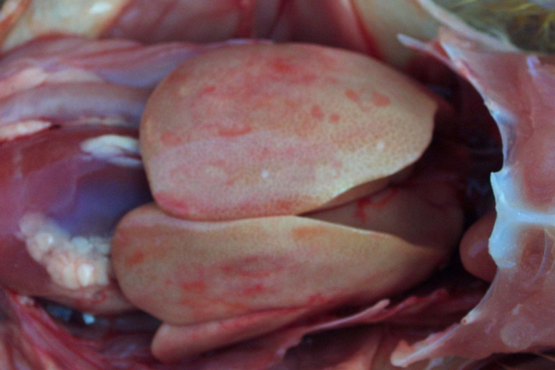
Fig. 1: Photograph of liver from dead bird showing necrosis and pin point haemorrhages

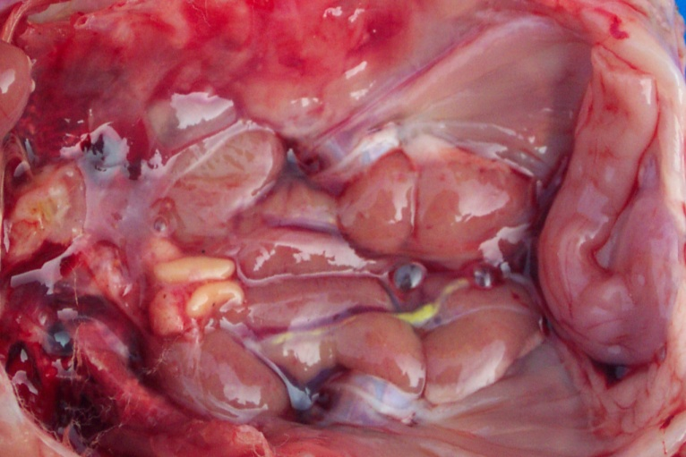

Fig. 2: Photograph of kidney from dead birds showing enlargement and congestion with focal area of necrosis
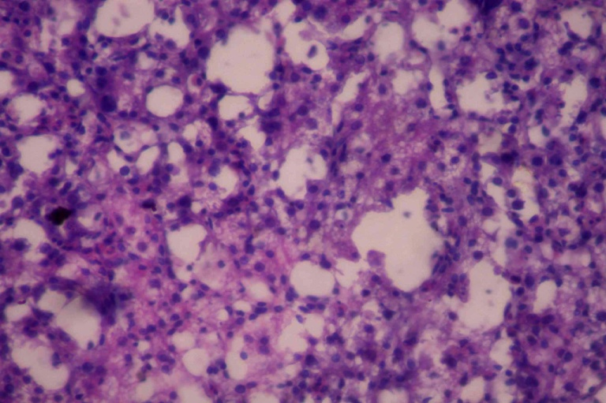
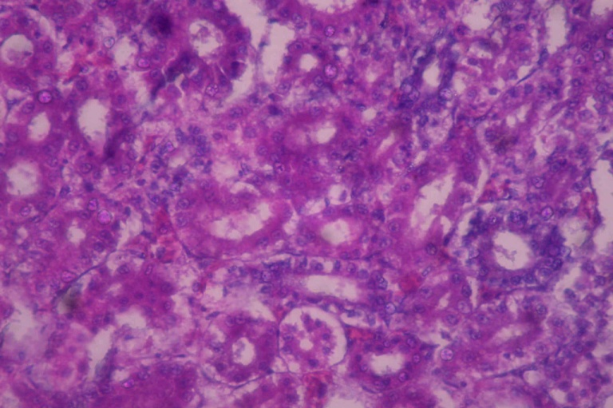
Fig. 3: Photomicrograph of Liver showing basophilic intranuclear inclusion bodies in hepatocytes with infiltration of mononuclear cells. (H&E stain x 400).area of necrosis
Fig. 4: Photomicrograph of kidneys showing degeneration and necrosis of tubular epithelium with intranuclear inclusion bodies, focal haemorrhages and mononuclear cell infiltration. (H & E x 400)

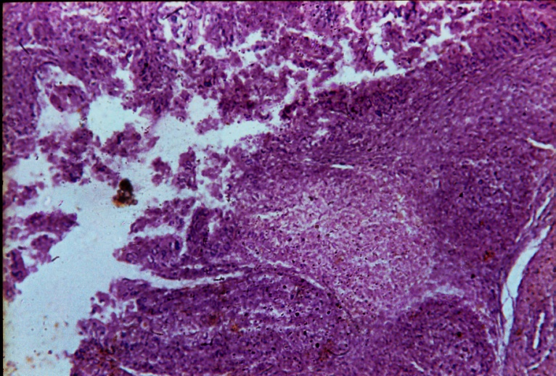
Fig. 5: Photomicrograph of bursa of Fabricius showing degeneration and necrosis of bursal follicles, focal areas of haemorrhages and mononuclear cell infiltration. (H & E 400).

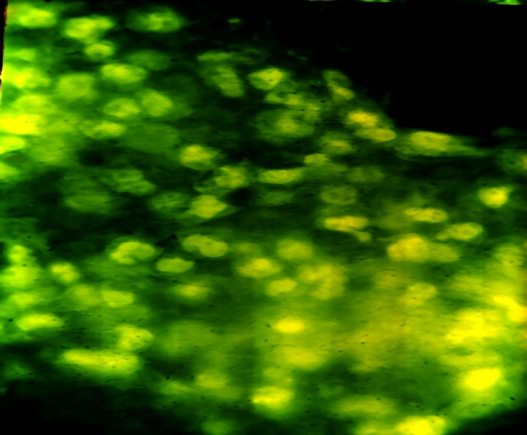
Fig. 6: Photograph of infected CEL cells showing intranuclear fluorescence. (X 400).

