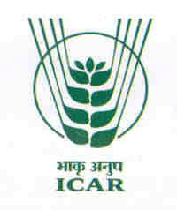 | 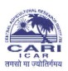 | dsUnzh; d`f"k vuqla/kku laLFkku  Hkkjrh; d`f"k vuqla/kku ifj"kn~  iksLV ckWDl u- 181] iksVZ Cys;j&744101  v.Meku fudksckj }hi lewg
Dr. Jai Sunder  Sr. Scientist, Animal Science Division |  | Central Agricultural Research Institute  (Indian Council of Agricultural Research)  Post Box No.181, Port Blair – 744 101  Andaman and Nicobar Islands

Dated : 28.09.2013
To
The Editor
Advances in Animal & Veterinary Sciences

Sub: Submission of Research Article entitled “Effect of Feeding Of Morical – A Herbal Based Supplement On Production And Egg Quality In Japanese Quail -reg
Sir,
Please find attached herewith softcopy of the article entitled “Effect of Feeding Of Morical – A Herbal Based Supplement On Production And Egg Quality In Japanese Quail” for its publication in the esteemed Journal of Advances of Animal & Veterinary Research.
This is submitted for your information and necessary action please.
With regards,
Yours sincerely

(Jai Sunder)

Telephones : 03192-250303 (Off.) 09434281840 (Mob)
Fax : 03192-251068/233281 Email: jaisunder@rediffmail.com

