Case report: Clinical picture of peste des petits ruminant (PPR) in buck
Arslan Tariq*^{[1]}, Asim Shahzad^{[2]}, Razia Kausar^{[3]}, Uzair Ahasan fiaz^{[1]}, Syed Sohail Jan^{[1]}
Corresponding Author: dr.arslantariq3418@live.com
- Faculty of Veterinary Sciences (FVS), University of Agriculture Faisalabad (UAF), Pakistan
- Department of Veterinary Pathology, Faculty of Veterinary Sciences (FVS), University of Agriculture Faisalabad (UAF), Pakistan
- Department of Anatomy and Histology, Faculty of Veterinary Sciences (FVS), University of Agriculture Faisalabad (UAF), Pakistan
Abstract:
This case study signifies the diagnosis of Peste des Petits ruminants (PPR) in a buck of discrete breed on the basis of clinical signs and Hematology. Case presented to department of clinics medicine and surgery (CMS), University of Agriculture Faisalabad, Pakistan (UAF) with chief complains of anorexia, watery diarrhea, ocular discharge and muco-purulent nasal discharge from last 4 days. Clinical examination revealed high fever, increase respiration, pulse rate and capillary refill time. Blood oozing lesions on gums and swollen lymph nodes could be seen. Lymphopenia complete blood count (CBC) provides another clue to diagnose the disease as PPR on clinical basis. Treatment was done symptomatically for 7 days because of unavailability of specific treatment. Animal recovered completely on 10th day after visit.
Key words: Buck, peste des petits ruminants (PPR), Vero cell-based vaccines
Introduction:
Morbillivirus of Family paramyxoviradae produce an important contagious disease in sheep and goat called Peste des petits ruminant (PPR) known as “Small ruminant plague” (Zahur et al., 2011; Mahajan et al., 2012) .There is very close relationship between PPR virus and Rinderpest virus (Abubakar et al., 2008; Rajak et al., 2005). It results in production losses, abortion in pregnant animals and even death of the animals.
Signs of the disease includes rise in temperature, diarrhea (Fig.1~2), ocular and muco-purulent nasal discharge (Fig. 3~4), lesions on the gums from which blood is oozing out (Fig. 5), pneumonia and coughing and if remain untreated then cause the death of the animal (Mahajan et al., 2012). Lymphopenia is seen in case of PPR virus infection (Rajak et al., 2005). Excluding clinical signs, history and Complete blood count the PPR can also be diagnosed by using Heamagglutination test (HA), Compliment fixation test (CFT), Immuno-electro-osmo-precipitation test and Enzyme linked immuno-sorbent assay (ELISA) (Ezeibe et al., 2004).There is no specific treatment and control is possible only with vaccination.
One report in Maharashtra, India, shows the losses of Rs. 945millions in goats and Rs. 918 millions in sheep annually. Because of its trans-boundary nature it is economically very significant disease can greatly affect the import and export. The risk of PPR is 62.5 % in domestic small ruminants around the globe (Zahur et al., 2011).
As the disease is economically very important for developing country like Pakistan, so should be control all over Pakistan by starting free vaccination programs in every part of country and by awareness of farmers about the bad impact of the disease on production and economy.
Case description:
Approximately 2 year old buck of discrete breed weight about 27 kg visited the outdoor clinic at CMS. The main presenting complaint of animal was that the animal was suffering from diarrhea (Fig. 1~2) and anorexia from last 4 days. Ocular and nasal discharge could be seen as in Fig. 3 and 4 respectively. Vaccination history against any disease was not found but deworming was done with Oxfendazole about 20 days before.
Clinical examination of the animal showed very high fever 104.4*F, Respiration rate about 38/min, pulse rate was 112/min and CRT was more than 3 means animals was dehydrated. Lesions from which blood was oozing out could be seen on the gums (Fig. 5). Nasal discharge was muco-purulent in nature. Lymph nodes were also palpable. Because of diarrhea the hind quarter was soiled with feces. Feces were check for parasitic ova but result was negative. Complete blood count (CBC) revealed lymphopenia (Table. 1) as an indicator of PPR virus infection (Rajak et al., 2005). On the basis of history, clinical signs and complete blood count (CBC) the disease was diagnosed as PPR.
Symptomatic and supportive treatment was done because there is no specific treatment (http://osp.mans.edu.eg/elsawalhy/Inf-Dis/PPR.htm). Animal was infused with ringer lactate @ 20ml/kg b.w, Metronidazole @ 10mg/kg b.w, Amoxicillin @ 3mg/kg b.w to check the dehydration and diarrhea and secondary infection respectively for 7 days. As take home medicine Somogel (Lignocaine INN 0.6%) was recommended 3 times a day for its soothing affect and advice the owner to offer feed to animal just after applying this gel. Oral rehydration solution (ORS) and a multivitamin powder (Bendoz powder) were also recommended for 15 days to rehydrate the animal and to maintain the body condition so that animal could recover as early as possible. Animal started showing recovery signs from 5th day and recovered from disease on 10th day of initial treatment.
Discussion:
PPR is a World animal health organization (OIE) listed disease of sheep and goat caused by morbillivirus, 1st identified in Pakistan in 1991 and endemic in Central Asia, Pakistan, India, Iran, Iraq and in different parts of Africa. In recent years this disease known to cause big economic losses ( Zahur et al 2011; Abubakar et al., 2008).
Close contact is the way of transmission of this virus. The virus come out in every secretion and excretion of infected animal and infects the healthy animals near to it (Abubakar et al., 2008). Transfer of sheep and goats from one place to another and PPR outbreaks are linked closely. Disease stays for 15 days and mostly animal dies in 10-12 days. Morbidity in this disease is 90 % and mortality is 50 – 80 % but mortality may be reach up to 100% (Zahur et al., 2011; Mahajan et al., 2012).
On clinical examination the animal was found to have high rise in body temperature, diarrhea (Fig.1~2), ocular discharge (Fig. 3) , nasal discharge which was muco-purulent (Fig. 4), lesion on gums in oral cavity (Fig. 5) and dyspnea as seen by the Mahajan in 2012. In complete blood count (CBC) Lymphopenia is seen. Lymphopenia is seen in case of PPR virus infection which is known to cause immune-suppression and show strong affinity towards the lymphoid tissue and epithelial cell (Rajak et al., 2005).
On clinical basis we can we can diagnose the disease as PPR but for further confirmation we can also go for some other tests like ELISA, CFT and HA etc. For diagnosis of viral disease ELISA and CFT are difficult to perform and somewhat expensive. Instead of these a less expensive test is done known as Heamagglutination test (HA). The best thing about HA is that it is effective and easy to perform to diagnose viral diseases in developing countries like Pakistan (Ezeibe et al., 2004).After confirming the disease we treated the disease symptomatically because still there is no specific treatment available for this disease.
As disease is endemic, so the effective vaccination is the best way to control this disease rapidly. For this purpose a Vero cell-based homologous live attenuated vaccine is developed in India found to be effective and safe in non-pregnant as well as pregnant animals (Saravanan et al., 2008). Only effective vaccination programs can prevent us from huge economic losses from this disease.
Acknowledgement:
This case report is especially dedicated to Dr. Asad Manzoor (Lecturer at Department of clinic medicine and surgery, University of agriculture Faisalabad Pakistan) and Dr. Mumtaz A khan (Professor at Department of clinic medicine and surgery, University of agriculture Faisalabad Pakistan) for their inspiration, advice, support and everything they provide me to complete this report.
References:

- Abubakar M, Jamal SM, Hussain M and Ali Q (2008). Incidence of peste des petits ruminants (PPR) virus in sheep and goat as detected by immuno-capture ELISA (Ic ELISA). Small Ruminant Research 75: 256-259
- Ezeibe MCO, Wosu LO and Erumaka IG, (2004). Standardisation of the haemagglutination test for peste des petits ruminants (PPR). Small Ruminant Research 51: 269-272
- Mahajan S, Agrawal R, Kumar M, Mohan A, and Pande N (2012). Risk of seroconversion to peste des petits ruminants (PPR) and its association with species, sex, age and migration. Small Ruminant Research 104: 195-200
- Rajak KK, Sreenivasa BP, Hosamani M, Singh RP, Singh S.K, Singh R.K and Bandyopadhyay SK (2005). Experimental studies on immunosuppressive effectsof peste des petits ruminants (PPR) virus in goats. Comparative Immunology, Microbiology & Infectious Diseases 28: 287-296
- Saravanan P, Sen A, Balamurugan V, Bandyopadhyay SK and Singh RK (2008). Rapid quality control of a live attenuated Peste des petits ruminants (PPR) vaccine by monoclonal antibody based sandwich ELISA. Bioologicals 36: 1-6
- Zahur AB, Ullah A, Hussain M, Irshad H, Hameed A, Jahangir M and Farooq MS (2011). Sero-epidemiology of peste des petits ruminants (PPR) in Pakistan. Preventive Veterinary Medicine 102: 87-92
Pictures:
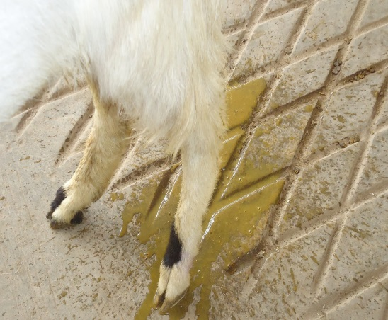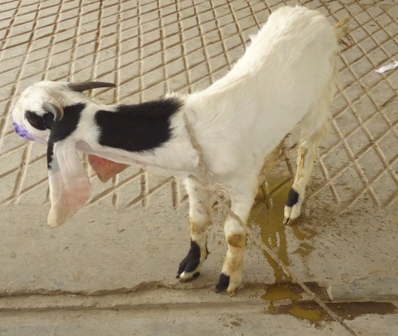
(Fig.1 and 2) Watery diarrhea
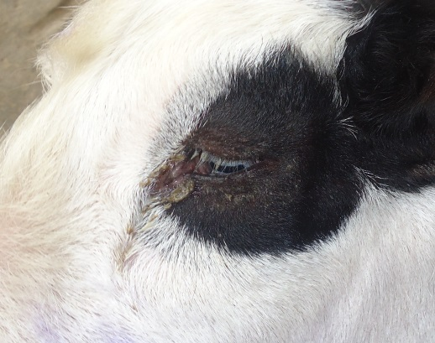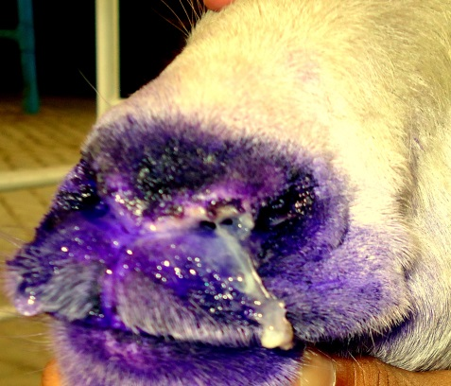
(Fig.3) Ocular discharge (Fig.4) Muco-purulent nasal discharge
`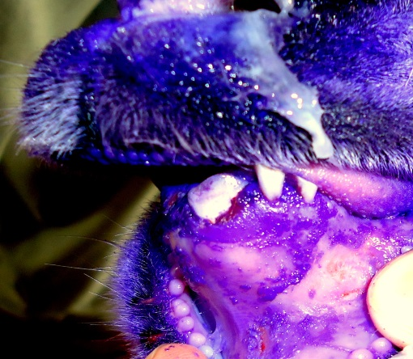
(Fig.5) Lesions on the gums from which blood is oozing out
CBC Report:
Parameters | Results | Reference values
Red blood cells count (10¹²/l) | 12.2 | 8-18
Packed cell volume % | 29 | 22-38
Hemoglobin Conc. (g/dl) | 12.5 | 8-14
Mean corpuscular volume (fl) | 21.3 | 16-25
Mean corpuscular hemoglobin (pg) | 10.9 | 5.2-8
Mean corpuscular hemoglobin concentration (g/dl) | 39 | 30-36
White blood cells (10⁹/l) | 10.5 | 4-13
Neutrophils % | 66 | 30-48
Lymphocytes % | 29 | 50-70
Monocytes % | 03 | 0-4
Eosinophilia % | 02 | 1-8
Basophils % | Nil | 0-1
(Table.1) Complete blood count (CBC) before treatment
Parameters | Results | Reference values
Red blood cells count (10¹²/l) | 14.5 | 8-18
Packed cell volume % | 31 | 22-38
Hemoglobin Conc. (g/dl) | 13.7 | 8-14
Mean corpuscular volume (fl) | 20.6 | 16-25
Mean corpuscular hemoglobin (pg) | 8.2 | 5.2-8
Mean corpuscular hemoglobin concentration (g/dl) | 37 | 30-36
White blood cells (10⁹/l) | 10.5 | 4-13
Neutrophils % | 41 | 30-48
Lymphocytes % | 57 | 50-70
Monocytes % | 01 | 0-4
Eosinophilia % | 01 | 1-8
Basophils % | Nil | 0-1
(Table.2) Complete blood count (CBC) after treatment

