Concurrent Inguinal hernia and vaginal leiomyoma in a bitch: A case report
Deepti Bodh¹, Kiranjeet Singh², A.Gopinathan³, Mohsina.A¹, and Sangeetha.P ¹
PG Scholar¹, Senior Scientist², Scientist³, Division of Surgery, IVRI, Izatnagar,Bareilly,UP
Abstract
The present report puts on record a successful surgical treatment of an 11 year old Pomerian bitch presented for concurrent unilateral inguinal hernia and vaginal leiomyoma. Clinically the inguinal growth was found hard and was irreducible. Radiography confirmed the intertinal loops in the protruded mass indicative of inguinal hernia. Soft tissue growth in vaginal cavity was also evident on the lateral radiograph of same animal. Inguinal herniorraphy and vaginal leiomyoma resection was performed under general anesthesia. No post operative complications were reported after one year of surgery.
Key words: - Inguinal hernia, leiomyoma, bitch
Introduction
An inguinal hernia is a protrusion of an organ or parts of an organ, fat or tissue through the inguinal ring, i.e. the region in the groin where the abdominal musculature meets the back legs. Factors potentially involved in the development of inguinal hernias may be anatomical, hormonal, and/or metabolic in nature; however the causes of inguinal herniation in small animals are poorly understood (Byers et al., 2007). Contents of inguinal hernia may include omentum, fat, ovary, uterus, small intestine, colon, bladder and spleen. These hernias are often chronic and do not cause clinical signs until pregnancy or pyometra develops (Fossum et al., 2002). Leiomyoma is a benign tumor of smooth muscle cells that may arise in any organ with a connective tissue or mesenchymal component (Susaneck, 1981). Leiomyomas are common in the canine female reproductive tract and account for 2.4% of all canine neoplasms (Hulland, 1978). About 85% of leiomyomas occurring in the reproductive tract of the bitch arise from the vagina, vestibule and vulva (Bojrab MJ, 1975). The incidence of leiomyomas is highest between five and 16 years of age (Susaneck, 1981). Vaginal leiomyomas may be single or multiple, intraluminal or extraluminal. Their size and consistency may vary depending upon duration of growth, becoming firmer due to an increase in connective tissue. This case report presents rare case surgical management of concurrent inguinal hernia and vaginal leiomyoma in a Pomerian bitch.
Case history and clinical observations
An 11 year old, 10 kg, intact Pomerian bitch with a unilateral swelling in the inguinal region (prominent in left side) (Fig. 1) was presented to the Referral Veterinary Clinics, IVRI. History revealed long standing duration (2 years) of swelling in the inguinal region without any pain and discomfort to the animal. According to owner the dog had 3 parturitions up to date and last parturition was two years back. He further indicated that the dog was completely normal, but after her last estrus about 5-7 months back a gradual increase in size of swelling was observed. On physical examination the hernia ring was not palpable and there was a large orange sized, non -reducible painless mass with a soft doughy consistency above the mammary gland. Lateral radiograph of abdomen revealed soft tissue opacity in cranial abdomen along with intestinal loops and gas pocket suggesting inguinal hernia of intestine (Fig.6).
In the same dog, mild perineal swelling along with a small tennis ball sized mass protruding from the vulval lips was observed (fig.1). This mass was seen since last 15-20 days but the dog had not been showing signs of discomfort. The skin and tissue overlaying the mass was intact and appeared normal. On vaginal examination, a round, smooth, firm mass arising from the region of the ventral vaginal wall and extending into the vulvar opening was observed. The extent of the attachment of the mass to the vaginal wall could not be fully evaluated during this examination due to intact vaginal mucosa overlying the mass. Lateral radiograph of caudal abdomen revealed a small tennis ball sized soft tissue opacity arising from the vagina (Fig.6). Clinical examination of dog revealed normal body temperature, heart rate and respiratory rate. Feeding, defecation, urination and hydration status was also normal. According to history, physical examination and diagnostic test results, inguinal herniation of small intestine was confirmed and vagina leiomyoma was suspected.
Treatment
The bitch was premedicated by atropine (0.04 mg/kg IV) and five min later induced by diazepam (0.5 mg/kg IV) and ketamine (5 mg/kg IV), followed by intubation. Anesthesia was maintained with diazepam-ketamine combination (1:1) administered intravenously. The dog was placed in dorsal recumbency , the ventral abdomen and perineal region was aseptically prepared in standard fashion.
Condition -1: A skin incision was made over the swelling just lateral to the groin fold. The subcutaneous tissue was undermined to expose the hernial ring and hernial sac and an incision was made over the hernia sac. The hernial contents included small intestine and part of omentum were reduced into the abdominal cavity (Fig.2). The base of the hernial sac was resected and closed with 1-0 vicryl in simple continuous pattern and the inguinal ring was sutured with 1-0 vicryl in a simple interrupted pattern (fig.3). Subcutaneous tissue was sutured in a simple continuous pattern using No. 0 Catgut to eliminate dead space. Finally, the skin incision was sutured by No. 1-0 nylon in a cross mattress pattern. The dog recovered after the operation without any problem.
Condition -2: The mass was smooth, oval, submucosal growth that measured approximately 6 cm in diameter (Figure. 4). It was firm to the touch and had a well defined stalk (3 by 1 cm base) attached to the left ventral vaginal wall. Intraluminal or extraluminal tumors tend to cause perineal swelling and may impinge upon the urethra causing the animal to show signs of of dysuria, constipation and tenesmus. As the urethral orifice was close to the pedicle of the mass, a size no.7 urinary catheter was placed in the urethra to help in defining and avoiding trauma to this structure (Bojrab, 1975). A skin incision was given directly over the mass and through blunt dissection of subcutaneous tissue the vaginal growth was removed and sent immediately for histopathology and cytology. Closure of the excision site was achieved by approximating the mucosa of the vaginal floor as well as occluding the submucosal dead space via a submucosal interrupted simple suture pattern of 1-0 chronic catgut.' No postoperative complications such as urine retention or incontinence were observed. Normal saline (500ml) was administered during the surgical procedure.
Post operative treatment included: Inj. Intacef (250 mg), IM bid for 7days; Inj.Melonex 1ml, IM, oid for 3 days, Tab Bedanzin (10mg) 1 tab PO bid for 5 days, Tab Rabex (10mg) 1 tab PO oid before meals plus soft laxative diet for a two weeks. Daily antiseptic dressing with betadine (5% povidone iodine) and pressure bandaging was advised till suture removal on 12th post operative day. The follow up study for one month revealed a sound recovery without any complications.
Discussion
Condition-1: The incidence of inguinal hernia was found higher in female dogs as compared to males (Mc Cunn, 1953). Inguinal hernia in unspayed, middle-aged bitches may be caused by stretching of the abdominal muscles during pregnancy or atrophy of the abdominal wall due to old age. In the present case the hernia was of chronic nature which became noticeable several months after last parturition and few months after the estrus indicating the close relationship between estrogen hormone and the development of inguinal hernia. As inguinal hernias typically appear during estrus or in pregnant bitches, estrogen is believed to play a major role in the development of these types of hernias in dogs (Fossum et al., 2002; Byers et al., 2007). Sex hormones may change the strength and character of the connective tissue, weakening of enlarging the inguinal rings (Smeak et al., 2003). Inguinal hernia can be confused by mammary tumor on gross examination. Thus, inguinal swelling should be differentiated from a mammary tumor or an abscess in inguinal region. Diagnosis of hernia can be made by physical examination, palpation and radiography. Radiography makes diagnosis even easier when the herniated contents comprises of intestine and fetal skeleton. In the current case report, the dog was in normal body condition and there was no history of trauma. The role of trauma in the development of inguinal hernia remains unclear. Herniorrhaphy by simple interrupted suture pattern is reported as effective. Omentum is reportedly the most common organ present in canine inguinal hernia (Bojrab et al., 1998; Fossum et al., 2002; Waters et al., 1993) the omentum and intestine were also the main content of inguinal sac in the present case too. As the dog in the current report was referred very late; it could not possible to find out the exact reason of the occurrence of inguinal hernia. Prognosis was evaluated to be good in this case due to the absence of incarceration and intestinal perforation or leakage. Complications in dogs treated surgically for inguinal hernia are incisional infection, wound dehiscence, hematoma, seroma, excessive postoperative swelling, hernia recurrence, sepsis or peritonitis and death. The reported case did not show any form of complications having been monitored for one month. Since this disorder is mostly inherited, dogs that have had hernia or a surgical repair of hernia should not be used for breeding.
Condition-2: Histopathology confirmed the mass to be a leiomyoma and the owner was recommended that the dog should be spayed to prevent regrowth of the tumor. Local treatment of vaginal leiomyomas primarily involves surgical excision of the mass as was done in this case. Because most tumors arise from the vestibule or the smooth muscle wall of the vagina, they are usually removed per vulva. During surgery there is possibility of iatrogenic damage to the urethra or accidental injury to other perineal structures. In such cases catheterization of urethra prior to resecting the mass must be done as it greatly assists in avoiding damage to this structure. Urethral obstruction can also occur as a result of contraction of scar tissue or postoperative infection.
Surgical management of inguinal hernia consists of identification of the hernia sac, assessment of the viability of the hernia contents, surgical resection of nonviable tissue, herniorrhaphy, and, in some instances, neutering. Excision of the vaginal leiomyoma is usually curative but the condition can recur due to hormonal influence. Therefore, leiomyomas can best be prevented and controlled by perfoming ovariohysterectomy in early age.

References
Bojrab MJ (1975) Current techniques in small animal surgery I. Philadelphia: Lea & Febiger,pp-248 - 254.
Bojrab MJ, Ellison GW, Slocum B (1998). Current Techniques in Small Animal Surgery. 4th ed. Williams and Wilkins,pp-. 552- 554.
Byers CG, Williams JE, Saylor DK. (2007) Pyometra with inguinal herniation of the left uterine horne and omentum in a beagle dog. Jounal of Veterinary Emergency Critical Care, 17: 86-92.
Fossum, TW, SH Choyl, AH Doland, LJ Ann, BS Howard, Michae DW.(2002) Small Animal Surgery. 2nd Ed., Mosby Inc Missouri.pp-261-267.
Hulland, TJ. (1978). Tumors of muscle, In: Moulton JE, ed. Tumors in domestic animals. 2nd ed. Berkely: University of California Press, pp-75-88.
Mc Cunn, J. (1953). Hobday’s Surgical diseases of the dog and cat. 6th Ed. Bailliers Tindall and Cox, London,pp- 265-270.
Smeak DD (2003). Abdominal Hernias. In: Slatter D, editor. Text Book of Small Animal Surgery. 3rd ed. Philadelphia, U.S.A: W B. Sunders, pp- 452-455.
Susaneck, SJ. (1981). Tumors of the female reproductive tract. In: Oncology notes. Fort Collins: Comparative Oncology Unit, Colorado State University,
Waters DJ, RG Roy, EA Stone Retrospective study of inguinal hernia in 35 dogs. Vet. Surgery 1993: 22, 44-49.
Hamali H, Ashrafihelan J (2010). Vaginal fibrosarcoma in cow (A case report). International Journal of Veterinary Research, 4(4): 225-228

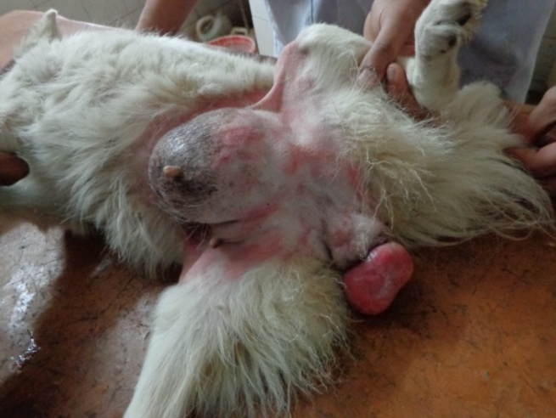
Figure. 1 .Animal with Inguinal hernia and vaginal leiomyom
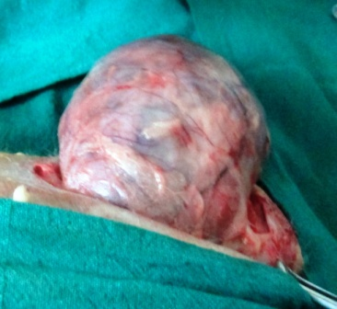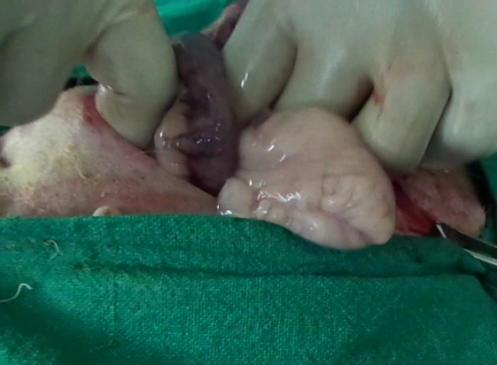
B
A

Figure.2. Visible hernia sac (A) and hernia contents (B) after skin incision

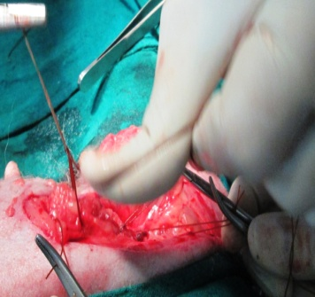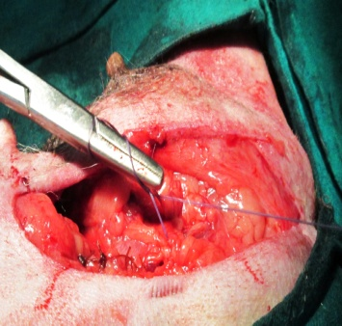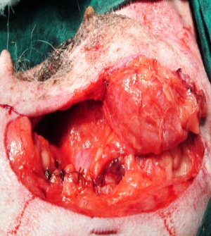
B
A
C
Figure.3.Suturing of the hernia ring (A,B,C)

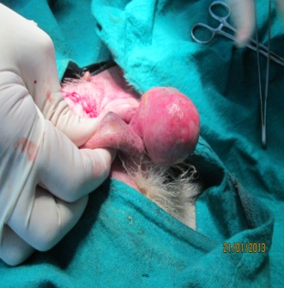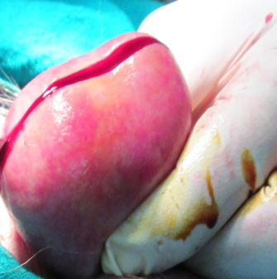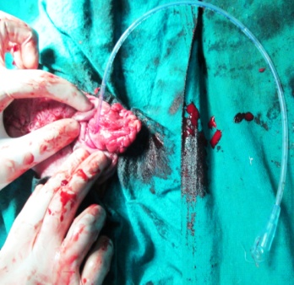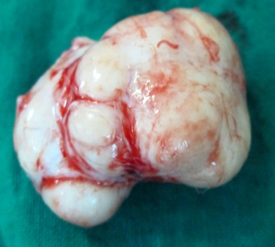
C
B

D
A
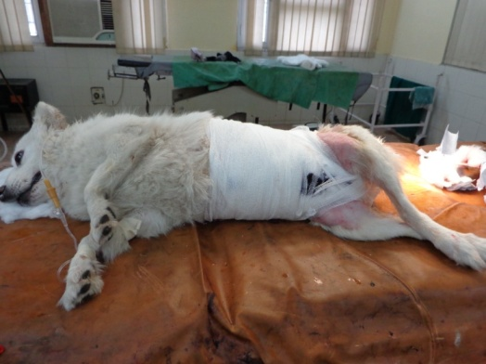
Figure.4.Surgical removal of vaginal leiomyoma (A,B,C,D)
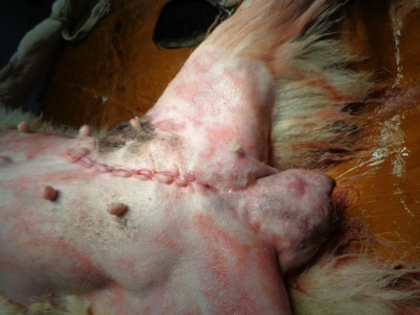
B
A

Fig.5.Photographs of the animal taken after surgery (A and B)

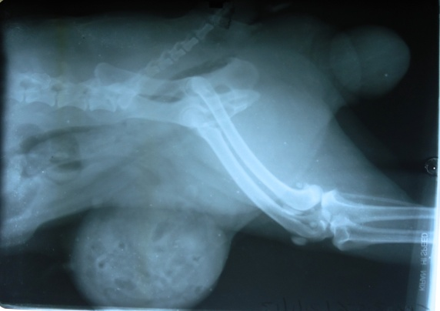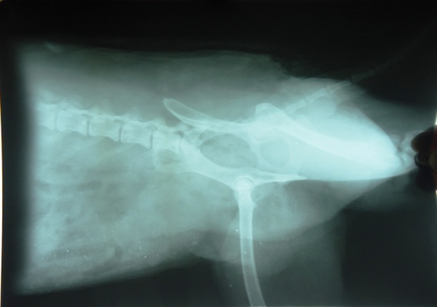
B
A
Figure6. Preoperative (A) and Post operative (B) radiographs of the same animal

