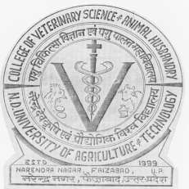 | Department of Veterinary Public Health and Epidemiology  College of Veterinary Science and Animal Husbandry  N. D. UNIVERSITY OF AGRICULTURE AND TECHNOLOGY  Kumarganj-224 229, Faizabad (U.P.), India  Phone: 05270-262847 (R)  09450763939 (M) |  | 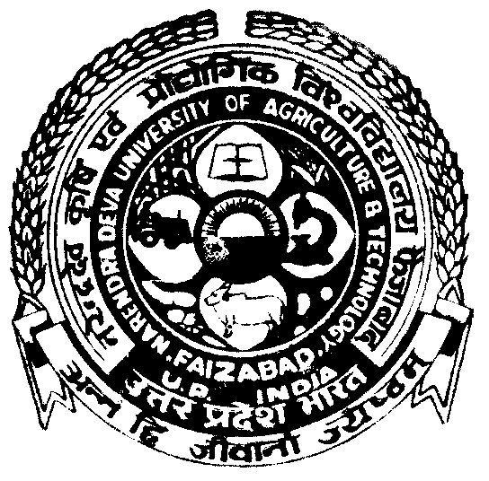
Dr. Namita Joshi  M.V.Sc., Ph. D.  Professor and Head |  | e-mail: namitajoshivet@gmail.com

To
The Chief Editor
Journal of Food Science and Technology
Sir
Please find attached herewith, our research article entitled “Molecular characterization of E. coli isolated from raw vegetable”. The statistics of the paper is as follows:

Kindly consider it for publication in your esteem publication ‘Advances in Animal and Veterinary Sciences’.

With regards
Yours Sincerely
(Namita Joshi)

