Title Page

Title: MUSK GLAND SWELLING IN AN ANEMIC BLACK BENGAL GOAT: CASE STUDY

Running Title: Musk Gland swelling

Authors and Co-authors:
Md. Ahaduzzaman, Suchandan Sikder, Morium Naznin Mukta, Md. Atikur Rahman* and Mohammed Ashif Imtiaz

No. of Tables: 3
No. of Figures: 2

Addresses:
Md. Ahaduzzaman, Masters Fellow (Medicine), Department of Medicine & Surgery, Chittagong Veterinary & Animal Sciences University (CVASU); e-mail: zaman.cvasu@yahoo.com; Mobile: +8801746077242.

Suchandan Sikder, Assistant Professor, Department of Medicine & Surgery, CVASU; e-mail: ssikder.cvasu@yahoo.com; Mobile: +8801825145300.

Morium Naznin Mukta, Masters Fellow (Medicine), Department of Medicine & Surgery, CVASU; e-mail: mukta.cvasu@gmail.com; Mobile: +8801917583597.

Md. Atikur Rahman, Masters Fellow (Medicine), Department of Medicine & Surgery, CVASU; e-mail: cvasunoman@yahoo.com; Mobile: +8801722431423.

Mohammed Ashif Imtiaz, Masters Fellow (Phamacology), Department of Physiology, Biochemistry and Phamacology, CVASU; e-mail: ashif.shawn@gmail.com; Mobile: +8801670442370.
MUSK GLAND SWELLING IN AN ANEMIC BLACK BENGAL GOAT: CASE STUDY
M Ahaduzzaman¹, S Sikder¹, MN Mukta¹, MA Rahman¹* and MA Imtiaz²
1. Department of Medicine & Surgery, Chittagong Veterinary & Animal Sciences University (CVASU), Bangladesh.
2. Department of Physiology, Biochemistry & Pharmacology, CVASU, Bangladesh.

*Corresponding author:
Md. Atikur Rahman, Masters Fellow (Medicine), Department of Medicine & Surgery, CVASU; e-mail: cvasunoman@yahoo.com; Mobile: +8801722431423.

ABSTRACT
Musk gland swelling was found in a six months old Black Bengal buck with profound musk odor at the caudal base of horn. Hematobiochemical parameters were indicated neutrophilia and lymphocytopenia together with signs of mild anaemia. Topical application of 0.05% clobetasol propionate was found effective in reduction of the swelling and odor within seven days.
Key words: Musk gland, anaemia, clobetasol propionate

Musk gland is a modified sebaceous gland located in both sexes caudal to the base of the horn. As these are activated by the presence of male hormones in the blood, this activity is seasonal in the male and unusual in the female (The Kebun, 2008). Due to its anatomical location this gland is also known as horn gland or cornual gland. Musk (sebaceous) gland adenitis is an uncommon and idiopathic skin disease (Crig, 2006) characterized by an immune response against the sebaceous glands, which can lead to the destruction of the gland. It was first described in veterinary literature in the 1980s (Spaterna et al., 2003) and there are only few pair articles are available on this regard. The normal function of these glands is to emit scent commonly known as pheromone to exhibit the reproductive behavior and primarily testosterone dependent to attract the female to make the mate. The ‘‘male effect’’ is well known in sheep and goat as a good example of pheromone induced activation of reproductive function (Iwata et al., 2000). Physiological activation of the glands is anticipated but desperate activation due to infection or idiopathic causes are despiseful to the animals. Therefore, the current therapy was taken to find out the therapeutic outcome of musk gland swelling.

A six months old Black Bengal buck was admitted to the SA Quadery Teaching Veterinary Hospital, Chittagong Veterinary and Animal Sciences University, Bangladesh, with a history of anorexia and musk odor. Clinical examination revealed that the buck posses heart rate 85/minute and 103.5⁰F rectal temperature. Examination found prominent swelling of musk gland at the base of the horn having the following measurement taken by slide calipers (Table 1).
Topical application of Clobetasol propionate 0.05% w/w (Clobesol^{R}) Aristopharma Ltd. once in a day for a week medication found improvement.
The total erythrocyte count (TEC) and hemoglobin (Hb) were 6.7 million per cubic millimeter and 6 gram% respectively, that were below the physiological range that was an indication of anemia may be due to malnutrition. Erythrocyte sedimentation rate (ESR) and packed cell volume (PCV) were shown 0 and 30% respectively. Total leukocytes count (TLC) was 13.17% close to the value of normal range and the hierarchy may be due to neutrophilia. The neutrophil count was 55% that is higher than the physiological parameter as an indication of infection. Lymphocyte count was 35% indicating lymphopenia which may be due to recent infection. Eosinophil, basophil and monocyte count were 5%, 1% and 4% respectively (Table 2).

The hematology of mineral constituents such as calcium, magnesium, phosphorus was 10, 3.5 and 7.5 milligram per deciliter respectively. Total protein, albumin and glucose found 58 g/l, 15.1 g/l and 45 mg/dl respectively. ALT and AST value found 22.4 (U/L) and 67.7 (U/L) respectively. Triglyceride value found 94.1 mg/dl that was higher than the normal physiological range (Table 3).
Topical steroids are widely used for various skin conditions. Clobetasol propionate has potency in yielding good results with minimal adverse effects when properly used topically (Guiglia et al., 2007). Antiproliferative effects of topical application of glucocorticoids mediated by inhibition of DNA synthesis and mitosis acts on several cell types (Abidi et al., 2010). Therefore, clobesol can be used at low dose without systemic adverse effect.
Anemia is a condition caused by a depletion of hemoglobin or total red blood cells. There are multiple causes of anemia in a goat that may be intermingled or unique based on circumstances, ranging from improper nutritional level such as a deficiency of copper or iron, may be due to parasitism (Pfalzbot, 2013). The goat coproscopy did not reveal parasitic ova there for it was assumed due to shortage of nutrients as describe by Smith and Sherman (2009). Total leukocyte count was slight uprising. The absolute lymphocyte counts increased with relation to age of the males. Similarly, absolute neutrophil counts followed the same trend and reached the peak at 1 to 2 years of age. Absolute count of eosinophil and monocyte gradually decrease with age to some extent and later fluctuated. The eosinophil, basophil and monocyte value was found lower than the value of Egbe-Nwiyi (2000) but close to the value found by Shaikat et al. (2013).
Neutrophils conduct a potential role in the exemption of body to free pathogens so called phagocytosis by release of preformed granular enzymes and proteins as a component of innate immune response. Neutrophilia was marked in our study which was suspected to inflammation or infectious condition as supported by Summers et al. (2010). And Mackowiak (2012) he had shown elevated blood neutrophil counts during adenitis.
Hundred of proteins are dissolved in the plasma. By measuring the total concentration of serum protein and albumin level was found lower which may be due to anaemic condition of the goat. Shaikat et al. (2013) found normal protein range was higher than our findings. Serum albumin level was also found below the normal range. The serum protein and albumin level were closed to the value found by Goklaney et al. (2012) in anaemic goat, in addition serum glucose level was also found lower as our finding.
Serum triglyceride level exceeds the normal range which may be correlated with ketosis as the animal was inappetance during hospitalization and serum glucose level was also depleted. This finding agreed with the findings of Sotillo et al. (1994). No abnormalities were found in Serum ALT, AST and uric acid concentration.
Musk gland is so called pheromone producing gland that tends to activate following puberty and in breeding seasons and unusual in young. Due to absence of available data the disease mechanism is still obscure. Therefore, it is suggest that there is a need of extended study about the case.

ACKNOWLEDGEMENTS
We would like to acknowledge the animal owner and the stuffs of Department of Physiology, Biochemistry & Pharmacology, CVASU, Bangladesh.

REFERENCES
Abidi A, Ahmad F, Singh SK and Kumar A (2010). Study of reservoir effect of clobetasol propionate cream in an experimental animal model using histamine-induced wheal suppression test. Indian J Dermatol. 55(4): 329–333.
Craig M (2006). Clinical refresher: Canine sebaceous adenitis. Compan. Anim. 11 (5): 62–8.
Egbe-Nwiyi TN, Nwaosu SC and Salami HA (2000). Hematological values of apparently healthy sheep and goat as influenced by age and in arid zone of nigeria. Afr. J. Biomed. 3(2): 109-115.
Goatlink.com. (2009). http://goat-link.com/content/view/204/194/#.UrJ_-eKFe8w. Retrive: 11.08.2013. Accessible date: 19.12.2013.
Goklaney D, Singh AP, Dhuria RK and Ahuja A (2012). Therapeutic evaluation of mineral preparation for tamelioration of anaemia in goats of arid zone of rajasthan. Iran J Appl Anim Sci. 2(2): 137-141.
Guiglia R, Di-Liberto C, Pizzo G, Picone L, Lo-Muzio L and Gallo PD (2007). A combined treatment regimen for desquamative gingivitis in patients with oral lichen planus. J Oral Pathol Med. 36: 110-116.
Iwata E, Wakabayashi Y, Kakuma Y, Kikusui T, Takeuchi Y and Mori Y (2000). Testosterone dependent primer pheromone production in the sebaceous gland of male goat. Biol. Reprod. 62: 806–810.
Mackowiak PA (2012). Chronic cervical adenitis in an infant born to a woman with discoid lupus. Clin Infect Dis. 54 (8): 1166.
Pfalzbot G (2013). Anaemia. Goatworld.com. http://www.goatworld.com/articles/anemia/. Last update: 16.11.13. Accessible date: 19.12.2013.
Shaikat AH, Hassan MM, Khan SA, Islam MN, Hoque MA, Bari MS, Hossain ME (2013). Haematobiochemical profiles of indigenous goats (Capra hircus) at Chittagong, Bangladesh, Vet. World. 6(10): 789-793.
Smith and Sherman (2009). Goat medicine. 2nd ed. Wiley-Blackwell publication, London, U.K. ISBN: 978-0-781-79643-9; pp: 276.
Sotillo J, Montes A, Ceron JJ, Benedito JL and Bruss M (1994). Variation in serum lipids and minerals determined during different productive periods in fasted goats. An. Vet. (Murcia), 9-10: 69-74.
Spaterna A, Antognoni MT, Cappuccini S and Tesei B (2003). Sebaceous Adenitis in the Dog: Three Cases. Vet. Res. Commun. 27: 441–443.
Summers C, Rankin SM, Condliffe AM, Singh N, Peters AM and Chilvers ER (2010). Neutrophil kinetics in health and disease. Trends Immunol. 31(8): 318-324.
The Kebun (2008). Deodorizing your goat. http://thekebun.wordpress.com/2008/12/14/de-odourizing-your-goat/. Retrive: 15.12.2013. Accessible date: 19.12.2013.

Table 1: Measurement of musk gland

Parameters | Left (cm) | Right (cm)
Length | 3 | 3
Cranial portion | 0.5 | 0.5
Mid portion | 0.8 | 0.8
Caudal portion | 1.0 | 1.0

Table 2: Hematological status

Parameter | Tested Value | Reference value*
TEC (million/cumm) | 6.7 | 8.0-18.0
TLC (thousands/cumm) | 13.7 | 4.0-13.0
Hb (gm %) | 6 | 8.0-12.0
PCV (%) | 30 | 22-38.
ESR | 0 | 0
Neutrophil (%) | 55 | 30-48
Eosinophil (%) | 5 | 1-8
Basophil (%) | 1 | 0-1
Lymphocyte (%) | 35 | 50-70
Monocyte (%) | 4 | 0-4
*(Goatlink.com, 2009)

Table 3: Hemato-biochemical status

Parameter | Tested Value | Reference value*
Calcium (mg/dl) | 10 | 8.9-10.6
Magnesium (mg/dl) | 3.5 | 2.1-2.9
Phosphorus (mg/dl) | 7.9 | 3.2-9.8
Total protein (g/l) | 58 | 64-78
Glucose (mg/dl) | 45 | 60-100
Albumin (g/l) | 15.1 | 24-44
ALT (U/L) | 22.4 | 15.3-52.3
AST (U/L) | 67.7 | 66.0-230.0
Uric acid (mg/dl) | 6.7 | 6.16-7.69
Triglyceride (mg/dl) | 94.1 | 32.18-58.11
*(Goatlink.com, 2009)

FIGURES

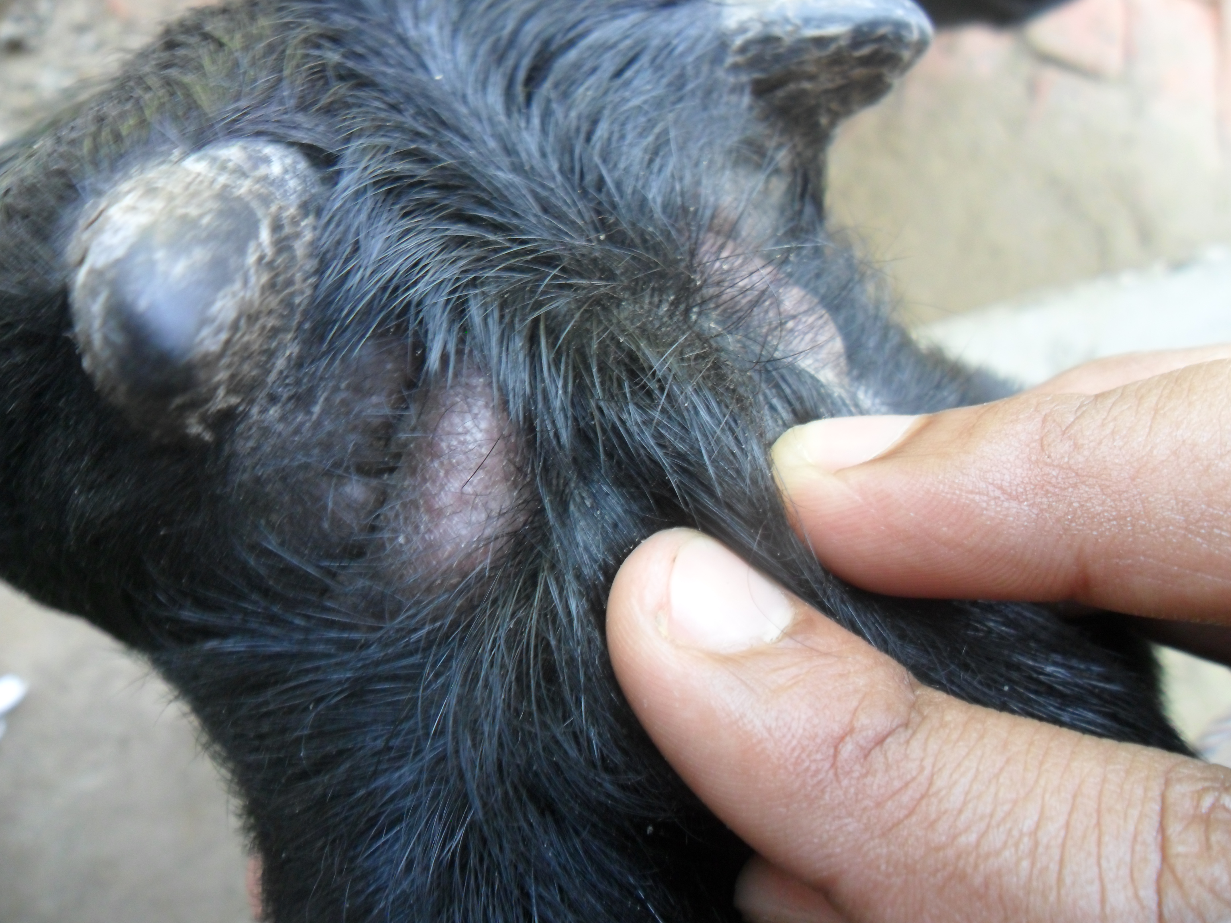
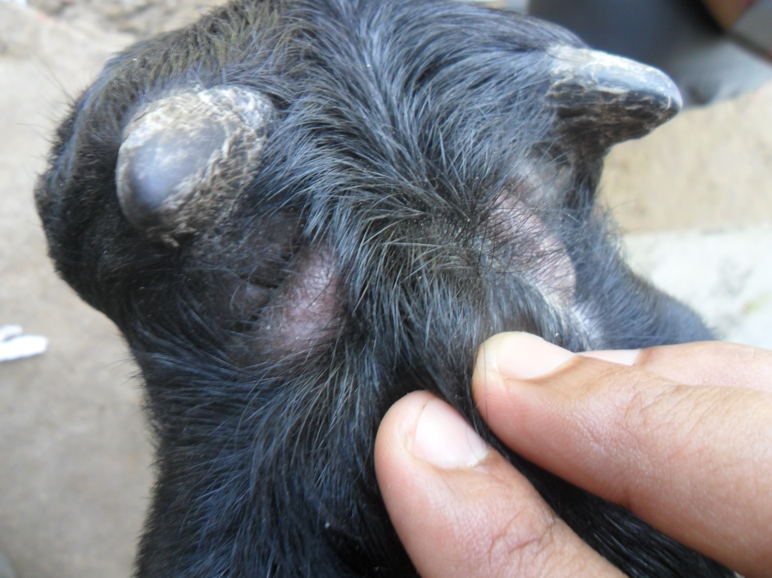

Figure: Arrow marks are indicating the swollen musk glands at the caudal base of horn.

