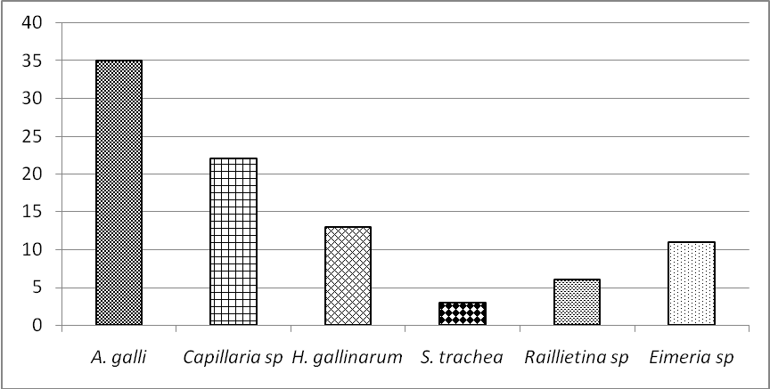

Fig. 1: Prevalence of GI parasitic infections in pigeon

