Title page

Title: SEROPREVALENCE OF ANTIBODIES AGAINST NEWCASTLE DISEASE IN LAYER CHICKEN AT COX’S BAZAR, BANGLADESH.

Running Title: Seroprevalence of antibodies against ND in layer

Authors and Co-authors:
Mohammed Arif Uddin, Kamrul Islam, Shaharin Sultana, A.K.M. Saifuddin, Mohammed Ashif Imtiaz* and Mukti Barua

No. of tables: 2
No. of figures: 4

Addresses:
Mohammed Arif Uddin, Masters Fellow (Microbiology), Department of Microbiology, Faculty of Veterinary Medicine (FVM), Chittagong Veterinary and Animal Sciences University (CVASU), Chittagong. e-mail: arifvet@yahoo.com, Mobile: +8801557482804.

Kamrul Islam, Masters Fellow (Microbiology), Department of Microbiology, FVM, CVASU. e-mail: kamruldvm13@gmail.com, Mobile: +8801813142500.

Shaharin Sultana, Masters Fellow (Microbiology), Department of Microbiology, Bangladesh Agricultural University (BAU), Mymensingh, Dhaka. e-mail: shaharin_sultana@yahoo.com, Mobile: +8801724598274.

A.K.M. Saifuddin, Professor and Head, Department of Physiology, Biochemistry and Pharmacology, FVM, CVASU. e-mail: saifuddincvu@yahoo.com, Mobile: +8801813309788.

Mohammed Ashif Imtiaz, Masters Fellow (Pharmacology), Department of Physiology, Biochemistry and Pharmacology, FVM, CVASU. e-mail: ashif.shawn@gmail.com, Mobile: +8801670442370.

Mukti Barua, Masters Fellow (Animal Science), Department of Animal Science and Animal Nutrition, CVASU. e-mail: mukti.barua@yahoo.com, Mobile: +8801846335679.

Title: SEROPREVALENCE OF ANTIBODIES AGAINST NEWCASTLE DISEASE IN LAYER CHICKEN AT COX’S BAZAR, BANGLADESH.
Mohammed Arif Uddin¹, Kamrul Islam¹, Shaharin Sultana⁴, A.K.M. Saifuddin², Mohammed Ashif Imtiaz²* and Mukti Barua³

¹Department of Microbiology, ²Department of Physiology, Biochemistry and Pharmacology, ³Department of Animal Science and Animal Nutrition, Faculty of Veterinary Medicine, Chittagong Veterinary and Animal Sciences University (CVASU), Chittagong, Bangladesh and ⁴Department of Microbiology, Bangladesh Agricultural University (BAU), Mymensingh, Dhaka, Bangladesh.

*Corresponding Author:
Mohammed Ashif Imtiaz, Masters Fellow (Pharmacology), Department of Physiology, Biochemistry and Pharmacology, FVM, CVASU. e-mail: ashif.shawn@gmail.com, Mobile: +8801670442370.

ABSTRACT
The present research work was conducted to determine the seroprevalence and immune status of the birds to Newcastle Disease Virus (NDV) among layer chickens in Cox’s Bazar district, Bangladesh. A total of 179 serum samples were collected from different layer farms. Samples were divided into 3 age groups likely as; 20-27 weeks, 36-42 weeks and 48-50 weeks. Haemagglutination Inhibition (HI) test was performed to determine the serum antibodies against NDV. Calculated geometric mean titers for layer groups of 20-27 weeks, 36-42 weeks and 48 to above weeks of age were found to be log₂8.39, log₂7.67 and log₂10.66 respectively and all birds show positive specific immunity of 100%. Newcastle Disease (ND) in poultry is a focus for concern throughout much of the world’s agricultural community due to severe economic losses that have occurred from illness, death, and reduced egg production following infection with pathogenic or disease causing strains.
Key words: Newcastle Disease Virus, serum antibodies, Haemagglutination, Haemagglutination Inhibition.

INTRODUCTION
Newcastle disease (ND) is a highly contagious viral disease that attacks many species of domestic and wild birds which also known as Ranikhet disease (RD). The causal agent is the Newcastle disease virus (NDV) which is a negative-sense single-stranded RNA virus belonging to the family Paramyxoviridae (Hossain et al., 2010). Based on the pathogenicity, Newcastle disease virus (NDV) is classified into highly virulent (velogenic), intermediate (mesogenic) or avirulent (lentogenic) (Beard and Hanson, 1984). ND is noticed as the most important viral disease of poultry in the world including developing countries. In Africa and Asia ND is a major constraint against the development of both industrial and village poultry production (Alders et al., 2001). NDV infections of poultry range from latent to rapidly fatal depending upon the pathotype of virus involved (Alexander, 2003). The transmission of NDV occurs through newly introduced birds, selling or giving away sick birds, exposure to fecal and other excretions from infected birds and contact with contaminated feed, water, equipment and clothing. The disease causes high economic losses due to high mortality, morbidity, stress, decreased egg production and hatchability (Hossain et al., 2010). Vaccination has been reported as the only safeguard against endemic ND (Orajaka et al., 1999). The current vaccination schedule in Bangladesh directed by the Directorate of Livestock Services (DLS) includes administration of a live lentogenic vaccine (BCRDV) of F-strain by intra-ocular instillation to chicks followed by a live mesogenic vaccine (RDV) of M-strain by intramuscular injection at 21 days old chicks which is repeated at every six months interval. The infection still occurs in Bangladesh every year in the form of epidemic and appears to cause up to 40-60% of the total mortality in poultry population creating one of the major problems in the development of poultry industry in Bangladesh (Chowdhury et al., 1982). It is significant to elucidate the immune status of NDV among chickens in order to formulate appropriate vaccination schedule and control measures. So, the study was conducted to determine the seroprevalence and immune status of the birds to Newcastle Disease Virus (NDV) among layer chickens in Cox’s Bazar district, Bangladesh.

MATERIALS AND METHODS
The study was carried out at different upazilla of Cox’s Bazar from June to August, 2012. A total of 17 farms were randomly selected which comprised at least thousand birds from 3 surrounding upazilla at Cox’s Bazar district. 179 birds of 17 commercial layer farms; 8 samples per one thousand of birds were randomly selected for Blood collection.

Collection of Blood samples
1ml of blood was collected from each bird through wing vein puncture in a sterile syringe. All samples were maintained in the refrigerator and after clotting blood serum were separated from blood samples. Then sera were separated and stored at -20°C until the haemagglutination inhibition test was carried out. The antigen (Avinew® ND, VG/GA strain) used in this study was purchased from the Advance Animal Science Co. Ltd. Dhaka, Bangladesh. HI test was conducted to detect the antibodies against NDV.

Preparation of chicken red blood cell (RBC) suspension
A total of 5ml of chicken blood was collected aseptically in a disposable syringe containing 1ml of sodium citrate (4% solution) as anticoagulant. The blood was centrifuged at 1500 rpm for 15 minutes and the plasma, buffy coat were discarded with a pipette. After washing three times with phosphate buffered saline (PBS), 1% suspension in PBS was prepared for HI test.

Haemagglutination inhibition (HI) test
HI test was done according to the procedure of OIE (2002). Briefly, two fold serial dilution of 25µl serum was made with PBS in V-bottomed microtiter plates (Nunc) up to 10th well. 25µl of 4 haemagglutinating (HA) units of Newcastle disease virus or antigen was added up to 11th well. The plates were kept at room temperature for more than 30 minutes to facilitate antigen antibody reaction. Then 50µl of 1% (v/v) chicken RBC suspension was added to each well. The 11th well contains antigen and RBCs as the positive control and the 12th well contains only RBCs as the negative control. After gentle mixing, the RBCs were allowed to settle at room temperature for 40 minutes and agglutination was assessed by tilting the plates. The samples showing peculiar central button shaped settling of RBCs were recorded as positive and maximum dilution of each sample causing haemagglutination inhibition was considered as the end point, which was used to estimate the HI titer (Figure 4). The HI titer of each serum sample was expressed as reciprocal of the serum dilution.

Post mortem diagnosis of poultry diseases
In Upazilla Veterinary hospital poultry diseases were diagnosed on the basis of post mortem examination findings. Post mortem examination of dead and clinically ill birds supplied to the veterinary hospital was done and diseases were recorded (Figure 1).

Data Analysis
Data that were collected and observed been entered which was primarily stored into MS excel (Microsoft office excel-2007, USA). Descriptive analysis was through by STATA version-11 (STATA Corporation, Texus, USA). Results were expressed as proportion ± SEM, 95% Confidence interval (CI) and also followed as logarithm table.

RESULT
The study was undertaken to evaluate the level of antibody in layers against Newcastle disease reared in seventeen commercial layer farms in Cox’s Bazar. A total of 179 serum samples were collected from different commercial layer farms and were subjected to HI test. Out of 99 serum samples of layers ranging from 20-27 weeks of age, all were found positive for specific immunity with positive percentage of 100 (Table 1). The HI antibody titer varied from log₂4 to log₂12 with a GMT of log₂8.49 (Table 2).

On 53 serum samples in the layers ranging from 36-42 weeks of age, all were presented positive for specific immunity and showed 100% (Table 1). The HI antibody titer varied from log₂3 to log₂12 with a GMT of log₂7.67 (Table 2). And finally out of 27 serum samples in the layers ranging from 48 to above weeks of age were found positive for specific immunity as 100% (Table 1) and the HI antibody titer varied from log₂9 to log₂12 with a GMT of log₂10.66 (Table 2).

Postmortem examination of the dead birds show the following lesions, hyperemia and congestion in respiratory tract, serous or catarrhal exudates in larynx and trachea, thickened air sacs, may contain yellow exudates, typical Petechiae in the tip of proventriculus and on the sub-mucosae of the gizzard. Hemorrhagic lesions in digestive tract, hemorrhages in the intestinal lymphoid nodules and caecal tonsils, spleenomegali were found (Figure 2 and 3).

DISCUSSION
In the present study, all samples irrespective of age, represents positive for specific immunity with a positive percentage of 100 where Tariq et al., 2010 found 26%, 54% and 75% positive for specific immunity at 24-36, 36-48 and more than 48 weeks in chicken, which is very lower than the present study. ND-HI titer of log₂3 and above is generally accepted as positive for specific immunity (Allan and Gough, 1974). According to Numan et al., 2005, log₂7 to log₂8 in layer of 17-47 weeks of age, this is close to the present study. This shows that the serum antibody titers were low in some cases and was enough to protect the birds from the Newcastle disease infection. There are several possible reasons for this low level of protection in birds, such as poor vaccine quality, unsuitable vaccination schedule or vaccination techniques, impaired immune-competence due to immunosuppressive substances in the feed or to immunosuppressive diseases, and therefore, unable to protect the chicks from NDV infection.

According to Hossain, 2010, 98.35%, 92.86%, 97.46% and 97.98% layer chickens had protective HI titers in the summer, rainy, autumn and winter, respectively. Sa’idu et al., 2006 found log₂7.6 ± 1.62 in parent stock of layer; this result is similar to the present findings at the age of 36-42 weeks. Birds of this group showed lower antibody levels than the previous group and showed relatively decreased susceptibility to clinical infection. One of the causes for outbreaks in vaccinated chickens might be the introduction of new ND virus strains against which the local birds have no or very low immunity, leading to vaccine failure.

Group of birds age 48 to above showed higher antibody level than the previous groups (age less than 48 weeks). Similar reports have been described by Numan et al., 2005 who reported 100% of layer chickens were positive for specific immunity against NDV in Pakistan. In the present study, the birds in 48 to more weeks of age showed the highest level of antibody titers (GMT 10.66) and showed relatively low susceptibility to clinical infection. The HI titers obtained in the present study were higher than those reported by (Biswas et al., 2006) who recorded that 64.0%, 47.4%, 62.6% and 56.3% of sonali chickens in southern part of Bangladesh had protective HI titers against NDV in the autumn, winter, summer and rainy seasons respectively.

According to Pazhanivel et al., 2002, post-mortem lesions includes petechial hemorrhages and ulcers with raised borders on the mucosa of proventriculus, pneumonic lungs, and hemorrhages in trachea, air sacs, brain and spleen.
Other factors like poor vaccine quality is a common problem in developing countries and results poor manufacturing standards, lack of adequate storage facilities, application of expired vaccine batches, faulty application and vaccine handling during transportation (Vui et al., 2002). Heat stress and water deprivation also lead to production of steroids and thus result an immune-suppression. Quality of water which is offered to the birds was also found questionable which might hinder the development of specific immunity possibly due to acid base imbalance. Unsuitable vaccination schedule also leads to the neutralization of maternally derived antibodies and resultantly making the birds more susceptible to the infection. Since low ND-HI antibody prevalence is suggestive for an intermediate epidemic phase or early phase of infection (Awan et al., 1994), problems with ND outbreaks in the near future may have to be expected unless the vaccination practice is improved.

CONCLUSION
To maintain good farm practices it is very important to vaccinate the birds of the flock at proper time with proper dose and schedule. Regular vaccination should be held on. Before vaccination HI titers should be monitored in the serum of birds against Newcastle disease. The prevalence of Newcastle disease is higher level than the other viral diseases. In postmortem diagnosis about 45.6% Newcastle disease cases were recorded. Although birds of commercial layer farms had mean titers, that was protective to ND, still then there were some birds remain susceptible to ND and these sections of birds may become affected when bio-security program is not ensured and the virus enter the farms from deshi and wild birds. So vaccination should be intensified by monitoring immune status of the flock against ND through analyzing the HI titers to NDV.

ACKNOWLEDGEMENT
The author is highly grateful to the farmers and Veterinary Clinicians, Veterinary Surgeon and all the staff of Upazilla Veterinary Hospital, Cox’s Bazar for their cordial co-operation participated in this study.

REFERENCES
Alders RG, Costa R, Dias P, Fringe R, Fumo A, Lobo Q, Mata BV, Silva A and Young MP (2001). Investigations into the Control of Newcastle Disease in Village Chickens in Mozambique: Review of work done in Mozambique. Report on the ACIAR/INIVE Newcastle Disease Control Project Coordination Meeting, Tofo, Inhambane Province, Appendix 3.
Alexander DJ (2000). Newcastle disease and other avian Paramyxoviruses. In: Revue Scientifique et Technique de l’OIE, pp. 443–462.
Allan WH and Gough RE (1974). A standard haemagglutination-inhibition test for Newcastle disease: A comparison of macro-and micromethods. Vet. Rec. 95:120-123.
Awan M, Otte J and James AD (1994). The epidemiology of Newcastle disease in rural poultry: a review. Avian Path. 23:405-423.
Beard CW and Hanson RP (1984). Newcastle Disease. In: Hofstad MS, Barnes HJ, Calnek BW, Reid WM and Yoder HW (Eds), Diseases of Poultry (8th edn). pp. 452-470.
Biswas PK, Uddin GMN, Barua H, Roy K, Biswas D, Ahad A and Debnath NC (2006). Immune status of semi-scavenging Sonali chickens in Bangladesh against Newcastle disease. Livestock Rural Development. 18 (6). (http://www.lrrd.org/lrrd18/6/bisw18074.htm)
Chowdhury SI, Chowdhury T, Sarker AJ, Amin MM and Hossain W (1982). The role of residual maternal antibody on immune response and selection of an optimum age for primary vaccination of chicks. Studies on Newcastle disease in Bangladesh. A research report. pp. 12-22.
Hossain MMK, Ali YM and Yamato I (2010). Antibody Levels against Newcastle Disease Virus in Chickens in Rajshahi and Surrounding Districts of Bangladesh. Int. J. of Biol., 2 (2): 102-103.
Numan M, Zahoor MA, Khan HA and Siddique M (2005). Serologic status of Newcastle diseae in broilers and layers in Faisalabad and surrounding districts. Pakistan Vet. J. 25(2):55-58.
Orajaka LJE, Adene DF, Anene BM and Onuoha EA (1999). Seroprevalence of Newcastle disease in local chickens from Southeast derived savannah zone of Nigeria. Revue Elevage Mẻdecine Vẻtẻrinaire Pays Tropicaux, 52 (3-4):185-188.
Pazhanivel N, Balsubramaniam GA, George VT and Mohan B (2002). Study on natural outbreak of Newcastle disease in and around Namakkal. Indian Vet. J. 79(3):293-294.
Sa’idu L, Abdu PA and Tekdek LB (2006). Newcastle disease antibodies in parent stock, yolk and chicks. J. of Ani. and Vet. Adv. 5(6):503-506.
Tariq AGA and Taib AA (2010). Serological Survey of Newcastle Disease in Domestic Chickens in Sulaimani Province. Journal of Zankoy Sulaimani. 13(1) Part A: 31-38.
Vui TQ, Lohr JE, Kyule MN, Zessin KH and Baumann MPO (2002). Antibody level against Newcastle disease virus, Infectious Bursal Disease virus and Influenza virus in rural chicks in Vietnam. Int. J. Poult. Sci. 1:127-132.

Tables

Table 1: Serum samples of layer chicks showing immune response to NDV using Haemagglutination Inhibition (HI) test

Age of Birds(wks) | No. of Sample(s) | Specific immunity | Non-specific immunity | Specific immunity percentage (%)
20-27 | 99 | 99 | - | 100.00
36-42 | 53 | 53 | - | 100.00
48-50 | 27 | 27 | - | 100.00

Table 2: Distribution of layer birds on the basis of Haemagglutination Inhibition (HI) titers obtained against NDV

Age  (wks) | No. of Sample(s) | Antibody titers using HI test
Age  (wks) | No. of Sample(s) | Log₂1 | Log₂2 | Log₂3 | Log₂4 | Log₂5 | Log₂6 | Log₂7 | Log₂8 | Log₂9 | Log₂10 | Log₂11 | Log₂12 | GMT
20-27 | 99 | 0 | 0 | 0 | 7 | 11 | 12 | 6 | 7 | 11 | 22 | 17 | 6 | 8.39
36-42 | 53 | 0 | 0 | 5 | 7 | 6 | 2 | 3 | 0 | 9 | 16 | 0 | 5 | 7.67
48-50 | 27 | 0 | 0 | 0 | 0 | 0 | 0 | 0 | 3 | 6 | 3 | 0 | 15 | 10.66

Figures:
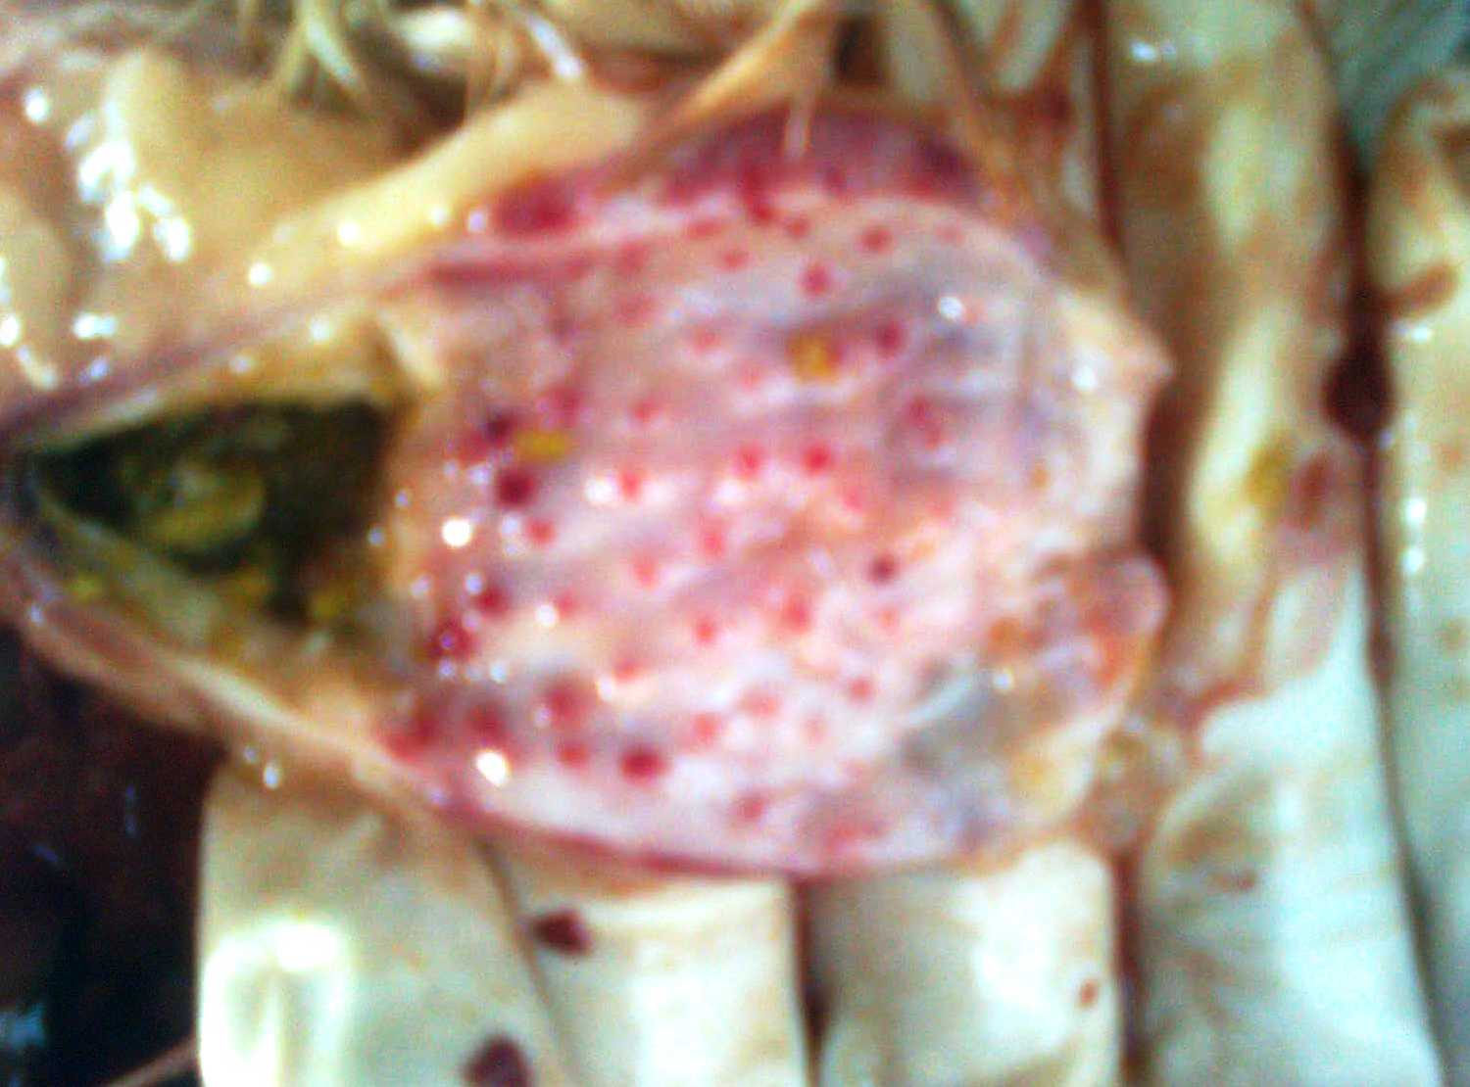
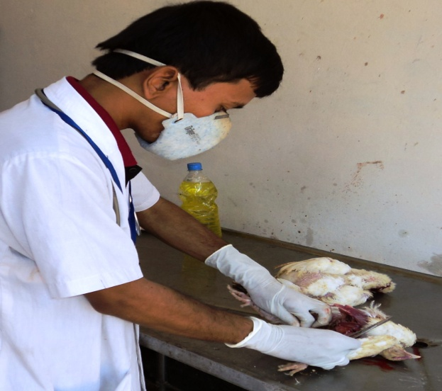

Figure 1: Post-mortem examination of Poultry
Figure 2: Petechae at the tip of proventriculus

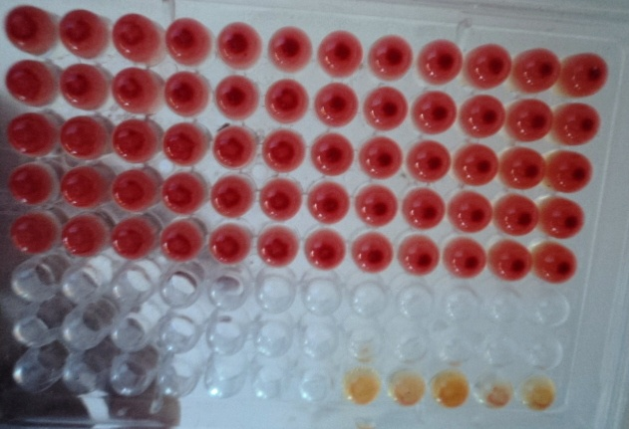
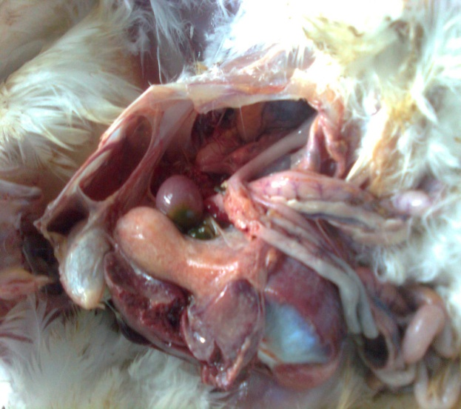
Figure 4: Haemagglutination Inhibition (HI) test

Figure 3: Spleenomegali

