To
The Editor
Research Journal for Veterinary Practitioner
Nexus Academic Publishers

Subject: About publication of manuscript entitled “Seroprevalence of Antibodies against Newcastle Diseases in layer chicken at Cox’s Bazar, Bangladesh.”

Dear Sir,
It’s our pleasure to submit the original research entitled “Seroprevalence of Antibodies against Newcastle Diseases in layer chicken at Cox’s Bazar, Bangladesh.” for your kind acceptance. The work was Cox’s Bazar based which is known as the Commercial Poultry zone of Bangladesh. The major innovations of the research were: determination of the seroprevalence and immune status of the birds to Newcastle Disease Virus among layer chickens in Cox’s Bazar district, Bangladesh.
In addition we assure that all the authors have significant contribution in this manuscript, the manuscript has not been submitted to any local or international journals to date and any portion of the submitted materials have not been published previously or are under consideration for publication elsewhere.

Thanks for your time.

Sincerely yours
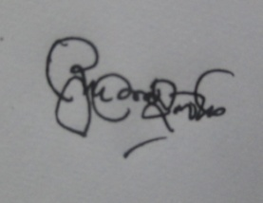
Mohammed Ashif Imtiaz
Corresponding author

