Title page
Title: Schistosomus reflexus syndrome: A congenital defect in ruminants and it’s management through caesarean section in dairy cow
Running Title: Schistosomus reflexus syndrome: A congenital defect in ruminants and it’s management through caesarean section
Authors and Co-authors:
Mukti Barua, Farhad Hossain, Md. Zohorul Islam and Kamrul Islam.
No. of figures: 6

Addresses:
Mukti Barua, Masters Fellow (Animal Science), Department of Animal Science and Animal Nutrition, CVASU. e-mail: mukti.barua@yahoo.com, Mobile: +8801846335679.

Farhad Hossain, Assistant Director, District Artificial Insemination (AI) centre, Chittagong. E-mail: kresearch13@gmail.com

Md. Zohorul Islam, Lecturer, Department of Microbiology, FVM, CVASU, e-mail: zahir_vet@yahoo.com

Kamrul Islam, Masters Fellow (Microbiology), Department of Microbiology, FVM, CVASU. e-mail: kamruldvm13@gmail.com, Mobile: +8801813142500.

Title: Schistosomus reflexus syndrome: A congenital defect in ruminants and it’s management through caesarean section in dairy cow
Mukti Barua³, Farhad Hossain², Md. Zohorul Islam¹ and Kamrul Islam¹.

¹Department of Microbiology, ³Department of Animal Science and Animal Nutrition, Faculty of Veterinary Medicine, Chittagong Veterinary and Animal Sciences University (CVASU), District Artificial Insemination (AI) centre², Chittagong, Bangladesh

*Corresponding Author:
Kamrul Islam, Masters Fellow (Microbiology), Department of Microbiology, FVM, CVASU. e-mail: kamruldvm13@gmail.com, Mobile: +8801813142500.
Abstract :
A crossbred dairy fetus exhibiting congenital anomalies and meeting the criteria for being considered as a case of atypical schistosomus reflexus (SR) is described. Schistosomus reflexus (SR) is a rare and fatal congenital disorder. Primarily observed in ruminants, its defining features include spinal inversion, exposure of the abdominal viscera because of a fissure of the ventral abdominal wall, limb ankylosis, positioning of the limbs adjacent to the skull. Delivery of SR was achieved by caesarean section through an expert team and finally the cow was recovered after a continuous treatment regimen. This is probably the first case of atypical SR reported in dairy cow at Chittagong city of Bangladesh.

Key words: Schistosomus reflexus, caesarean section, crossbred dairy cow, dystocia, spinal inversion, limb ankylosis.
Schistosomus reflexus (SR) is a major congenital fatal anomalies primarily observed in ruminants. However, dystocia due to this monster is comparatively ordinary in Large ruminants like cattle and buffalo than small ruminants (Suthar et al., 2011). This congenital anomalies are reported to be encountered during embryonic developmental stage in domestic animals (Özsoy et al., 2009). Typical SR depicts acute angulations of spinal column as a consequence the head, limbs and tail are in close proximity resembling a distinctive ventral convex curvature, limb ankylosis and failure of the closure of all or part of the ventral wall of the faetal body resulting viscera out (Prasad et al., 2012). A three years old crossbred dairy cow carrying full term was examined. Animal had history of artificial insemination and for the past 15h was evincing unsuccessful labour pain. Anamnesis revealed normal rectal temperature (102.5̊ F) and respiratory rate of about 35/min. Animal was slightly dehydrated and abdominal straining had ceased. Per-vaginal palpation revealed dead fetus in posterior presentation with fully exposed abdominal viscera particularly liver and intestine of fetus. Morphologically, there were ankylosed foetal limbs, angulated lumbar region and abnormal 'S' shaped curve of the thoracic region (Fig.D). The congested abdominal viscera were exposed out of the abdominal cavity. To avoid the risk of injury caesarean section followed to manage dystocia due to schistosomus reflexus monster. Following local infiltration (inverted “L” block) of anesthetics as 50ml; 2% lignocaine hydrochloride (Jasocaine®) in the left flank region, the cow was positioned at standing condition (Fig. A). In addition to this Diazepam (Sedil®) was given at a dose rate of 0.5 mg/ kg through intravenous route along with cholera saline at the left jugular vein. An 8-10 cm long vertical incision was given in the left flank region (Fig. B). At first rumen was exteriorized and pushed with pressure. Then uterus was explored & incision was given in the horn of uterus. When the fetus was palpated a fore limb & a hind limb were found together but all limbs & the head were held closely in same direction & it was difficult to expel the fetus. The dead fetus turned out by holding 2 limbs along with head. The organs were sutured through the following patterns like uterine wall through Lembert followed by Czerny, Peritoneum and Muscles sutured by Simple continuous interlock and Skin through Cross-mattress suture pattern (Fig. C). Dam recovered uneventfully following treatment with normal saline ( 5000cc) by i/v route and seven days treatment with antibiotic ( Streptopenicillin, 20cc daily), anti-inflammatory (ketoprofen, 10cc daily) and anti-histaminic ( Pheneramine meleate, 10cc daily) through i/m route. Neobactrin ointment applied at the sutured area daily until complete healing (Fig. E+F). Foetal monster with herniation of abdominal viscera and skeletal defectsis referred to as Schistosomus reflexus (Dennis et al., 1965).
References
- Suthar DN, Sharma VK, Dabas VS and Bhoi DB (2011). Per-vaginal handling of Schistosomus reflexus as a cause of dystocia in a Goat. Vet. World., Vol.4(7): 330
- Özsoy SY, Oto C and Haziroglu R (2009). Schistosoma reflexum in a dog. Ankara Üniv. Vet. Fak. Derg., 56: 225
- Prasad JK, Ghosh SK, Kumar B, Krishnappa B, Ramteke S, Rakesh HB, Sharma GC and Singh M (2012). Dystocia due to Atypical Schistosomus Reflexus Fetus with Roman Nose in Murrah Buffalo, Ind. Vet. J., vol. 89 (10): 91
- Dennis SM and Mayer EP (1965). Schistosomus reflexus in a sheep. Vet. Rec., 77: 1386.
Figures :
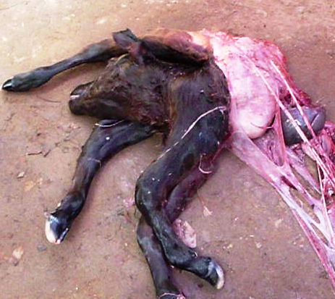
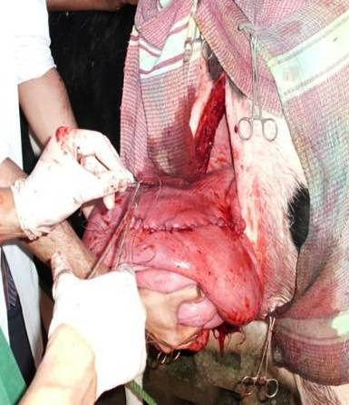
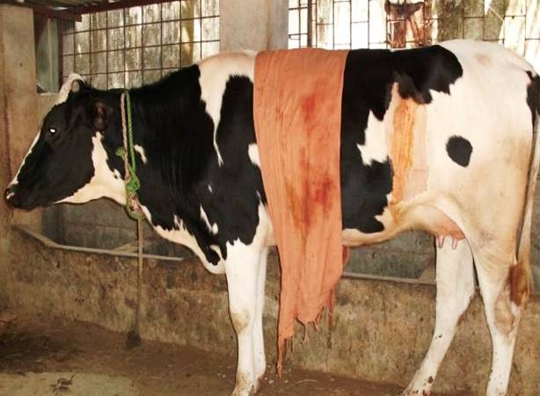
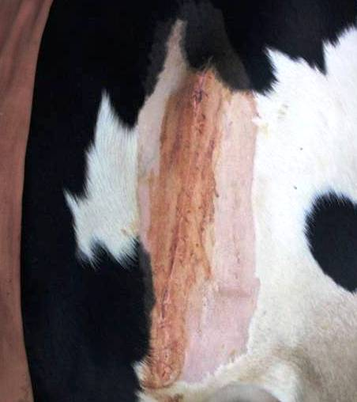
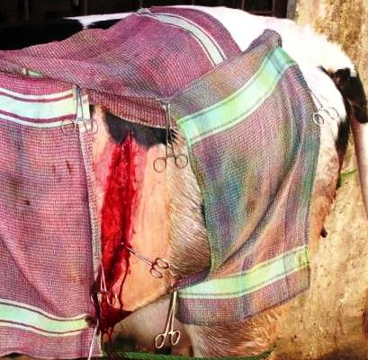
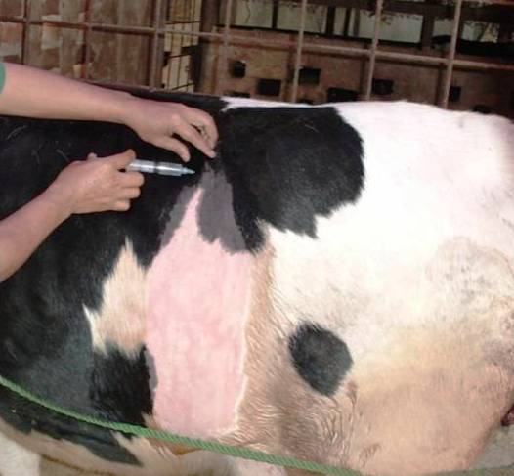
Figures : A. administration of anaesthesia, B. Incision site ( Left flank)
C. Suturing of incised area, D. Schistosomus reflexus fetus
E. Healing of sutured area, F. Recovered cow
E
D
C
B
A
F

