Title: Gut Obstructive Toxocariasis in a Puppy; Case Report
Md. Ahaduzzaman^{1,*}, Al Amin² and Md. Mizanur Rahman³
1. Md. Ahaduzzaman, Masters Fellow (Medicine), Department of Medicine and Surgery, Chittagong Veterinary and Animal Sciences University (CVASU), Bangladesh. E-mail: zaman.cvasu@gmail.com, Mobile: +8801746077242.
2. Al Amin, Masters Fellow (Physiology), Department of Physiology, Biochemistry and Pharmacology, Chittagong Veterinary and Animal Sciences University (CVASU), Bangladesh, E-mail: dvm.alamin40@yahoo.com, Mobile: +8801988712405.
3. Md. Mizanur Rahman, PhD, Associate Professor (Medicine), Department of Medicine and Surgery, CVASU. E-mail: rahmanys2b7@gmail.com, Mobile: +8801720150625.

*Corresponding author
Dr. Md. Ahaduzzaman, Masters Fellow (Medicine), Department of Medicine and Surgery, Chittagong Veterinary and Animal Sciences University (CVASU), Bangladesh. E-mail: zaman.cvasu@gmail.com, Mobile: +8801746077242
Abstract
Toxocara sp. is common resident of intestine especially in puppy that reared in unhygienic condition devoid of deworming. A gut obstructive case was found as sequel of Toxocariasis in a puppy that was manifested by obstipation and distended abdomen. Oral co-administration of pyrantel pamoate and magnesium hydroxide with other supportive therapy was found effective. And these can be implemented as alternative for surgery in gut obstructive case.
Key words: Toxocariasis, puppy, pyrantel pamoate, gut obstruction.

Toxocariasis is a globally important gastrointestinal parasitic disease of canids particularly a younger one that frequently acquire infection through contaminated environment extensively by ingestion of infective ova from infected one and exposing paratenic hosts (Pawlowski, 2001). The infestation could be occurred from contact with contaminated soil, dirty hand and raw vegetable. Pica as a nutrition disorder has also an important role in the infestation with Toxocara spp. (Tavassoli, 2012). Clinically it is manifested by anorexia, weight loss, abdominal pain, diarrhoea, nausea, vomition, mild fever, anemia, bloat (due to obstruction of the alimentary tract) and increased irritability. In Chittagong district of Bangladesh the highest seasonal prevalence of Toxocariasis found 35.71% in stray dog during the summer season (Das, 2012) and it seems to be a headache for the pet owners as the puppies frequently affected by it in comparison to other enteric parasites. Some of the case reports presented on canine ascariasis complicated with eosinophilic ascitis (Chira 2005), ocular ascariasis (Azira and Zeehaida, 2011) and drugs trial but there is a greater shortage of information and treatment protocol to handle a case of Toxocariasis with enteric obstruction and complications. Therefore, the current therapy was taken to find out the therapeutic outcome of intestinal obstruction and complications due to Toxocariasis in a puppy.
A 2.5 months old non-descriptive puppy was admitted to the S.A.Q. Teaching Veterinary Hospital, Chittagong Veterinary and Animal Sciences University, Bangladesh, with a history of anorexia, vomiting with worm (single time) and absence of voiding for 48 hours with no deworming record. Clinical examination revealed that the puppy possessed heart rate 90/minute and 99⁰F rectal temperature with respiration rate 23 breaths/minute. Physical examination found pale mucous membrane and abdominal distention.
Fecal sample was collected from the rectum and direct smear was made to perform the coproscopy under the light microscope. On coproscopy characteristics eggs of Toxoxara sp. were found, that confirmed by ova morphology. Other parasites or their eggs were not noticed in further coproscopy of fecal sample by adopting different techniques. As a result on the basis of clinical signs/symptoms and findings of coproscopy it was confirmed that puppy was suffering fromToxocariasis.
The puppy was treated with orally Pyrantel pamoate (Delentin syrup^{R}, 50mg/ml, Renata Ltd., Bangladesh) @5mg/kg body weight for single time and repeated dose two weeks apart to prevent re-infection; Magnesium hydroxide (Milk of magnesia^{R}, 40mg/ml, Acme Pharmaceutical Ltd., Bangladesh) @ 5ml orally at a time as laxative, intravenous 5% dextrose normal saline @ 30ml for two consecutive day for mimicking dehydration and providing energy; and systemic vitamin B-complex (B₅₀ Injection, Square pharma. Ltd., Bangladesh) @ 1ml/day for five days to combat anemia and weakness. Following therapy defecation occurred after three hours with expulsion of Toxocara sp. with feces and no further complication were reported.

Toxocara is the ubiquitous parasite and most patients with this intestinal parasitism have mild symptoms that include nausea and intermittent abdominal discomfort. Some patients remain asymptomatic and found incidentally on radiographic examination or ova found in stool samples. Therefore, coproscopy is suggested as easily approached clinical diagnostic technique as supported by Khuroo (2003).
Pyrantel pamoate is widely used as a deworming against round worms in dogs, cats and many other species. It was first launched in the market for the practitioner in the 1970s and was very popular all those years, and it still is today. Several trials have been reported by Schmid et al. (2010), observed that 94.3% efficacy in a controlled trial with 20 dogs experimentally infected with Toxocara canis, and 100% efficacy in naturally infected dogs. Since Pyrantel is poorly absorbed by the host's intestine and causes paralysis of the worm as supported by Mora et al. (2006); so it can be used effectively with purgative for rapid expulsion of worm in non-severe cases prior to surgical approach along with other supportive therapy such as vitamin B-complex as agreed with Katona and Katona-Apte (2008).
Obstruction of alimentary tract due to ascariasis may occur in variety of extent that’s leads to scanty feces, mild colic to bloat, enterotoxaemia, absent of defecation and even death due to functional abnormality. Based on clinical assessment the appropriate therapeutic measures should be taken prior to surgical intervention in serious obstructive cases.
We would like to acknowledge the animal owner and the stuffs of Department of Medicine & Surgery, CVASU, Bangladesh.
Authors declare that they have no competing interests.
Figure:
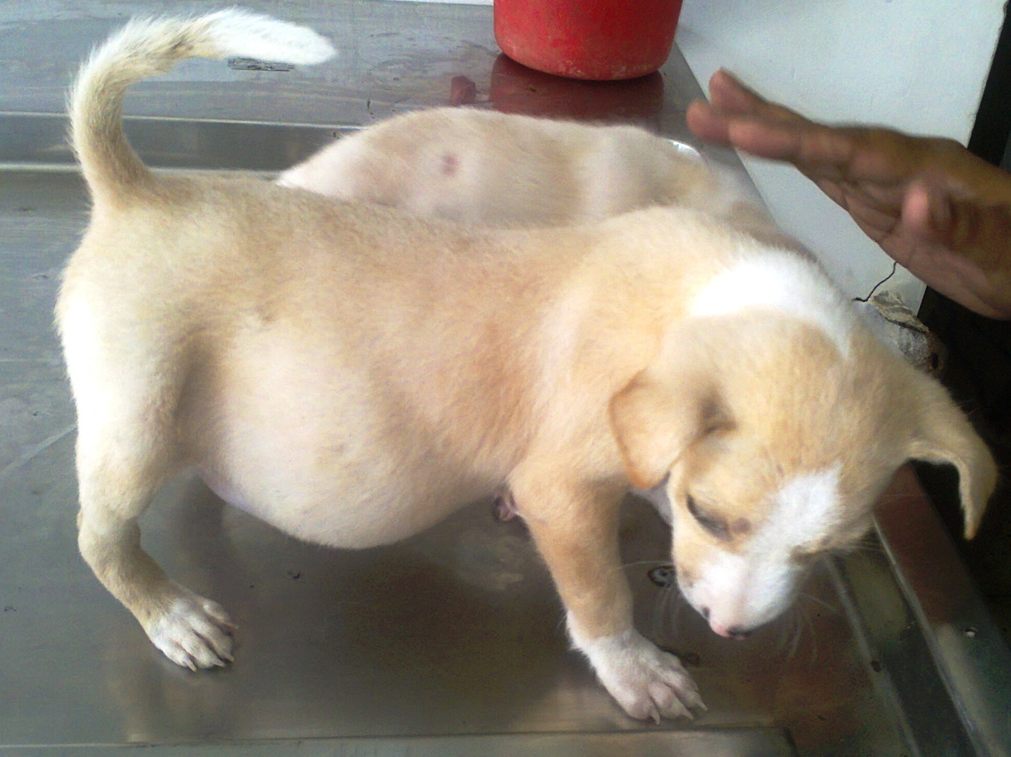
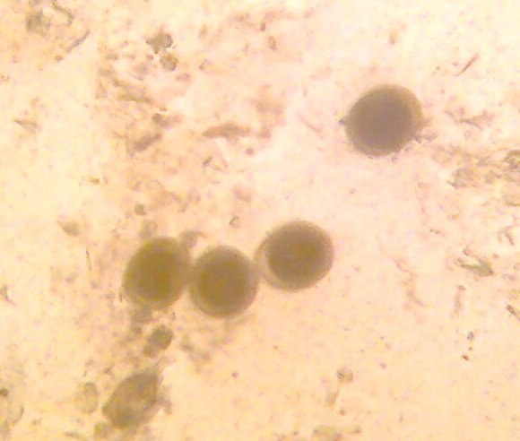

Fig.2: Thick wall, oval shape, granulated eggs of Toxocara canis (Under 10X light microscopy).
Fig.1. Puppy showing pendulous abdomen with obstipation due to gut obstruction by Toxocara canis

References
Azira NMS and Zeehaida M (2011). A case report of ocular toxocariasis. Asian Pac. J. Trop. Biomed. 1(2): 164-165.
Chira O, Badea R, Dumitrascu D, Serban A, Branda H, Hajjar N, Chiorean E, Cruciat C (2005). Eosinophilic ascites in a patient with Toxocara Canis infection: A case report. Rou. J. Gastrointestin. 14(4):397-400.

Das S, Alim MA, Sikder S, Gupta AD, Masuduzzaman M (2012). Prevalence and worm load of enteric helminthiasis in stray dogs of Chittagong metropolitan, Bangladesh. J. Ank. Uni. Fac. Phar. 23 (3):141-145.

Katona P, Katona-Apte J (2008). The interaction between nutrition and infection. Clin. Infect. Dis. 46 (10): 1582-1588.
Khuroo MS (2003). Parasitic diseases of the liver and intestines: ascariasis. Gastroenterol. Clin. Sept. 25:1-23.

Mora NCT, Lavery EAL, Chun HM (2006). Partial small bowel obstruction in a traveler. Clin. Infect. Dis. 43 (2): 256-258.
Pawlowski Z (2001). Toxocariasis in humans: clinical expression and treatment dilemma. J. Helminthol. 75: 299-305.
Schmid K, Rohdich N, Zschiesche E, Kok DJ, Allan MJ (2010). Efficacy, safety and palatability of a new broad‐spectrum anthelmintic formulation in dogs. The Vet. Rec. 167:647‐651.
Tavassoli M, Javadi S, Firozi R, Rezaei F, Khezri AR, Hadian M (2012). Hair contamination of sheep dog and pet dogs with Toxocara cani’s eggs. Iranian J. Parasitol. 7 (4):110-115

