An evaluation of foot-and-mouth disease outbreak in relation to vaccination in a herd of cattle and buffaloes

By

Muhammad Abubakar¹, Aatka Jamil² and Qurban Ali¹
¹ National Veterinary Laboratory, Park Road, Islamabad, Pakistan
² FAO National Project, Progressive control of Foot and mouth Disease in Pakistan (GCP/PAK/123/USA)

Abstract

An outbreak of foot-and-mouth disease in a vaccinated herd of cross breed cattle and buffaloes at Islamabad capital territory (ICT) area of Pakistan was investigated. The herd was vaccinated three months ago by a locally manufactured FMD vaccine. Although the cattle and buffaloes were of similar vaccination status yet the disease affected only the cross breed cattle where as no clinical signs were appeared in buffaloes. In a herd of 81 animals, disease occurred in 5 out of 15 cross bred cattle within three days of the index case. Disease spread quickly and a total of ten cases occurred during the first week yet no clinical disease occurred in buffaloes. Tissue epithelial samples from affected cattle were found positive against serotype “O” of FMDV using lab diagnosis. The possible source of the outbreak virus could be the mix grazing with local animals where disease was reported earlier. Another feature of the outbreak was the happening of disease within three months of vaccination which indicates vaccine failure. The investigation suggests the monitoring of FMD vaccination being carried out as well as the immunity and resistance studies in buffaloes to FMDV.
Introduction
Foot-and-mouth disease (FMD), a highly communicable viral disease concerned primarily with cloven-hoofed animals, is caused by RNA virus belonging to genus Aphthovirus of family Picornaviridae (Belsham 1993). FMDV exists in seven distinct serotypes i.e. O, A, C, SAT1, SAT2, SAT3 and Asia-1 (Domingo et al., 2003). FMDV produced extensive vesicular lesions on the lips, tongue, gums, dental pad, feet and udder (Lubroth, 2002; Rweyemamu et al., 2008). Although mortality in adult animals due to FMDV infection is rare, but other losses associated with FMD are weight loss, decreased milk production and loss of draft power (Blacksell et al., 2008), while farmer has to face substantial losses in terms of treatment expenses and time spent caring for sick animals (Rushton et al., 2002).

Pakistan is considered to be endemic for FMD and outbreaks are being reported throughout the country. There are three serotypes of FMD (i.e., O, A and Asia1) which are predominantly present but at one time one serotype dominates over the others (Abubakar et al., 2012; Abubakar and Manzoor, 2013). So following report includes detailed investigation of an outbreak in cattle and buffaloes in relation to the vaccination failure in endemic disease situation.

Materials and methods
Outbreak description
The outbreak of FMD in a herd of cross breed cattle and buffaloes at Islamabad capital territory (ICT) area was investigated. The herd type was semi-organized with common grazing with village animals. The outbreak started with the clinical signs in two animals which spread to five in three days. The animals were vaccinated within last three months by a locally manufactured vaccine. As it was a dairy herd so remarked drop in milk production was also observed.
Clinical examination
At clinical examination of animals the characteristic feature of FMD was observed i.e. blister like lesions on tongue and oral mucosa. There was also high temperature and profuse salivation (Figure-1).
Sample collection and laboratory confirmation
Epithelial tissues from oral blisters were taken aseptically in buffered glycerine. The samples were brought to ELISA lab of National Veterinary Laboratory, Islamabad for the confirmation of FMDV. ELISA for FMDV antigen detection and serotyping was performed by using kit manufactured by IZSLER, Brescia, Italy. A color reaction on the addition of enzyme substrate indicated a positive reaction and the results were read spectrophotometrically (Immunoskan, BDSL, Finland) at recommended wavelength (450 nm). In this case, an absorbance reading greater than 0.1 above background indicated a positive reaction; thus the confirmation of FMD antigen and serotype was identified.
Results
The most exciting feature of this outbreak was the onset of disease in only cross breed cattle in the presence of buffaloes. After the onset of clinical signs in index case it took only 48 hours when disease spread to other five animals. A sudden drop in milk production (up to 75%) in clinically affected animals was also recorded.
In a total of 81 animals, disease occurred in 5 out of 15 cross bred cattle within three days of first case. Disease spread quickly and a total of ten cases occurred during the first week yet no clinical disease occurred in buffaloes (Table-1).
Tissue epithelial samples from affected cattle were found positive against serotype “O” of FMDV using lab diagnosis. To confirm the disease epithelial tissue samples from oral blister were taken and tested. The results of antigen detection ELISA showed that samples were positive. The serotype of FMDV was serotype “O”. The disease spread was controlled by separation of affected animals and vaccination of healthy animals.

Discussion
Vaccination is considered as main tool to prevent animals from diseases such as FMD. But outbreaks of FMD have been reported in literature even after vaccination (Jamal et al., 2010). This was also observed in our findings that animals were vaccinated three months ago. This finding was also coincides with Jamal et al., (2013) who reported very low humoral immune responses against FMDV by the locally produced vaccines. The failure of vaccination may be due to differences between the circulating field strains and the strains included in the vaccine.

The serotype which caused the outbreak was “O”. This finding is supported by the previous studies (Abubakar et al., 2009, Jamal et al., 2010, Abubakar et al., 2012) that the most prevalent serotype in Pakistan is serotype “O’. However a shift of between FMDV serotypes may cause more severe outbreaks even in vaccinated animals (Abubakar et al., 2012).

According to a study conducted by Abubakar et al. (2009), cattle and buffaloes are main dairy animals in country and both are at risk to FMD but cattle and especially cross-bred are more susceptible as compared to buffalo. Our findings are in concurrent with these as the buffaloes in the same herd remained protected while the clinical disease occurred in cattle.

During investigation of this outbreak, it was noticed that milk yield decreased up to (75%) even in one day. Similar findings was reported in a study conducted in Pakistan by Ferrari et al., 2013 where they followed FMD affected cattle and buffalos up to 2 months of disease and reported 72% drop in milk 24 hours of disease commencement. Abubakar et al., (2013) also reported FMD outbreak in ICT (the same region) and reported 70% to 90 % milk reduction in lactating animals. They also highlighted that in cattle milk reduction is more pronounced as compared to buffalo. Annual losses due to drop in milk production and vaccine failure as reported by Jones and Rushton (2013) are between US$6.5 and 21 billion.

The study concluded that the monitoring of FMD vaccination should be carried out in cattle and buffaloes separately as well as the immunity and resistance studies of FMDV in buffaloes.
References
- Abubakar M, Khan E, Arshed MJ, Hussain M, Ali Q and Afzal M (2013). Mortality Rate in Association with Foot and Mouth Disease Outbreaks in Cattle and Buffaloes, Pakistan. ASM Sci. J. 7(2), 139–143.
- Abubakar M and Manzoor S, (2013). Epidemiological Aspects of Foot and Mouth Disease Outbreak in a Sheep Herd. Pak. J. life soc. Sci. 11(3): 244-246.
- Abubakar M, Arshed MJ, Ali Q and Hussain M (2012). Spatial Trend of Foot and Mouth Disease Virus (FMDV) Serotypes in Cattle and Buffaloes, Pakistan. VIROLOGICA SINICA. 27 (5):320-323.
- Abubakar M, Ferrari G, Hussain M, Khan E, Arshed MJ and Ali Q (2009). Prevalence of Foot-and-Mouth Disease Virus Serotypes in Pakistan. Pakistan J. Zool. Suppl. Ser., No.9, pp. 351-355.
- Belsham G J (1993). Distinctive features of foot-and-mouth disease virus, a member of the picornavirus; aspect of virus protein synthesis, protein processing and structure. Prog Mol Biol 60:241–260.
- Blacksell S, Khounsy S, Conlan J ,Gleeson L, Colling A, and Westbury H (2008). Foot and mouth disease in the Lao People’s Democratic Republic: II. Sero-prevalence estimates, using structured surveillance and surveys of abattoirs. Rev. Sci. Tech. Off. Int. Epiz. 27, 851–859.
- Domingo E, Escarmis C, Baranowski E, Ruiz-Jarabo C M, Carrillo E, Nunez J I, Sobrino F (2003). Evolution of foot and- mouth disease virus. Virus Res 91(1):47–63.
- Ferrari G, Tasciotti L, Khan E, Kiani A (2013). Foot-and-Mouth Disease and Its Effect on Milk Yield: An Economic Analysis on Livestock Holders in Pakistan. Transbound. Emerg.Dis. doi: 10.1111/tbed.12072.
- Jamal S M, Ahmed S, Hussain M and Ali Q (2010). Status of foot-and-mouth disease in Pakistan. Arch. Virol. 155, 1487–1491.
- Jamal SM, Shah SI, Ali Q, Mehmood A, Afzal M, Afzal M, Dekker A (2013). Proper Quality Control of Formulated Foot-and-Mouth Disease Vaccines in Countries with Prophylactic Vaccination is Necessary. Transbound Emerg Dis. doi: 10.1111/tbed.12051.
- Jones K and Rushton J (2013).The economic impacts of foot and mouth disease - what are they, how big are they and where do they occur? J. Pre vet med., 112(3-4):161-73.
- Lubroth J (2002). Foot and mouth disease: a review for the practitioner. Vet. Clin. North Am. Food Ani. Pract. 18, 475–499.
- Rushton J, Pilling D and Heffernan C (2002). A literature review of livestock diseases and their importance in the lives of poor people. In: Perry, B., J. Randolph, J. Madermott, K. Sones, and P. Thornton (eds), Investigation in Animal Health Research to Alleviate Poverty. pp. 129. International Livestock Research Institute, Nairobi, Kenya.
- Rweyemamu M, Roeder P,Mackay D, Sumption K, Brownlie J, Leforban Y, Valarcher J , Knowles N and Saraiva V(2008). Review: epidemiology patterns of foot-and- mouth disease worldwide. Transbound. Emerg.Dis. 55, 57–72.
Table-1: Summary of FMD outbreak in a herd of cattle and buffaloes
Area | Animal Species | Total animal in shed | Morbidity Rate | FMD Serotype Confirmed
ICT  (Islamabad Capital Territory) | Cattle | 35 | 5/15 | O
ICT  (Islamabad Capital Territory) | Buffaloes | 46 | -- | --

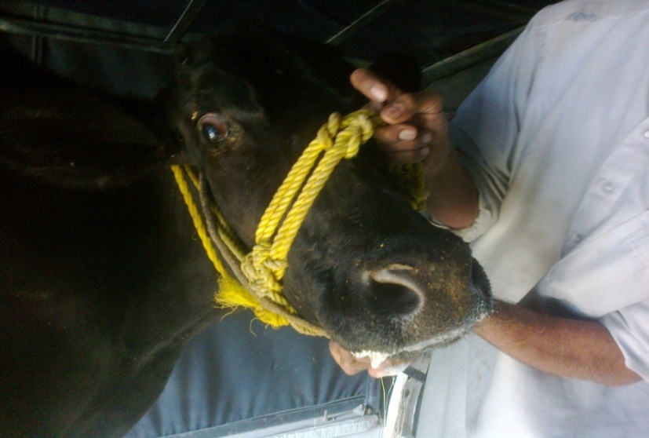
Figure 1: FMD affected cattle with profuse salivation and mouth lesions

