Aspergillus fumigatus infection among dromedary camels in Saudi Arabia

F.A. Al. Hizab

Department of pathology, College of Veterinary Medicine and Animal Resources, King Faisal University, Saudi Arabia.
Corresponding author: email: mhamouda@kfu.edu.sa P.O. Box 400 Al hufof 31982. Saudi Arabia.
Number of figures: 2 figures (8 photograpghs).
Numbers of words: 2046.

ABSTRACT

This study was conducted on Eastern Province (2012). The field problem was mortality among camels (Camelus dromedarius) in Hardd region in KSA.Clinical signs were anorexia, depression, nasal discharges, lacrimationand enlargement of submandibular lymph nodes. Moreover, there was bloody diarrhea.Out Of 150 camels,70 animals showed the disease and about 19of them were died within three days after the appearance ofthe first clinical signs. Consistent necropsy findings were haemorrhagic abomasal folds, massive haemorrhage within small intestine associated with severely congested mesenteric lymph nodes. Epicardial and subendocardial haemorrhages were also observed. The pharyngeal and laryngeal areas were congested and contained serosanguinous fluid. Aspergillus fumigatus was cultured and isolated from trachea, lung, omasum and intestine. No other potential microorganisms or toxic agents has been identified.

INTRODUCTION

A. fumigatus, is associated with respiratory system infections in livestock but may also cause gastroenteritis. Moldy litters are often suspected as sources of infection.A. fumigatus is an opportunistic fungus and has been recorded in alpacas and dromedaries (Bhatia et al., 1983; Pickett et al., 1985; Severo et al., 1989; Gareis and Wernery, 1994).
The majority of aspergillosis are sapronoses, that is transmissible from environment, and not from person to person, or zoonosis (Alesandro, 2010). Genus Aspergillus is a wide spread fungi around the world. Among its types; A. fumigatus is the most pathogenic type causing diseases in human & animals. A. fumigatus is an opportunistic fungus affecting respiratory system (Kwon-Chung, 1992). Elevated pathogenic manifestations of A. fumigatus belong to several factors; it's ability to growth faster than other types in wide range of temperature (20-50) ºC, A. fumigatus is highly sporelating fungus for which it has found in about (1-100) spore/m³ in the atmosphere (Lacey, 1996).
A. fumigutus is responsible for 90-95% of Aspergillus infections in animals. Aspergillus species can produce colonies of different colours (black, green or yellow). These colours are due to pigmented spores. Aspergillus species may be invasive, cause mycotoxicoses and allergic reactions in humans (Taylor et al., 2009). A haemorrhagic disease in camels characterized by a variety of clinical signs and hemorrhages at a necropsy has been noticed by El-Khouly et al. (1992). Eastern Province is considered a good place for the growth of fungi because its climatic condition (Khalid AL-Busadah, 2007).

MATERIALS AND METHODS

Animals:
Atotal numbers of animals were 150 camels. Out Of 150 camels,70 animals showed signs and about 19 of them were died within three days after the appearance of the first clinical signs.The age of animals ranged from 3 to 8 years.The diet was a variable mix of Rhodes grass or hay, barley, maize and dates. Camels graze in a nearby farm field 20 km., where a number of grass wet at this time of the year and the temperature reaches 45°C and this is a very suitable environment for the presence of fungi, especially with the presence of excess moisture.

Blood samples:
Blood samples were collected using EDTA for haematological examinations. Most haematological parameters were made using a coulter counter electronic analyzer (Vet scan 5 HM-ABaxis-USA).
Serum samples:
Serum samples were collected into plain containers and centrifuged. This samples was stored at -20 until analysis.Total protein, albumin, glucose, blood urea nitrogen (BUN), creatinine, calcium, phosphorous, cholesterol , bilirubin and uric acid and the activities of aspartate aminotransferase (AST), alanine aminotransferase (ALT), gamma glutamyltransferase (GGT), lactate dehydrogenase (LDH), creatine kinase (CK) and alkaline phosphatase (AP).These parameter was tested by coulter ELLEPC (Italy 2003).

Mycotic culture:
At necropsy swabs taken from trachea, lung, omasum and inestine were inoculate into Sabouraud glucose agar plates containing chloramphenicol and actidione, and incubated at 37°C for 24 h and then incubatedat 25°C for 3 successive days. Characteristics fungal growth were noted, mounted and examined microscopically (Scott, 1990).

Feedstuffs analysis for aflatoxin:
The feedstuffs were collected and analyzed for aflatoxin. The samples were analyzed for total aflatoxin according to Trucksess et al. (1991).

Histopathology:
Tissue specimens from lung, omasum, abomasum, small and large intestine, liver, and kidney as well as submandibular, bronchial and mesenteric lymph nodes were fixed in 10% formal saline and embedded in paraffin. Sections were stained with HE and Gomori methenamine silver stain for fungus demonstration (GMS).

RESULTS

Clinical signs:
The clinical signs displayed by affected animals were dyspnea, dullness and progressive weight loss.The oral mucosa was congested.Nasal and ocular discharges were noticed in the majority of cases (fig.1a).
In several cases, there was swelling of the throat and associated with enlargement of submandibular lymph nodes (fig.1b). Epistaxis was noted in some animals associated with bloody diarrhea in most cases. Pyrexia with an increase in heart and respiratoryrates. The nervous signs were hyperexcitability, marked incoordination, sternal recumbency proceeded to lateral recumbency, inability to stand, convulsions, and death within 3-5 days.

Clinical pathologyand chemistry findings:
The persistent haematological finding was an often profound leucopenia with white cell counts ranging from 1.3±0.5 × 10³ (normal value 14.4±5× 10³).The most clinical chemistry changes were increases in AST reached to 83.2±36.6IU\L (normal value 64.16±8.13 IU\L).

Toxicological findings:
There was no evidence for the presence of aflatoxins in the feedstuffs.

Necropsy findings:
The most striking necropsy findings was haemorrhage in the most organs. Oedema and haemorrhages were present in the throat, submandibular, pharyngeal and laryngeal regions (fig.1c). Haemorrhages were always observed on the mucosa of trachea and accompanied by frothy exudates. The surface of the lungs displayed large numbers of petechial and ecchymotic haemorrhages (fig.1d). Lymph nodes of the thoracic cavity were oedematous and haemorrhagic. Epicardium and endocardium haemorrhages were also noticed in some cases. The mucous membranes of omasum and abomasum were severely congested and haemorrhagic (fig.2a). Massive haemorrhages and clots obstruct the small intestine and may extend to caecum. Associated lymphnodes were severely congested and oedematous. Few cases had black-stained faeces.

Mycotic growth:
Cultures from trachea, lung, omasum and intestine resulted in growing colonies within 1 to 3 days. The colonies were identical with that of A.fumigatus as described by Pickett et al., (1985).

Microscopic lesions:
The tracheal and bronchial mucosa revealed fibrinonecrotic membrane associated with vascular thrombosis of submucosal blood vessels. This finding was accompanied by lymphocytic and histolytic aggregations. Alternative areas of necrosis could be seen everywhere in lung tissue. In the submandibular, bronchial and mesenteric lymph nodes the subscapular sinuses showed marked lymphocytic aggregations associated with prominent vascular congestion.
The most striking lesions in omasum, small intestine and colon were fibrinonecrotizing inflammation accompanied by capillaries thrombosis with lymphocytic and histocytic aggregations in the submucosa.In the liver, there were multiple necrotic areas of various sizes, most of which were located in the portal area. This was together with massive areas of haemorrhages (fig.2b).
Moreover, the blood vessels of lung, liver and kidney revealed severely congested blood vessels and perivascular cuffing (fig.2c). In some cases angioinvasion by Aspergillus fumigatus was evident.

DISCUSSION
Aspergillus fumigatus is a public feed contaminant particularly ubiquitous in preserved forages, produces some mycotoxins that can affect the animal health.The clinical findings were characterized by fever, lachrymation, swelling of throat, and bloody diarrhea. Nervous signs and epistaxis proceeded to death were also recorded. These findings were consistent with the findings of other researches (Jubb et al., 1993; Mandal and Gupta, 1993).Leucopenia and increased AST activity were prominent in most cases. This findings were agreed with Muntz (1999) in an aging lactating alpaca (Lama pacos).The decrease in the percentages of leucopenia may be due to suppression of lymphocyte blastogenesis by A. fumigatus (Chaparas et al., 1986).
The most salient lesions were observed in lung, liver, omasum, abomasum, small and large intestine, and the associated lymph nodes. This indicates the generalized infection. This infection may be developed from the embedding of spores on the naso-pharynx mucosa and lower respiratory passages, and the granulomatous lesions are somewhat slow to develop and so not seen in acute cases, hence the dissemination of the fungus from the pulmonary lesions can occur (Jubb et al., 1993). This findings were concomitant with Abbas and Omer (2005) who found out that A. fumigates was incriminated in an outbreak of bronchopneumonia and gastroenteritis that affected a large number of racing camels in the Emirates.Several authors confirmed these findingsin horses, cattle and lambs (Jungerman and Schwartzman, 1972; Sarfati, 1996). Furthermore ,A.fumigatus is considered to be the fungal agent that associated with systemic diseases in dromedary camels (Boudra and Morgavi, 2005).
The most outstanding necropsy findings was haemorrhage of the most organs, lung, liver, omasum, abomasum, intestine and kidney.This unusual coagulopathy may be due to some enzymes elaborated by Aspergillus sp. (McClellan et al.,1985). Furthermore, there is some suggestions that the ingestion of mouldy food infected with A. fumigatus can cause fatal haemorrhagic disease in cattle and swine (Jubb et al., 1993).
Histopathological changes were numerous foci of necrosis in the lungs and liver as well as fibrinonecrotizing inflammation in omasum, small intestine and colon associated with vascular thrombosis and hemorrhages. Such lesions could be attributed to invasion of Aspergillus organisms into vascular systemand consequent thrombosis of small to medium sized vessels associated with ischaemic necrosis (SEVERO, 1989).
In conclusion, according to our results, A. fumigatus should be considered among the diseases of the fatal and invasive nature among camels.

REFERENCES
Abbas B and Omer OH (2005). Review of infectious diseases of the camel. Veterinary Bulletin 75(8):1N-16N.
Alesandro CP (2010). Aspergillosis: from diagnosis to prevention. Part І, Introduction. Springer Science & Business Media.
Bhatia KC, KulshreshthaRCand Paul GuptaRK (1983). Pulmonary aspergllosis in camel. Haryuna Vet. XXII: 118-119.
Boudra H and Morgavi DP (2005). Mycotoxin risk evaluation in feeds contaminated by Aspergillus fumigatus. Animal Feed Science and Technology 120: 113–123.
Chaparas SD, Morgan PA and Holobaugh P (1986). Inhibition of Cellular Immunity by products of Aspergillus fumigatus. J. Med. Vet. Mycol. 24:67-76.
EL-khouly AB, Gadir FA, Cluer DD and Manefield GW (1992). Aspergillosis in camels affected with a specific respiratory and enteric syndrome. Australian Veterinary Journal Vol 69 (8): 182-6
Gareis M and Wernery U (1994). Determination of Gliotoxin in samples associated with cases of intoxication in camels. Mycotoxin Research (10): 2-8.
Jubb KVF, Kennedy PC and Palmer's N (1993). Pathology of Domestic Animals, 4th edn. Academic Press,San Diego.
Jungerman PF and Schwartvnan RM (1972). Veterinary Medical Mycology. Lea and Febiger, Philadelphia, p 75.
Kwon-Chung KJand Bennett JE (1992). Medical Mycology. Lea &Febiger, Philadelphia.
Khalid A AL-Busadah (2007).Some Biochemical and Haematological Indices in Different Breeds of Camels in Saudi Arabia.Scientific Journal of King Faisal University (Basic and Applied Sciences) Vol. 8 (1):131-142.
Lacey J (1996). Spore dispersal- its role in ecology & disease: The British contribution of fungal aerobiology, Mycological Research 100:641-660.
Mandal PC and Gupta PP (1993). Experimental aspergillosis in Goats: Clinical, Haematological and Mycological Studies. J. Vet. Med. B. 40:283-286.
McClellan SL, Komorowski RA, Farmer SG, Hussey CV, Kauffman HM and Adams MB (1985). Severe bleeding diathesis associated with invasive aspergillosis in transplant patients. Transplantation 39(4):406-10.
Muntz FH (1999). Oxalate-producing Pulmonary Aspergillosis in an Alpaca. Vet Pathol 36:631–632.
Pickett JP, Moore CP, Beehler BA, Gendron Fitzfatrick A and Dubielzig RR (1985). Bilateral chorioretinitis secondary to disseminated aspergillosis in an alpaca. Journal of the American Veterinary Medical Association 187, 1241-1243.
SarfatiJ, Jensen HE and Latge JP (1996). Route of infections in bovine aspergillosis. Medical Mycology Vol. 34(6): 379-383
18-Scott BM (1990). Natwal Pohonr, AOAC. Washington DC, p 1191 Sheridan JJ (1981) Vet. Res. Commun 5:1 Oxford, p 301.
Severo LC, Bohrerjc, Geyergr and Ferreirol (1989). Invasive aspergillosis in an alpaca (Lama pacos). Journal ofMedical and Veterinary Mycology 27: 193-195.
Taylor RT Dagenais and Nancy P Keller (2009). Pathogenesis of Aspergillus fumigatus in Invasive Aspergillosis. Clinical Microbiogy Reviews 22(3):447-465.
Trucksess MW, Stack ME, Nesheim S, Page SW, Albert RH and Hansen TJ et al., (1991). Immunoaffinity column coupled with solution fluorometry or liquid chromatography post-column derivatization for determination of aflatoxins in corn, peanuts, pea nut butter: collaborative study. J Assoc. Off. Anal. Chem. 74 (1):81.

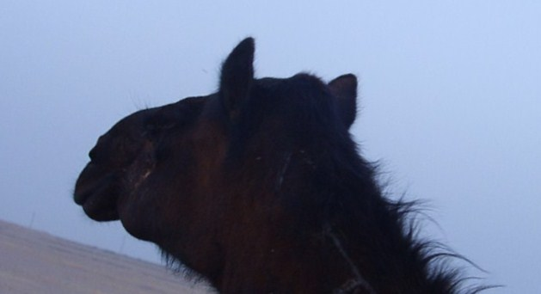
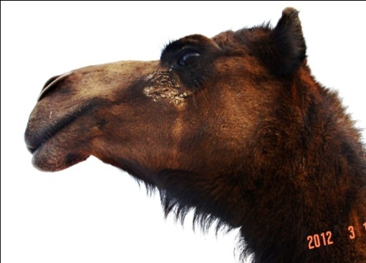
d

b
a
c
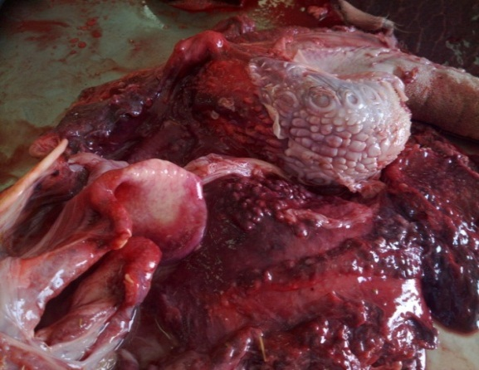
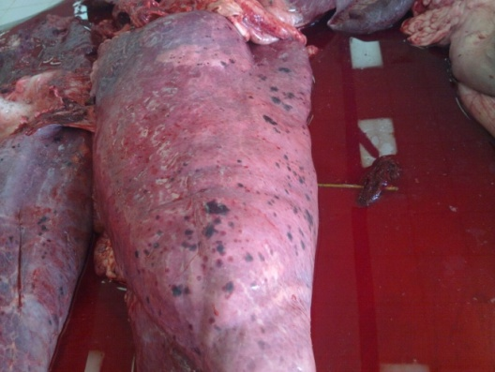

dD

Fig. 1.a- Ocular discharge (arrow). b. Enlargement of submandibular lymph node (arrow). c. Congested and haemorrhagic laryngeal (arrowhead) and pharyngeal mucosa (arrow). d.Petechial and ecchymotic haemorrhage along the lung surface (arrow).
c

d
c
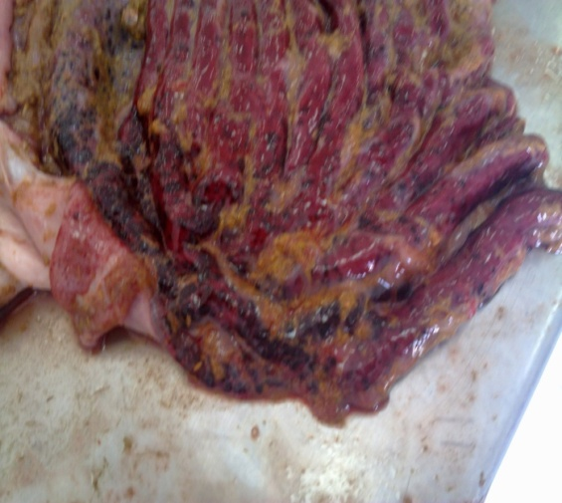
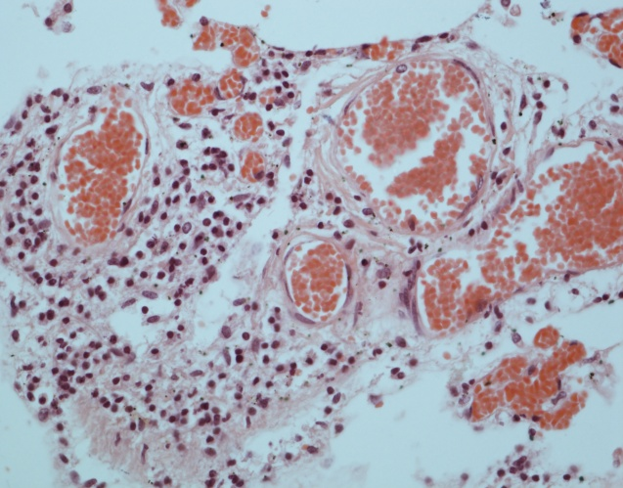

a

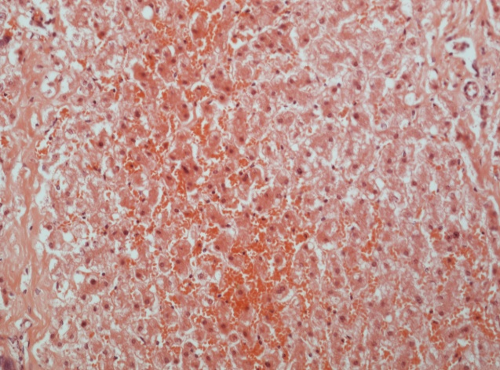

c
b

Fig. 2. a. Ecchymotic haemorrhages along the mucosal surface of abomasum (arrow).b. Liver showing massive areas of haemorrhage (arrow). HE x400. c. lung showing congested blood vessels (arrowhead) and perivascular cuffing (arrow). HE x400.

