Multiple Drug Resistance and Extended spectrum beta lactamase Production of Bacteria in Blood Culture Isolates
Nazia Shams, Iqbal Ahmad Alvi, Mujaddad Ur Rahman, Azam Hayat, Abdul Majid*

Department of Microbiology, Hazara University, Mansehra 21300, Pakistan

Nazia Shams, M.Phil, E-mail; nazia_huni@gamil.com
Iqbal Ahmad Alvi, E-mail; iqbalalvi741@hotmail.com
Mujaddad Ur Rahman, PhD, Post-Doc, r.mujaddad_huniversity@hotmail.com
Azam Hayat, PhD, azamhayyat@yahoo.com
Abdul Majid*, M.Phil, microbiologistic99@yahoo.com

Corresponding Author; Abdul Majid; microbiologistic99@yahoo.com
Phone number; +92 301 5396009; Fix number +92 0997 414111
Postal address; Department of Microbiology, Hazara University, Mansehra Pakistan, 21300.

Multiple Drug Resistance and Extended spectrum beta lactamase Production of Bacteria in Blood Culture Isolates
Nazia Shams, Iqbal Ahmad Alvi, Malik Mujaddad Ur Rahman, Azam Hayat, Abdul Majid*

Abstract
Enterobacteriaceae, major cause of nosocomial infections, is getting MDR against routinely in use drugs. Beta lactamase enzymes production is the main mechanism that makes penicillins, cephalosporins, monobactams and even carbapenems ineffective. Therefore infections due to ESBL isolates continue to pose a challenge to infection management worldwide. The aim of this study was to determine the frequency of MDR and ESBL production in bacterial blood culture Isolates. A total of 1056 blood samples were processed during this study period. Out of these 1056 samples, growth was obtained in 152 samples, of these 152 bacterial isolates 37 (24.34%) were Gram positive bacteria, 11 (7.23%) were MRSA, whereas 104 (68.4%) were Gram negative bacteria. Amongst Gram negative organisms Salmonella typhi 39 (25.65%) was the most predominant, followed by Pseudomonas aeruginosa 23 (15.13%), Escherichia coli 18 (11.84%), Klebsiella pneumonia 14 (9.21%), Proteus mirabilus 2 (1.31%), Enterobacter agglomerans 2 (1.31%), Acenetobacter calcoaceticus var antiratus 2 (1.31%), Enterobacter spp 1 (0.65%), Enterobacter cloacae 1 (0.65%) , Serratia mercescens 1 (0.65%) and Salmonella para typhi A 1(0.65%) . Among Gram positive organisms Staphylococcus aureus 30 (19.7%) was the predominant followed by Streptococcus viridians 7 (4.60%). In case of Gram negative bacteria 3 (2.88%) were ESBL producers and 58 (55.7%) were MDR, while in case of Gram positive 11 (36.6%) were MRSA.
Key Words: MDR, ESBL, MRSA, Bacteria, Blood.

Introduction
Multiple drug resistance is a state enabling a disease causing organism to resist distinctive drugs or chemicals of a wide assortment of structure and occupation embattled at eradicating the organism. Organisms that display multidrug resistance can be pathologic cells, including bacterial and neoplastic cells. Multidrug resistant (MDR) isolates are even more likely to be associated with complications in the therapeutic management of patients with infectious diseases (Karlowsky et al., 2003).

Extended spectrum beta lactamases (ESBLs) are one of the most important causes of resistance to penicillin and cephalosporins in E.coli and Klebsiella spp. ESBL producing bacteria are also frequently resistant to aminoglycosides, trimethoprim sulfamethoxazole and quinolones. This situation restricts the treatment choices (Quale et al., 2002). Antimicrobial resistance among the Enterobacteriaceae, a group of highly pathogenic Gram negative organisms, has increased dramatically in recent years against commonly used antimicrobials such as the tetracyclines, β lactams, fluoroquinolones, aminoglycosides and co trimoxazole (Fritsch et al., 2005). This is particularly true among pathogens such as Escherichia coli and Klebsiella pneumoniae that produce ESBLs (Paterson et al., 2005), a class of enzymes that has been strongly correlated with multidrug resistance among the Enterobacteriaceae (Kader and Kumar, 2004). However, study conducting the last two decades found that bacterial resistance mediated by plasmids which carry resistance gene to a large number of antibiotics, which are rapidly transferred has worsened the scenario (Ram et al., 2000).

In the last 15 years, ESBLs have gone from being an interesting scientific observation to a reality of great medical importance. The introduction of the oxyimino β lactam antibiotics was met with the emergence of new β lactamases. The development and spread of ESBLs have most likely been caused by the overuse of expanded spectrum cephalosporins in the hospital setting. Numerous methods have been proposed for the detection of ESBLs in clinical isolates. Current therapy for strains of Enterobacteriaceae that express ESBLs is limited to such broad spectrum agents as imipenem. However, there have already been reports of therapeutic failures of this drug with strains that produce multiple β lactamases (Ahmad et al., 1999; Iqbal et al., 2014). There are limited therapeutic options left for some of these organisms. Strains expressing extended spectrum β lactamases will present a host of challenges for clinical microbiologists and clinicians alike as we head into the 21st century.

The aims and objectives of the present study were to explore the possibility of developing “MDR and ESBL production in bacterial blood culture isolates”. For this purpose following objectives were set forth: To find out the ESBL production, to check the prevalence of MDR bacteria, to evaluate the effect of the drugs on specific bacteria and Area wise study of septicemic patients.

Materials and Methods
This research work was conducted at the Department of Microbiology, Hazara University, Mansehra Pakistan and Department of Pathology, Pakistan Institute of Medical Sciences, (PIMS) Islamabad, Pakistan.

Human Blood Samples
Blood samples of male and female septicemic patients (child, adults and old age) of PIMS hospital.

Method for Blood Collection
Blood was drawn aseptically in a room, using sterilized syringes from all adult and pediatric inpatients and outpatients with suspected Septicemia and directly inoculated into BD Bactec Plus Aerobic/F, BD Bactec Plus Anaerobic/F and BD Bactec bottles. The volume of blood obtained from adults was 5–10 ml and for the children 1–3 ml.

Procedure for Blood Culture
The Bactec 5070(Becton Dickinson Diagnostic Instrument System, Sparks, Md., USA), a continuous monitoring blood culture system, was used for further monitoring of blood cultures. The protocols of 7 day incubation for routine cultures were adopted .Blood culture positivity was based on three criteria i.e. Turbidity, Hemolysis, and Growth. All bottles positive in the system were Gram stained and subculture on suitable media (blood agar, MacConkey’s agar). If no organisms were seen, the bottle was returned to the system to complete the testing cycle. All clinically significant bacterial isolates were identified according to standard methods.

Antimicrobial Susceptibility Testing
The isolated microorganisms were tested by Kirby Bauer disk diffusion method on Mueller Hinton agar and the results were interpreted according to the current National Committee for Clinical Laboratory Standards (NCCLS) guidelines. Antimicrobial agents (disks) were obtained from their respective manufacturers. Bacterial strains were used as quality control.

Detection of Extended Spectrum Beta Lactamase (ESBL) Production
Evaluation of isolates for ESBL production was done by double disk (potentiating) test.

Bacterial Strains
Four bacterial strains were used in the tests (used for antibacterial activity of blood) were kindly provided by Mr. Sardar Atiq Fawad, Head Diagnostic Division, Qarshi Industries (Pvt,) Ltd, District Haripur, Pakistan, under Material Transfer Agreement (MTA). These bacterial strains included: Staphylococcus aureus ATCC®6538, Escherichia coli ATCC®25922, Salmonella typhimerium ATCC®14028 and Pseudomonas aeruginosa ATCC®27853.

Chemicals
All chemicals including MacConkey, Blood and Mueller Hinton agar. Ethyl alcohol, NaCl, H₂O₂, HCl, Oxidase Reagents and DNAse, used in this study were of highest grade of purity and were purchased from Sigma, Gibco BRL, Fluka Chemika, Life Technologies, Merck, BDH and Difco Laboratories, USA.

Mueller Hinton Agar
Mueller Hinton agar (MHA) (Mueller and Hinton, 1941) was used to perform antibacterial susceptibility testing and control antibiotics as it is an antimicrobial susceptibility testing medium which may be used in internationally recognized standard procedures (CLSI, 2000).

Composition of Mueller Hinton Agar
Dehydrated beef infusion 300.0 g/l, Casein hydolysate 17.5 g/l, Starch 1.5 g/l, Agar 17 g/l and PH 7.3 ± 0.1 @ 25°C.

MacConkey’s Agar Composition
52 g dehydrated powder in 1 liter distilled water. Further composition are Peptone 20.0 g/l, Lactose 10.0 g/l, Bile salts 1.5 g/l, NaCl 5.0 g/l, Neutral red 0.05 g/l, Crystal violet 0.001 G/L, Agar 15.0 g/l and pH 7.4±0.2

Blood Agar Base (BD)
40g dehydrated powder in 1 liter in distilled water. Further compositions are Heart muscle infusion 2.0 g/l, pancreatic digest of casein 13.0 g/l, Yeast extract 5.0 g/l, Sodium Chloride 5.0 g/l, Agar 15.0 g/l and pH 7.3±0.2.

Sample Processing
Samples were taken from different wards and OPDs of (PIMS). These pathological samples were preceded for isolation of pathogens. Pathogens were identified according to standard methods. Antimicrobial sensitivity, extended spectrum β-lactamases screening, and production were conducted according to the protocols at Main Pathology Department, (PIMS). Panel of 22 antibiotics were used to determine the antibiogram. All the specimens were inoculated on Blood agar, MacConkey’s agar and these plates were incubated aerobically at 35±2ºC for 24 hrs.

Identification of Culture Isolates
After overnight incubation, established microbiological methods, which include colonial morphology, Gram’s stain reaction and biochemical characteristics, were used for identification.

Grams staning
Reagents
1) Violet dye Crystal violet 10g; Absolute alcohol 100 ml; Distilled water 1000 ml.
2) Iodine solution Iodine crystals 10g; Potassium iodide 20 g; Distilled water 1000 ml.
3) Decolorizer Absolute alcohol.
4) Counter stain Safranine 0.5% in diluted ethanol.

Procedure
The direct smear from the thick and tenacious part of clinical samples and the culture smear from the suspected Enterobacteriaceae colony was prepared, air dried and heat fixed. Smear was flooded with 1% Crystal violet [Primary stain] for 1 minute, and washed with water. Smear was decolorized with absolute alcohol till no colour was seen to flow out of the preparation. Smear was counterstained with 0.5% safranine for 1 minute. The smear was washed with water, air dried and observed under oil immersion objective for the presence of inflammatory cells and organisms. Gram negative organism’s tissue elements take up pink (red) colour.

Turbidity Standard Solution (0.5 McFarland Standard)
1% v/v solution of sulphuric acid was prepared by adding 1ml of concentrated sulfuric acid to 99ml of water. 1.75% w/v solution of barium chloride was prepared by dissolving 2.35g of dehydrated barium chloride in 200ml of distilled water. 0.5% turbidity standard was prepared by adding 0.5ml of BaCl2.2H2O solution to 99.5ml of sulphuric acid solution and constantly stirred. This was stored in dark at room temperature.

Biochemical Identification of Isolates
Isolates were identified by API 20E kit (Biomeriuex, USA) is a standardized identification system for Enterobacteriaceae. It has 20 miniaturized biochemical tests. A strip contains 20 micro tubes containing dehydrated substrates. These tests were inoculated with bacterial suspension. During incubation, metabolism produced color changes that were either spontaneous or revealed by the addition of the reagents.

β Galactosidase Test
Ortho NitroPhenyl β D Galactopyranosidase was identified by using the substrate 2 nitrophenyl β D galactopyranoside (ONPG). If β galactosidase was produced by the isolate, it turned the colorless solution to yellow. Bacteria require this enzyme to hydrolyze lactose.

Arginine Dihydrolase (ADH) Test
Bacteria require ADH to breakdown Arginine, an amino acid. Yellow color of the solution was turned red or orange due to its activity.

Lysine Decarboxylase (LDC) Test
L-lysine, an amino acid is hydrolyzed by lysine Decarboxylase. It turned yellow color of the solution to red or orange.

Ornithine Decarboxylase (ODC) Test
L-ornithine is broken down by ornithine Decarboxylase. Positive test was indicated by red or orange color of the yellow colored solution.

Citrate Utilization Test
Bacteria use trisodium citrate as an energy and carbon source. Green color was turned blue if bacteria used citrate.

H₂S Production Test
H₂S production was detected by the blackening of the media. Media contained sodium thiosulphate and ferric citrate.

Urea Test
Urea is broken down by urease enzyme. Yellow color of the solution was turned red or orange in case of positive test.

Tryptophane Deaminase (TDA) Test
L-Tryptophane, an amino acid is hydrolyzed by tryptophane deaminase enzyme. Immediate color change was noted after adding TDA reagent. Positive result was indicated by reddish brown color of the yellow colored solution. TDA reagent contained ferric chloride.

Indole Production Test
L-Tryptophane is degraded by enzymatic action to Indole, by the bacteria. Ehrlich’s reagent was added and change in color from colorless to pink was noted. Ehrlich’s reagent contained benzaldehyde.

Voges Proskauer (VP) Test
If Pyruvate was converted to acetone its production was determined by addition of reagents containing alpha-naphthol and potassium hydroxide. Pink or red color was considered positive after 10 minutes of addition of solution. No appearance of color was considered as negative result.

Gelatin Hydrolysis Test
Gelatinase broke down the gelatin. Black color throughout the tube indicated the positive test.

Carbohydrate Test
Fermentation or oxidation of different sugars was detected by production of acid. Acid turned the blue/blue-green color of solution to yellow. D glucose, D mannitol, inositol, D sorbitol, L rhamnose, D sucrose, D melibiose, amygdalin, and L arabinose were added in the panel.

Motility Test
The motility of test organisms was determined by stabbing the semisolid motility media with sterile wire loop. Growth was observed along with the line (non-motile) or growth spreading away from the line in media (motile).

Oxidase Test
Cytochrome oxidase enzyme activity was determined by using freshly prepared oxidase reagent and poured on filter paper. Colonies of isolates were spread on the paper and blue color within 10 seconds was observed.

Disk Agar Diffusion Method
Overnight fresh cultures were used to make lawns on Mueller-Hinton agar (MHA). Suspension was made as turbid as 0.5% McFarland standard. 6 disks were placed on the 90mm petri plates as using modified Kirby-Bauer method. Each bacterial suspension with the help of cotton swab was used to make lawn. The inoculum was spread evenly on the entire surface of MHA plate in three directions. The plate was allowed to dry for 5 minutes. Antibiotic disks were aseptically placed at reasonable equidistance on the prepared lawn (Bauer, 1966). The plates were incubated at 36±1ºC for 16 to 18 hours in ambient air. Zone of inhibitions in millimeter were measured, recorded and the isolates were classified as “resistant”, “intermediate”, “sensitive” according to clinical laboratory standard institutes criteria (CLSI, 2006).

Antibiotics
Aztreonam ATM (30μg), ceftazidime CAZ (30μg), cefpodoxime CPD (10μg), ceftriaxone CRO (30μg), cefepime FEP (30μg), amoxicillin / clavulanic acid AMC (20 / 10μg), cefoxitin FOX (30μg), imipenem IPM (10μg), trimethoprim-sulfamethoxazole SXT (1.25 / 23.75μg), chloramphenical C (30μg), tetracycline TE (30μg), ciprofloxacin CIP (5μg), amikacin AK (30μg), Tigecycline TGE (15μg), piperacillin PRL (100μg), nitrofurantoin F / M (300μg), cefoperazone / sulbactam SCF (95 / 10μg), piperacillin / tazobactam TZP (100 / 10μg), CXM, CN (10µg), E, MEM (10µg), LEV, VA, FD, CTX (30µg) were used (Oxoid, UK).

β-Lactamase Investigations
Extended spectrum β lactamase production of clinical isolates were investigated by Double Disk Diffusion Method using aztreonam, ceftazidime, cefpodoxime and ceftriaxone in close proximity of 20 to 30 mm center to center from amoxicillin/clavulanic acid disk. Cefepime is placed 25mm away center to center from piperacillin/tazobactam disk. In this test, the organism is swabbed onto a Mueller Hinton agar plate. A susceptibility disk containing amoxicillin clavulanate is placed in the center of the plate, and disks containing one of the oxyimino β lactam antibiotics are placed 30 mm (center to center) from the amoxicillin clavulanate disk, enhancement of the zone of inhibition of the oxyimino β lactam caused by the synergy of the clavulanate in the amoxicillin clavulanate disk is a positive result .This test remains a reliable method for the detection of ESBLs. The sensitivity of this test can be increased by reducing the distance between the disks to 20 mm .The use of Cefpodoxime as the expanded spectrum cephalosporin of choice for use in double disk tests for ESBL detection is also done. Alternatively, the addition of clavulanate (4 ug/ml) to the Mueller Hinton agar can be used to potentiate the zone of inhibition of one or more disks containing expanded spectrum cephalosporins.

Preservation of Isolates
Isolates were preserved on the nutrient agar slants. Pure growth of pathogen was inoculated on blood agar. After overnight incubation well isolated, colonies were taken and were inoculated on the slants. These slants were incubated overnight at 36±1ºC. Then these slants were placed at 4ºC.

Statistical Analysis
Means, percentages and ± SE within the values of present research data were carried out and their graphic representation was also determined by SPSS 13 and/or Microsoft Excel version 98.

Results
The present study was conducted on different blood culture isolates from PIMS, Islamabad from July 2009 to January 2010 to determine the frequency of MDR (multiple drug resistance) & ESBL (extended spectrum beta lactamase) producers.
Total 1056 blood samples were collected from different units of PIMS Islamabad, out of these, 14.39% (n = 152) were positive isolates and rest of all 85.6% (n = 904) were contaminants. Out of these positive isolates 38.1% (n = 58) were MDR producers and 1.97% (n = 3) were ESBL producers while 7.23% (n = 11) were MRSA.

Analytical Profile Index
Miniaturized biochemical test results were noticed and seven digit figures were determined. These were looked in Analytical Profile Index. S. typhimurium and P. aeruginosa gave some common positive results but these were differentiated on some biochemical tests, LDC, citrate utilization, urease, and VP. P. aeruginosa was beta galactosidase, arginine dihydrolase, citrate, urease, gelatinase positive, and fermented sugars like glucose and meilibiose. Similarly S. typhimurium was also beta galactosidase, LDC, H2S, and citrate positive and fermented sugars like glucose, mannitol, sorbitol and meilibiose as shown in Table (1).

Table: 1. Biochemical reactions of S. typhi, P. aeruginosa, P. mirabilis, E. cloacae, S. para typhi A, S. mercescens, E. coli and K. pneumonia.
Test Name | S. typhi | P. aeruginosa | P. mirabilis | E. cloacae | S. para typhi A | S. mercescens | E. coli | K. pneumonia
beta-galactosidase | + | + | + | + | + | + | + | +
Arginine Dihydrolase | - | + | - | + | - | - | - | -
Lysine decarboxylase | + | - | - | - | - | + | + | +
Ornithine decarboxylase | - | - | + | - | + | + | + | -
Citrate utilization | + | + | - | + | - | + | - | +
H₂S production | + | - | + | - | - | - | - | -
Urease | - | + | + | - | - | - | - | +
Tryptophane deaminase | - | - | + | - | - | - | - | -
Indole production | - | - | - | - | - | - | + | -
Acetoin production | - | + | - | + | - | + | - | +
Gelatinase | - | + | - | - | - | + | - | -
D-glucose fermentation | + | + | + | + | + | + | + | +
D-mannitol fermentation | + | - | - | + | + | + | + | +
Inositol fermentation | - | - | - | - | - | - | - | +
D-sorbitol fermentation | + | - | - | + | + | + | + | +
L-rhamnose fermentation | - | - | - | + | + | - | + | +
D-sucrose fermentation | - | - | - | + | - | + | + | +
D-melibiose fermentation | + | + | - | + | + | + | + | +
Amygdalin fermentation | - | - | - | + | - | +
L-arabinose fermentation | - | + | - | + | + | -

Criteria used for MDR
A criterion used for MDR in this study was “Any organism that was resistant to at least 3or more than three groups of antibiotics was said to be MDR (multiple drug resistant)”.

Susceptibility Testing
All the isolates were tested against a panel of 20 different antibiotics; i.e AMC (30µg), CAZ (30µg), CRO (30µg), IPM (10µg), AK (30µg), ATM (30µg), LEV, SCF (95/10µg), FEP (30µg), TZP (100/10µg), FOX (30µg), CIP (5µg), SXT (1.25/23.75µg), VA, FD, CXM, CN (10µg), E, CTX (30µg), MEM (10µg). 58 isolates were presumed to be MDR and they have proceeded further for ESBL production (Figure 1).

ESBL Detection Test
In this test, the organism was swabbed onto a Mueller Hinton agar plate. A susceptibility disk containing Amoxicillin-clavulanate is placed in the centre of the plate and disks containing one of the oxyimino beta lactam antibiotics are placed 30mm (centre to centre) from the Amoxicillin-clavulanate disk. Enhancement of the zone of inhibition of the oxyimino beta lactam caused by the synergy of the clavulanate in the Amoxicillin-clavulanate disk is a positive result as shown in Figure 2.

The prevalence of ESBL producers
Out of 152 positive isolates, 55.7% (n = 58) were MDR (Multiple drug resistant). ESBL production was detected in 2.88% (n = 3) isolates by phenotypic method, while the remaining were ESBL negative 94.8% (n = 55) out of 58 in total MDR.

Gender distribution
Of the 152 isolates, MDR (multiple drug resistance) isolates, 37 (24.34%) were obtained from male patients, of which 2 (5.40%) were ESBL positive and rest of all were ESBL negative and 21 (13.81%) from female patients, of which only1 (4.76%) was ESBL positive and remaining were ESBL negative. In this study the prevalence of ESBL producers was higher in male than in female. Overall, 3.44% (2/58) of ESBLs were from males comparing to those from females; 1.72% (1/58) (figure 3).

Sample Origin Distribution
MDR (Multiple drug resistant) isolates were more prevalent at Emergency, 44.8% (n = 26); followed by General Medicine, General Medicine filter 12.06% (n = 7), Medical wards 20.6% (n = 12), Surgical ward 1.72% (n=1), and Nephrology 1.72% (n=1) respectively. Out of 26 isolates from Emergency; 7.69% (2/26) were ESBL producers. Out of 5 isolates from Medical wards; 8.33% (1/12) was ESBL positive based on phenotypic detection (figure 4).

Age Distribution
The age of patients was categorized into four groups. Common age group for sample isolation was 21-40 years from which32.89 % (50) of the total isolates (n =152) were collected, out of which 23 were MDR and only 1 was ESBL producer. From age group 0-20, 23.02% (35) isolates were obtained, out of which 15 were MDR producers. From 41-60 age group 13 out of 40isolates were MDR and only a single isolate was ESBL producer from 61> age group 7 out of 27 were MDR producers and only one was ESBL producer (Figure 5a, b and c).

Region wise distribution of MDR and ESBL producers
Region wise distribution of MDR and ESBL producers showed that total of 58 MDR producers (75.8%) 44 was from Islamabad, (12.06%) 7 from Rawalpindi, (3.44%) 2 each from Jhelum and Dera Ismail Khan, and (1.72%) 1 each from Azad Jammu and Kashmir, Wah Cantt, and Pind dadan khan. While in case of ESBL production all the ESBL producers were from Islamabad region. This means that the high rates of both MDR and ESBL producers was from Islamabad (figure 6).

Frequency of Total and Positive Isolates from different sites
Samples were received from all indoor wards, emergency and outdoor patients. Samples were categorized as surgical, non surgical and OPDs (Figure 16). 38.3% (n = 405) samples were from Emergency, 12.02% (n = 127) from General Medicine, 8.23% (n = 87) from General Medicine filter, 6.34% (n = 67) from Medical ICU, 1.70% (18) from Nephrology, 1.23% (13) from Cardiology, 0.94% (10) from Private ward, 0.85% (9) from Gastroenterology, 21.4% (226) from Medical wards, 1.89% (20) from surgical, and 7.00% (74) from OPDs respectively. Whereas in case of positive isolates 20.3% (n = 31) were from Medical wards, 1.97% (n = 3) were from Surgical wards, 43.4% (n = 66) from Emergency, 34.21% (n=52) were isolated from OPDs respectively (figure 7).
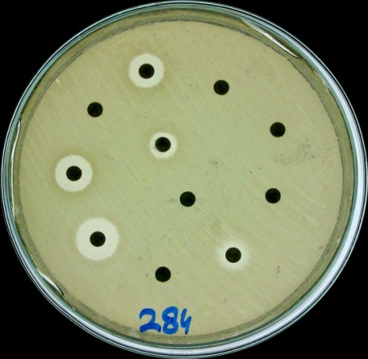
Figure 1: Kirby-Bauer disc for susceptibility testing on Mueller-Hinton agar

Figure 2: Culture plates with ESBL -producing bacterial strains. The plate on the left shows the synergy between clavulanic acid and cefotaxime/ceftazidime, one of the ways of confirming ESBL -production. The plate on the right shows high-grade resistance to a variety of beta-lactam antibiotics.

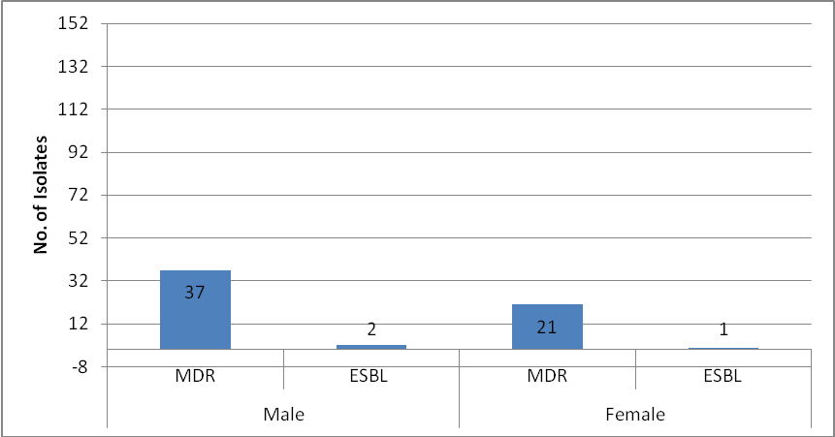
Figure 3: Gender distribution of MDR and ESBL producing isolates
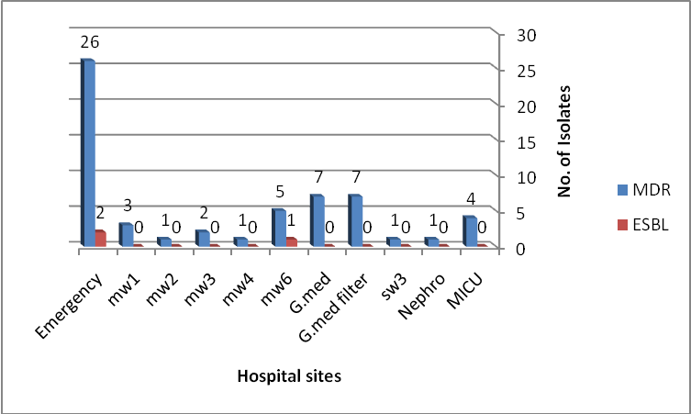

Figure 4: Frequency of MDR and ESBL producing isolates in different hospital sites
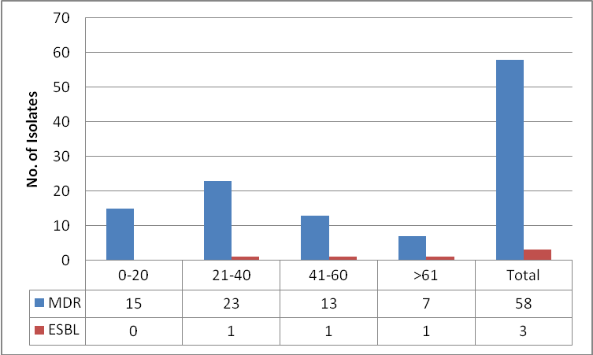

Figure 5a: Age wise distribution of MDR and ESBL producers.
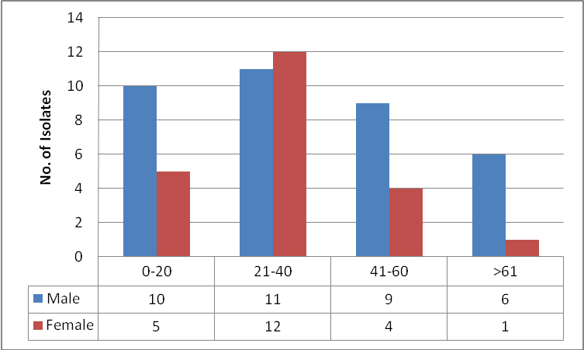

Figure 5b: Distribution of MDR producing isolates in different age groups
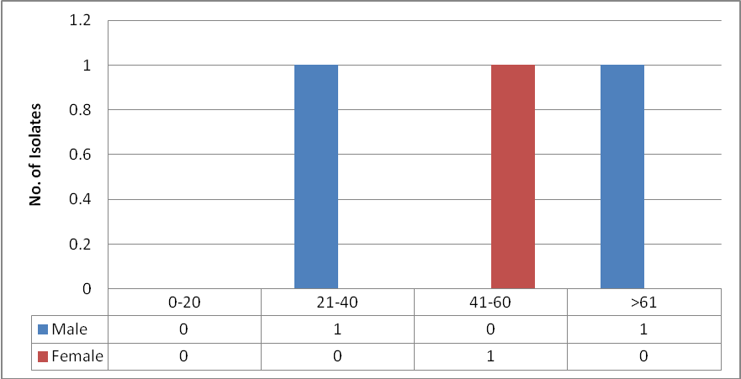

Figure 5c: Distribution of ESBL producing isolates in different age groups
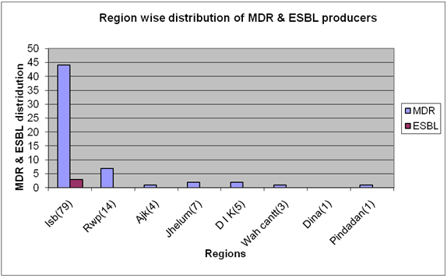

Figure 6: Region wise distribution of MDR and ESBL producers
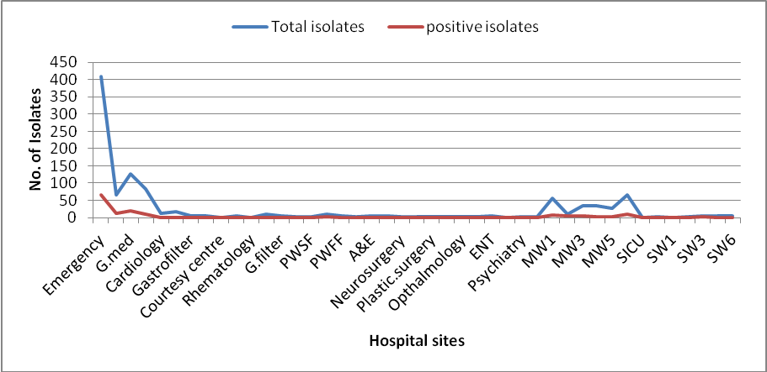

Figure 7: Frequency of total and positive isolates in different hospital sites

Discussion
The emergence and spread of resistance in Enterobacteriaceae are complicating the treatment of serious nosocomial infections and threatening to create species resistant to all currently available agents. Emerging resistance in Enterobacteriaceae is a significant problem that requires immediate attention. Resistance related to production of extended spectrum β lactamases (ESBLs) is a particular problem in the handling of Enterobacteriaceae infections (Paterson et al., 2005). MDR in many Nosocomial pathogens is on the rise, rendering many antimicrobial agents ineffective. Resistance to antimicrobial agents is an increasing public health threat (Cosgrove and Carmeli, 2003).

The present study was conducted to determine the frequency of MDR and ESBL producing isolates from clinical isolates from PIMS Islamabad. This hospital was selected because it has 1000 beds and catchment areas include Khyber Pakhtunkhwa, Punjab, Azad Jammu and Kashmir, Sindh and Balochistan. This study was very important to determine the resistance mechanisms by which the MDR bacterial blood culture isolates have been prevalent in the clinical setup.

In the present study blood culture positivity was seen in 152 (14.39%) cases whereas Khanal et al., 2002; Sharma et al., 2002) have reported 44%, 33.9% and 16.4% respectively. In India, variation might be due to the fact that most of the patients are given the antibiotics before they come to the hospital and other reason is that in most of the cases self medications is very important as the medicines are available at the counter. In concurrent study the incidence of gram positive organisms was (25%) while (75%) isolates were gram negative bacilli. It is in accordance with the study of Sharma et al., (2002) and Khanal et al., (2002) have reported incidence of streptococcus and staphylococcus to be 25% and gram negative bacilli 15%. But in most of the studies gram negative organisms have taken over the gram positive organisms especially in the hospital settings (Chugh et al., 1988).

Most of the gram negative bacilli (50.87%) were MDR. Majority of gram negative isolates as MDR (Sharma et al., 2002). Maximum resistance was seen against Amoxicillin (100%), Nalidixic acid (92%), ciprofloxacin (100%), Amoxicillin + clavulanic acid (100%), co trimoxazole (100%), Cephems (100%), and cefperazone (71%).

High antibiotic resistance and ESBLs rates among K. pneumoniae and E.coli towards commonly used antibiotics are the major reasons for prolonged infections, increased hospitalization, increased cost of therapy and enhanced morbidity mortality rates. Special care must be taken regarding treatment of infections especially in developing countries like Pakistan. Moreover physician must change their prescription priorities towards alternative treatments in management of enteric infections.

Conclusion
So it is concluded that Septicaemia is an important cause of Morbidity and Mortality .The causative agents are acquired in Hospital. The perspective study conducted showed both gram positive and gram negative bacteria were responsible for Septicaemia. Most of the strains were MDR.

Acknowledgements
We are grateful to the Department of Microbiology Hazara University, Mansehra and PIMS (Pakistan Institute of Medical Science) Islamabad for approving and funding to complete this research work.

Transparency declarations
The authors do not have any competing interests

References
Karlowsky JA, Jones ME, Thornsberry C, Friedland IR and Sahm DF (2003). Trends in antimicrobial susceptibilities among Enterobacteriaceae isolated from hospitalized patients in the United States from 1998 to 2001. Antimicrobial Agents Chemotherapy. 47: 1672-1680.
Quale JM, Landman D, Bradford PA, Visalli M, Ravishankar J, Flores C, Mayorga D, Vangala K and Adedeji A (2002). Molecular epidemiology of a citywide outbreak of Extended spectrum β lactamase producing Klebsiella pneumoniae infection. Clinical Infectious Disease. 35 (7): 834-841.
Fritsch TR, Strabala PA, Sader HS, Dowzicky MJ and Jones RN (2005). Activity of tigecycline tested against a global collection of Enterobacteriaceae, including tetracycline Resistant isolates. Diagnostic Microbiology Infectious Disease Journal. 52: 209-213.
Paterson DL, Rossi F and Baquero F (2005). In vitro susceptibilities of aerobic and Facultative Gram negative bacilli isolated from patients with intra abdominal Infections worldwide: the 2003 Study for Monitoring Antimicrobial Resistance Trends (SMART). Journal Antimicrobial Chemotherapy; 55: 965-973.
Kader AA and Kumar AK (2004). Prevalence of extended spectrum beta lactamase among multidrug resistant Gram-negative isolates from a general hospital in Saudi Arabia. Saudi Medical Journal. 25: 570-574.
Ram S, Gupta R and Gaheer M (2000). Emerging antibiotic resistance among the uropathogens. Indian Journal Medical Science. 54: 388-394.
Ahmad M, Urban C, Mariano N, Bradford PA, Calcagni E, Projan SJ, Bush K and Rahal JJ (1999). Clinical characteristics and molecular epidemiology associated with imipenem resistant Klebsiella pneumoniae. Clinical Infection Disease. 29: 352–355.
Cosgrove SE, Carmeli Y (2003). The impact of antimicrobial resistance on health and economic outcomes. Clinical Infectious Disease. 36: 1433-1437.
Khanal B, Harish BN, Sethuraman KR and Srinivasan S (2002). Infective endocarditis: Report of prospective study in an Indian hospital. Tropical Doctor. 32: 83-85.
Sharma M, Goel N, Chaudhary U, Aggarwal R, Arora DR (2002). Bacteraemia in children. Pediatrics. 69: 1029-32.
Chugh K, Aggarwal DB, Kaul VK and Aryase J (1988). Bacteriological profiles of neonatal septicaemia. Pediatrics. 55: 961-67.
Iqbal R, Majid A, Alvi IA, Hayat A, Andaleeb F, Gul S, Irfan S and Rahman MU (2014). Multiple Drug Resistance and ESBL Production in Bacterial Urine Culture Isolates. American Journal of BioScience. 2(1): 5-12.
http//:dx.doi: 10.11648/j.ajbio.20140201.12

