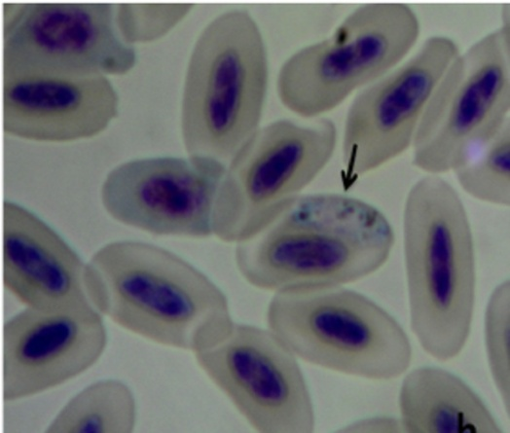
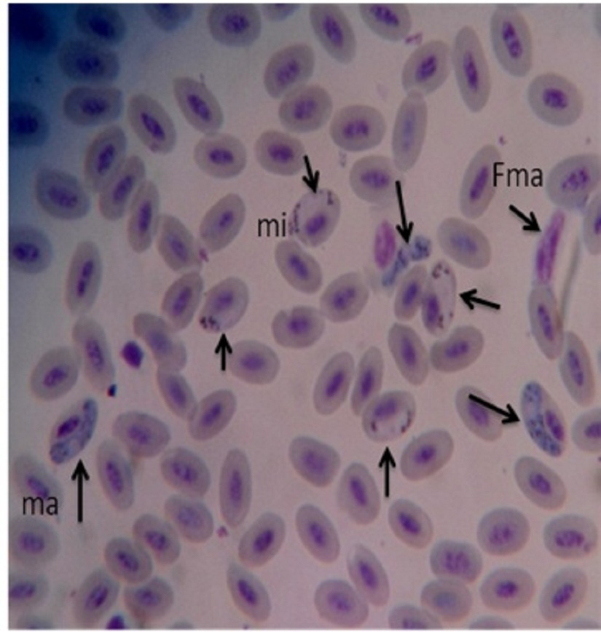
A
B

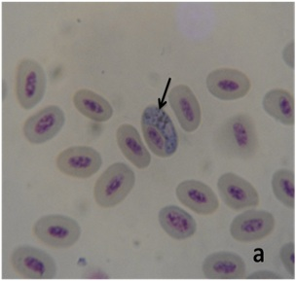
C

Picture 1: A. Macrogametocyte (ma), Microgametocyte (mi) and free gametocyte (Fma) in the blood picture that are released from the erythrocyte
B. Microgametocytes C. Macrogametocytes

