Title page

Title: EAR MITE (Otodectes cynotis) INDUCED OTITIS EXTERNA AND COMPLICATED BY STAPHYLOCOCCI INFECTION IN A PERSIAN CAT

Running title: Ear mite induced otitis externa

Author name: Md. Ahaduzzaman

No of figure: 3

Affiliation and Address: Masters fellow in Medicine, Department of Medicine & Surgery, Chittagong Veterinary & Animal Sciences University (CVASU), Khulshi-4225, Chittagong, Bangladesh.
Email: zaman.cvasu@gmail.com; Mob: +88 01746077242

EAR MITE (Otodectes cynotis) INDUCED OTITIS EXTERNA AND COMPLICATED BY STAPHYLOCOCCI INFECTION IN A PERSIAN CAT
Md. Ahaduzzaman*
Department of Medicine & Surgery, Faculty of Veterinary Medicine, Chittagong Veterinary & Animal Sciences University (CVASU), Khulshi-4225, Chittagong, Bangladesh.

*Corresponding author: Md. Ahaduzzaman; Masters Fellow in Medicine, Department of Medicine & Surgery, Chittagong Veterinary & Animal Sciences University (CVASU), Khulshi-4225, Chittagong, Bangladesh. Email: zaman.cvasu@gmail.com; Mob: +88 01746077242

ABSTRACT
Ear mite induced otitis externa complicated with Staphylococci was determined in a two month old Persian cat. For treatment, two dose of ivermectin @ 0.2 mg/kg body weight was given with 0.3% ciprofloxacin otic drop for seven days. After seven days post treatment clinical symptoms disappeared and in microscopic examination it was found that there were no agents of O. cynotis.

Otodectes cynotis commonly known as ear mite is non-burrowing, white and very active parasite belongs to the member of Psorptidae and the most common cause of ear infection in cats while it is less common in dogs (Maazi et al., 2010). The host’s range of this highly contagious mite is wide enough and includes cats, dogs, foxes, ferrets and infrequently humans (Wiwanitkit, 2011). The cat plays a vital role of transmission in adult dogs, rabbit and ferret (Sasikala, 2011). Cat infested with ear mite results in itching sensation and otitis externa which is manifested by erythematous ear canal and the presence of dark brown ceruminous otic exudates, not necessarily all cats will display symptoms of ear mites but often they will scratch at their ears or shake their heads (Wiwanitkit, 2012). Secondary bacterial (mainly Staphylococci) and fungal (Malassezia spp.) infections are also very common in cats affected by ear mite as being most frequently isolated microorganisms in such cases (Roy et al., 2011). Evidences of risk factors such as age, sex, breed, shape of ear, type and length of hair is usually controversial but contact with other animals act as potential risk factors (Souza et al., 2008). The degree and extent of damage to the ear depends on duration of illness, housing system, litter mates, secondary infection and physiological status of the cat. The diagnosis and management of the disease is laborious and efficacy is controversial in complicated cases as most of the owner are not aware about the ear canal of their pets in comparable to the body coat and also burden for the veterinarian to treat due to unavailability of suitable veterinary product to combat the condition. Therefore, the current therapy was taken to find out the therapeutic outcome of otitis externa caused by O. cynotis complicated with secondary bacterial infection.
Two months old a male Persian cat was admitted to the Thana Veterinary Hospital (Metro), Boalia, Rajshahi, Bangladesh with a history of head shaking and ear scratching. Physical examination revealed bilateral excessive dark brown ceruminous exudates softly attached to the inner surface of pinnae. The exudates were crustier towards the ear canal than the scapha of pinnae (Figure: 1). There was no offensive odor in ear or other abnormalities. Audiometry test was done to check the hearing ability by using sound and recording the cat response toward the sound. The cat noticed normal respond toward the source of sound and was interpreted as normal hearing ability.
Some smears of ear discharge were made for both parasitological and bacteriological examination by cotton swabs. Smears were stained with Gram’s staining methods for evaluation of bacteria as per procedures described by Merchant and Packer (1969). Direct microscopic examination was performed for parasitological examination under light microscope. On microscopic examination of ear swab with liquid paraffin characteristics adult O. cynotis was found (Figure: 2). After Gram’s staining of ear swab Staphylococci were found that confirmed by morphology, appearance and culture property on Mannitol salt agar (selective media) of the bacteria (Figure: 3).
The cat was treated with Ivermectin @ 0.2 mg/kg body weight subcutaneously (Ivertin^{R}, 1%, Chemist Laboratories Ltd., Bangladesh). Repeated dose was done after 15 days interval to break re-infection cycle. Ciprofloxacin 0.3% ear drop (Ciprox^{R}; 10 ml, Opso Saline Ltd., Bangladesh) was used two times a day for seven days. After seven days post therapy cat ear became normal with no exudation and irritation. Re-examination of cerumen was done at the same procedure as previous for parasitological examination but no parasite was noticed.
Otodectes cynotis mites are surface mite that posse’s otitis externa in cats and dogs manifested by intense itching in one or both ears, which in turn triggers scratching at the affected ear. During feeding of superficial epidermis it can cause a hypersensitivity reaction and pyogenic secondary infection. Bacterial infection particularly Staphylococci is a common finding due to their normal inhabitant of skin, nose and ear canal and become pathogenic due to concurrent infection with Otodectes cynotis as agreed with the findings of Petrov et al. (2013). Similarly Salib and Baraka (2011) result showed that specific and mixed infestation of Otodectes cynotis in cats were (24.56%) and (6.57%) respectively in otitis externa.
Age is an important parameter on which pathogenic involvement, prevalence, severity, stage and rate of infection depends on. Lefkaditis et al. (2009) shown that kitten between 3-6 months were more susceptible to Otodectes infestations compared with kittens below 3 months, this disagreed with our cat age but Thompson (2011) found younger cats are more vulnerable to serious mite infestations than adult and this is because the immunity of cats towards mites develops and builds up with age that agreed with our findings.
There are a number of approved medications for ear mites in many countries of the world. Many of these products can be applied directly into the external ear canal depending on availability. Ivermectin is effective against wide group of external and internal parasites. The pharmacokinetics of ivermectin in cats receiving a single dose of 0.2 mg/kg by subcutaneous injection revealed a rapid absorption, high distribution, slow elimination and high possibility for the elimination as described by Chittrakarn et al. (2009) thus it is effective against ear mite infection. Use of topical otic antibiotic is a common practice among the veterinarian to treat ear infection with a good success rate. Mösges et al. (2011) stated that fluroquinolones (ciprofloxacin) showed a trend towards the superiority of cure rate in comparison to non quinolones. Ciprofloxacin is a drug of choice against Staphylococci in the developing country where antibiogram rate is high.
Cat ear mite infection is irritating and challenging clinical problem for its contagious and unwelcome disease nature. This disease is frequently misdiagnosed as otorrhoea that solely related to microbial origin. Proper choice of drug is crucial. Although topical acaricidal otic drugs are more beneficial in terms of therapeutic principle as to application of drug directly to the lesion but where there is no available local preparation like ours, systemic therapy can also be taken as alternative with the success rate.
Author grateful to the animal owner, livestock officer (TLO) and District Livestock Office, Rajshahi for providing laboratory support.

REFERENCES
Chittrakarn S, Janchawee B, Ruangrut P, Kansenalak S, Chethanond U, Kobasa T and Thammapalo S (2009). Pharmacokinetics of ivermectin in cats receiving a single subcutaneous dose. Res. Vet. Sci. 86(3): 503-507.
Lefkaditis MA, Koukeri SE and Mihalca AD (2009). Prevalence and intensity of Otodectes cynotis in kittens from Thessaloniki area, Greece. Vet. Parasitol. 163: 374-375.
Maazi N, Jamshidi SH and Hadadzadeh HR (2010). Ear Mite Infestation in Four Imported Dogs from Thailand; a Case Report. Iran J. Arthropod-Borne Dis. 4(2): 68–71.
Merchant IA and Packer RA (1969). Veterinary Bacteriology and Virology. 7th edn., The Iowa State University Press, Ames, Iowa, USA. 211–305.
Mösges R, Nematian-Samani M, Hellmich M and Shah-Hosseini K (2011). A meta-analysis of the efficacy of quinolone containing otics in comparison to antibiotic–steroid combination drugs in the local treatment of otitis externa. Current Medical Research and Opinion, 27(10): 2053-2060.
Petrov V, Mihaylov G, Tsachev I, Zhelev G, Marutsov P and Koev K (2013). Otitis externa in dogs: microbiology and antimicrobial susceptibility. Revue Méd. Vét. 164(1): 18-22.
Roy J, Bedard C and Moreau M (2011). Treatment of feline otitis externa due to Otodectes cynotis and complicated by secondary bacterial and fungal infections with Oridermyl® auricular ointment. Can. Vet. J. 52: 277–282.
Salib FA and Baraka TA (2011). Epidemiology, genetic divergence and acaricides of Otodectes cynotis in cats and dogs. Vet. World, 4(3): 109-112.
Sasikala V, Saravanan M, Ranjithkumar M, Sarma K, and Vijayakaran K (2011). Management of ear mites in cats. Indian Pet J. 11: 5-9.
Souza CP, Ramadinha RR, Scott FB and Pereira MJS (2008). Factors associated with the prevalence of Otodectes cynotis in an ambulatory population of dogs. Pesq. Vet. Bras. 28(8): 375-378.
Thompson T (2011). http://www.nativeremedies.com/petalive/articles/ear-mites-cats-study-diagnosis-symptoms.shtml (Retrieved on 10.02.2014).
Wiwanitkit V (2012). Role of Molecular Diagnosis for Dog Ear Mite Infestation. Int. J. Mol. Vet. Res. 2(2): 6-7.
Wiwanitkit V (2011). Dog ear mite infestation: a possible problem in public health system. Iran J. Arthropod-Borne Dis. 5(2): 1.
FIGURES
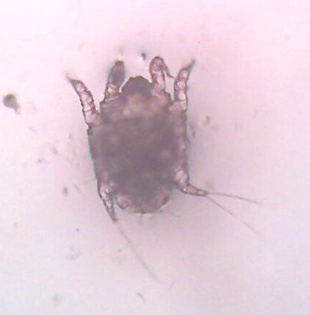
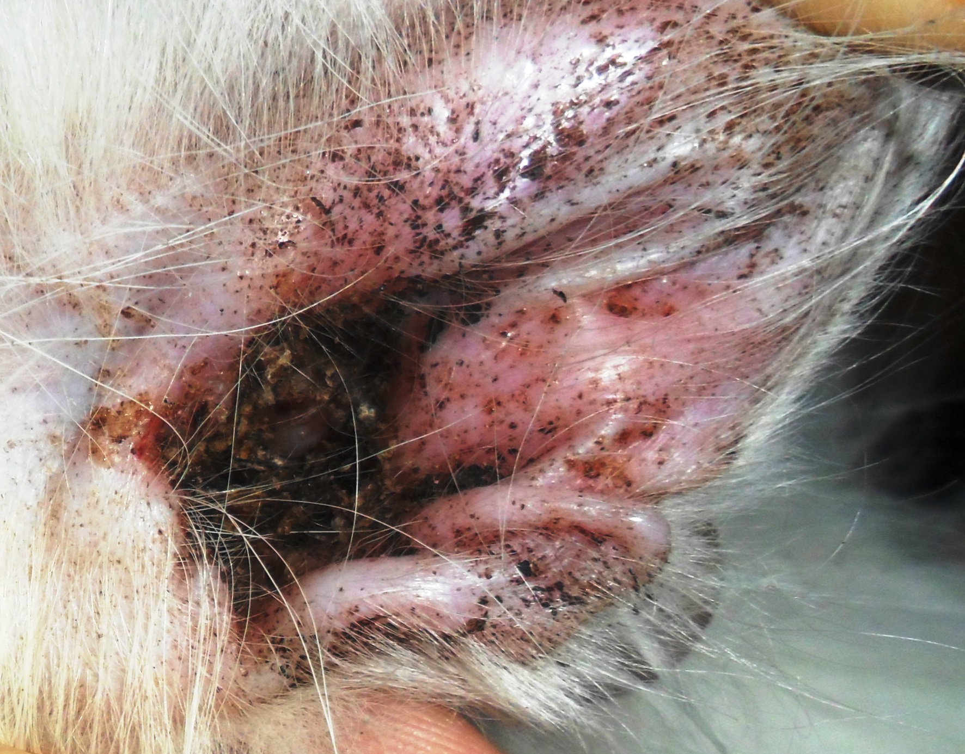

Figure 3: Gram positive, grapes like clustered appearance of Staphylococci after Gram’s staining (100X light microscopy)
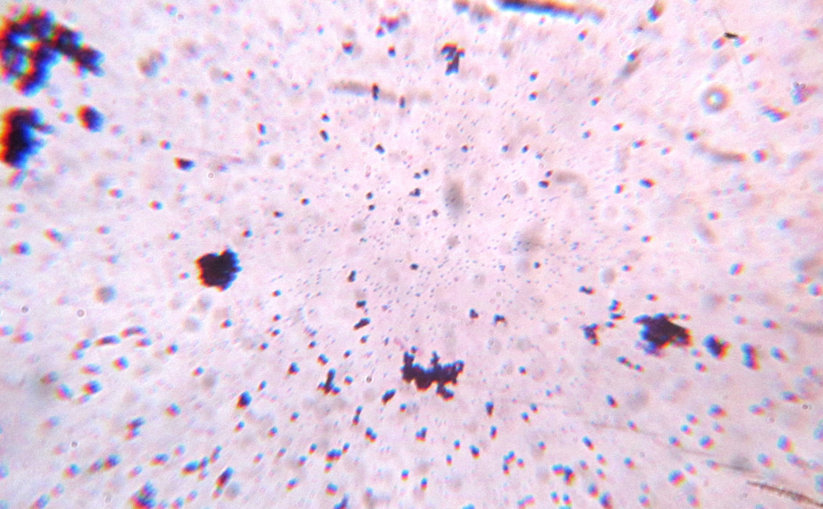
Figure 1: Dark brown ceruminous exudates in the pinna of Persian cat (left ear)
Figure 2: O. cynotis under 10X light microscopy (dorsal view)

