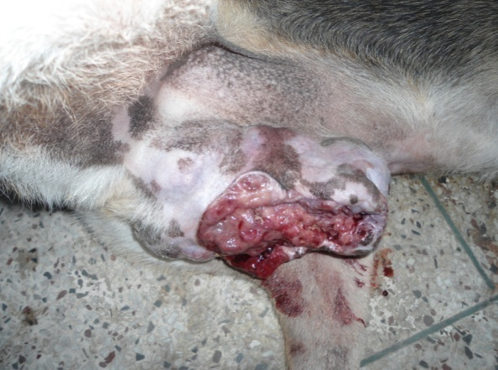
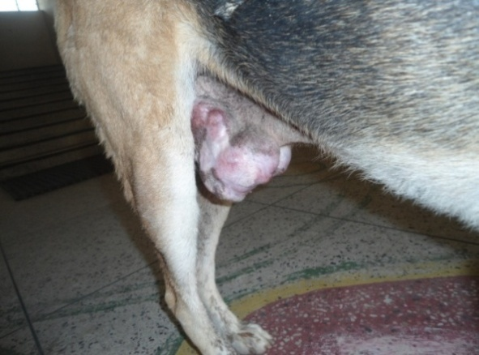

Figure 1: Large cauliflower-like growth, along with bloody discharge from penile region

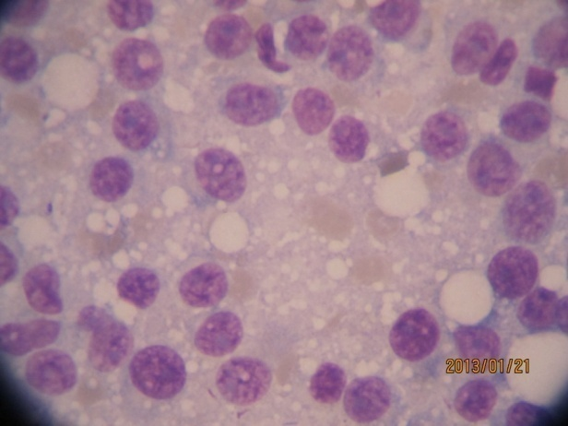

Figure 2: Cytology shows numerous round cells with coarse eccentric nuclei and pale finely granular cytoplasm

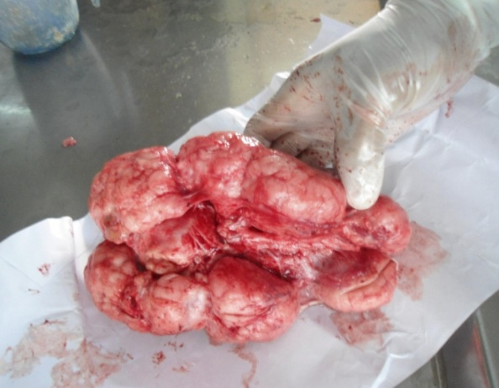

Figure 3: Multiple round to oval, encapsulated nodular mass observed at necropsy

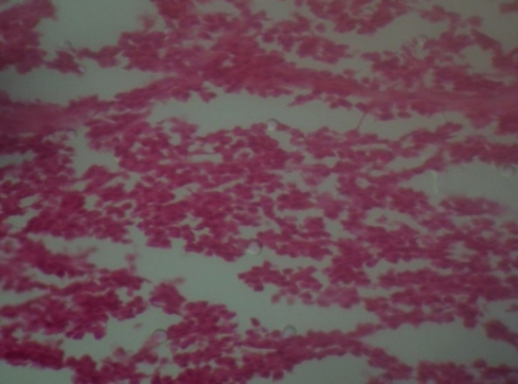

Figure 4: Confluent sheets of round cells arranged in grapes like or strings like appearance in loose stroma

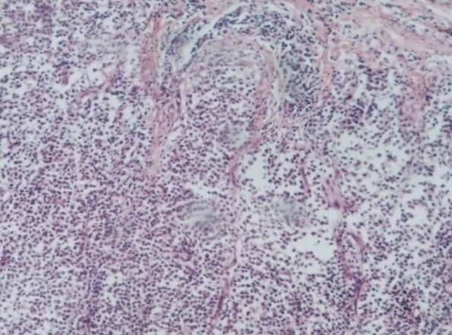

Figure 5: Scanty amount of connective tissue stroma indicate progressive stage of CTVT

