Bacteriophages: Effective Alternative to Antibiotics
Kumaragurubaran Karthik^{1*}, Narayanan Selvaraj Muneeswaran²,
HaranahalliVasanthacharManjunathachar³, Marappan Gopi⁴, Appavoo Elamurugan⁵, Semmannan Kalaiyarasu⁶
¹Division of Bacteriology and Mycology, ²Division of Virology, ³Division of Parasitology, ⁴Division of Animal Nutrition, ⁵Immunology Section, Indian Veterinary Research Institute, Izatnagar,⁶High Security Animal Diseases Labortary, Indian Veterinary Research Institute,Bhopal, India
*Corresponding author: karthik_2bvsc@yahoo.co.in

ABSTRACT
Bacteriophages are the viruses which infect bacteria and hence, they are friendsto human beings. Bacteriophages belong to a group of viruses which have the greatest number of entities in it. There are 10 families of phages which include tailed and sessile phages. Some phages like T4, T7 have an unique structure of having head and tail. Phages follow two patterns of life cycle as lytic and lysogenic cycle. Lytic cycle causes killing of the bacteria and this property is utilized for the phage therapy. Twort and d’Herelle were the two scientists who identified bacteriophage, and contributed immensely to the field of phage therapy. Phages are unique antibacterial agents in their ability to increase their numbers only in the presence of bacterial targets. Bacteriophages are used for the detection of bacteria, typing of bacteria, destruction of biofilms, phage ligand technology, bacteriophage therapy against various infections and phage display. To counteract antibiotic resistance, an increasing menace to the human community, phage therapy is a timely gift. Though bacteria develop resistance to phages rarely, they are less toxic with minimum adverse effects compared to antibiotics and occasionally needs repeated administration. These points favor the use of phages as alternative to antibiotics. Bacteriophage or phage therapy is therefore very useful in various fields like medicine, veterinary science, dentistry, and even agriculture. This current review deals with the history, taxonomy and life cycle of phages, and their uses in veterinary and biomedicine, andthe commercially available phage products.
Keywords: Bacteriophages, Antibiotic alternatives, Phage lysins, Phage therapy
INTRODUCTION
Viruses are the microorganisms which are widespread throughout the world, and infecting almost all organisms showing no mercy even to the bacteria. Phages are the special group of viruses which includes the bacteriophages and virophages. Bacteriophages are viruses that attack and lyse the bacteria in lytic cycle. Since their discovery in 1915, they are fascinating and researchers are working on their therapeutic potential against various drug resistant bacteria (Dhama et al., 2013; Tiwari et al., 2014). Though the advent of antibiotics reduced the importance of phage therapy, it is gaining momentum due to recent emergence of antibiotic resistance. Phages have the unique record of the last three classes of virus to be identified during the period of World War I (Grabow, 2001). Bacteriophages are also used as surrogate viruses for lot of human and animal viruses (Ackermann, 2011). Phages either incorporate its genetic material or remain quiescent in lysogenic cycle but disrupt the bacterial metabolism and causes rupture of bacterial cell wall in lytic cyclePhages are genetically diverse (Hambly and Suttle, 2005) and are known to infect more than 140 bacterial and archeal species in the world. The list of phages is huge, and it lines up in such a fashion that every bacterial species has a pile of bacteriophages to infect them. The number is rising day by day and presently there are around 5360 tailed phages and 179 other phages (Ackermann, 2011). This overwhelming number makes it the largest virus group known. The present review describes the salient features of bacteriophages and their therapeutic potential as well their use as alternative to antibiotics.
History of phages
Phages were unveiled to the universe officially by the work of the French-Canadian microbiologist Felix d’Herelle in 1917, though much has been reported by the English bacteriologist Frederick Twort earlier (Twort, 1915; d’Herelle, 1917). Felix d’Herelle aptly named them as bacteriophages, and he suggested that there is only one phage as Bacteriophagumintestinale and rest others are its races. But the history of phage is still older than what has been documented which is extracted from Greek word ‘phagein’ which means ‘eat’- to eat or devour the bacteria (d’Herelle, 1918). Immediately after their discovery, the thought of using phages to fight bacterial infections was already apparent. Phages were used by the Russians during World War-II, to treat many soldiers infected with various bacterial diseases such as dysentery and gangrene (Abedon et al., 2011). Earlier in 1896, a British bacteriologist named Ernest Hankin reported that there were some unidentified antibacterial agents against Vibrio cholera in Ganges and Yamuna rivers of India (Hankin, 1896). Gamaleya, a Russian bacteriologist when working on Bacillissubtilis also recorded a similar phenomenon (Samsygina and Boni, 1984). Soon after his discovery of phages, d’Herelle started working on the therapeutic potential of the bacteriophages against the bacteria which causes dysentery. Felix d’Herelle used the phages against patients suffering from bacterial dysentery and this study yielded a good response with patients showing reduced clinical symptoms but these results were not recorded properly. Richard Bruynoghe and Joseph Maisin were credited for their work on phage therapy against staphylococcal skin disease,and first time documented it (Bruynoghe and Maisin, 1921).
Taxonomy of Phages
Sir Macfarlane Burnet initiated the classification of phages in 1937 while he observed the difference in size and activity against various physiochemical agents (Burnet, 1933) where as H. Ruska suggested the classification based on their shape and structure visualized under electron microscope (Ruska, 1943). Holmes in 1948 classified whole viruses into three major families namely Phaginae, Phytophaginae and Zoophaginae (Holmes, 1948). Phages come under the family of Phaginae according to his classification.Lwoff, Horne and Tournier in 1962 proposed that the classification of viruses should be based on the nucleic acid properties and their system had latinised naming system (Lwoff et al., 1962). In the year 1971, International Committee on Taxonomy of Viruses (ICTV) classified phages in to six genera which are as follow: the φX group, filamentous phage, lipid phage PM2, T-even phages, λ phage, and the ribophage group (Ackermann, 2009). Abeles et al. (1984) classified phages based on a handful of characters like morphology, physical, chemical properties, nucleic acid possession, host, pathogenesis and behavior in the environment. Goyal et al. (1987) classified phages into three groups based on their receptorson the host. According to this classification, the phages may be of:
- Somatic phages- receptors present on the cell wall
- Capsular phages- receptors present on the capsular polysaccharide
- Appendage phages- receptors present on the appendages like flagella, pili or fimbriae
According to the ICTV classification, phages have been classified under the order Caudoviralesand there are about 10 families. Like other viruses, phages too have either DNA or RNA which may be either single stranded or double stranded. They may be either filamentous or pleomorphic in shapes which is unique, and may also have a tail (tailed phages) (Ackermann, 2011). Caudovirale is the order under which both tailed phages and sessile phages are grouped. The tail in the tailed phages varies in their length and based on the criteria, they are further grouped into three families as Myoviridae, Siphoviridaeand Podoviridae.Myoviridae includes the phages which have contractile tail, Siphoviridae includes phages which have long tail but they are non-contractile and Podoviridae includes phages which have short tail (Fauquet et al., 2005). These tailed phages are a large group of viruses which account for 96% of the phages. There are seven other families of filamentous, pleomorphic phages which come under unassigned group as per the recent classification of ICTV 9th report. List of phages with details about shape and structure is given in table 1.
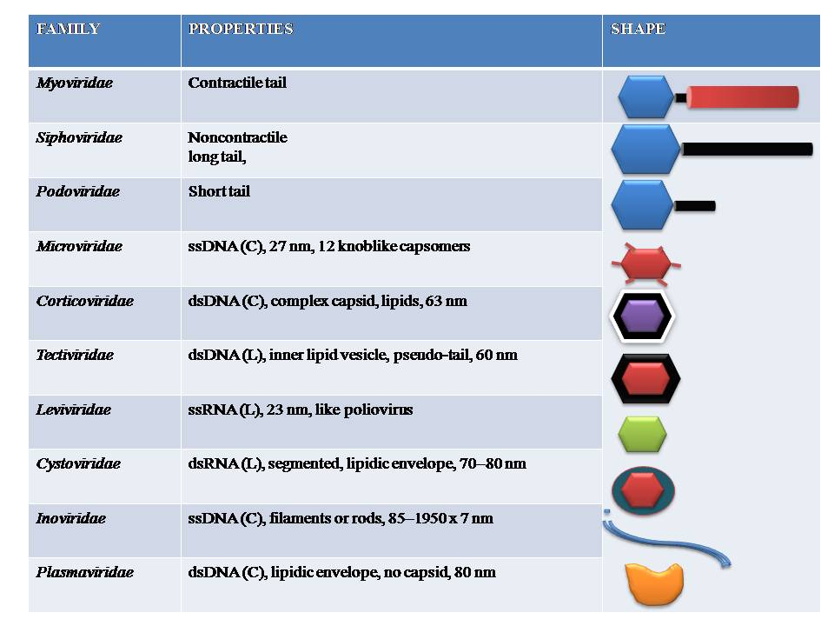
Table 1: Taxonomy of Bacteriophages
Replication of phages
To replicate inside the host, bacteria the first step in phage life cycle is the attachment of phage to the host membrane. Attachment is mediated by the presence of the tail in case of tailed phages, while in sessile phages; it is driven in by some other structures which are present over their surface. This binding is mostly reversible. Followed by attachment, the next important process is the penetration of nucleic acid. Penetration is achieved by two ways either by the contraction of tail or by the presence of some specialized enzymes which cause the distortion of the bacterial cell membranes. The hollow tail of the phage forms a pore over the cell membrane through which the phage nucleic acid makes its entry into the bacterial cell. The phage without the nucleic acid remains attached to the cell wall of bacteria as a ghost. Most of the phages are the host specific and sometimes a bacterium can be made susceptible to a phage through artificial means of transfection. Once gaining entry into the host, the nucleic acid has two ways to propagate itself.
In case of lytic cycle, phage causes the lysis of the bacterial cell once the replication cycle is completed.They take over the machinery of the cell to make phage components. Immediately after the entry of nucleic acid into the bacterial cell, eclipse period starts and at this moment not even a single infectious phage particle can be found either outside or inside the bacterial cell. Replication cycle is similar to the replication cycle of all viruses in that once the nucleic acid is formed; it is packaged into the head, followed by the assembly of tail. The cell wall of the bacteria is weakened by the phage enzymes which lead to the rupture of the membrane and ultimately the mature phages make their release from the infected bacterial cell (Skurnika and Strauch, 2006). A key difference between the lytic and lysogenic phage cycles is that in the lytic phage, the viral DNA exists as a separate molecule within the bacterial cell, and replicates separately from the host bacterial DNA without integration. Figure 1 show the steps involved in lytic cycle phage.
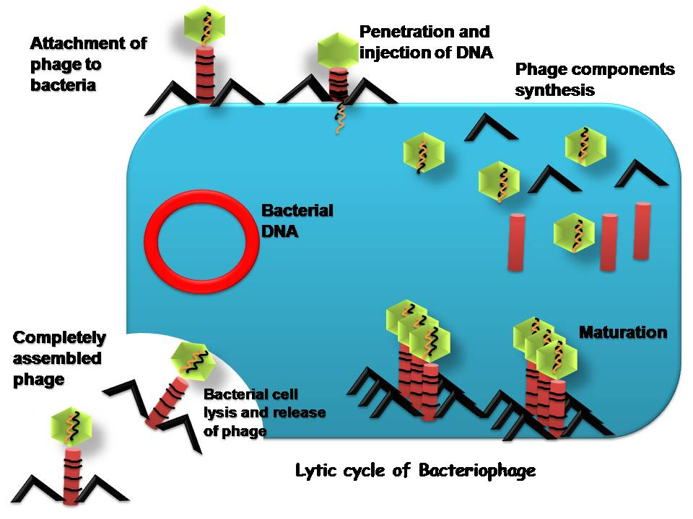
Figure 1: Steps during lytic cycle of Bacteriophage
Temperate or lysogenic phages are either undergo lytic cycle or can integrate its nucleic acid with the host genome, and can remain dormant. Integration of nucleic acid causes the transfer of phage nucleic acid to daughter bacteria. Integrated phage is also called as prophage and the bacteria harboring this prophage are called as lysogenic bacteria. Due to the integration of phage nucleic acid, the properties of the bacteria may vary and this process is called as lysogenic or phage conversion (Skurnika and Strauch, 2006). The exposure to UV or other radiations, some chemicals etc may lead to termination of this lysogenic cycle and induces startof lytic cycle. This process is called induction.
Uses of Bacteriophages
Bacteriophages are currently used for the diagnosis and typing of a particular bacterial species. Each bacteriophage has a specific affinity for a particular bacterium which helps in typing of that particular bacterium. The most useful aspect of bacteriophage is the phage therapy against bacterial infection which yields promising results. Bacteriophages have also been successfully used against bacterial biofilms. In case of therapeutic approach, bacteriophages could be used either directly or genetically modified form. Bacteriophages are also widely used in food industry to minimize the bacterial load and phages are also used in phage display (Westwater et al., 2003).

Phage endolysins or lysins are enzymes that cause damage to the cell wall’s integrity by hydrolyzing the four major bonds in its peptidoglycan component; it can be used as antimicrobilas. Phage lysins have been used in veterinary field mainly to control mastitis which is of major importance economically. Ply700 lysin has very good effect on Streptococcal organisms that are involved bovine mastitis. LysH5 lysin acts against Staphylococcus organisms causing mastitis in cattle (Obeso et al., 2008). LySMP has broad spectrum of activity against Streptococcus suis, swine pathogen causing endocarditis and is also a zoonotic pathogen (Lun et al., 2007). Ply3626, a lysin against Clostridium perfringens, showed good effect in controlling the pathogen in poultry houses. Ply511 is a Listeriamonocytogenes phage lysin used to control Listeria infection in dairy products (Gaeng et al., 2000).
Bacteriophages have also been used as diagnostics for the detection of food borne pathogens like Enterobacter, E. coli, Salmonella and Staphylococcus. Biosensors based on phages are rapidly growing and gaining its importance in food industries (Clark and March, 2006). Bio detectors based on either whole phage or phage proteins like tail-spike protein of Salmonella phage P22 are used. Phages and their proteins immobilized on atomic force microscopy can detect pathogens and used for Salmonella detection. Immobilization of phages on silica particles also guarantees cheap and effective method of pathogen detection. Phage based bio sensors can be linked to PCR based systems for better detection efficacy (Pettya et al., 2006). Recombinant phages like phage against Vibrioharveyi carrying luxAB genes, when enters the bacterium undergoes usual replication and this gene is incorporated into the bacterium. While detecting the bacteria, an illumination is produced due to the presence of luxAB gene which confirms Vibrioharveyiinfections (Loessner et al., 1996; Oda et al., 2004). Infection of pathogenic phage leads to release of many particles of phage origin. These particles can be detected by other non pathogenic bacteria by this way the primary pathogenic bacteria can be detected. Streptavidin-coated quantum dots and phages tagged with biotins can be used as a detection system as well (Edgar et al., 2006). A newer technology called as Sensing of phage-triggered ion cascade (SEPTIC) uses phage DNA which when injected into a bacterium causes pore in their membrane thus causing the release of ions from the formed bacterial pore (Dobozi-King et al., 2005). When the amount of released ion is 10⁸/ cell a sensor can detect this by the voltage change between the two capacitors (Kish et al., 2005). The major advantage of this technique is that the bacteria need not be cultured for this and hence bacteria which are zoonotic or harmful can be detected based on this method. A chip based on this SEPTIC technique with several bacterial phages can detect simultaneously many bacteria at a single point of time (Pettya et al., 2006).
Need of phage therapy
Currently, there is a huge problem of antibiotic resistance throughout the world in both human and animal medicine (Davies and Davies, 2010). As evolution over the time period is the basic properties of bacteria, it has its own time frame within which it develops resistance against an antibiotic to which it was susceptible earlier. Staphylococcus is the most common bacterium which develops resistance to most antibiotics (Davies and Davies, 2010).Methicillin resistant S. aureus, Vancomycin resistant S. aureus and - lot more versions has come which are hunting the animals and human (Housby and Mann, 2009). Similarly, a pile of Mycobacterium species developed resistance to most of the known antibiotics. A group of bacteria termed as ESKAPE (Enterococcus faecalis, S. aureus, Klebsiella, Acinetobacterbaumanii, Pseudomonas aeruginosa and Escherichia coli) which are superbugs, causes a major concern to the physician (Kutateladze and Adamia, 2010).
Advantages of bacteriophages over antibiotics
Bacteriophages target very specifically and cause lysiswhere as antibiotics harm normal flora also due to its broad spectrum nature. Due to its replicative nature, there is no need to administer repeatedly. Most of the phages can be administered orally as they can survive in gastric environment (Tiwari et al., 2011; Tiwari et al., 2014), and are even lethal to antibiotic resistant bacteria. Because of minimal side effects, they are considered safe (Mattey and Spencer, 2008).
Problems associated with phage therapy
Due to its very narrow host range, treating the patient with mixed infections is difficult. There are exaggerated claims of effectiveness of commercially available phage preparations. One such example is a preparation called Enterophagus which was marketed as being effective against herpes infections, urticaria, and eczema conditions; but the preparation was not effective (Sulakvelidze et al., 2001). Also, there is lack of understanding of the heterogeneity and mode of the action of the phages.
Key considerations before phage therapy
Identification of causative agent followed by screening with a library of phages is the primary consideration. Availability of number of known phages in the laboratory should be ensured always. The selected phage should have a lytic life cycle because in lysogenic life cycle there will be an integration of its genome with that of host genome, and does not cause much damage to the host leading to failure in the phage therapy (Goodridge, 2010). A cocktail of phages should be used so that risk of resistance development could be nullified or minimized (Merril et al., 2006). The phage should not have any toxin gene or any other deleterious gene which may be harmful to human or animal. To prevent this, selected phages should be sequenced and characterized completely in order to know the genome content.
Therapeutic and clinical experience with phage therapy
Bacteriophages are used both externally and internally in human medicine to treat some complications and diseases which are not cured by antibiotics. Bacteriophage wetted in biodegradable films gave good relief to patients affected having the ulcers, and the ulcers healed quickly (Markoishvili et al., 2002). Commercial product named PyoPhage which is effective against Pseudomonas aeruginosa(Soothill, 1999), Escherichia coli, Staphylococcusaureus,StreptococcusandProteushas been used for healing the ulcers (Abedon et al., 2011). Phage derived from sewage could act well against Staphylococcusaureus which causes wound abscess (Wills et al., 2005). Studies indicated that the intra-peritoneal injection of bacteriophage against P. aeruginosa infection causes reduced infection in mice (McVay et al., 2007). Oral administration of bacteriophage can prevent diarrhea caused by E. coli in calves (Smith and Huggins, 1987). Similarly oral administration of phage could also prevent the sepsis caused by P. aeruginosa(Watanabe et al., 2007). Intramuscular preparations have also been tried against E. coli in chickens which showed good results against septicemia (Barrow et al., 1998). Phages against vancomycin-resistant Enterococcus faeciumprevented mice from death (Biswas et al., 2002). Phages against Acinetobacterbaumanii, P. aeruginosa and S. aureusalso had good results in mice models (Soothill, 1992). Use of phage has resulted in reducing the dissemination of SalmonellaTyphimurium, one of the prime foes for the swine industry (Ahmad et al., 2002; Garcia et al., 2008; Gyles, 2008).
Use of phage in poultry industry is gaining importance due the problem of antibiotic resistance which enters the food chain to human. Studies have been conducted for the use of phages specific to pathogens of poultry like SalmonellaGallinarum and E. coli. EC-Nid1 and EC-Nid are the two phages isolated from sewage water and poultry litter, proved to be highly effective against O1, O2 and O78 serotypes of E. coli. INT-401 is a bacteriophage cocktail which has controlled the problem of necrotic enteritis in chickens caused by Clostridium perfringens(Miller et al., 2010). Phages like CP8 and CP34 has been used successfully against Campylobacter jejuniinfections in poultry (Loc Carrillo et al., 2005; Loc Carrillo et al., 2007). There is reduction in the load of Salmonella and Campylobacter organisms in the poultry meat when a multivalent/cocktail of lytic bacteriophages are used, helping the meat industry to produce a safe and good quality meat (Carvalho et al., 2010; Connerton et al., 2011).Contamination of poultry products with Listeria spp. is a major problem both to the poultry industry, and also to end users as the pathogen is zoonotic. FDA has approved for the use of phages against Listeria spp. in ready to eat meat so as to eliminate the zoonotic pathogen (Soni et al., 2010). Various routes of the phage administration like oral, aerosol and intra-muscular injections were tried to control the dissemination of Salmonella through poultry meat (Toro et al., 2005; Bori et al., 2008).
ListexP-100 is a product marketed by Dutch company EBI, and it is an effective product against Listeria. Further, it is tested for its efficacy showing effective against Listeria and it lyse almost all organism, and it showed a complete reduction in viable counts of Listeria without any toxic effects (Carlton et al., 2005). This product is approved by FDA in 2006 for commercialization (Monk et al., 2010). Similar product which acts against L. monocytogenes causing food poisoning is produced by a US based company Intralytix, and is known asListShield (Lu and Koeris, 2011).Similarly, Intralytix also claimed to have developed a bacteriophage based product against E. coli O157. FASTPlaqueTBTM is a commercial diagnostic kit for the detection of Mycobacteriumtuberculosis from the sputum of human samples. This is marketed by Biotec Laboratories (Ipswich, UK), and now the test has been combined with PCR to increase its effectiveness (Botsaris et al., 2010). MicroPhage is another system used to detect MRSA (Lu and Koeris, 2011). Agriphage is a product for treatment of tomato and pepper spot, and it is marketed by US based firm Omilytics (Lu and Koeris, 2011).
CONCLUSION
Bactriophages causes the destruction of harmful bacteria in human as well as animal, they can be considered a good option to treat even antibiotic resistant microorganisms. Bacteriophages have vast utilities which make them friend to human, and the most dangerous enemy to bacteria. Lytic and lysogenic phages are present in the environment but lytic phages are used for phage therapy, becauselysogenic phage integrates its genome into the bacterium and hence,it is unable to kill the bacterium. Phage therapy has many other potential benefits, and giving it ample support can pave the way to a healthier future. Phage therapy is gaining importance day by day in the community because of the increase in the antibiotic resistance scenario in the population. Unlike antibiotics which may produce contraindications, these bacteriophages are natural and produce no or few unwanted effects when used for treatment. There are a lot of positive points on phages which recommends the use of phage over antibiotics for the prevention and cure of bacterial diseases. Lot of phage based products is making their entry into the market which shows good result for what they are intended to. Hence, future research on bacteriophage will show the world regarding its potential to treat infections caused by MDR bacterial pathogens.
REFERENCES
Abedon ST, Kuhl SJ, Blasdel BG and Kutter EM (2011).Phage treatment of human infections.Bacteriophage. 1: 66-85.
Abeles AL, Snyder KM andChattoraj DK (1984). P1 plasmid replication: Replicon structure. J. Mol. Biol. 17: 307-324.
Ackermann HW (2009).Phage classification and characterization.In Bacteriophages.Methods and Protocols, Vol. I, Isolation, Characterization, and Interactions (Clokie M.R.J. and Kropinski A.M., eds), Methods Mol.Biol. 501: 127–140, Humana Press, Clifton, NJ.
Ackermann HW (2011). Bacteriophage taxonomy.Microbiol Aust. 32: 90-94
Ahmad SI (2002).Treatment of post-burns bacterial infections by bacteriophages, specifically ubiquitous Pseudomonas spp. notoriously resistant to antibiotics. Med. Hypotheses. 58: 327–331.
Barrow P, Lovell M and Berchieri A (1998). Use of lytic bacteriophage for control of experimental Escherichia coli septicemia and meningitis in chickens and calves. Clin.Diagn. Lab. Immunol.5: 294-298.
Biswas B, Adhya S, Washart P, Paul B, Trostel A, Powell B, Carlton R andMerril C (2002). Bacteriophage therapy rescues mice bacteremic from a clinical isolate of vancomycin-resistant Enterococcus faecium. Infect.Immun. 70: 204-210.
Borie C, Albala I, Sanchez P, Sanchez ML and Ramirez Sand Navarro C (2008). Bacteriophage treatment reduces Salmonella colonization of infected chickens. Avian Dis. 52: 64-67.
Botsaris G, Liapi M, Kakogiannis C, Dodd C and Rees C (2010).Application of a rapid and sensitive combined phage-PCR method for the detection of Mycobacteriumavium subspecies paratuberculosis in raw milk.In Proceedings of the 10th International Colloguium on Paratuberculosis, pp. 25–28. USA: IntAssoParatubercul.
Bruynoghe R and Maisin J (1921).Essais de the´rapeutique au moyen du bacteriophage.C. R. Soc. Biol. 85: 1120–1121.
Burnet FM (1933).The classification of dysentery-coli bacteriophages. III. A correlation of the serological classification with certain biochemical tests. J. Pathol. Bacteriol.37, 179–184.
Carlton RM, Noordman WH, Biswas B, de Meester ED and Loessner MJ (2005). Bacteriophage P100 for control of Listeria monocytogenes in foods: genome sequence, bioinformatics analyses, oral toxicity study, and application. Regul.Toxicol.Pharmacol. 43: 301–312.
Carvalho CM, Gannon BW, Halfhide DE, Santos SB, Hayes CM, Roe JM and Azeredo J (2010).The in vivo efficacy of two administration routes of a phage cocktail to reduce numbers of Campylobacter coli and Campylobacter jejuni in chickens.BMC Microbiol.10: 232.
Clark JR and March JB (2006). Bacteriophages and biotechnology: vaccines, gene therapy and antibacterials. Trends Biotechnol. 24(5): 212-218.
Connerton IF, Connerton PL, Barrow P, Seal BS and Atterbury RJ (2008).Bacteriophage therapy and Campylobacter. In: Nachamkin I, Szymanski CM and Blaser MJ (eds) Campylobacter. Washington, DC: ASM Press, pp. 679-693.
d’Herelle F (1917). Sur un microbe invisible antagoniste des bacillus dysentériques. C.R. Hebd. Seances Acad. Sci. D.165: 373–375.
d’Herelle F (1918).Technique de la recherche du microbe filtrant bacteriophage (Bacteriophagumintestinale).C. R. Seances Soc. Biol. Filiales.81, 1160–1162.
Davies J and Davies D (2010).Origins and evolution of antibiotic resistance.Microbiol. Mol. Biol. Rev. 74: 417–433
Dhama K, Chakraborty S,Mahima, Wani MY, Verma AK, Deb R, Tiwari R and Kapoor S (2013). Novel and emerging therapies safeguarding health of humans and their companion animals: a review.Pak. J. Biol. Sci. 16(3): 101-111.
Dobozi-King M, Seo S, Kim JU, Young R, Cheng M and Kish LB (2005). Rapid detection and identification of bacteria: SEnsing of Phage-Triggered Ion Cascade (SEPTIC). J. Biol. Phys. Chem. 5: 3–7.
Edgar R, McKinstry M, Hwang J, Oppenheim AB, Fekete RA, Giulian G, Merril C, Nagashima K and Adhya S (2006).High-sensitivity bacterial detection using biotintagged phage and quantum-dot nanocomplexes.U. S. A. 103: 4841–4845.
Fauquet CM and Fargette D (2005).Virus Taxonomy.VIIIth Report of the International Committee on Taxonomy of Viruses, pp. 7, 43–94, 279–299, 443–446, 741–749, Elsevier Academic Press.
Gaeng S, Scherer S, Neve H and Loessner MJ (2000).Gene cloning and expression and secretion of Listeria monocytogenesbacteriophage-lytic enzymes in Lactococcuslactis.Appl. Environ. Microbiol.66: 2951-2958.
Garcia P, Martínez B, Obeso JM and Rodríguez A (2008).Bacteriophages and their application in food safety.Lett. Appl. Microbiol. 47(6): 479-485.
Goodridge L (2010).Designing phage therapeutics.Curr. Pharm. Biotechnol. 11: 15–27.
Goyal SM, Gerba CP and Bitton G (1987).Phage Ecology. John Wiley and Sons, New York. pp.321.
Grabow WOK (2001). Bacteriophages: Update on application as models for viruses in water. Water SA. 27: 251-268.
Gyles CL (2008).Antimicrobial resistance in selected bacteria from poultry.Anim. Health Res. Rev.9: 149-158.
Hambly E andSuttle CA (2005).The viriosphere, diversity, and genetic exchange within phage communities.Curr.Opin.Microbiol.8: 444–450.
Hankin E H (1896).L’action bactericide des eaux de la Jumna et du Gangesur le vibrion du cholera. Ann. Inst. Pasteur.10: 511-523.
Holmes FO (1948). Order Virales. In Bergey’s Manual of Determinative Bacteriology (6th edn) (Breed, R.S. et al., eds), pp. 1126–1286. Williams & Wilkins, Baltimore, MD.
Housby JN and Mann NH (2009).Phage therapy.Drug Discov.Today. 14: 536-540.
Kish LB Cheng M, Kim JU, Seo S, King MD, Young R, Der A and Schmera G(2005). Estimation of detection limits of the phageinvasion- based identification of bacteria. Fluctuation and Noise Letters. 5: L105–L108.
Kutateladze M and Adamia R (2010).Bacteriophages as potential new therapeutics to replace or supplement antibiotics.Trends Biotechnol. 28(12): 592-595.
Loc Carrillo C, Atterbury RJ, El-Shibiny A, Connerton PL, Dillon E, Scott A and Connerton IF (2005).Bacteriophage therapy to reduce Campylobacter jejuni colonization of broiler chickens. Environ.Microbiol. 71: 6554-6555.
Loc Carrillo C, Connerton P, Pearson T and Connerton I (2007).Free-range layer chickens as a source of Campylobacter bacteriophage.Antonie van Leeuwenhoek. 92: 275-284.
Loessner MJ, Rees CE, Stewart GS and Scherer (1996). Construction of luciferase reporter bacteriophage A511: luxAB for rapid and sensitive detection of viable Listeria cells. Appl. Environ. Microbiol. 62: 1133–1140.
Lu TK and Koeris MS (2011).The next generation of bacteriophage therapy.Curr.Opin.Microbiol.14:524–531.
Lun ZR, Wang QP, Chen QG, Li AX and Zhu XQ (2007).Streptococcus suis: an emerging zoonotic pathogen. Lancet Infect. Dis.7: 201-209.
Lwoff A et al. (1962).A system of viruses.In Basic Mechanisms in Animal Virology. Cold Spring Harbor Symposia on Quantitaive Biology 27: 51–62.
Markoishvili K, Tsitlanadze G, Katsarava R, Morris G and Sulakvelidze A (2002). A novel sustained-release matrix based on biodegradable poly(ester amides) and impregnated with bacteriophages and an antibiotic shows promise in management of infected venous stasis ulcers and other poorly healing wounds. Int. J. Dermat. 41:453-458.
Mattey M and Spencer J (2008). Bacteriophage therapy—cooked goose or Phoenix rising? Curr.Opin.Biotechnol. 19: 608–612.
McVay C, Vela´ squez M and Fralick J (2007). Phage therapy of Pseudomonas aeruginosa infection in a mouse burn wound model. Antimicrob.Agents Chemother.51:1934-1938.
Merril C, Scholl D and Adhya S (2006).Phage therapy.In The Bacteriophages (Calendar, R., ed.), pp. 725–741, Oxford University Press.
Miller RW, Skinner EJ, Sulakvelidze A, Mathis GF and Hofacre CL (2010). Bacteriophage therapy for control of necrotic enteritis of broiler chickens experimentally infected with Clostridium perfringens. Avian Dis. 54: 33-40.
Monk AB, Rees CD, Barrow P, Hagens S and Harper DR (2010). Bacteriophage applications: where are we now? Lett. Appl. Microbiol. 51: 363–369.
Obeso JM, Martinez B, Rodriguez A and Garcia P (2008).Lytic activity of the recombinant Staphylococcal bacteriophage phiH5 endolysin active against Staphylococcusaureusin milk.Int. J. Food Microbiol.128: 211-218.
Oda M, Morita M, Unno H and Tanji Y (2004). Rapid detection of Escherichia coli O157:H7 by using green fluorescent protein-labeled PP01 bacteriophage. Appl. Environ. Microbiol. 70: 527–534.
Pettya NK, Evansa TJ, Finerana PC and Salmond GPC (2006).Biotechnological exploitation of bacteriophage research.Trends Biotechnol. 25: 1-14.
Ruska H (1943).VersuchzueinerOrdnung der Virusarten.Arch.Virol. 2: 480–498.
Samsygina GA and Boni EG (1984).Bacteriophages and phage therapy in pediatric practice.Pediatria. 4: 67–70.
Skurnik M and Strauch E (2006). Phage therapy: facts and fiction. Int. J. Med. Microbiol. 296:5-14.
Smith H and Huggins B (1987).The control of experimental Escherichia coli diarrhea in calves and in their environment.J. Gen. Microbiol. 133: 1127-1135.
Soni KA, Nnnapaneni R and Hagens S (2010). Reduction of Listeria monocytogenes on the surface of fresh channel catfish fillets by bacteriophage Listex P100. Foodborne Pathog. Dis. 7: 427-434.
Soothill J (1992).Treatment of experimental infections of mice with bacteriophages.J. Med. Microbiol. 37: 258-261.
Soothill J (1994). Bacteriophage prevents destruction of skin grafts by Pseudomonas aeruginosa. Burns. 20: 209-211.
Sulakvelidze MA, Alavidze Z and Glenn J (2001).Bacteriophage therapy.Antimicrob.Agents Chemother.45:649-659.
Tiwari R, Dhama K, Wani MY, Verma V, Vaid RK and Chauhan RS (2011). Bacteriophage therapy: anovel tool for combating bacterial diseases of poultry - areview. J Immuno and Immunopathol. 13: 55-66.
Tiwari R, Dhama K, Chakroborty S, Kumar A, Rahal A and Kapoor S (2014). Bacteriophage therapy for safegaurding animal and human health: areview. Pak. J. Biol. Sci. 17: 301-315.
Toro H, Price SB, McKee AS,Hoerr FJ, Krehling J, Perdue M and Bauermeister L (2005). Use of bacteriophages in combination with competitive exclusion to reduce Salmonella from infected chickens. Avian Dis. 49: 118- 124.
Twort FW (1915).An investigation on the nature of ultra-microscopic viruses.Lancet ii.1241–1243.
Watanabe R, Matsumoto T, Sano G, Ishii Y, Tateda K, Sumiyama Y, Uchiyama J, Sakurai S, Matsuzaki S, Imai S and Yamaguchi K (2007).Efficacy of bacteriophage therapy against gutderived sepsis caused by Pseudomonasaeruginosa in mice.Antimicrob.Agents Chemother.51: 446-452.
Westwater C, Kasman LM, Schofield DA, Werner PA, Dolan JW, Schmidt MG and Norris JS (2003). Use of genetically engineered phage to deliver antimicrobial agents to bacteria: an alternative therapy for treatment of bacterial infections. Antimicrob.Agents Chemother.47: 1301-1307.
Wildy P (1971).Classification and nomenclature of viruses.First Report of the International Committee on Nomenclature of Viruses. S. Karger, Basel.
Wills Q, Kerrigan C and Soothill J (2005). Experimental bacteriophage protection against Staphylococcus aureus abscesses in a rabbit model. Antimicrob.Agents Chemother.49: 1220-1221.

