NEW APPROACHES FOR DIAGNOSIS OF VIRAL DISEASES IN DOMESTIC AND WILD ANIMALS

Minakshi Prasad¹, Koushlesh Ranjan¹, Basanti Brar¹, Supriya Ambawat¹, Mukhtar Shafiq¹, Alisha Alisha¹, Pawan Kumar¹, Vinay joshi Ganesharao¹, Savi Jakhar¹, Shweta Balodi¹, Anjali Singh¹, Gaya Prasad¹

¹Department of Animal Biotechnology, LLR university of Veterinary and Animal Sciences, Hisar, Haryana, India, 125004

Number of Figures- 12
Number of Tables-0

*Corresponding author:
Dr. Minakshi Prasad, Professor and Head
Department of Animal Biotechnology, LLR University of Veterinary and Animal Sciences, Hisar, India.
Phone no. 01662289132
Email: minakshi.abt@gmail.com

ABSTRACT
Identification and control of viruses that causes diseases in human, domestic animals and wild ruminants represent continuous challenges to human and veterinary medicine. The ubiquity of infections makes their detection a healthcare priority. From centuries many diagnostic techniques have been tried to identify individual infectious agents by their clinical signs and symptoms produced in the susceptible host. But it is not always possible to identify or differentiate the disease on the basis of its signs and symptoms and thus requires other diagnostic procedures to clearly identify and confirm the disease etiology which is desirable or, indeed essential. Rapid detection of infectious agents in animals as well as ecosystem is essential for effective control and management of infectious diseases. To control any disease causing agents, it is necessary to first diagnose it. There are various approaches for detection of viral diseases which includes conventional as well as modern approaches. Conventional methods such as culture, serology, and histological identification are traditionally used to identify viral pathogens. However, the latest molecular diagnostic technologies are more advantageous as are sensitive, less time consuming, high throughput, offer unparalleled detection and discrimination methodologies. The novel technologies such as polymerase chain reaction (PCR), Reverse Transcriptase PCR (RT-PCR), Real Time-PCR, DNA probe, nucleic acid sequencing etc. provide a thorough understanding of accurate diagnosis and discrimination of present and emerging diseases. The aim of these new tools is to detect the presence of pathogen before the onset of disease. The development of novel technologies can only be successful if they are transferred and used in the field with a sustainable quality-assured application to allow for the optimal detection and effective control of diseases. Here we have discussed the advancement of diagnostic tools and their applications for important animal viruses of domestic and wild animals.
Keywords: BTV, Rota virus, Diagnostic tools, DNA probe, real time PCR

Introduction
Viruses are serious threats to human and animal health. Only few antiviral treatments are available viral infections. However, vaccines can prevent viral diseases. The early and rapid detection and characterization of specific nucleic acids of medico-veterinary pathogens have proven invaluable for diagnostic purposes. Bluetongue virus (BTV) has been in the forefront of molecular studies for last three decades and now represents one of the best understood viruses at the molecular and structural levels (Roy, 2008). For bluetongue virus (BTV), specific peptides representing its antigenic epitopes and ssRNA-binding domains have been utilized to develop unique diagnostics that can differentiate whether an animal is vaccinated with BTV vaccine or infected by BTVs. The gene-silencing tool has been used for RNA inference (RNAi) for determination of gene functions and as potential therapeutics for Bluetongue disease. The signature amino acid sequences have been identified to develop a peptide-based assay to differentiate a BTV-vaccinated animal from an animal infected with BTV. Other viruses such as Rotavirus (Niture et al., 2008; Minakshi et al., 2004), Parvovirus (Savi et al., 2009), Caliciviruses (Yu et al., 2013), Paramyxoviruses (Killip et al., 2012) and Influenza virus (Tonnessen et al., 2013) have also been extensively studied at the molecular level. Various molecular techniques such as polymerase chain reaction (PCR), probe hybridization (Minakshi et al., 2005), microarray, nucleic acid sequencing etc. have been extensively used for this purpose. The integration of amplification and signal detection systems, including online real-time devices, have increased speed and sensitivity and greatly facilitated the quantification of target nucleic acids. They have also allowed for sequence characterization using melting or hybridization curves. In this paper molecular techniques for detection of viruses are reviewed and the potential for their application are discussed. The application of new techniques as a routine tool in a diagnostic laboratory is an area where relevant literature is not available and this may contribute to the acceptance of these methods.

I. CONVENTIONAL APPROACHES
Viral disease diagnosis include the isolation of live virus in cell cultures or embryonated eggs, the detection of viral proteins (antigens) and the detection of viral genome fragments (viral nucleic acid). In general, various viral disease diagnostic tests can be grouped into 3 categories:

1. Direct Examination of Specimen
Direct examination methods are often called rapid diagnostic methods because they can usually give result either within the same or the next day. This is extremely useful in cases when the clinical management of the patient depends greatly on the rapid availability of laboratory results.
a. Antigen Detection
Virus isolation is the most effective, standard method and it must be compared with other methods available. Growth of viruses was restricted initially to animal inoculation. Initially sheep inoculation was used as the diagnostic method for BTV. Subsequently developing chicken embryo was used for isolation of the virus. Now days, cell culture is mainly used for production of live virus. Large quantities of viruses are grown in various cell lines (eg BTV in BHK-21 or Vero cell line) to produce diagnostic antigens (Fig.1).
b. Light/Electron microscopy (EM)
Replicating virus often produce histological changes in infected cells which can be observed by light microscopy. Low sensitivity is the biggest limitation of this assay as a diagnostic tool. A skilled microscopist is needed to detect virus when the specimen contains fewer than 10⁷ virions per milliliter. Specimens are stained negatively with phosphor-tungstate, or sometimes uranyl acetate and then scanned by electron microscopy (Fig. 2). Modification in the basic EM was made by using immunogold electron microscopy by adding specific antibodies labeled with gold (Prasad et al., 1993).

2. Indirect Examination/Virus Isolation
Virus isolation is the ‘gold standard’ method for many viruses that can be grown in vitro, including FMD virus (FMDV), Bluetongue virus (BTV) and Avian influenza virus (AIV). Although time consuming, the method is very sensitive, and offers the maximum opportunity for subsequent viral characterization. Cell cultures, eggs, and animals may be used for virus isolation. Various cell lines have been established such as BHK-21 for BTV and MA104 for rotaviruses. CRFK and MDCK are some of the effective cell lines for canine, feline parvovirus and bovine herpes virus respectively. Viruses can be adapted by different cell lines which include primary (Monkey Kidney), semi-continuous cells (Human embryonic kidney and skin fibroblasts) and continuous cultures (HeLa, Vero, LLC-MK2, BGM). Confirmation of the identity of the virus may be carried out using neutralization, immunofluorescence, or molecular tests (Mishra et al., 2002; Prasad and Minakshi, 1999).

3. Serological examinations
Many different types of serological tests are available for diagnosis of viral antigen or antibodies. With some assays such as enzyme immuno assay (EIA) and radio immuno assay (RIA), one can look specifically for IgM or IgG, whereas with other assays such as compliment fixation test (CFT) and Haemagglutination Inhibition (HAI), one can only detect total antibody, which comprises mainly IgG. Some of these tests are much more sensitive than others. Newer techniques such as EIAs offer better sensitivity, specificity and reproducibility than classical techniques such as CFT and HAI. Certain viruses such as influenza, parainfluenza, adenoviruses, rubella, flaviviruses etc have been detected using Haemagglutination Inhibition (HAI) test. Agar gel immunodiffusion (AGID) test and dot immunobinding assay were employed for canine distemper virus (CDV) and feline parvovirus (FPV) antibody detection in Asiatic lions.
a) Enzyme linked immunosorbent assay (ELISA)
ELISA is now the most widely used form of immunoassay for the rapid detection of viral antigens and antibodies and there are many different formats available such as DOT blot (Fig. 3) and Plate method. DOT blot method has been used for bovine herpes, rotavirus and BTV detections. Commercial enzyme-linked immunosorbent assay kits were also used for feline immunodeficiency virus (FIV) and feline leukemia viral (FeLV) antigen detection (Ramanathan et al., 2007). AGID has also been used to detect antibodies against bluetongue virus in deer and camel and sheep (Naresh et al., 1996). Serological survey of bluetongue virus antibody in domestic and wild ruminants in and around Sariska tiger reserve in Rajasthan has shown presence of antibodies in deer as well as sheep (Prasad et al., 1998).
b) Immunofluorescense
Immunofluorescence (IF) assay is widely used for the rapid diagnosis of virus infections by the detection of virus antigen in clinical specimens, as well as the detection of virus-specific IgG or IgA or IgM antibody. The technique makes use of a fluorescein- labelled antibody to stain specimens containing specific virus antigens, so that the stained cells fluoresce under UV illumination (Fig. 4). Direct or indirect IF can be used for the detection of virus antigen, whereas indirect IF is used for the detection of antibody. In vitro susceptibility of goat mononuclear cells to bluetongue virus has been studied in Haryana using IF test (Garg et al., 1996).

II. MOLECULAR APPROACHES
Molecular biology techniques for the direct detection of viral genomes in the specimen will play an increasingly important role in the clinical virology laboratory in the 21st century. In the molecular techniques, typically, DNA is extracted from the sample of interest which can be probed by DNA hybridization and analyzed by restriction fragment length polymorphism (RFLP). More commonly, DNA is amplified by the polymerase chain reaction (PCR) using specific primers for diagnostic sequences. A number of assays like RNA-polyacrylamide gel electrophoresis (RNA-PAGE), reverse transcription polymerase chain reaction (RT-PCR) etc have been employed for rotavirus diagnosis, bluetongue virus diagnosis (Dalal et al., 2008; Kovi et al., 2007; Dahiya et al., 2005).

1. Nucleic Acid Probes
Nucleic acid probes are segments of DNA or RNA that have been labeled with enzymes, antigenic substrates, chemiluminescent moieties or radioisotopes. They can bind with high specificity to complementary sequences of nucleic acid. Probes can be directed to either DNA or RNA targets and can be from 20 to thousands of bases long. The presence and the quantity of hybrids after hybridization are determined by the detection of the label. A variety of labeling and detection systems exist for nucleic acid probes which includes both radiolabelled (Fig. 5) and nonradiolabelled methods. These include labeling with a variety of haptens such as biotin or digoxygenin (DIG) (Fig. 6) and detection by antibody binding coupled with fluorescent, chemiluminescent or colorimetric detection methods (Minakshi et al., 2005).

2. Polymerase chain reaction (PCR)
Polymerase chain reaction is a technique for amplifying a specific region of DNA by a thermostable DNA polymerase (Fig.7). PCR reaction uses short oligonucleotide primer sequences, dNTPs, DNA template and thermostable DNA polymerase enzyme. PCR reaction involves three steps viz. denaturation, annealing and extension repeatedly for 30-40 cycles in thermal cycler. It can be used for viral diagnostic purposes. There are several modifications of PCR such as RT-PCR, Real-Time PCR, Multiplex PCR and Multiplex real-time PCR used in molecular diagnosis of viruses. The PCR amplified products can be used for nucleic acid sequencing to analyze the phylogenetic variations (Fig. 8) and new strains of pathogens can be identified (Susmitha et al., 2012).

3. Reverse transcription polymerase chain reaction (RT-PCR)
In RT-PCR, the RNA template is first converted into a complementary DNA (cDNA) using a reverse transcriptase enzyme (eg Moloney murine leukemia virus enzyme). The cDNA is then used as a template for exponential amplification using PCR using specific oligonucleotide primer. RT-PCR is currently the most sensitive method of RNA detection available. In molecular virology RT-PCR is used for diagnosis of RNA viruses (Rotavirus and BTV etc). RT-PCR uses specific sequences of viral nucleic acid (RNA) to make accurate diagnosis of viral pathogen. The sensitivity and specificity achieved in a well-designed RT-PCR make it an ideal tool for use in the surveillance and monitoring of covert infections. It has been used to detect and identify the speciﬁc G and P genotypes present in rotavirus (Harimohan, et al., 2012). Similarly, segment 2 and segment 6 based RT-PCR has been standardized for BTV diagnosis (Kumar et al., 2013; Ranjan et al., 2013; 2014a, b).

4. Poly acrylamide gel electrophoresis (PAGE) Analysis
The RNA-PAGE has been used as a confirmatory tool for the identification of segmented dsRNA viruses such as Rota virus and bluetongue virus. Viral dsRNA are extracted either from cell culture grown samples or directly from various biological samples such as blood, semen or vector. The dsRNA can be analyzed by 8% RNA-PAGE followed by silver staining using the discontinuous buffer system without SDS (Laemmli, 1970; Svensson et al., 1986). Recently, a highly sensitive silver staining method for BTV has been developed (Minakshi et al., 2013). The characteristic genomes of Rota virus or BTV are visualized after silver staining (Minakshi et al., 2011a) (Fig. 9). RNA-PAGE is a sensitive test and can detect up to 10⁵ TCID₅₀/ml of BTV genomic segments (Prasad and Minakshi, 1999). RNA-PAGE can be used for electropherotyping in rotavirus (Harimohan et al., 2012) where several distinct RNA patterns can be observed (Fig.9) while SDS-PAGE can be used for visualization of recombinant protein expression (Fig. 10).

5. Real-Time PCR
A more recent development is the application of real-time PCR (Fig. 11) in which the concentration of the PCR product is measured as the reaction proceeds, enabling the viral load within a sample to be measured. Real-time PCR is carried out in a thermal cycler with the capacity to illuminate sample with a beam of light of a specified wavelength and detect the fluorescence emitted by the excited fluorophore. The thermal cycler is also able to rapidly heat and chill samples, thereby taking advantage of the physicochemical properties of the nucleic acids and DNA polymerase. Real-time RT-PCR is a highly sensitive method that can be used for the laboratory detection of viral RNA from a variety of biological samples. During the real-time RT-PCR reaction, viral RNA is reverse transcribed into cDNA and subsequently amplified. A fluorogenic signal from labelled probe is released during amplification and recorded in real time. The primers and probe combination for each real-time RT-PCR reaction are designed to amplify and detect a targeted region of the BTV genome such as ns1 gene (Vishwaradhya et al., 2013).

6. Multiplex PCR
In conventional multiplex PCR, several primer sets are used to allow amplification of multiple templates within a single reaction. It has been used for veterinary diagnostics for feline herpes virus, porcine epidemic diarrhea virus and transmissible gastroenteritis virus. Multiplex PCR enables the presence of nucleic acids from several pathogens to be checked for in one test, but care must be taken to avoid interference between primer pairs or templates. It is time and cost-efficient method and has been successfully applied in many areas of nucleic acid diagnostics, including gene deletion analysis (Satish et al., 2011). Segment 6 based multiplex PCR for simultaneously detection of Indian isolates of BTV serotype 1, 2, 10, 16 and 23 has been standardized (Surendar and Reddy, 2012).

7. Multiplex Real-Time PCR
The term multiplex real-time PCR is used to describe the use of two to four fluorogenic oligoprobes for the discrimination of multiple amplicon. To date, there have been only a few truly multiplexed real-time PCR assays described in the literature. The use of non-fluorescent quenchers and the continuous development of better light sources in the machines are now in use and first applications for virus detection are becoming available (Read et al., 2011).

8. Restriction Fragment Length Polymorphism (RFLP)
RFLP is a technique in which organisms may be differentiated by analysis of patterns derived from cleavage of their DNA. Isolation of sufficient DNA for RFLP analysis is time-consuming and labor intensive. However, PCR can be used to amplify very small amounts of DNA, usually in 2-3 hours, to the levels required for RFLP analysis. Therefore, more samples can be analyzed in a shorter time. RFLP was used to differentiate the Canine Parvovirus2 (CPV-2) antigenic variants (Savi et al., 2009) (Fig.12).

9. DNA microarrays
DNA microarrays can be used for the detection of unique DNA (or RNA) sequences and thus can prove useful in the future for diseases diagnosis. Microarrays offer advantages of high sensitivity, rapid detection, lower cost, automation, and low background levels in compared to conventional tests. In this technique the known DNA i.e. the target, is immobilised on small solid supports such as glass slides, silicon chips or nylon membranes, and the unknown DNA, in the liquid phase, is labelled to make a probe. DNA or RNA is extracted from the samples, and after PCR and/or RT-PCR amplification is labelled with a ﬂuorescent dye. This labeled DNA is then hybridized with the microarray. Speciﬁc patterns of ﬂuorescence are detected by a microarray reader which allows the identiﬁcation of speciﬁc gene sequences. DNA microarrays represent a potential solution to diagnose multiple pathogens including BTV (Jack et al., 2009).
10. Nucleic acid sequencing
Nucleic acid sequencing has provided a unique opportunity to study viral epidemiology by providing information on the potential geographical origin of particular viral isolate (Fig.11). The determination of the nucleic acid sequence may provide information on where the virus came from. The scope of nucleotide sequencing is beyond just diagnosis and characterization. For example, VP2 and VP5 proteins of BTV are highly variable and determine the serotype specificity (Kumar et al., 2013; Ranjan et al., 2013; 2014a, b). The nucleotide sequence and the phylogenetic analysis of these genes can provide a rapid approach for characterization of circulating viral strains in particular geographical region.
Although, individual gene sequencing of viruses of veterinary importance is quite common, however, the complex nature of virus-vector-environment and virus-vector-host interactions, and the continuing evolution of virus under selection pressure have forced researcher to go for full genome sequencing. Similarly, in order to identify reassortment events (between different isolates and or serotypes) in viruses having segmented genome, it is necessary to sequence all the genome segments. The provision of a full genome sequence for the BTV isolates, thus, makes it possible to track any changes or reassortment events that occur in the virus isolates, and also facilitate future analysis of the genetic diversity and phylogenetic relationships of BTV strains. In India full genome sequencing has been carried out for BTV serotype 16 (Minakshi et al., 2012).
Nucleic acid sequencing methods
(a) First generation sequencing
First generation sequencing technologies include the Maxam-Gilbert method, discovered by Allan M. Maxam and Walter Gilbert (chemical method), and the Sanger method (or dideoxy method), discovered by Frederick Sanger. However, the Sanger method was more commonly used. Fundamental to this method is use of dideoxy nucleotides, which lack a 3` hydroxyl group, along with the normal deoxy nucleotides. Here DNA chains are synthesized on a template strand. However, when one of the four possible dideoxy nucleotides became incorporated, chain growth is stopped, thereby preventing the addition of another nucleotide. In this way a population of nested, truncated DNA molecules are produced that represent each of the sites of that particular nucleotide in the template DNA. The molecules are separated according to size on an electrophoresis gel, and the inferred nucleotide sequence is deduced. In 1986, the laboratory of Leroy Hood at Caltech, in collaboration with Applied Biosystems (ABI), developed the first report of automation of DNA sequencing (Smith et al., 1986) which is now commonly used. Segment 6 and 3 of Indian isolates of BTV has been sequenced using ABI 3130xl genetic analyser (Ranjan et al., 2012; Minakshi et al., 2011b).
(b) Second or Next Generation methods
They are high through put sequencing methods enable many DNA fragments (sometimes on the order of millions of fragments) to be sequenced at one time and are much faster than first-generation technologies. Four platforms for next generation sequencing are currently in wide use: the Roche/454 FLX, the Illumina/Solexa Genome Analyzer, Ion Torrent/Personal Genome Machine (PGM) and the Applied Biosystems SOLiDTM System. Recently, another two massively parallel systems were announced: the Helicos HeliscopeTM and Paciﬁc Biosciences SMRT instruments. Although these platforms are quite diverse in sequencing biochemistry as well as in how the array is generated, their work flows are conceptually similar. Library preparation is accomplished by random fragmentation of DNA, followed by in vitro ligation of common adaptor sequences. The generation of clonally clustered amplicons to serve as sequencing features can be achieved by several approaches, including in situ polonies, emulsion PCR or bridge PCR depending upon type of sequencer. The full genome sequence of one of the Indian isolate of BTV serotype 16 has been done using Ion Torrent -PGM (Minakshi et al., 2012).
CONCLUSION
Isolation of pathogen from various field samples will remain as gold standard for viral disease diagnosis. However, rapid detection and molecular characterization of the viral agent in clinical samples on the basis of nucleic acid sequence are very powerful tools for clinical and epidemiological studies. Other modern tests such as micro array, real-time PCR, next generation sequencing etc. are demand of modern era for rapid and reliable diagnosis. Moreover, very less is known about the molecular basis of pathogenesis and virulence of viral pathogens. There are still many situations where live virus in cell culture or animal hosts is inoculated for study of pathogenesis and virulence of virus. In addition, the speed and multiplexing capacity of PCR-based technologies have limitations not to detect live virus. While nucleic acid based diagnostic tests will have clear significance as rapid tests, virus isolation will remain an important component of viral disease diagnosis of domestic as well as wild animals.

Acknowledgment
The study reported in present paper was funded by Indian council of Agricultural Research and Dept. of Biotechnology, New Delhi. The authors are thankful to Dept. of Animal Biotechnology, LLR University of Veterinary and Animal Sciences, Hisar for providing infrastructural facility.

References
- Dahiya S, Prasad G, Minakshi and Kovi RC (2005). Typing of bluetongue virus serotype 1 and 23 by RT-PCR. Indian J. Biotech. 4: 373-377.
- Dalal S, Prasad G, Minakshi and Maan S (2008). VP7 gene based molecular characterization of two Indian isolates of bluetongue virus. Haryana Vet. 47: 41-45.
- Garg A K and Prasad G. (1996). In vitro susceptibility of goat mononuclear cells to bluetongue virus. Indian J Exp Biol. 34: 818-820.
- HariMohan, Minakshi, Kumar P and Prasad G (2012). Detection of Group B rotavirus in buffalo calves in Haryana state of Northern India. Indian J. Field Vet. 7: 71-74.
- Jack PJ, Amos-Ritchie RN, Reverter A, Palacios G, Quan PL, Jabado O, Briese T, Lipkin WI and Boyle DB (2009). Microarray-based detection of viruses causing vesicular or vesicular-like lesions in livestock animals. Vet. Microbiol. 133 (1-2): 145-153.
- Killip MJ, Young DF, Precious BL, Goodbourn S and Randall RE (2012). Activation of the beta interferon promoter by paramyxoviruses in the absence of virus protein synthesis. J General Virol. 93: 299–307.
- Kovi RC, Dahiya S, Prasad G and Minakshi (2007). Nucleotide sequence analysis of VP7 gene of Indian isolates of bluetongue virus vis-vis other serotypes from different parts of the world. DNA Seq,. 17: 187-198.
- Kumar P, Minakshi P, Ranjan K, Dalal R and Prasad G (2013). Evidence of reassortment between eastern and western topotype strains of bluetongue virus serotype 16 (BTV–16) from India. Adv. Anim. Vet. Sci. 1 (4S): 14 – 19.
- Laemmli, UK. (1970). Cleavage of structural proteins during the assembly of head of bacteriophage T4. Nature. 227: 680-685.
- Minakshi P, Ranjan K, Kumar P and Prasad G (2013). A novel method of staining of RNA in polyacrylamide gel electrophoresis. Adv. Anim. Vet. Sci. 1 (4S):20 – 23.
- Minakshi P, Ranjan K., Pawan, Rupinder and Prasad G. (2011b). Segment 3 based genetic diversity among Indian isolates of bluetongue virus. Haryana vet. 50: 68-71.
- Minakshi P, Singh R., Ranjan K., Kumar P, Joshi C.G, Reddy YKM and Prasad G (2012). Complete Genome Sequence of Bluetongue Virus Serotype 16 of Goat Origin from India. J. Virol. 86(15): 8337.
- Minakshi, P, Prasad, G, and Gupta A (2011a). Characterization of buffalo rotaviruses using DNA probes. Inter. J. Applied Engineering and Res. 6: 687-690.
- Minakshi, Prasad G, Malik Y and Pandey R (2005). G and P genotyping of bovine group A rotaviruses in fecal samples of diarrhoeic calves by DIG- labeled probes. Indian J. Biotech. 4: 93-99.
- Minakshi, Prasad G, Sunita Verma and Swati Dahiya (2004). Detection of Group A avian rotaviruses from diarrhoeic poultry in India. Indian J Microbiol. 44: 205-209.
- Mishra I, Grover YP, Pandey R and Minakshi (2002). Comparison of detection limit of a non radioactive VP4 cDNA probe based dot blot hybridisation test and RNA-PAGE of cell culture grown bovine rotavirus. J. Immuno. Immunopatho. 4: 33-39.
- Naresh A, Roy P and Prasad G. (1996). Evaluation of recombinant bluetongue virus antigens using dot immunobinding assay. American J Vet. Research. 57:1556-1558.
- Niture GS, Karpe AG, Minakshi P, Bhonsle AV, Ingale SS (2008). Genomic Diversity among Rotaviruses isolated from Diarrhoeic Buffalo calves. Vet World. 2(7): 259-260.
- Prasad G, Garg AK and Srivastava RN (1993). Electron microscopic observations on the morphogenesis and release of bluetongue virus from BHK 21 cells. Indian J. Virol. 9: 23-30.
- Prasad G, Malik P, Malik P K and Minakshi (1998). Serological survey of bluetongue virus antibody in domestic and wild ruminants in and around Sariska tiger reserve, Rajasthan. Indian J Virol. 14: 51-53.
- Prasad, G and Minakshi (1999). Comparative evaluation of sensitivity of RNA-polyacrylamide gel electrophoresis and dot immunobinding assay for detection of bluetongue virus in cell culture. Indian J. Exp Biol. 37: 157-160.
- Ramanathan A, Malik PK, Prasad G. (2007). Seroepizootiological survey for selected viral infections in captive Asiatic lions (Panthera leo persica) from western India. J Zoo Wildl Med. 38(3): 400-408.
- Ranjan K, Minakshi P, Kumar P and Prasad G. (2014a). VP5 gene based molecular comparison of Indian and global isolates of bluetongue virus 2. Adv. Anim. Vet. Sci. 2 (2): 91 – 97.
- Ranjan K, Prasad G, Kumar P and Minakshi P (2013). Vp5 gene based molecular characterization of bluetongue virus 9 from South India. Adv. Anim. Vet. Sci. 1 (4S): 30 – 36.
- Ranjan K, Prasad G, Kumar P and Minakshi P (2014b). Molecular characterization of segment 6 of bluetongue serotype 16 of sheep origin from India. Adv. Anim. Vet. Sci. 2(2): 98 – 103.
- Ranjan K., Minakshi P, Hari mohan, Rupinder, Vishwaradhya T.M. and Prasad G. (2012). Nucleotide sequence variation in vp5 gene of Indian isolate of bluetongue virus serotype 2. Harayana Vet. 51: 29-33.
- Read SJ, Mitchell JL and Fink CG (2001). LightCycler multiplex PCR for the laboratory diagnosis of common viral infections of the central nervous system. J Clin Microbiol. 39: 3056 - 3059.
- Roy P (2008). Bluetongue virus: dissection of the polymerase complex. J Gen Virol. 89(Pt 8): 1789 –1804.
- Satish S, Kumar A, Singh Y, Minakshi and Prasad G (2011). Identification and differentiation of raw meats of sheep, goat, cattle, pig and poultry by Multiplex PCR. Indian J Anim. Sciences. 81 (6): 588 - 591.
- Savi J, Minakshi P, and Prasad G (2009). Genotyping of field strains of canine parvovirus in Haryana using PCR and RFLP, Indian J Anim Sciences.79:71 - 73.
- Smith LM, Sanders JZ, Kaiser RJ, Hughes P, Dodd C, Connell CR, Heiner C, Kent BH, Hood LE (1986). Fluorescence detection in automated DNA sequence analysis. Nature 321: 674 – 679.
- Surendar S and Reddy YKM (2012). Development of multiplex RT-PCR for the determination of bluetongue virus serotypes. Tamilnadu J. Vet. Animal Sciences. 8 (2) :101-103.
- Susmitha B, Sudheer D, Rao PP, Uma M, Prasad G, Minakshi P, Hegde NR. and Reddy YN. (2012). Evidence of bluetongue virus serotype 21 (BTV-21) divergence. Virus Genes. 44(3): 466-469.
- Svensson L, Uhno, I, Grandien M and Wadeli G (1986). Molecular epidemiology of rotavirus infections in Upsala. Sweden. 1981; disappearance of a predominant electropherotype. J. Med. Virol. 18: 101-111.
- Tonnessen R, Kristoffersen A B, Jonassen CM, Hjortaas MJ, Hansen EF, Rimstad E and Hauge AG (2013). Molecular and epidemiological characterization of avian influenza viruses from gulls and dabbling ducks in Norway. Virol. J. 10:112.
- Vishwaradhya TM, Minakshi P, Ranjan K, Supriya, Kumar P and Prasad G (2013). Sensitive detection of novel Indian isolate of BTV 21 using ns1 gene based real-time PCR assay. 6(8): 554-557.
- Yu G, Zhang D, Guo F, Tan M, Jiang X, Jiang W (2013). Cryo-EM Structure of a Novel Calicivirus, Tulane Virus. PLoS ONE 8(3): e59817.

Figures
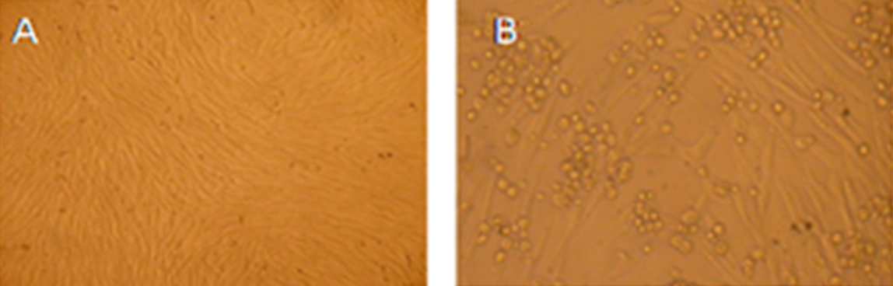
Fig.1 Isolation of bluetongue virus in BHK-21 cell line. A: Normal uninfected BHK- 21 cell monolayer (48 hours). B: BTV infected BHK 21 cells (48 hours) showing cytopathic effect characterized by rounding and degeneration of the infected cells.
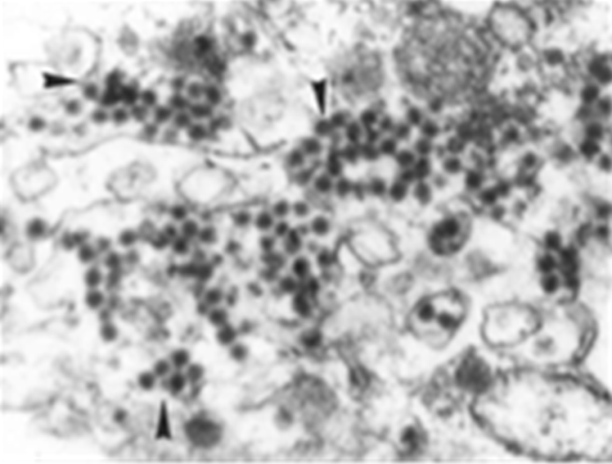
Fig. 2 BHK -21 cells infected with BTV, exhibiting several virus particles in the cytoplasm of the cells by transmission electron microscopy.
Fig. 3 Dot immunobinding assay showing dots of antigen on the dipstick membrane with BTV positive sera.
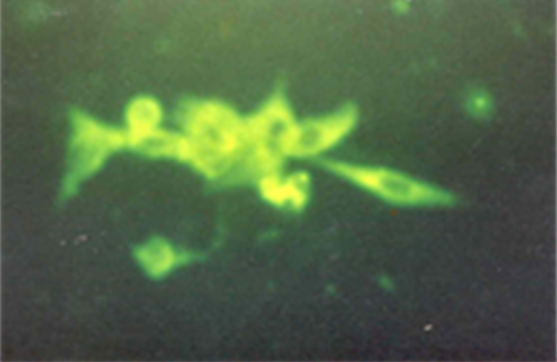
Fig. 4 BHK-21 cell line infected with BTV and stained with FITC. The infected cells are showing extensive green fluorescence.
Fig. 5 VP4 gene based genotyping of bovine group ‘A’ rotavirus by radio-labeled probes. Membrane A: detection of homologous dsRNA by full length vp4 probe; membrane B: P1 type and membrane C: P5 type and membrane D: P11 type.
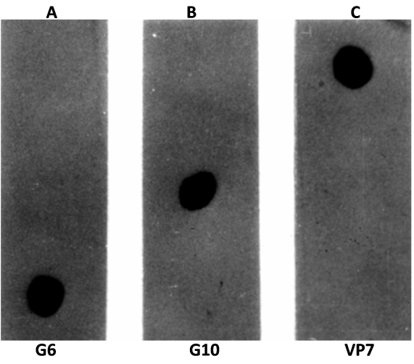
Fig. 6 VP7 gene based Genotyping of bovine group ‘A’ rotavirus by DIG-labeled probes. Membrane A: G6 type; membrane B: G10 type and membrane C: detection of homologous dsRNA by full length vp7 genomic probe.
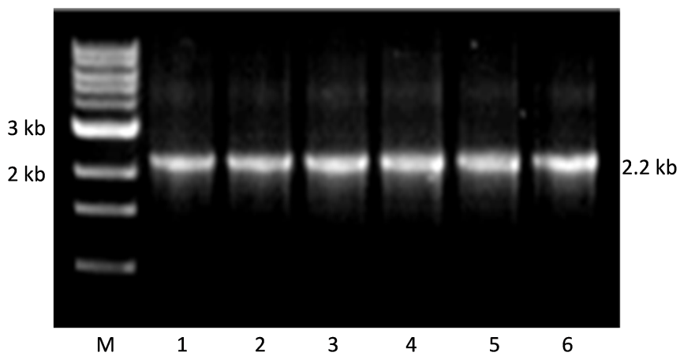
Fig. 7 PCR products of VP2 gene of canine parvovirus yielding 2.2 kb product. Lane M: Marker 1kb plus, Lane 1-6: sample1-sample6 of canine parvovirus.
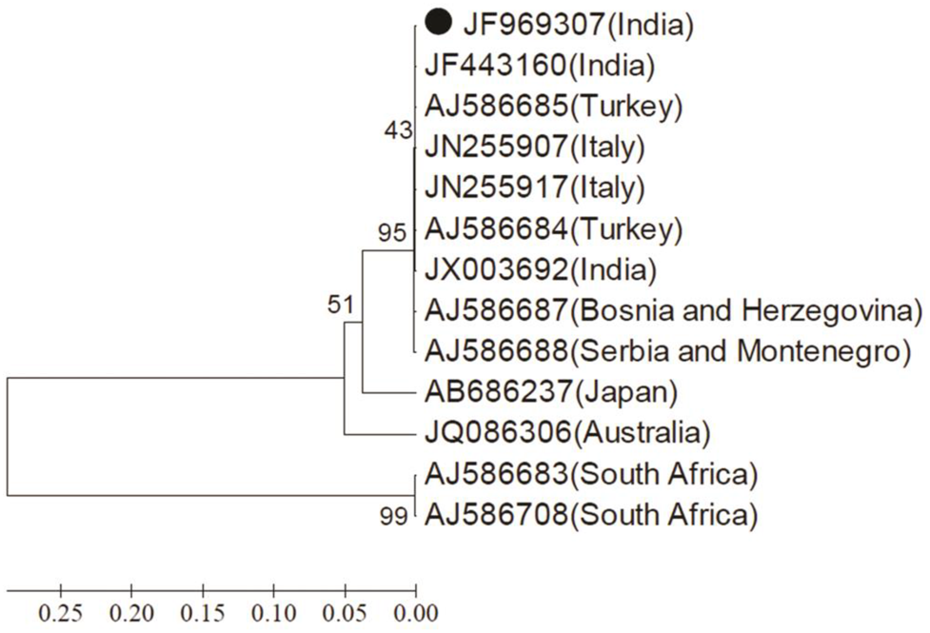
Fig. 8 Vp5 gene based phylogenetic analysis of Indian isolate of BTV9 along with other global isolates.
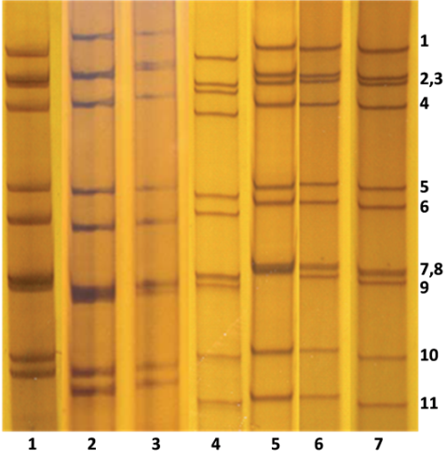
Fig. 9 Electrophoretic migration pattern of human rotavirus isolates. Lane 1-3: Short electropherotype, Lane 4-7: Long electropherotype. The numbers on the right side indicate 1-11 RNA segments.
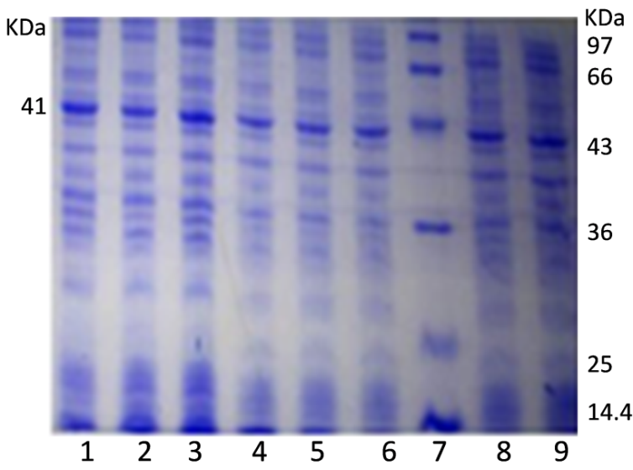
Fig. 10 SDS-PAGE for recombinant protein expression.
Fig.11 Real-Time RT-PCR threshold curves and limit of BTV21 isolate using TaqMan probe in 10 fold dilutions. Label: 1-70pg; 2-7.0pg; 3-0.7pg; 4-0.07pg; 5-7.0 pg; 6-0.7fg; 7-0.07fg and 8-NTC.
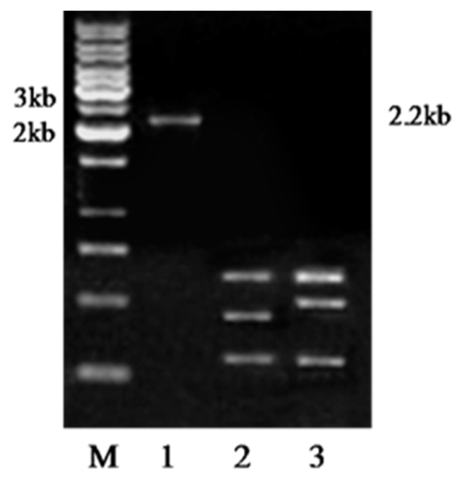
Fig. 12 Restriction profile of 2.2 kb PCR product VP2 gene with Rsa1. Lane M: 1kb marker (MBI Fermentas), 1: Uncut CPV 2.2 kb product, 2: R.E. digested pattern 1 of vaccine strain, 3: R.E. digested pattern 2 of field strain.

