PRESCRIPTION ANALYSIS OF AMBULATORY PATIENTS OF DIABETES MELLITUS AT LAHORE PAKISTAN
Allah Bukhsh¹*, Iqra liaqat¹, Sehrish Javaid¹, Mussarat Bashir¹, Busma Khan¹, HumairaYaseen¹, MominaNadeem¹

1 Institute of Pharmaceutical Sciences, University of Veterinary and Animal Sciences, Lahore,
Pakistan
* Corresponding Author: Allah Bukhsh,
Lecturer, Institute of Pharmaceutical Sciences, University of Veterinary and Animal Sciences, Lahore, Pakistan

Email: abukhsh@uvas.edu.pk
Contact No. +923334090591

No. of Tables: 2
No. Figures: 6

ABSTRACT
Diabetes is a major cause of mortality and morbidity worldwide. Its incidence rate appears to be increasing in the last few decades. In this study prescribing pattern of medications in 100 ambulatory patients of Diabetes mellitus was observed from September 2013 to December 2013 in Lahore. It was revealed from our study that diabetes is more prevalent in patients of age above 30 years (96%) & incidence rate was higher in females (61%) than males. 72% prescriptions were legible, dose was missing in 26% of the prescription, frequency in 38% and strength of medicines in 27%. Either insulin or oral hypoglycemic agent was prescribed in 54% of the prescriptions as monotherapy. Biguanides were the most prescribed oral hypoglycemics as monotherapy (33%) & insulin alone in 13% patients. Combination of antidiabetic agents was observed in 46% prescriptions and frequently prescribed combination was of Sulfonylureas with Biguanides (41%).
KEY WORDS: Insulin, diabetes, oral hypoglycemics, prescribing trends, Sulfonylureas, Biguanides.

INTRODUCTION
Diabetes mellitus is a metabolic disorder characterized by abnormal carbohydrate metabolism that leads to the hyperglycemia. It is related with a comparative or absolute deficiency of insulin secretion or resistance to the action of insulin. ^{[1]} It has been increasing in prevalence since last decades and currently affects more than 170 million people worldwide.^{[2]} While in Pakistan its prevalence is high ranging from 7.6 to 11% .^{[28]}
Type 1 diabetes or juvenile-onset diabetes is categorized by an absolute deficiency of insulin due to autoimmune-mediated destruction of the pancreatic beta cells that are responsible for the production of insulin.^{[3]} Type 2 Diabetes or maturity-onset diabetes is the most public type of diabetes (~90%). Type 2 diabetes is a common condition with high morbidity and mortality.^{[12]}
It is considered by fluctuating degrees of resistance to the action of insulin with comparative insulin deficiency. It is an advanced disorder which causes declining ability to produce insulin over time, leading to improved therapeutic requirements.^{[21]} Type 3 Diabetes or Brain diabetes having known reasons that brain instantaneously needs glucose. It can occur due to infections, sepsis hormonal changes, drugs and stress. It is also the cause of Alzheimer’s disease.^{[4]} In Type 4 diabetes or gestational diabetes, body is under metabolic and physiological stress because of fetus the consumption of glucose increases. In patients with Type 4 diabetes, indication for insulin therapy is ineffective exercise and nutritional therapy in checking prandial and fasting blood glucose levels.^{[5]}
Diabetes is diagnosed by a blood sugar tests either by fasting test (no food or fluid taken except water for eight hours) or a random test taken anytime during the day (2hr after a meal), or by Oral Glucose Tolerance Test or by HbA1C( every 2-3 months).^{[21]} In diabetes value of abstaining plasma glucose, oral glucose tolerance test and HbA1C is 126mg/dl, 200mg/dl and 6.5-7.5% respectively.^{[6][29]}
Treatment of diabetes is in two ways, pharmacological and non-pharmacological. Pharmacological treatment includes oral hypoglycemic agents and subcutaneous agents.^{[22]} Oral hypoglycemic agents include insulin sensitizers (Biguanides, Thiazolidinediones), secretagogues (Sulfonylureas, Glinides), alpha glucosidaseinhibitors, DPP-IV inhibitors (Dipeptidyl peptidase-IV inhibitors), and others (Rapid release bromocriptine). Subcutaneous agents are GLP-1 analogue (Exenatide, Liraglutide, Extended release exenatide), Incretin (Pramlintide), Insulin that includes Rapid-Acting (Aspart, Lispro, Glulisine), Short-Acting (Regular) Intermediate (Neutral Protamine Hagedorn), Long-Acting (glargine, detemir), Premixed (Humalog mix 50/50 and 75/25) and (NovoLog mix 70/30). ^{[9]}
Non-Pharmacological treatment includes dietary management, physical activity and stress management.^{[22]} Dietary Management includes chunks of food including Cereals, mixed coarse grains, whole pulses, salads, red rice, fruits & vegetables (low GI), brown bread ,dietary fibers (oats, pulses), proteins and Saturated fat (ghee, butter). Sugar, honey, jaggery, sweets, white rice, white bread (high GI), hydrogenated fat must be avoided.^{[10]} Dietary cholesterol intake should be <300mg/day. Physical Activities include regular exercise which is essential; brisk walk 30min/day & 150min/week. As the exercise leading to the benefits which are improvement in insulin sensitivity, weight management, improvement of lipid profile, improvement of the function of CVS, increase in bone density, improvement of the quality of life, mental and physical wellness^{[22]}. Stress management includes behavioral modification (Positive thinking), meditation, appropriate support and counseling; improve skills (reading, writing, poetry).^{[11]}
Study of prescribing practice, health facility or aggregate data indicators may indicate that there is over or under-consumption of medicines and these qualitative studies may indicate the reason that why certain health staff and patients behave the way they do. However, such studies do not give details about the exact nature of irrational use of medicines.^{[8]}
The purpose of study was evaluation of the prescription patterns of anti-diabetics using prescribing indicators of WHO ^{[25][26]} in hospital settings, to evaluate the trend of anti-diabetics prescribing and to evaluate the most prescribed anti-diabetic agents in diabetic patients.^{[23]} We grouped prescriptions for anti-diabetic medications by therapeutic classes: sensitizers, secretogogues, alpha glucosidase inhibitors, DPPIV inhibitors, GLP1 analogue, Incretin and Insulin.
We evaluated the prescriptions of ambulatory diabetic patients for WHO core and complementary indicators, average number of anti-diabetic drugs per prescription, percentage of drugs prescribed by generic name,^{[24]} percentage of prescriptions with an insulin prescribed, percentage of prescriptions with dose mentioned, percentage of prescriptions with legible handwriting, percentage of prescriptions with frequency mentioned and percentage of prescriptions with mentioned strength.^{[22][25][26]} .The most common preference as drug of choice in a community either oral hypoglycemic agents or insulin was also evaluated. Prescribing errors have the potential to cause serious side effects in diabetic patients. Poor hand writing, improper communication and the use of inappropriate abbreviations are major prescribing errors.^{[25]}

MATERIAL AND METHOD
In this descriptive, qualitative and cross sectional study carried out by collecting the data from prescriptions of diabetic patients by GP’s practicing in different hospitals of Lahore, from September 2013 to December 2013. For this purpose 100 prescriptions were collected from various areas of Lahore. A questionnaire was designed by using WHO core and complementary indicators to collect the data of ambulatory patients. The Prescribing indicators of WHO used for this study included average number of drugs per prescription, percentage of drugs prescribed with generic names, and percentage of encounters with legible hand writing. ^{[25][26]} All the outpatients with diabetes mellitus either with type 1 or type 2 were included in the study except inpatient, pregnant and lactating women. The independent variables in this study were age and gender of the patient. The dependent variables were average number of anti-diabetics; percentage of drugs prescribed with generic name, legible handwriting, prescriptions containing insulin and mentioned dose, frequency and strength.^{[19][26]} We grouped prescription data of anti-diabetic medications by therapeutic class which included oral anti-diabetic drugs and injectable anti-diabetic drugs . Data obtained were analyzed by using SPSS version 16.0 statistical software programs. Results were analyzed in the form of percentages and presented in tabulation form according to the tool types. ^{[18]}
RESULTS
The age of majority of patients in study was observed to be above 30 years (n=96). Patients with age below 30 were less in number as shown in Fig. 1 (n=4).
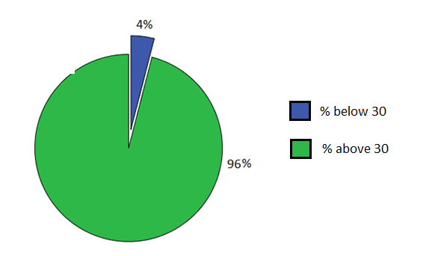
Figure 1 : Percent distribution of diabetic patients of the basis of Age
According to clinical characteristics and demographics, females were more prone to diabetes (n=61) as compared to male patients as shown in Fig. 2 (n=39)
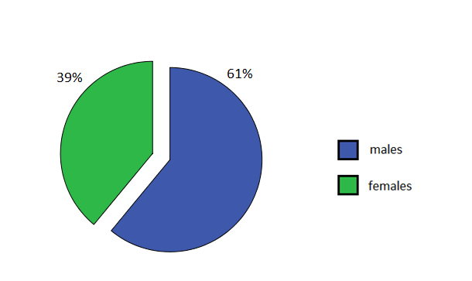
Figure 2 : Percent distribution of diabetic patients of the basis of Distribution
Average number of drugs prescribed per prescription was 3.5 whereas antidiabetic drugs per prescription were 1.5 as shown in Fig. 4. 48% prescriptions contained 3 or less drugs per prescription, 38% prescriptions contained 4 or 5 drugs per prescription and 14 % prescriptions contained more than 5 drugs per prescription as shown in Fig. 3.
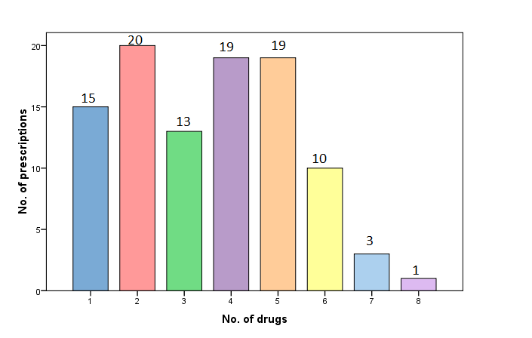
Figure 3 : Average no. of drugs per prescription

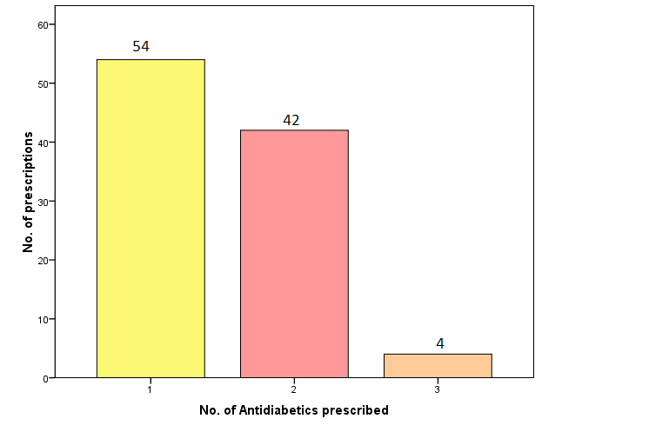
Figure 4 : Average no. of anti diabetic agents per prescription
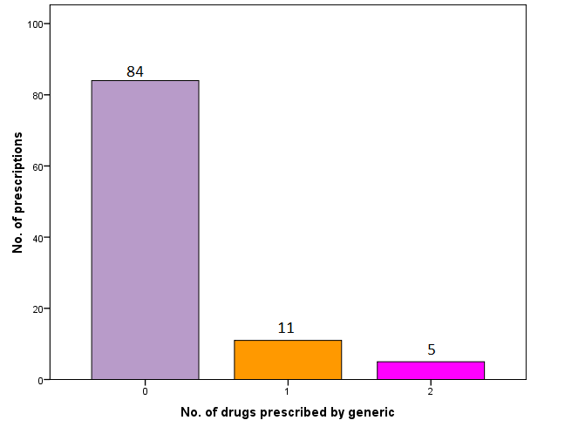
Figure 5: No. of drugs prescribed by generic name per prescription
Generic name of the medicines was mentioned in only 16% prescriptions (11% of antidiabetics and 5% other drugs) as shown in Fig.5 and in 28% prescriptions handwriting was illegible. Dose was missing in 26% of the prescription, frequency in 38% and strength of medicines in 27% of prescriptions. Either insulin or oral hypoglycemic agent was prescribed in 54% of the prescriptions. Biguanides were the most prescribed oral hypoglycemics as monotherapy (33%) as shown in Table. No. 2 & insulin alone in 13%, out of which 10% prescriptions contained premixed insulin, 2% short acting insulin and 1% intermediate acting insulin. Combination of antidiabetic agents was observed in 46%. Combination of oral anti diabetic agents was observed in 43% prescriptions. Frequently prescribed combination was of Sulfonylureas with Biguanides (41%) and combination of three oral anti-diabetic drugs (biguanides + sulphonylureas + thaizolidines) was observed in 2 % prescriptions. Combination of various types of insulin with oral anti diabetic agents was observed in 3% of prescriptions. 1% prescriptions contained combination of premix insulin and diasaccahridase inhibitor, 1% prescription with combination of premix insulin and two oral anti-diabetics (biguanides + sulphonylureas). Prescription with combination of oral anti-diabetic drugs (biguanides) and pre mixed insulin was prescribed in 1 % as shown in Table 1
Table No. 1 Percentage distribution of anti diabetic agents according to therapeutic class in prescriptions
Therapeutic Class | %age
Biguanides | 33%
Sulphonylureas | 8%
Biguanides and Sulphonylureas (combination) | 41%
Short acting insulin | 2%
Inter mediate acting insulin | 1%
Premixed insulin | 10%
Premix insulin and Diasaccahridase inhibitor (combination) | 1%
Premix insulin and oral anti-diabetics (biguanides+sulphonylureas) | 1%
Combination of oral anti-diabetic drugs (biguanides+sulphonylureas+thaizolidines) | 2%
Combination of Biguanides and Pre mixed insulin | 1%

Figure 6: Percentage distribution of antidiabetics therapeutic class and combination wise
DISCUSSION
Based on the prescription analysis data, 100 prescriptions of diabetic patients selected randomly from various areas of Lahore were analyzed. In this study, the high prevalence (96%) of diabetes was observed in patients above 30 years as shown in figure 1. A study conducted at U.S. and UK showed the similar result. ^{[20]} In our study the rate of occurrence of diabetes in females was greater (61%) than that of males (39%) as shown in figure 2. WHO core and complementary indicators were used in this study to analyze the prescribing trends in ambulatory diabetic patients. According to WHO average number drugs per prescription should be 1.6 – 1.8 ^{[27]}, in our study average number of drugs per prescription was 3.5, which is almost double to the WHO standard as shown figure 3. Average number of anti diabetic agents was 1.5 (as shown in Fig. 4) same trend was observed in similar studies conducted at Karachi Pakistan and Southwest Ethiopia.^{[25][26]} It was observed that only 16 % drugs prescribed by generic name (as shown in Fig.5) which is very low as compared to WHO standard which is100%. ^{[27]} Mono therapy was observed in 46% of prescriptions and combination therapy in 54% as shown in Fig. 6. Biguanides were the most frequently prescribed agents (33%) as monotherapy (as represented by A in fig.6). A similar trend of biguanides prescribing was also observed in a study performed in UK. ^{[13]} A similar study conducted in Italy and Manitoba in which the prescribing percentage of biguanides was also high. ^{[7][14]} Mostly prescribed insulin as mono therapy (10%) was premixed insulin followed by short acting insulin (2%) and intermediate acting insulin (1%) as represented in fig.6.
Combination of biguanides and sulphonylureas was mostly prescribed (41%) as shown in Fig.6. A study conducted in US in 2008, showed similar higher proportion of same combination of oral anti diabetic agents.^{[18]} Combination of three oral anti diabetic drugs (biguanides + sulphonylureas + thaizolidines) was observed in 2% prescriptions as represented by as shown in fig.6. A combination of oral anti-diabetic drugs (biguanides) and pre mixed insulin was prescribed on 1% prescriptions as represented by (Fig.6). Another similar study conducted at Italy in which the same results were obtained ^{[7].} Combination of premixed insulin and diasaccahridase inhibitors was in 1% (Fig.6.) and combination of premix insulin and oral anti-diabetic drugs (biguanides+sulphonylureas) in 1% (Fig.6.).
Biguanides was the most prescribed oral hypoglycemic agent alone and in combination with sulfonylureas. Poor prescribing practices were observed as for as generic prescribing and average number of drugs was concerned. This study appears to suggest that prescribing practices use to be in line with recent scientific evidences. There is a need to develop Diabetes mellitus management guidelines and Continuous Education (CE) programs on Good Prescribing Practices for family physicians in order to meet the WHO standards for prescribing practices.

ACKNOWLEDGEMENT
The authors humbly pay their profound gratitude to Vice Chancellor Prof. Dr. Talat Naseer Pasha, University of Veterinary and Animal Sciences Lahore, Pakistan and head of Pharmacy Department Dr. Farzana Chowdhry, Institute of Pharmaceutical Sciences, for their kind support and special attention throughout this study project.

REFERENCES:
[1]OgedengbeO. S, Synopsis of diabetes mellitus,Journal of Postgraduate MedicineVol. 11 No. 1 December, 2009
[2] Patel H,Srishanmuganathan J, Car J, Majeed A, November 2006,Trends in the prescription and cost of diabetic medications and monitoring equipment in England 1991–2004, Journal of Public Health | Vol. 29, No. 1, pp. 48–52
[3] CuthbertsonD,Synopsis of Causation Diabetes Mellitus,September 2008
[4]Steen E, M B., Terry, J E., Rivera, L.J, Cannon, R. T, Neely, Tavares R, Julia X, R J.,Monte J and SImpaired insulin and insulin-like growth factor expression and signaling mechanisms
in Alzheimer’s disease – is this type 3 diabetes?Journal of Alzheimer’s Disease 7 (2005) 63–80

[5] W Akwilina. Mwanri, Kinabo J , Ramaiya K ,Feskens E, Prevalence of gestational diabetes mellitus in urban and rural Tanzania, December 2013, Diabeteresearch and clinical practice 103 (2014) 71 – 78

[6]Madelyn L.Wheeler, Stephanie A. Dunbar,Lindsay M. Jaacks, WahidaKarmally,ElizabethJ.Mayer-Davis,JudithWylie-Rosett,and William S. YancyJr(2013) ADA guidelines DIABETES CARE, VOLUME 36, SUPPLEMENT 1

[7]Mazzagliaa G, Yurginb N, Boyeb K S, Triﬁr G, Cottrelle G, Allene E, Filippia A, Medeaa G, Cricellia C (2008) Prevalence and antihyperglycemic prescribing trends for patients with type 2 diabetes in Italy: A 4-year retrospective study from national primary care data, Pharmacological Research 52:358–363
[8]SUBHASISH S, KAUSHIK D K,SABITA S, DEBASISH S(2010) PRESCRIPTION ANALYSIS IN DIABETES MELLITUSV1(1)
[9]Lub R, Denig, Berg P B V, HoogenbergK &de Jong-van den Berg L TW(2006) The impact of new insights and revised practice guidelineson prescribing drugs in the treatment of Type 2 diabetes mellitus,Br J ClinPharmacol 62:6 660–665
[10] Diabetes Management in General Practice ,Guidelines for type 2 diabetes, www.diabetesaustralia.com 2012/13
[11]PhanH,Porter K, Sill B, C M. Nahata(2012)Prescribing Trends for the Outpatient Treatment of Adolescents and Young Adults with Type 2 Diabetes Mellitus,Journal of Managed Care Pharmacy JMCP Vol. 18, No. 8
[12]Lusignan S D , Sismanidis C, Carey M I,Wilde S D,Richards N, Cook D(2005) Trends in the prevalence and management of diagnosed type 2 diabetes 1994–2001 in England and WalesBMC Family Practice,Vol6:13

[13] Filion K B, JosephL,FrancJ¸Boivin O,SuissaS,Brophy J M (2009) Trends in the prescription of anti-diabetic medications in the United Kingdom: a population-based analysis
pharmacoepidemiology and drug safety VOL18: 973–976

[14]Ludwig M L,Griffith E J,McQuillen K I,Anderson W A,Kvern B L(2006) Manitoba Diabetes Care Project: ExaminingTrends in Diabetes Therapy Prescribing Patterns in Manitoba,CANADIAN JOURNAL OF DIABETES VOL 30(3):248-255
[15]Kennedy D L,Piper J M ,Baum D C(1988) Trends in Use of Oral Hypoglycemic Agents 1964-1986,DIABETES CARE, VOL. 11, NO. 7
[16] Sismanidis C, Carey M L, Wilde S D, Richards N, Cook G D(2005), Trends in the prevalence and management of diagnosed type 2 diabetes 1994–2001 in England and Wales, BMC Family Practice,VOL 6:13

[17]Anthony R, Ferner E R(2009), Prescribing Errors In Diabetes, The British Journal of Diabetes & Vascular Disease

[18]Alexander G C,Sehgal N L,Moloney R M,Stafford R S(2008) National Trends in Treatment of Type 2Diabetes Mellitus, 1994-2007,Arch Intern Med VOL 19 2088-2094
[19]Carey N, StennerK,Courtenay M(2008), PRESCRIPTION WRITING FOR PATIENTS WITH DIABETES: COMPLIANCE WITH GOOD PRACTICE, Research Fellow, School of Health and Social Care, University of Reading
[20]PhanH,PorterK,Sill B,Nahata M C (2012) Prescribing Trends for the Outpatient Treatment of Adolescents and Young Adults with Type 2 Diabetes Mellitus ,Journal of Managed Care PharmacyJMCP Vol. 18, No. 8
[21]Riethof M, Flavin PL, Lindvall B, Michels R, P O C, Redmon B, Retzer K, Roberts J, Smith S, SperlHillen J. Institute for Clinical Systems Improvement. Diagnosis and Management of Type 2 Diabetes Mellitus in Adults(2012),Health Care Guideline Diagnosis and Management of Type 2 Diabetes Mellitus in Adults Edition 15
[22]DrAlwan A AS(1994) MANAGEMENT OF DIABETES MELLITUS STANDARDS OF CARE AND CLINICAL PRACTICE GUIDELINES
[23]Mahalli A A E(2012) WHO/INRUD drug prescribing indicators at primaryhealth care centres in Eastern province, Saudi Arabia, 1College of Applied Medical Sciences, University of Dammam, Dammam, Saudi Arabia; and Department of Health Administration and BehaviouralSciences, High Institute of Public Health, University of Alexandria, Alexandria, Egypt EMHJ Vol. 18 No. 11
[24]DrDuerdenM,ProfessorMillsonM,Professor Avery A,DrSmart S(2011),The quality of
GP prescribing,The King’s Fund 2011
[25]Khan A A, Marvi,IqbalJ,Nadeem M(2013) PRESCRIBING PRACTICES OF GENERAL PRACTITONARS OFPUBLIC HOSPITALS OF PAKISTAN,Volume 2, 285-296.
[26]Angamo M T,Wabe N T, Raju N J(2011) Assessment of Patterns of Drug use by usingWorld Health Organization’s Prescribing, Patient Care and Health facility indicators in Selected Health Facilities in Southwest Ethiopia,Journal of Applied Pharmaceutical Science VOL 01(07),62-66
[27]Desalegn A A(2013)Assessment of drug use pattern using WHOprescribing indicators at Hawassa University teaching and referral hospital, south Ethiopia: a cross-sectional study,DesalegnBMC Health Services ResearchVOL 13:170
[28]Hakeem R.FawwadA(2010) Diabetes in Pakistan: Epidemiology, Determinants and
Prevention, Journal of Diabetology, VOL 3:4
[29]Madelyn L.Wheeler, Stephanie A. Dunbar,Lindsay M. Jaacks, WahidaKarmally,ElizabethJ.Mayer-Davis,JudithWylie-Rosett,and William S. YancyJr(2013) ADA guidelines DIABETES CARE, VOLUME 36, SUPPLEMENT 1

