To, Date: 23rd March, 2014
The Editor- in- Chief
Advances in Animal and Veterinary Sciences

Sub: Submission as a review article entitled “ONE HEALTH APPROACH: VETERINARY PERSPECTIVES IN GLOBAL AND INDIAN CONTEXT” authored by J. Vergis and co-workers

Dear Sir,

With reference to the subject cited above, we hereby submit a review article entitled “One health approach: Veterinary perspectives in global and Indian context” authored by J. Vergis and co-workers, for publication in the journal of your repute. We hereby confirm that the manuscript and its essential substance have not been considered for publication elsewhere. Myself, Dr. Jess Vergis will be the corresponding author for the submitted manuscript and will handle the correspondence regarding publication. Hope to hear a positive note of reply from you at the earliest.
Thanking you,

Yours sincerely
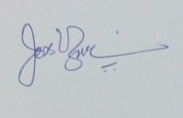
(Jess Vergis*)

