Title Page
DETECTION OF RABIES VIRUS IN INSECTIVOROUS BAT POPULATION OF PAKISTAN
Running Title: Detection of Rabies Virus in Insectivorous Bat
Authors:
Farzana Shaheen ¹, Masood Rabbani⁴, Zafar Qureshi², Mahmood ul Hassan³, Arfan Ahmad ⁴, Fareeha Akhtar⁴, Suliman Qadir Afridi¹, Hassaan bin Aslam⁵, Tasra Bibi¹, Nadia Mukhtar¹
Corresponding Author: Nadia Mukhtar
¹ Quality Operations Lab, University of Veterinary and Animal Sciences, Lahore, Pakistan
² Veterinary Research Institute, Lahore
³ University of Agriculture Faisalabad
⁴ University Diagnostic Laboratory, University of Veterinary and Animal Sciences, Lahore, Pakistan
⁵Department of Microbiology, University of Veterinary and Animal Sciences, Lahore, Pakistan
Corresponding Author:
Nadia Mukhtar
Research Associate, Quality Operations Lab, University of Veterinary and Animal Sciences
Lahore
E. mail: nadiamukhtar84@yahoo.com
Cell # 923337384750
Fax # 924299213303
Abstract
Rabies is an ancient zoonotic disease of mammals, caused by an envelope, negative sense RNA virus- a member of the Lyssavirus genus within Rhabdoviridae family. Lyssavirus surveillance in bats was performed in Pakistan during 2009 and 2010 thourgh iFAT, MIT and RT-PCR techniques. One hundred oropharngeal swabs and brain tissues collected from different districts of Punjab were included in the study. All the techniques were validated by suspected brain samples of dog, cow, mule, and known positive control. In the study, all insectivorous bats representing Taphozous nudiventris, Scotophilus heathii, Scotoecus pellidus, Pipistrellus pipistrellus and Scotophilus kohlil species were tested negative by all the three assays.
Key Word: Lyssavirus, Surveillance, Bats, iFAT, MIT, RT-PCR

INTRODUCTION
Rabies is an ancient zoonotic disease of mammals, caused by an envelope, negative sense RNA virus- a member of the Lyssavirus genus within Rhabdoviridae family (Warrell and Warrell, 2004). Rabies virus infects domestic and wild animals and is present in the saliva of the carrier animal (dogs, cats, skunks, foxes, raccoons, coyote, bats, groundhogs, farm livestock including cows, sheep, goats, horses and pigs etc). The virus spreads by bite of infected animals. Humans are recognized as dead end host for rabies virus (Brass et al., 1994).
Rabies is a non reportable disease in Pakistan and its incidence is grossly under reported. So it is needed to develop an effective surveillance network to assess the magnitude of the disease in Pakistan (Anonymous, 2004). Bats belonging to order Chiroptera, have about 1100 species (Harris et al., 2006). On the basis of food habits, bats are divided into two groups fruit eaters (frugivorous) and insect eater (insectivorous). It is reported that bats are also natural reservoirs of the emerging and re-emerging infectious diseases (Omatsu et al., 2007). Bats are responsible for the aerial cycle of rabies virus which is transmitted among vampire, insectivorous, and frugivorous bats and from bats to wild animals. Humans can be accidentally infected by the bite of any of the above cycles (Barbosa et al., 2008). Bats are equally susceptible to rabies as carnivores. Basic aspects of rabies pathogenesis to and from the CNS of bat are the same as for the other animals. Physiologically active, minimum and maximum incubation periods of rabies in the Chiroptera are believed to be no different than those observed in the Carnivora. Both aspects of paralytic and furious rabies have been found in bats. With the exception of Antarctica, the distribution of rabies virus in bats is global in nature. Bats are the most prominent direct source of human rabies in parts of North America, Western Europe and Australia, especially where the disease in carnivores has been controlled (Niezgoda et al., 2002). Bats are among the least studied group of mammals in Pakistan (Hassan et al., 2009), about a quarter of all known mammal species (Simmons, 2005). Fifty species of bats representing 23 genera and 8 families are reported to exist in Pakistan. (Horacek et al., 2000)
Among the rabies cases in animals and human beings, the exact source often could not be ascertained. Unfortunately as for the bat as a source for transmission of rabies among the animals, no research work has been conducted in Pakistan. Positive cases of rabies due to bat bite have been found in other countries as mentioned above. There is the need of the time to rule out bats as a source of rabies transmission. Keeping in view the above facts the present study has been conducted to identify the Rabies virus in bats as an emerging infectious disease of human and animals and to know the current status of Rabies virus circulating in the bat populations in Pakistan.
MATERIALS AND METHODS
A total of 100 samples origination from each of oropharyngeal swabs and brain tissues were collected from bats. Both samples were transferred to sterile pre-labeled tubes containing 1.5 ml of glycerol buffer (1:1 aqueous sol of glycerol; pH 8.2) and transported on ice pack to the UDL, UVAS, Lahore for further processing. Beside the bats samples; 6 preserved brain samples (2 each of dog, cow and mules) and one known positive (Rabid dog brain) and negative (Chicken brain) were also included in the study.
PROCESSING OF SAMPLES
All the collected samples were subjected to MIT, iFAT and RT-PCR for Rabies virus confirmation.
MOUSE INOCULATION TEST (MIT)
PREPARATION OF INOCULA
The MIT was performed as recommended by Koprowski et al. (1996). Briefly the oropharyngeal swabs were thoroughly squeezed in the microfuge tube containing glycerol buffer and the suspension was semi-purified using refrigerated centrifuge machine (1000 x g for 30 min at 4ºC) to remove the debris. The supernatant was harvested and filtered through syringe filter of 0.2µm porosity (Sartorius, USA) and collected in aliquots for MIT. For brain samples, 20 per cent homogenate was prepared by grinding the brain tissue in glass tissue grinder (SGA, 527, USA) in a sterile phosphate buffer saline (PBS, pH 7.4) containing 2mg streptomycin and 500 IU penicillin. The suspension was centrifuged at refrigeration temperature (4°C; at 200 xg) for 5 minutes and the supernatant was collected in aliquots.
MOUSE INOCULATION TECHNIQUE
Albino Swiss mouse about 20-25 days old (weighting 12-15gms) free from any infection were procured from Veterinary Research Institute (VRI), Ghazi Road, Lahore.
MIT was performed at Veterinary Research Institute (VRI), Lahore, briefly; 0.03 ml of each inoculums was injected between eye and ear over the eye orbit at symphasis of frontal temporal and occipital bone (0.1 - 0.2 cm deep) to each mouse using one ml tuberculin syringe (26 gauge and 1.5 cm long needle) and placed in a clean pre-labeled mice cage. All mice were observed for four weeks with daily observation for the first five days, and then twice daily from day six to 28. The findings were recorded on a clinical score sheet that included ruffled fur (score 1), slow/circular movements (score 2), trembling, shaking movements or lameness (score 3), paralysis / convulsions (score 4), prostration / permanently recumbent (score 5). If there was no sign of disease, a score of ‘0’ was given. Mice that died within first five days after inoculation were considered as non-specific deaths, and not due to rabies infection. However, there brain samples were later on confirmed negative through indirect fluorescent antibody technique.
During 5 - 28 days post-inoculation, brain samples from all inoculated mice were removed that were at a clinical score of 2-3. These samples were tested for presence of any intra-cytoplasmic inclusion bodies through indirect FAT. If no mice succumbed to rabies infection after 28 days, the sample was deemed to be negative. After completion of 28 days, the mice were killed by using chloroform for collection of brain.
FLUORESCENT ANTIBODY TECHNIQUE (FAT)
All samples including oropharyngeal swabs and brain tissues of bats, cow, dog and mules, inoculated mice along with known positive and negative tissues were tested through iFAT as recommended by Dean et al. (1996). The brain tissue was transferred to a sterile Petri dish and a thin section of the brain was cut out on to a clean poly-L lysine coated glass slide and pressed slightly against the cut surface of the section to make an impression smear for FAT. Smears of swab samples were also prepared on slides. A test impression was recorded as positive when brilliant apple-green fluorescence areas were observed against dark background, whereas, no such color or fluorescence was taken as negative.
REVERSE TRANSCRIPTASE POLYMERASE CHAIN REACTION (RT-PCR)
Reverse transcriptase polymerase chain reaction (RT-PCR) was used as gold standard for confirmation rabies virus and to validate the results of MIT and FAT.
RNA EXTRACTION
Total RNA from oropharyngeal swabs and brain tissues of bats, cow, dog and mules, inoculated mice along with known positive and negative tissues were extracted using TRIZOL method as recommended by Davis (1998) and using KIT method (High Pure RNA extraction, Roche) as recommended by Dean et al. (1996).
RT-PCR
cDNA was synthesized by using Revert Aid first Strand Synthesis Kit (Fermentas, EU) followed by RT-PCR as recommended by Tordo et al. (1996). Briefly 5µl,of each template DNA was mixed to reaction mix containing 5µl of PCR buffer (10x), 1µl of dNTPs (10 mM), 3μl of MgCl, 34µl of DD.H₂0 and 1µl of each of forward and reverse primers. After preparing the reaction mix, PCR reaction was completed by 45 cycles after initial denature 94ºC for 4 min followed by denaturation 94ºC for 45 sec, annealing at 45C 90 sec and, extension at 72 ºC for 2 min. The RT-PCR products were examined by gel electrophoresis as recommended by Davis, (1998).
RESULTS
None of the bat species (Taphozous nudiventris, Scotophilus heathii, Scotoecus pellidus, Pipistrellus pipistrellus and Scotophilus kohlil), were tested positive for rabies virus through mouse inoculation test (MIT), indirect fluorescent antibody technique (iFAT) and reverse transcriptase polymerase chain reaction (RT-PCR). However, mice inoculated with positive control tissue and brain tissues originated from rabies suspected dogs, cows, and mules showed typical signs of rabies like ruffled fur, slow / circular movements, trembling, lameness, paralysis/convulsions, prostration, permanent recumbency, lack of appetite and death at terminal stage on 5^{th,} 6th, 7^{th,} and 8th day of inoculation. While negative control group of mice remained healthy and active till end of the fourth weeks. The results of MIT were also validated by iFAT and RT-PCR as no immune-fluorescence was observed under UV light of fluorescent microscope in slides prepared from bat samples and negative control, whereas, the positive control and suspected dog, cow and mule samples showed prominent focal areas of apple green color fluorescence. Through RT-PCR, the samples tested positive by MIT and IFAT remained positive. Specific bands of 879bp were obtained by the amplification of intergenic region using specific set of primers.
DISCUSSION
Pakistan is a rabies endemic country and 50,000 cases of the dog bite have been estimated per year in some government hospitals treating as many as 150 cases per day. Although, no accurate figures are available probably 5000 persons die from rabies each year (Salahuddin, 2001). Bats are the important reservoirs for the Lyssavirus according to the recent observations and the virus variants associated with Chiroptera bat order may occasionally spill over into other mammals (WHO, 2005). Bats have been associated with a number of emerging zoonotic viral diseases (Johnson et al., 2010).
Indirect fluorescent antibody technique (FAT), mouse inoculation test (MIT) and reverse transcriptase polymerase chain reaction (RT-PCR) have already been established to detect rabies virus antigen from bat (McElhinney et al., 2008; Whitfield et al., 2001; Woldehiwet, 2005) All the three techniques applied in this study were validated using Known positive, negative controls as well as 6 rabies suspected samples. All suspected samples along with known positive control were tested positive by all the three assys. After validation of techniques, bats samples were processed to detect rabies virus. None of the samples originated from Taphozous nudiventris, Scotophilus heathii, Scotoecus pellidus, Pipistrellus pipistrellus, and Scotophilus kohli species of bats was tested positive by All three techniques which is in concordance with the findings of Kuzmin et al. (2006) who declared same species of bats free from rabies virus using FAT and MIT. In another study brain tissues of Mormoops megalophylla, Myotis californicus, M. ciliolabrum, M. thysanodes, M. velifer, M. yumanensis, Eptesicus fuscus, Pipistrellus hesperus, P. subflavus, Plecotus townsendii, Antrozous pallidus and Tadarida brasiliensis species of bats were also found negative for rabies virus in USA (Yancen et al., 1997; Megalid et al., 2010). However some researchers got positive results in bats (Arai et al., 2003; Echevarría et al., 2001; Gordon et al., 2001; Scheffer et al., 2007) that might be due to testing of small sample size.
In this study, due to lack of proper sampling facilities, only insectivorous bats were possible to test, whereas frugivorous bats that have been reported to play role in dissemination of rabies virus remained untested. Therefore testing of frugivorous bats may lead to otherwise results.
It is pertinent to mention here that according to our information, this is first time study of this type in Pakistan that depicted the status of rabies virus in bats.
CONCLUSION
In the present study only one hundred bats were captured from five district of Punjab province and their samples elicited no rabies detection. This represent insufficient data for declaring bats of this region clean in having or disseminating rabies virus to others. The complete surveillance work is required to be done in future studies in the remaining potential areas of Punjab province including its northern and southern regions where the dogs, cats, wolves, jackals, foxes, mongoose and bats thrive more. On similar analogy bats populations in other provinces of Pakistan may be screened for rabies virus.
REFERENCES

Arai TY, IV Kuzmin, Y Kameoka and AD Botvinkin, 2003. New Lyssavirus genotype from the lesser mouse-eared bat (Myotis blythi) in Kyrghyzstan. Emerg Infec Dis, 9: 333-337.
Anonymous, 2004. Effective surveillance of rabies imperative the humanitarian news and analysis service of the UN office for the coordination of humanitarian affairs. IRIN (News Report) Islamabad, Pakistan. Nov. 22 (http://www.irinnews.org/report).
Barbosa SFT, DBDA Medeiros, ESTD Rosa, LMN Casseb, R Medeiros, ADS Pereira, ACR Vallinoto, M Vallinoto, AL Begot, RJDS. Lima, PFDC. Vasconcelos and MRT Nunes, 2008. Molecular epidemiology of rabies virus isolated from different sources during a bat-transmitted human outbreak occurring in Augusto Correa municipality, Brazilian Amazon Virol, 370(2): 228-236.
Brass DA, 1994. Natural history and public health implications. In: Rabies in Bats: Eds. D.A. Brass, pp. 151-162. Livia Press, Ridgefield. USA.
Dean DJ, MK Abelseth and P Atanasiu, 1996. The Fluorescent Antibody Test. In: Laboratory Techniques in Rabies by F.X. Meslin, M.M. Kaplan and H. Koprowski. 4th ed. Geneva WHO: 88-93.
Gordon SLL and JS Smith, 2001. Survey of bat populations from Mexico and Paraguay for rabies. J Wild Dis, 37(3): 582-593.
Harris SL, SM Brookes, G Jonesa, AM Hutson, PA Racey, J Aegerter, GC Smith, LM McElhinney and AR Fooks, 2006. European bat Lyssaviruses: distribution, prevalence and implications for conservation. Biol Cons, 13: 93-210.
Hassan MM and PO Nameer, 2006. Diversity, role and threats to the survival of bats in Pakistan. J Anim Pl Sci, 16(1-2): 38-42.
Horacek I, V Hanak and J Gaisler, 2000. Bats of the Palearctic Region: A Taxonomic and Biogeographic Review. Proceedings of the VIIIth EBRS, 1:11-157.
Johnson N, A Vos, L Neubert, C Freuling, KL Mansfield, I Kaipf, A Denzinger, D Hicks, A Nunez, R Franka, CE Rupprecht, T Muller and AR Fooks, 2008. Experimental study of European bat lyssavirus type-2 infection in Daubenton's bats (Myotis daubentonii). J Gen Virol, 89: 2662-2672.
Koprowski H, 1996. The Mouse Inoculation Test. In: Laboratory Techniques in Rabies by F.X. Meslin., M.M. Kaplan and H. Koprowski. 4th ed .World Health Organization (WHO). Geneva.80-86.
Kuzmin VI, M Niezgoda, DS Carroll, N Keeler, MJ Hossain, RF Breiman, TG Ksiazek and CE Rupprecht, 2006. Lyssavirus surveillance in bats in Bangladesh. Emerg Infec Dis, 12(3): 486-488.
Megalid A, G Yannic, ML Zahno, D Brgger, G Bertoni, P Christe, R Zanoni, 2010. Surveillance for European bat lyssavirus in Swiss bats. Archiv Virol, (10):1655-1662.
McElhinney LM, AR Fooks and AD Radford, 2008. Diagnostic tools for the detection of rabies virus. Zoonosis, 18(3): 224-229.
Niezgoda, M, CA Hanlon and CE Rupprecht, 2002. Animal Rabies: In. Rabies by A.C. Jackson and W.H. Wunner. ed: San Diego. Calif., Academic Press, Elsevier Science, 199-200.
Omatsu T, S Watanabe, H Akashi and Y Yoshikawa, 2007. Biological characters of bats in relation to natural reservoir of emerging viruses. Comp Immunol Microbiol Infec Dis, 30: 357-374.
Salahuddin N, 2001. In Pakistan sheep brain vaccine or nothing a moral dilemma. In: Rabies control in Asia by B. Dudet and F.X. Meslin. John Libbey Eurotext, Paris.66.
Scheffer CK, M L Carrieri, A Albas, HCPD Santos, I Kotait and F H Ito, 2007. Rabies virus in naturally infected bats in the State of Sao Paulo, Southeastern Brazil. Rev Saude Publica, 41(3): 1-8.
Shabbir ZM, M Rabbani, A Ahmad, T Yaqub, K Muhammad and Z Rehman, 2010. Detection of rabies virus from equines showing nervous signs. Pak J Zool, 42 (6). (In press).
Teichman VFB, GR Thomson, CD Meredith and LH Nel, 1995. Molecular epidemiology of rabies virus in South Africa: evidence for two distinct virus groups. J Gen Virol, 76: 73-82.
Tordo N, D Sacramento and H Bourhy, 1996. The Polymerase Chain Reaction (PCR) Techniques for Diagnosis, Typing and Epidemiological studies of Rabies In: Laboratory Techniques in Rabies by F.X. Meslin, M.M. Kaplan and H. Koprowski. 4th ed. Geneva WHO: 157-170.
Warrell MJ and DA Warrell, 2004. Rabies and other lyssavirus diseases. Seminar. Lancet. 363: 959-969.
Whitfield GS, M Fekadu JH Shaddock, M Niezgoda, CK Warner and SL Messenger, 2001. A comparative study of the fluorescent antibody test for rabies diagnosis in fresh and formalin-fixed brain tissue specimens. J. Virol. Methods. 95: 145-151.
Woldehiwet Z, 2005. Clinical laboratory advances in the detection of rabies virus. Clin. Chimica Acta. 35: 49-63.
WHO Expert Committee on Rabies. First Report. Geneva World Health Organization 2005 (WHO) Technical Report Series, No. 931.
Yancen DF, P Raj, SU Neill and C Jones, 1997. Survey of rabies among free flying bats from the big band region of Texas. Museum of Taxes Tech. Univ. Occassional papers. 165: 1-5.
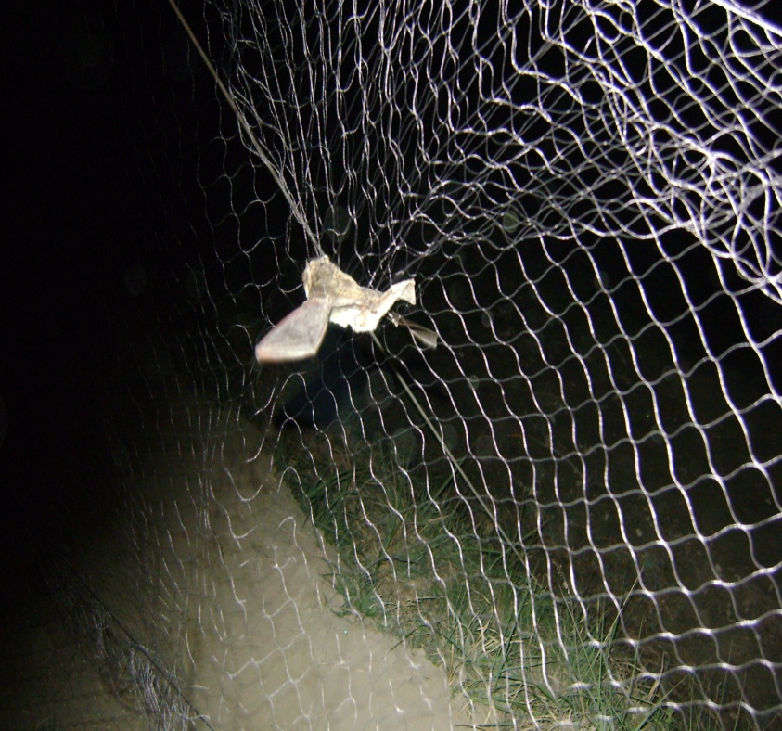
Fig.1: Captured bat in mist net

Fig.2: RT-PCR of six positive brain samples including positive and negative controls. Lane 1: bat brain sample, Lane 2: Ladder, Lane 3-4: Bat brain sample, Lane 5: negative control. Lane 6-7: dog brain sample brain .Lane 8-9: cow brain sample, Lane 10-11: mule brain sample, Lane 12 positive control, Lane 13: Ladder, indicating 900bp of conserved “pseudogene” region.

