Bacterial Analysis of Raw Milk of Different Dairy Farms in Mansehra City
Muhammad Naveed*, Adil Hassan, Hamid Ali, Zaheer Ud Din, Aftab Ahmad, Tahir Ali Khan, Zohaib Hassan, Abdul Majid,Jehangir Khan and Qamar Zaman
Department of Microbiology, Hazara University, Mansehra-21300, Pakistan
Abstract: The pathogenic bacterial strains grow in raw milk is a source of many diseases in local population of Mansehra. The present study was carried out in Mansehra city. Ten samples of 10 ml of raw milk sample were taken. The serial dilutions were made and the bacteria were cultured on nutrient agar medium. After maturation of colonies, these were counted and recorded to identify the bacterial strains. Pure colonies were cultured on Mac-Conky agar and Mannitol Salt agar medium. Out of Ten samples 4 strains were found gram positive which are Staphylococcus aureus,Staphylococcus saprophyticus, Lactobacillus spp, and Enterococcus specie and 4 strains were found gram negative which are Pseudomonas aeruginosa, Klebsiella pneumonia, Proteus mirabilis and E.coli with gram staining. Milk is an excellent nutrient medium for the growth of pathogenic bacteria that contaminate milk from various sources and cause different disease. We should control this contaminant by improving the hygienic quality of milk and also providing cooling systems at milk collection sites.Fast and dust proof transportation systems will also play a key role in reducing contamination of milk.
Key words: pathogenic bacteria, Mac-Conky agar, Mannitol Salt agar, gram staining.

Introduction
Milk and milk products have high humidity, neutral pH and rich in vitamins and has a multifarious biochemical composition (Pelczar and Reid,1991; Frank and Hassan, 2003). The microbial contamination can generally occur from 3 sources which include the udder, external environment and contact surfaces. It is frequently contaminated by Escherichia coli. Under poor sanitary conditions which effect on public health (Bramley and McKinnon, 1990). The coliform group of bacteria is defined as the indicator (fecalcoliform) of suitability of milk for consumption (Ame, 1981). Milk micro flora includes spoilage and pathogenic microorganisms which can cause spoilage such as Fermentative or acid producing bacteria for i.e. lactic acid bacteria, coliforms. Proteolytic, lipolyticbacteriaetc and Gas producers for example coliform bacteria (Goffand Horst, 1997).Some microorganisms growing in the milk and milk products also cause Discoloration, sliminess, rapines, putrefaction, rancidity and many other defects (Adesiyun, 1994).
Most of the microbes in milk are gram negative rods like bacteria, such as Pseudomonas, Acinetobacter, Flavobacteriumand Enterobacter, even though some yeast and molds are also able to grow in milk (Walstra et al., 2006).Milk is a complex natural fluid and support growth of many microorganisms. The number and types of micro-organisms in milk directly after milking are affected by factors such as animal and equipment cleanliness, season, feed and animal health. The specific production is impossible to avoid contamination of milk with micro-organisms therefore the microbial content of milk is a major feature in determining its quality (Rogelj, 2003). Bacterial contamination of raw milk can originate from different sources such as air, milking equipment, feed, soil, feces and grass (Coorevitset al., 2008).
The present study was conducted to investigate the isolation and characterization of microbial population of raw milk from different milk samples taken from different areas of district Mansehra.
Methods and Materials
Samples were collected from different areas of Mansehra city and Chennai. Total 10 samples were collected in sterile bottles from apparently healthy animals. The raw milk samples were transported to Microbiology Laboratory of Hazara University Mansehra in an ice box contained ice for further study.
Colour and pH was observed and samples were stored at 4 ⁰C before their dilutions. 05 folds of dilutions were made.
In present investigation different culture media were used as, Nutrient agar, Mac-Conkey Agar, Mannitol Salt Agar, Trypton Soya Broth, Methyl Red VogesProskauer (MRVP) and Siemon’s Citrate Agar for the isolation, growth and identification of bacterial species.
Primary isolation was done on Nutrient Agar to allow the growth of all bacteria from the milk. Each sample of milk was shaken properly to ensured homogeneity. Fivefold serial dilutions were made of each sample and 1 ml of the appropriate dilutions was used as inoculum using the streak plate method. Agar plates were incubated at 37°C for 24-48 hours for growth.
Different types of biochemical tests were performed to confirm the specific type of bacterial species. A drop of saline solution was placed on a clean glass slide. A separated bacterial colony was picked up by using flame sterilized and then cooled wire loop. With this loop a smear was made on the saline glass slide. Air dried the slide and then heat fixed using spirit lamp. Then Crystal violet dye was applied for 1 minute and then washing was done using distal water. Gram’s Iodine was applied for 1 minute and then washed gently with distal water. Decolourizer (a solution of ethanol 50% v/v and acetone 50%v/v) was added. Washing was done with distal water. In the last step counterstained with safranin for 45 seconds and then washing was done with distal water (Prescott, 2003). A drop of immersion oil was applied on the slide and observed under light optical microscope, starting from 40X to 100X zoom lenses.
Results
In the present study, 8 bacterial species were isolated from 10 milk samples. It comprises of Pseudomonas aeruginosa, Klebsiella pneumonia, Staphylococcus aureus, Enterococcus specie, Staphylococcus saprophyticus, Lactobacillus spp, Proteus mirabilis, E.coli. The bacterial strains was dominant Lactobacillus spp as it was found in 100% samples followed by E.coli, Staphylococcus saprophyticus, Proteus mirabilis, Staphylococcus aureus 90%, , Pseudomonas aeruginosa, Enterococcus specie 70% Klebsiella pneumonia 60%. The results are given in table1 and figure 1 and 2.

Table.1.Bacterial strains isolated from collected milk samples
Sample No. | E.coli | Pseudomonas aeruginosa | Klebsiella pneumoiae | Staphylococcus aureus | Enterococcus specie | Staphylococcus saprophyticus | Lactobacillus spp. | Proteus mirabilis
1 | + | + | + | + | + | + | + | +
2 | + | + | + | + | + | + | + | +
3 | + | + | + | + | - | - | + | +
4 | + | - | + | + | + | + | + | +
5 | + | - | - | + | - | + | + | +
6 | + | + | - | - | + | + | + | +
7 | + | + | + | + | + | + | + | +
8 | + | + | - | + | + | + | + | -
9 | + | + | + | + | + | + | + | +
10 | - | - | - | + | - | + | + | +

Discussion
The present investigation was carried out to evaluate the microbial contamination of milk of Mansehra. In this investigation total 8 species were isolated and the bacterial species Lactobacillus species, E.coli, Staphylococcus aureus, Staphylococcusaprophyticus, Proteus mirabilis, Pseudomonas aeruginosa, Enterococcus species and Klebsiella pneumoniawere dominant and the same species were also counted by the earlier investigation by Garedewet al., (2012) where they found that Escherichia coli accounts for 29.6%, Pseudomonas aeruginosa 18.5% and Klebsiella pneumonia 16.7%. The higher prevalence of E. coli may be due to contamination as normal micro flora of animal body.
Farhan and Salik (2007) evaluated milk microbiology earlier they get Escherichia coli, Staphylococcus aureus, Lactobacilli and Salmonella. According to Singh et al., (2011) reports from U.K., that milk sample have the prevalence of E. coli sp. (32.14%), Staphylococcus sp. (21.4%), Salmonella sp. (21.4%), Proteus sp. (17.8%) and Bacillus sp. (7.14%).Brucella and E. coli was also isolated in Tanzania by Swai and Schoonman (2011).
The isolation of bacterial species in present investigation were also involved in diseases as Hemorrhagic colitis, hemolytic Uremic syndrome (HUS), food poisoning, urinary tract infections, respiratory system infections, dermatitis, soft tissue infections, bacteremia, bone and joint infections, gastrointestinal infections and nosocomial infections. Some diseases were also encountered by Anonymous, (2006) like Staphylococcal enterotoxin poisoning, Hemorrhagic colitis,hemolytic Uremic syndrome (HUS), Listeriosis, Salmonellosis, Campylobacteriosis, Tuberculosis, Brucellosis, Streptococcal infections, Q fever, Yersiniosis, Cryptosporidiosis, Tick borne encephalitis, Diarrhea and Hepatitis.
Conclusion
Milk is an excellent nutritional medium for the growth of pathogenic bacterial strains that contaminate milk from various sources and cause different disease. We should control this contaminant by improving the hygienic quality of milk and also providing cooling systems at milk collection sites. Fast and dust proof transportation systems will also play a key role in reducing milkcontamination.
Acknowledgment
The authors of this research group are thankful to the Department of Microbiology and all those who are directly or indirectly contribute to fulfill this study.

Competing Interest
The author and co-authors of this manuscript do not have any conflict and competing interest.
REFFERENCES
Adesiyun AA (1994). Bacteriological quality and associated public health risk of pre-processed bovine milk in Trinidad.Int. J. Food Micro. 21 (3): 253-261.
Ame J (1981). Standard Method Committee for water and waste water analysis, Public Health Association Washington. DC.
Bramley AJ and McKinnon CH(1990).The microbiology of raw milk, In Robinson, R. K. (Ed.), Dairy Microbiology, Elsevier Science Publishers, London.1, pp 163-208.
Byron HW, Arnold HJ and Johan AA(1974).Fundamentals of dairy chemistry. Westport, Connecticut. The AVI Publishing Company,Inc. 2nd ed., pp. 2-8.
Coorevits A, De Jonghe V, Vandroemme J, Reekmans R, Heyrman J, Messens W, De Vos P and Heyndrickx M (2008). Comparative analysis of the diversity of aerobic-spore-forming bacteria in raw milk from organic and conventional dairy farms. Syst. Appl. Microbiol. 31(2): 126-140.
De Buyser ML,Dufour B, Maire M and Lafarge V (2001). Implication of milk and milk products in food-borne diseases in France and in different industrialised countries. J. Food Microbiol.67 (1–2): 1–17.
Farhan M and Salik S (2007). Evaluation of Bacteriological Contamination in Raw (Unprocessed) Milk Sold in Different Regions of Lahore (Pakistan). J. Agri. Soc. Sci.3 (3): 104-106.
Frank JF and Hassan AN (2003). Microorganisms associated with milk. InRoginski H Fuquay JW and Fox PF (Eds.). Encyclopedia of dairy sciences. London, UK. Academic Press, Elsevier Science. pp. 1786-1796.
Garedew L, Berhanu A, Mengesha D andTsegay G (2012). Identification of gram-negative bacteria from critical control points of raw and pasteurized cow milk consumed at Gondar town and its suburbs, Ethiopia. BMC Public Health 12 (950): 1-7.
Goff JP and Horst RL (1997). Effects of the addition of potassium or sodium, but not calcium, to prepartum rations on milk fever in dairy cows. Journal of Dairy Science. 80:176-186.
McPhee JD and Griffiths MW (2003). Psychrotrophic bacteria. In: Roginski H, Fuquay JW and Fox PF (eds). Encyclopedia of dairy sciences. London, UK. Academic Press, Elsevier Science. pp. 2340-2351.
NormannoG,SalandrabLa,Dambrosioa A,Quagliaa NC,Correntea M,Parisib A, SantagadabG, FirinucA, CrisettibE and CelanoaGV (2007). Occurrence, characterization and antimicrobial resistance of enterotoxigenic Staphylococcus aureus isolated from meat and dairy products. J. Dair. Sci.115:290-296.
Pelczar, M. J. J. R and RD Reidni (1991). Microbiology, Tata Mcgraw Hill Publishing Company Ltd. Newyork. 5thed, pp 230-300.
Rogelj I Ml (2003). Bem Z., et al. (Eds.), Mikrobiologijaživilživalskegaizvora. Ljubljana, Biotehniškafakulteta, Oddelekzaživilstvo. pp. 515-538.
Singh V, Kaushal S, Tyagi A and SharmaP (2011). Screening of bacteria responsible for the spoilage of milk. J. Chem. Pharm. 3(4): 348-350.
Swai ES and Schoonman L(2011). Microbial quality and associated health risks of raw milk marketed in the Tanga region of Tanzania. Asian Pacific J. Trop. Biomed. 1691:(11).217-222.
Walstra P,Wouters JT and Geurts TJ(2006).Dairy Science and Technology, Boca Raton, Florida, USA: CRC Press. 2nded; pp. 824.
Anonymous (2006). A qualitative assessment of the risks of transmission of microorganisms to humans resulting from the consumption of raw milk and raw cream in Norway, Norwegian Scientific Committee for Food Safety.5: (104): 1-40
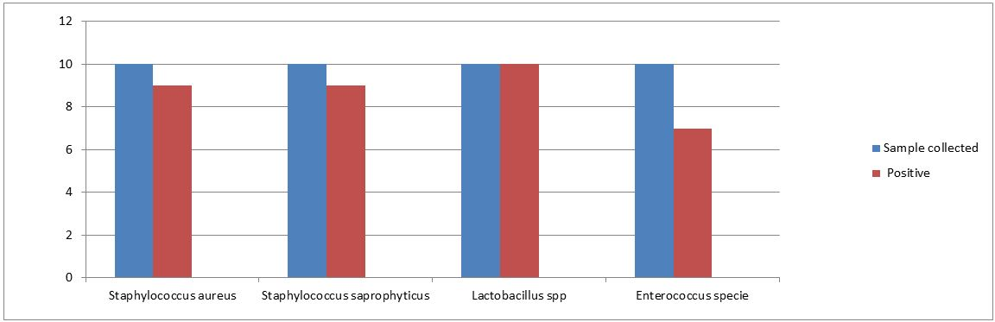
Fig.1. different gram positive bacterial strains in collected samples

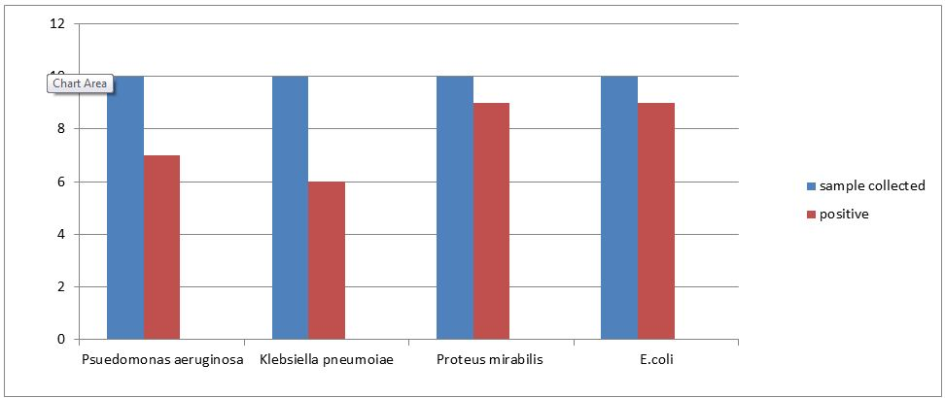
Fig.2: different gram negative bacterial strains in collected samples

