COMPARATIVE ANALYSIS OF RESPIRATORY MICROBIOTA FROM CLINICALLY HEALTHY AND DISEASED BROILER BREEDERS
Husnain Ahmed, ,M. Rabbani*K. Muhammad**, M.Y.Tipu***, Z.Shabbir+
*University Diagnostic Laboratory, University of Veterinary and Animal Sciences, Lahore, Pakistan
**Department of Microbiology, Faculty of Veterinary Science, University of Veterinary and Animal Sciences, Lahore, Pakistan
***Quality Operations Laboratory, University of Veterinary and Animal Sciences, Lahore,Pakistan.
+Quality Operations Laboratory, University of Veterinary and Animal Sciences, Lahore,Pakistan.
Corresponding Author e-mail address: husnain101@gmail.com
ABSTRACT
The pulmonary system of birds is a considered a reservoir of innumerable bacterial pathogens including those which are subject to public health significance.There are many respiratory outbreaks in poultry that causes huge economic losses and a number of bacterial pathogens either acting as primary or secondary pathogen can be held responsible for these losses. A very small fraction of (<1%) of bacterial species are culturable, through conventional microbiological procedures. With the advancement of technology metagenomic analysis of a given sample has emerged as a major culture independent technique for identification of many pathogens, by reading the hypervariable region of the 16S rRNA gene, culture-independent technique such as 454-pyrosequencing, can provide species specific sequence of any bacteria in a given sample. A total of 12 T-BAL (Tracheo-broncho alveolar lavage) samples from breeder birds were selected based upon the quality and quantity of the double-stranded gDNA. Using 454 bar-coded pyrosequencing, the hypervariable regions of the 16S rRNA gene corresponding to V1 – V5 (~ 1,000 bp) were sequenced. Of the high-quality reads obtained (296,811) using the MOTHUR platform, the sequences were processed for sequence alignment with the 16S RDP database via BLASTn, and subsequent taxonomic analysis through MEGAN programs using a homology-based method to bin sequence reads.The results of study indicate that birds harbor a diverse microbial community including number of phyla, families, genera and characterized bacterial species. The clinically diseased birds contained more number of microflora as compared to healthy birds but the microbial diversity was more in healthy birds as compared to diseased birds.
KEY WORDS: Metagenomics, T-BAL, gDNA, MOTHUR
INTRODUCTION

In routine, the respiratory system of birds is constantly interacting with a vast number of bacteria, viruses and other pathogens from outside environment e.g, microbes or fungi present in litter can also get penetrate in respiratory tract of birds through nostrils. However not enough data is available on the difference of a healthy and diseased bird’s respiratory microflora (Simbert et al., 1957; Silvanose et al., 2001; Nehme et al., 2005). Although culture based analysis have demonstrated that the lower respiratory tract is sterile in healthy birds (Pecora, 1963). The clinical outcome of a disease depends on various factors such as type of pathogen, its role as primary or secondary pathogen, birds immune status, management system under which bird is reared, quality of feed, vaccination schedule etc (Glisson, 1998; van Empel and Hafez, 1999; Pan et al., 2012). Since clinical signs of many diseases overlap with each other sometimes it becomes difficult to identify the potential pathogen. To date, the isolation and phenotypic identification of a number of genera and microorganisms (either alone or in synergy with other organisms) have permitted the identification of the bacterial causes of respiratory infection in birds around the globe (Vandamme et al., 1994; Travers, 1996; Van Empel and Hafez, 1999; Zorman-Rojs et al., 2000; El-Sukhon et al., 2002; Hafez, 2002; Chin et al., 2003; Canal et al., 2005; Murthy et al., 2008; Pan et al., 2012). In Pakistan, a number of bacterial species, such as Haemophilus paragallinarum (Akhter et al., 2001; Hasan et al., 2002; Siddique et al., 2012), Escherichia coli (Hasan et al., 2002; Mustafa et al., 2005), Mycoplasma and Salmonella spp. (Mustafa et al., 2005; Lateef et al., 2006), Staphylococcus, Streptococcus, and Bacillus spp. (Lateef et al., 2006), Pasteurella multocida (Zahoor and Siddique, 2011), and Mycoplasma synoviae (Ehtisham-ul-Haque et al., 2011), have been isolated and identified with varying prevalence in birds raised in free range, open house, and/or controlled house systems.
As less than 1% of microbes are culturable the primary pathogens of most of respiratory bacterial diseases remain hidden due to their non-culturable nature (Schuster, 2008). In field conditions in case of an outbreak generally broad spectrum anti-biotics are used which further limits the ability to culture specific pathogen.
Through metagenomic analysis we can study bacterial communities directly at nucleic acid level by-passing the need to culture them in any sample (Schuster, 2008; Pereira et al., 2010). Because more than 99.8% of organisms cannot be cultured, the hypervariable region of the 16S rRNA gene, the sequence of which is species-specific, can be used as an alternative to the phenotypic identification of bacteria.

MATERIALS AND METHODS

The International Animal Care and Use Committee (IACUC), USA, and the Ethical Research Committee of University of Veterinary and Animal Sciences, Lahore, Pakistan, approved the protocol used for the collection of the T-BAL samples. The sample collection procedure was performed as aseptically as possible using personal protective equipment (PPE). Approximately 500 µL to 1.2 mL of respiratory lavage was collected from each bird using a sterile catheter tip disposable syringe (STAR, Jiangsu Kanghua, China), which was attached to a sterile pipette tip that was adjusted according to the tracheal opening. The collected lavage was transferred to a sterile 1.5-mL microfuge tube (Eppendorf, Germany) and stored at -80°C until further processed for genomic DNA extraction.
The apparently healthy and morbid birds were euthanized by intravenous injection of potassium chloride (KCl) at a concentration of 1 to 2 mEq/kg of body weight (Merck, Germany) (Raghav et al., 2011). The birds were placed in a dorsal recumbent position, and a ventral midline incision was made from the angle of the mandible to the thoracic inlet. The surrounding fascia was removed from the trachea, and the trachea was cut transversely at the mid-cervical region. A 60-mL catheter tip disposable syringe (STAR, Jiangsu Kanghua, Medical Equipment Co., Ltd., China) attached to a sterile pipette tip was placed into the trachea to form an airtight seal. While pushing back the plunger of the 60-mL catheter syringe, air was withdrawn and negative pressure or a vacuum was created in the respiratory airway of the bird (visualized by the partial collapse of the extra-thoracic portion of the trachea). The vacuum-created airway was blocked by placing the trachea between the index finger and thumb. Using another catheter syringe placed in the trachea, while carefully maintaining the vacuum, approximately 3 – 5 mL of sterile phosphate buffered saline (PBS) was added. The bird was rocked/rolled from side to side to allow the fluid to reach and make contact with all parts of the respiratory tract. Finally, the T-BAL was withdrawn slowly until partial collapse of the trachea was observed again.
GENOMIC DNA EXTRACTION AND MEASUREMENT
The collected lavage was centrifuged at 14000×g for 10 minutes, and the pelleted bacteria were resuspended in 300 µL – 500 µL sterile PBS. The resuspended solution was used for genome extraction (gDNA) using a commercially available BiOstic® FFPE Tissue DNA Isolation Kit (Mobio, USA) according to the manufacturer’s instructions. All procedures were carried out inside a sterile BSL-2 biohazard safety cabinet (BH-EN 2004-5 CE, Italy) at the University Diagnostic Laboratory and Quality Operations Laboratory at UVAS, Lahore.
The gDNA samples with concentrations of at least 5 ng/µL and 260/280 and 260/230 ratios >1.80 were considered of good quality and processed further..
3.4. PREPARATION OF PCR AMPLICONS (dsDNA) AND 454-SEQUENCING
One-way read amplicons (Lib-L) were prepared using bar-coded fusion primers and the 27F (5´AGAGTTTGATCMTGGCTCAG 3´) and 907R (5´TACGGGAGGCAGCAG 3´) 16S primers (forward: CCATCTCATCCCTGCGTGTCTCCGACTCAG-MID-AGTTTGATCMTGGCTCAG and reverse: CCTATCCCCTGTGTGCCTTGGCAGTCTCAG-TACGGGAGGCAGCAG). PCR (25 µL) was performed with the 27F and 907R primers using 5 pmoles of the forward and reverse primers, 5 to 10 ng of ds DNA, 5 nmoles of each dNTP, 0.25 µL of Taq (Fast Start High Fidelity PCR system, Roche, Indianapolis, IN), and 2.5 µL of the 10X buffer solution supplied with the enzyme. The samples were denatured at 94°C for 3 minutes, followed by 35 cycles of 94°C for 15 sec, 55°C for 45 seconds, and 72°C for 60 seconds and a final extension at 72°C for 8 min (Gene AMP PCR System 9700; Applied Biosystems, Foster City, CA). The PCR products (approximately 1,000 bp) were separated on agarose gels and were extracted and purified using Agencourt AMPure technology (Beckman Coulter, Brea, CA). The products were pooled based on the molar amounts, separated on a 1% agarose gel and extracted. After purification, using the QIAquick PCR purification kit (Qiagen,Valencia, CA), the quality and quantity of the samples were assessed again using a DNA 7500 LabChip on an Agilent 2100 Bioanalyzer (Agilent Technologies, Santa Clara, CA) and Qubit flourometer quantification. Pyrosequencing on a 454/Roche GS FLX+ instrument using titanium chemistry (Roche Diagnostics, Indianapolis, IN) was performed in accordance with the manufacturer’s instructions. The 16S rRNA genomic region (V1 – V5) was amplified using fusion primers containing the sequences to amplify the 16S, adaptor, key and MID sequences for the FLX+ sequencing.
3.5. SEQUENCE PROCESSING
The GS-FLX-Titanium sequencer data was generated (.sff file) with the GS Amplicon software package (Roche, Branford, CT). In total, 278,040 raw sequences were processed, including 278,040 reads from clinically diseased and healthy birds 135,136.
Briefly, the primer sequences and barcodes were removed from each raw sequence, and the sequences were screened based on the quality score from 454 sequencing using the MOTHUR software platform v. 1.20.0. (Schloss et al., 2009). Reads containing more than 8 bases in a row or exhibiting an average quality score less than 25 were trimmed, and the individual bird sequence data were split using the split.groups command.
The pairwise sequence alignment tool BLASTN (http://blast.ncbi.nlm.nih.gov/Blast.cgi?CMD=Web&PAGE_TYPE=BlastDocs&DOC_TYPE=Download) was used to align sequences against the Ribosomal Database Project (RDP) “Bacteria + Archeaea (isolates only)” database (www.microgator.org/taxcollector/), which contains approximately 164,517 almost full-length 16S rRNA sequence reads. The sequence alignment was performed using the BLAST run and tabular output format with the 100 best hits in the background.
Using the LCA approach with a minimum threshold of 5 reads, every read retrieved from each lavage was assigned to a taxon .The 16S reads will not be assigned to any of the bacterial species unless more than one read is hit in the reference database. Conversely, using a simple LCA algorithm, if a read has a significant match to sequences in more than one species, MEGAN will assign the read to the “Lowest Common Ancestor (LCA)”.
Because the maximum diversity was observed at the genera node, it was selected to compute the matrix distance, rarefaction curve, and diversity indices using absolute counts of the reads in each dataset. The matrix distance of the datasets, comprised of clinically diseased and healthy birds within each management system, was calculated using Goodall’s ecological index and UPGMA algorithm, a simple version of UniFrac and Euclidean distances. The distance matrix was visualized by hierarchical clustering in which the diseased and healthy bird’s lavage were clustered closer or separately based on taxonomic content within each management system, the assigned genera node. Goodall’s index assigns more importance to the likeliness or similarity for reads corresponding to rare genera in data than for common or more abundant genera. Similarly, comparative taxonomic content richness as well as diversity in a given lavage sample (clinically diseased vs. healthy) were plotted in the form of a rarefaction curve that operates by repeatedly sampling subsets from a set of reads and computing the number of leaves to which taxa have been assigned. Furthermore, the biodiversity and richness of the flocks from each management system were evaluated using the Shannon-Weiner diversity index (SWDI) and the Simpson-Reciprocal diversity index (SRDI).

RESULTS AND DISCUSSION

The reads from both groups of birds were summarized and/or assigned to 10 phyla, 53 families, 66 genera, and 33 bacterial species. Compared to the diseased birds, more taxonomic diversity was observed in the clinically healthy birds, as indicated by the rarefaction plot and the increased number of taxon nodes represented. The microbiota harbored by the clinically healthy birds represented 10 phyla, 50 families, 58 genera, and 16 species. By contrast, the microbiota of the clinically diseased birds comprised 6 phyla, 27 families, 31 genera, and 24 species (Figure 6). As indicated in the hierarchical clustering at the genera node, a similarity in the taxonomic content of the diseased birds in flocks D and E and of the healthy birds in flock E was observed. However, the taxonomic content of the healthy birds in flock D differed from those in flock E .

Table 1: Brief history, geographical location, and individual clinical sample details (16S reads and subsequent diversity) for the controlled house system flocks
&Flock ID | Clinical History | #GC | *Sample ID | No. of Reads | α – diversity
 |  |  |  |  | ^{Ω}SWDI | ^{Ω}SWDI
CD | A 66-week-old breeder flock (n = 125,000) suffered from respiratory disease with clinical symptoms, such as sneezing and watery nasal discharge. Increased morbidity (60 – 80%) and mortality (12% to 15%) were observed within two weeks. Egg production and hatchability was decreased to 45% and 30%. | N31⁰38.822 and  E073⁰53.150 | CDH1 | 1,004 | 0.000 | 1.000
CD |  | N31⁰38.822 and  E073⁰53.150 | CDH2 | 6,556 | 2.848 | 4.036
CD |  | N31⁰38.822 and  E073⁰53.150 | CDH3 | 6,175 | 2.762 | 3.566
CD |  | N31⁰38.822 and  E073⁰53.150 | CDD1 | 9,939 | 1.302 | 2.031
CD |  | N31⁰38.822 and  E073⁰53.150 | CDD2 | 8,918 | 0.220 | 1.052
CD |  | N31⁰38.822 and  E073⁰53.150 | CDD3 | 8,058 | 0.276 | 1.064
CE | A 38-weeks-oldbreeder flock (n = 30,000) contracted respiratory disease with clinical symptoms that included an increase in body temperature, nasal discharge, gargling sounds, and neck paralysis at the terminal stage of the disease. Morbidity was high (70%), and within 5 days of onset, approximately 5,000 of the birds died. | 31°42′54″N and 73°59′06″E | CEH1 | 10,882 | 3.157 | 5.023
CE |  | 31°42′54″N and 73°59′06″E | CEH2 | 1,501 | 2.239 | 3.204
CE |  | 31°42′54″N and 73°59′06″E | CEH3 | 7,152 | 2.226 | 2.429
CE |  | 31°42′54″N and 73°59′06″E | CED1 | 7,603 | 0.354 | 1.096
CE |  | 31°42′54″N and 73°59′06″E | CED2 | 9.094 | 0.253 | 1.057
CE |  | 31°42′54″N and 73°59′06″E | CED3 | 21,990 | 0.451 | 1.112
&C = controlled house system, D and E = flock number assigned; #geographical co-ordinate; *H = healthy, D = diseased; ^{Ω}SWDI = Shannon-Weiner diversity index; ^{δ}SRDI = Simpson-Reciprocal diversity index
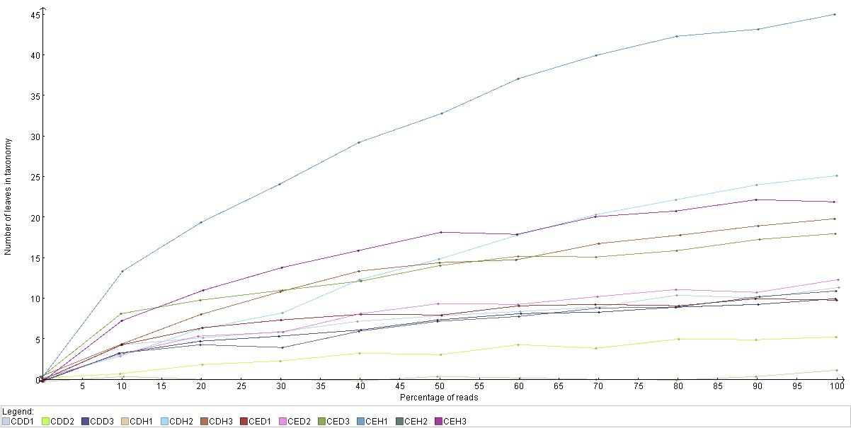Figure 2: Taxonomy rarefaction plot of the T-BALs from birds in the controlled house system at the genera node. The plot represents the percentage of reads present in a given sample corresponding to leaves in the NCBI taxonomy database.
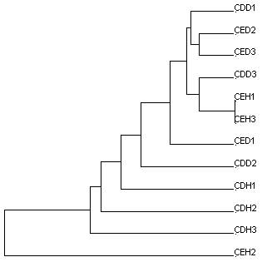Figure 3: NCBI taxonomic content-based hierarchical clustering of clinically diseased and healthy birds in the controlled house system collapsed at the genera node. The distances between branches in each sample were calculated using the Goodall normalization method with the UPGMA algorithm.
In the clinically diseased birds, of the 16S rRNA reads summarized at the phyla node, including those assigned to its descendants, Tenericutes (34,807, 54.49%) was the most abundant, followed by Firmicutes (17,992, 28.17%), Proteobacteria (10,095, 15.80%), Bacteroidetes (522, 0.82%), Actinobacteria (374, 0.58%), and Cyanobacteria (77, 0.12%). By contrast, Proteobacteria (20,269, 77.98%) was most abundant in the clinically healthy birds, followed by Firmicutes (2,609, 10.03%), Bacteroidetes (1,691, 6.50%), Actinobacteria (1261, 4.85%), Tenericutes (72, 0.27%), Fusobacteria (56, 0.22%), Cyanobacteria (9, 0.03%), Deinococcus-Thermus (9, 0.03%), Chloroflexi (8, 0.03%), and Verrucomicrobia (6, 0.02%). Reads corresponding to Verrucomicrobia, Fusobacteria, Deinococcus-Thermus, and Chloroflexi were not identified or found from clinically diseased birds (Figure 6b).
Reads corresponding to all families (n = 53) were identified in clinically healthy birds, with the exception of Micromonosporaceae, Paenibacillceae, and Burkholderiaceae. Enterobacteriaceae (7,318, 36.10%) was the most abundant family, followed by Pseudomonadaceae (3,600, 17.76%), Alcaligenaceae (2,198, 10.84%), Staphylococcaceae (1,676, 8.26%), Pasteurellaceae (1,160, 5.72%), Bacteroidaceae (983, 4.85%), Neisseriaceae (518, 2.55%), and others (2,816, 13.89%). Similarly, of the reads corresponding to 27 families identified in the clinically diseased birds, the most abundant families were Mycoplasmataceae (34,805, 62.83%), Pseudomonadaceae (7,142, 12.89%), Enterococcaceae (5,534, 9.99%), Lactobacillaceae (3,738, 6.74%), Enterobacteriaceae (1,275, 2.30%), Streptococcaceae (632, 1.14%), Pasteurellaceae (629, 1.14%), Flavobacteriaceae (398, 0.72%), and others (1242, 2.24%) (Figure 6c).
16S reads corresponding to 31 and 58 genera were identified in clinically diseased and healthy birds, respectively. Mycoplasma was found in abundance in the diseased birds (34,805, 65.41%), followed by Pseudomonas (7,136, 13.41%), Enterococcus (5,519, 10.37%)

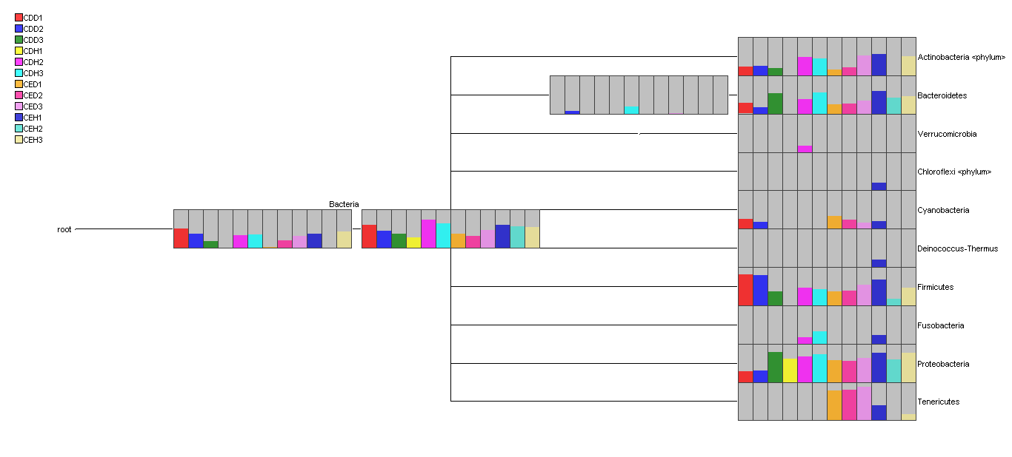Figure 14: Comparative visualization of the abundances of phyla in clinically diseased and healthy birds in the controlled house system using the NCBI taxonomy database.

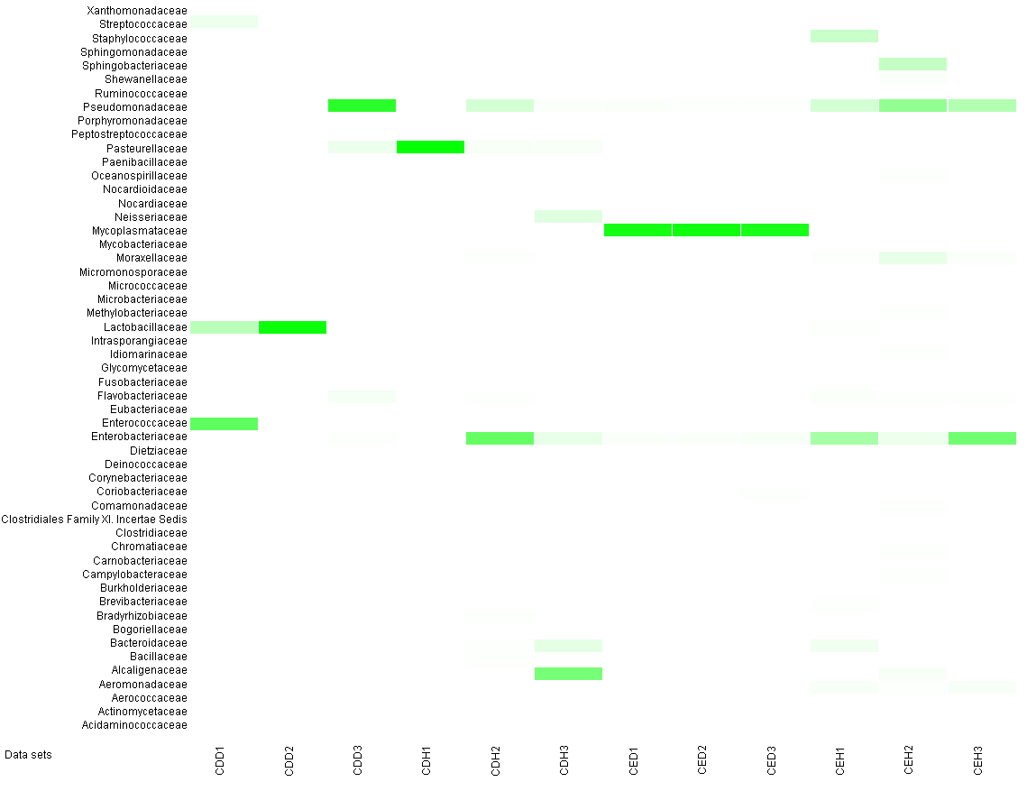Figure 5: Relative visualization of the abundances of bacterial families in clinically diseased and healthy birds in the controlled house system using the taxonomy database available at NCBI.

Lactobacillus (3,699, 6.95%), Streptococcus (632, 1.18%), Collinsella (269, 0.50%), Staphylococcus (208, 0.39%), Klebsiella (184, 0.35%), and others (754, 1.42%). Similarly, in the healthy birds, the highest number of reads corresponded to Pseudomonas (3,555, 37.40%), followed by Staphylococcus (1,526, 16.05%), Bacteroides (983, 10.34%), Klebsiella (865, 9.10%), Aeromonas (479, 5.04%), Acinetobacter (291, 3.06%), and others (1,804, 18.98%) (Figure 6d).
Of the 24 bacterial species identified in the diseased birds, Mycoplasma synoviae (5,222, 46.09%) was the most abundant, followed by Enterococcus cecorum (5,128, 45.26%), Collinsella aerofaciens (269, 2.37%), Streptococcus alactolyticus (191, 1.68%), Staphylococcus aureus (93, 0.82%), Eubacterium yurii (90, 0.79%), and others (336, 2.96%). Of the 16 bacterial species identified in the healthy birds, Staphylococcus aureus (712, 54.43%) was the most abundant, followed by Enterococcus cecorum (203, 15.51%), Sphingobacterium sp. EQH22 (94, 7.18%), Ornithobacterium rhinotracheale (90, 6.88%), Salinicoccus carnicancri (75, 5.73%), and others (134, 10.24%). Micromonosporaceae sp. SB1-35, Bacillus sp. PeC11, Brevibacillus agri, Abiotrophia defective, Lactobacillus agilis, Lactobacillus coleohominis, Lactobacillus intermedius, Lactobacillus pontis, Lactobacillus secaliphilus, Lactobacillus sp. oral taxon 052, Streptococcus alactolyticus, Streptococcus pluranimalium, Methylibacterium hispanicum, Mycoplasma arginini, and Mycoplasma synoviae were found exclusively in diseased birds. By contrast Alcaligenes sp. badwp, Marinomonas protea, Myroides sp. MY15, Ornithobacterium rhinotracheale, Sphingobacterium sp. EQH22, Salinicoccus carnicancri, Clostridium sp. TM-40, Eubacterium sp. Pei061, and Phascolaractobacterium faecium were found only in apparently healthy birds.

REFERENCES

Akhtar S, Bhatti AR, Muhammad K. 2001. Clinico-therapeutic observations on an outbreak of Infectious Coryza. Int. J. Agri. Biol. 3(4): 531 – 532.
Canal CW, Leao JA, Rocha SLS, Macagnan M, Lima-Rosa CAV, Oliveira SD, Back A. 2005. Isolation and characterization of Ornithobacterium rhinotracheale from chickens in Brazil. Res. Vet. Sci. 78: 225 – 230.
Chin RP, Van Empel PCM, Hafez HM. 2003. Ornithobacterium rhinotracheale infection. In: Disease of Poultry, 11th ed (Saif, Y. M., H. J. Barnes, J. R. Glisson, A. M. Fadly, L. R. McDougald, D. E. Swayne, Eds.) Iowa state University Press, Ames, Iowa, pp. 683 – 690.
Ehtisham S, Rahman SU, Siddique M, Qureshi AS. 2011. Involvement of Mycoplasma synoviae in respiratory distress cases of broilers. Pakistan Vet. J. 31(2): 117 – 119.
EL-Sukhon SN, Musa A, Al-Attar M. 2002. Studies on the bacterial etiology of airsacculitis of broilers in Northern and Middle Jordan with special reference to Escherichia coli, Ornithobacterium rhinotracheale and Bordetella avium. Avian Dis. 46: 605 – 612.
Glisson JR. 1998. Bacterial respiratory diseases of poultry. Poult. Sci. 77:1139 – 1142.
Hafez MH. 2002. Diagnosis of Ornithobacterium rhinotracheale. Int. J. Poultry Sci. 1: 114 - 118.
Hasan S, Ahmed K, Fawad N, Saddique B, Rehman H. 2002. Current respiratory disease problems and the probes in chicken. Pakistan Vet. J. 22(1): 17 – 19.
Lateef M, Rauf U, Sajid MA. 2006. Outbreak of respiratory syndrome in chukar partridge (Alectoris chukar). J. Anim. Plant Sci. 16(1-2): 31 – 33.
Murthy TRGK, Dorairajan N, Balasubramaniam GA, Dinakaran AM, Saravanabava K. 2008. Pathogenic bacteria related to respiratory diseases in poultry with reference to Ornithobacterium rhinotracheale isolated in India. Vet. Arch.78: 131 – 140.
Mustafa MY, Ali SS. 2005. Prevalence of infectious diseases in local and fayoumi breeds of rural poultry (Gallus domesticus). Punjab Univ. J. Zool. 20 (2): 177 – 180.
Nehme PA, Barbour EK, Sagherian VK, Hamadeh SK, Zurayk RK. 2005. Baseline data on enumerated tracheal bacterial flora and drug susceptibility in chicken reared under different systems. Int. J. Appl. Res. Vet. Met. 3(4): 372 – 377.
Pan Q, Liu A, Zhang F, Ling Y, Ou C, Hou N, He C. 2012. Co-infection of broilers with Ornithobacterium rhinotracheale and H9N2 avian influenza virus. BMC Vet. Res. 8: 104 – 111.
Pecora DV. 1963. A comparison of transtracheal aspiration with other methods of determining the bacterial flora of the lower respiratory tract. N. Engl. J. Med. 269: 664 – 666.
Pereira F, Carneiro J, Matthiesen R, van Asch B, Pinto N, Gusmao L, Amorim A. 2010. Identification of species by multiplex analysis of variable-length sequences. Nucleic Acids Res. 38 (22): e203. Doi: 10.1093/nar/gkq865.
Raghav R, Taylor M, Guincho M, Smith D. 2011. Potassium chloride as a euthanasia agent in psittacine birds:Clinical aspects and consequences for histopathologic assessment. Can. Vet. J. 52: 303 – 306.
Schloss PD, Westcott SL, Ryabin T, Hall JR, Hartmann M, Hollister EB, Lesniewski RA, Oakley BB, Parks DH, Robinson CJ, Sahl JW, Stress B, Thallinger GG, Van Horn DJ, Weber CF. 2009. Introducing mothur: open-source, platform-independent, community-supported software for describing and comparing microbial communities. Appl. Environ. Microbiol. 75(23): 7537 – 7541.
Schuster S C. 2008. Next-generation sequencing transforms today’s biology. Nat. Methods. 5: 16 – 18.
Silvanose CD, Bailey A, Naldo JL Howlett JC. 2001. Bacterial Flora of the conjunctiva and nasal cavity in normal and diseased captive bustards. Avian Dis. 45:447 – 451.
Smibert RM, Devolt HM, Faber JE. 1957. A study of the bacterial flora of the respiratory system of normal chickens. Poultry Sci. 159 – 166.
Van Empel P, van den Bosch H, Goovaerts D, Storm P. 1996. Experimental infection in turkeys and chickens with Ornithobacterium rhinotracheale. Avian Dis. 40: 858 – 864.
Vandamme P, Segers P, Van Canneyt M, Van Houe K, Mutters R, Hommez J, Dewhirst F, Paster B, Kersters K, Falsen E, Devriese LA, Brisguard M, Hinz KH, Mannheim W. 1994. Ornithobacterium rhinotracheale gen. nov. sp. nov, isolated from the avian respiratory tract. Int. J. Syst. Bacteriol. 44: 24 – 37.
Zahoor MA, Siddique M. 2006. Characteristics of Pasteurella multocida recovered from avian sources. Pakistan Vet. J. 26 (1): 41 – 43.
Zorman-Rojs O, Zdovc I, Bencina D, Mrzel I. 2000. Infection of turkeys with Ornithobacterium rhinotracheale and Mycoplasma synoviae. Avian Dis. 44: 1017 – 1022.

