THYROXIN LEVELS IN DOGS WITH SARCOPTIC MANGE
B.Sudhakara Reddy, K.Nalini Kumari and S.Sivajothi
Department of Veterinary Medicine,
College of Veterinary Science, Sri Venkateswara Veterinary University,
Tirupati-517 502, Andhra Pradesh. India.
Corresponding author: bhavanamvet@gmail.com
ABSTRACT:
Sarcoptic mange is one of the common contagious skin diseases affecting all domestic animals through host-adapted variants. Dogs infected with scabies had intense itching, restlessness, frantic scratching, hair loss, reddened skin and scabs. The most commonly affected areas are a dog’s ears, elbows, face and legs. Haematological alterations included reduced total erythrocyte count and haemoglobin. Affected dogs also showed leukocytosis accompanied by neutrophilia, eosinophilia and monocytosis. Biochemical changes included reduced in mean total serum protein, serum albumin in comparison to control healthy dogs. Reduced total T₄ (2.32±0.25µg/ dL) and free T₄ (1.37 ±0.04 ng/dL) levels was recorded.
KEY WORDS: Haemato Biochemical Changes - Thyroxin - Dogs - scabies
INTRODUCTION:
Scabies is a transmissible and zoonotic ectoparasitic skin infection caused by tiny mites of the species Sarcoptes scabiei and is transmitted readily among animals, often even throughout an entire household, by skin-to-skin contact. Scabies in humans is most prevalent in overcrowded and poor hygienic conditions. Zoonotic importance of scabies was also recorded in Andhra Pradesh (Sudhakara Reddy and Kumari, 2013). It is felt to be a disease of overcrowding and poverty rather than a reflection of poor hygiene (Heukelbach, 2005). Presence of scabies is also responsible for developemnet of recurrent pyoderma in dogs (Sudhakara Reddy et al., 2014a). Literature available on haemato biochemical changes and thyroxin levels in dogs affected with scabies was little. So, present paper reports the thyroxin changes along with other haemato-biochemical findings in dogs affected with scabies.
MATERIALS AND METHODS:
Dogs with dermatological problems were screened for the presence of sarcoptic mites in the two years period of research at College Hospital of college of veterinary science, Tirupati. Superficial and deep skin scrapings, slide impression smears and tape impression smears were also collected from various sites of all the dogs. All the dogs revealed papules, scales, hyperpigmentation, erythema, alopecia and pustules. Eczematous lesions on the face, margins of ears, trunk, legs, elbows, hocks, chest and ventral abdomen (Fig.1,2,3) were also noted. All the dogs exhibited pinna pedal reflex (Video). In 16 dogs skin scrapings revealed ova and adult live mites (Fig.4). Based on the history, exhibited clinical signs and microscopic examination sixteen dogs were identified as suffering with the scabies. From all the effected dogs and ten apparently healthy dogs’ blood was collected in EDTA coated vials. Blood was processed for packed cell volume (PCV) by microhaematocrit method, haemoglobin (Hb) by Sahli’s method, total leucocyte count (TLC) and total erythrocyte count (TEC) by dilution method. The blood smears were directly prepared and stained by Leishman’s stain for differential count (DLC) with battlement method and absolute counts were also calculated. Serum was collected from all the dogs and stored at deep freezer (-20ºC) up to serological examination. Serum total protein, albumin and total cholesterol were estimated by using Span diagnostics Ltd. Kits. Total T₄ and free T₄ levels were estimated by ELISA (as per manufacture’s procedure) using a kit obtained from United Biotech Inc. (Sudhakara Reddy et al., 2014b). The data in respect of each parameter was tabulated group wise and statistical analyses were carried out by using Statistical Package for Social Sciences (SPSS) using student “t” test.
RESULTS AND DISCUSSION:
The mean haematology and serum biochemistry values of apparently healthy dogs and dogs with scabies are given in Tables 1 and 2. The haemogram of apparently healthy dogs was within the normal reference range as quoated by and Villers (2005). Dogs with scabies had reduced mean Hb of 10.71 ±0.27g/dl with range from 9.8 g/dl to 12.2 g/dl. Mean PCV levels was 34.89 ±0.77per cent range of 33-37 percent. TEC ranged from 5.62 ±0.15 x 10⁶/cumm to 6.15 x 10⁶/cumm with mean of 5.89 ±0.15 x 10⁶/cumm. No statistically significant difference in the decrease of PCV was recorded. The decrease in the values of haemoglobin and TEC might be due to anaemia caused due to the loss of skin protein. Anemia might be due to the stress arising from the disease. Similar findings were reported by Gupta and Prasad (2001) and Biswas et al. (2002). A highly significant increase in mean total leucocyte count (12793.33 ±796.361), mean absolute neutrophil count (8529.78±311.68/cumm), mean absolute eosinophil count (1176.33±72.03/cumm), mean monocytes (355.89 ±37.36/cumm) and non significant reduction in reduced mean lymphocytes (2158.22±106.22/cumm) were found in this study. Dadhich and Khanna (2008) also observed the same findings in their studies. Decreased levels of haemoglobin may be due to chronicity and generalized nature of the disease (Ferreira et al, 1987). It might also be due to the significant low erythrocyte count and erythrocyte fragility and low production of erythropoietin due to toxaemia caused by mites. Leucocytosis might be due to allergic reaction caused by mite or their products of inflammatory reaction (Shah, 1994).

The serum biochemical values of apparently healthy animals recorded were within the normal range as reported by Villers (2005). Dogs with scabies revealed lowered normal total protein levels 6.12 ±0.17g/dl (range from 5.86 to 7.21 g/dl) and reduced mean serum albumin levels 2.54 ±0.19 with range from 2.14 g/dl to 3.24 g/dl. Serum globulin levels range from 3.14 g/dl to 4.10 g/dl with mean of 3.58 ±0.07 g/dl recorded. Hypoproteinaemia which was in agreement with the observations of Biswas et al. (2002) and Solanki et al.(2007). The mean total T₄ values of the normal and scabies affected dogs were 2.69 ±0.34 µg/dL and 2.32±0.25µg/dL. In this slight reduction in the mean levels was noticed, but there is no statistically significant reduction was noticed when compare with healthy dogs. The mean free T₄ value also (1.37±0.04 ng/dL) reduced than the normal group (1.57±0.07 ng/dL) without any significant levels. In this study dogs didi not show any hypothyroid signs.
Presence of severe itching due to the mites all over the body, there is a chance of proliferation of staphylococci which leads to severe damage to the skin. In severe cases ulcers can also observed due to secondary bacterial infections (Sudhakara Reddy et al., 2014a). In the present study reports the deceased levels of haemoglobin and protein. It suggests that dogs with scabies should required high protein diet and heamatonics in their feeding schedule.

Conclusion:
Dogs affected with scabies revealed significant reduction in total erythrocyte count, haemoglobin, leukocytosis accompanied by neutrophilia, eosinophilia. Reduced total serum protein and serum albumin levels were recorded.
REFERENCES:
Abbeen Sakina and RK.Mandial. 2013. Haematobiochemical changes in canine scabies. Vet scan. 7 (2). 27-30
Biswas L., Mukhopadhyay S.K., Bhattacharya M.K. and Roy S. (2002). J. Interacademicia, 6: 734-736.
Carson-DeWitt, R. (2002) In J. L. Longe (ed.), The Gale Encyclopedia of Medicine, Volume 4, 2nd edition.
Dadhich, H and Khanna, R (2008). Pathological, heamatobiochemical and immunological studies of cutaneous ectoparasitoses in dogs. Proceedings of the 15th Congress of FAVA, Bangkok, Thailand. Pp. 409-412.
Ferreira, H., Figueiredo C , Burini RC, Curi PR (1987). Serum vitamin levels, erythrocyte and lymphocyte counts, packed cell volume and haemoglobin determinations in normal dogs. Dogs with scabies and dogs with demodicosis. Arq.Bras. Med. Vet. 39: 905-917.
Gupta N. and Prasad B. (2001). Clinico diagnosis and therapeutic management of acariasis in dogs. Indian. Vet. Med ., 21:73-75.
Heukelbach, J., Walton,S.F. and Feldmeier,H (2005) Ectoparasitic infestations. Curr. Infect. Dis. Rep. 7:373-380.
Shah, H (1994). Clinico-biochemical and therapeutic studies on mange in dogs. M.V.Sc thesis, IVRI, Izatnagar, India.

Solanki J.B., Hasnani, J.J., Patel D.M., Patel, P.V. and Raval S.K. (2007). Canine demodicosis in Anand. J.Vet. Parasitol, 21(1): 79-80
Sudhakara Reddy B and Nalini Kumari K. Canine Scabies – Its Therapeutic Management and Zoonotic importance. Intas Polivet (2013) Vol. 14 (II): 292-294.
Sudhakara Reddy B, Nalini Kumari K, Sivajothi S (2014b) Haemato-biochemical findings and thyroxin levels in canine demodicosis. Comp Clin Pathol. DOI 10.1007/s00580-014-1893-y.
Sudhakara Reddy, B., Nalini Kumari, K., Vaikunta Rao, V., Rayulu, V.C. (2014a) Efficacy of Cefpodoxime with Clavulanic Acid in the Treatment of Recurrent Pyoderma in Dogs Hindawi Publishing Corporation ISRN Veterinary Science Volume 2014, Article ID 467010, 5 pages
Villers, E. (2005). Introduction to haematology. In : BASAVA manual of canine and feline pathology” 2nd Edn, Villers E and Blackwood L, BASAVA, Gloucester, UK, pp:33-60.

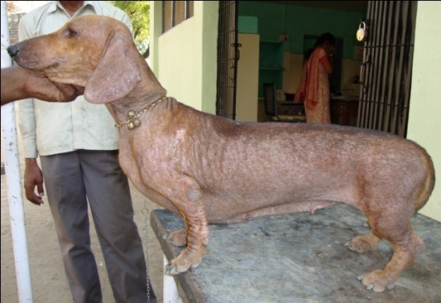
Figure-1: Dog with scabies

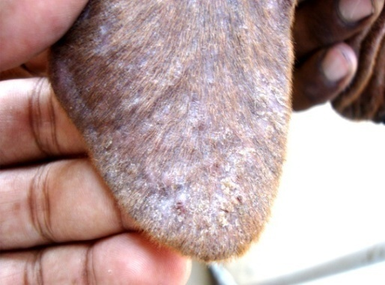
Figure-2: Lesions at the ear margin of scabies dog

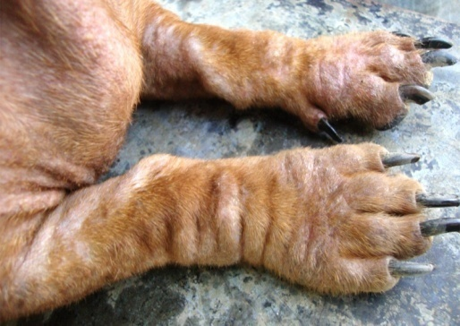
Figure-3: Lesions at the both fore limbs of scabies dog
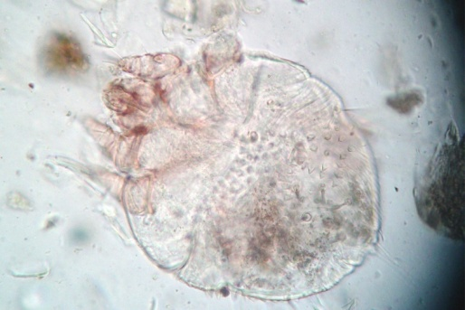
Figure-4: Sarcoptes mites (40X, 4x Camera magnification)

Legends:
Figure-1: Dog with scabies
Figure-2: Lesions at the ear margin of scabies dog
Figure-3: Lesions at the both fore limbs of scabies dog
Figure-4: Sarcoptes mites (40X, 4x Camera magnification)

Table 1: Mean haematological values of healthy and scabies affected dogs (Mean±S.E)

Parameters | Normal group (n=10) | Dogs with scabies (n=16) | t - test | P
Hb (g/dl) | 13.03 ±0.42 | 10.71 ±0.27 | 4.76** | 0.000
PCV (%) | 39.29 ±2.14 | 34.89 ±0.77 | 2.13 ^{NS} | 0.051
TEC x10⁶/cumm | 6.51 ±0.19 | 5.89 ±0.15 | 2.58* | 0.021
TLC /cumm | 9334.29 ±81.34 | 12793.33 ±796.361 | 3.57** | 0.003
Neutrophils /cumm | 6698.06 ±244.96 | 8529.78±311.68 | 4.41** | 0.000
Lymphocytes /cumm | 2417.37 ±119.77 | 2158.22±106.22 | 1.61 ^{NS} | 0.129
Eosinophils /cumm | 135.57 ±22.11 | 1176.33±72.03 | 12.31** | 0.000
Monocytes /cumm | 68.36 ±17.83 | 355.89 ±37.36 | 6.33** | 0.000

NS – Non Significant (P>0.05)
* Significant (P˂0.05)
* * Highly Significant (P˂0.01)

Table 2: Mean serum protein and thyroxin profiles of healthy and scabies affected dogs (Mean±S.E)

Parameters | Normal group  (n=10) | Dogs with scabies (n=16) | t-test | P
Total protein (g/dl) | 6.81 ±0.22 | 6.12 ±0.17 | 2.51 * | 0.024
Albumin (g/dl) | 3.25 ±0.04 | 2.54 ±0.19 | 3.17** | 0.006
Globulin (g/dl) | 3.56 ±0.20 | 3.58 ±0.07 | 0.11 ^{NS} | 0.910
A:G ratio | 0.85 ±0.11 | 0.71 ±0.06 | 1.13 ^{NS} | 0.276
Total cholesterol (mg/dl) | 84.57 ±6.81 | 104.00 ±6.91 | 1.96 ^{NS} | 0.060
Total T₄ µg/ dL | 2.69 ±0.34 | 2.32 ±0.25 | 0.58 ^{NS} | 0.575
Free T₄ ng/ dL | 1.57 ±0.07 | 1.37 ±0.04 | 1.27 ^{NS} | 0.228

NS – Non Significant (P>0.05)
* Significant (P˂0.05)

Assistant Professor (Veterinary Medicine), TVCC, C.V.Sc., Proddatur.
Professor and University Head, Dept. of Veterinary Medicine, C.V.Sc., Tirupati
Assistant Professor, Dept. of Veterinary Parasitology, C.V.Sc., Proddatur.

