.
From |  | To
Dr.B.Sudhakara Reddy, |  | The Journal of advances in parasitology,
Assistant Professor, |  | Nexus publication.
TVCC,
College of Veterinary Science,
Proddatur,
Andhra Pradesh

Sir,

Sub: Submission of RESEARCH Article - regarding.

I submit to state that here I am attaching the research article for publication in our journal.
We hereby declare that the above manuscript which is submitted for publication is not published already in part or whole (except in the form of abstract) in any journal. No part of this manuscript (referred or otherwise) has been copied verbatim from any source.

Thanking you sir,
Yours faithfully,

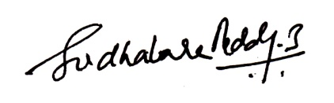
(Dr.B.Sudhakara Reddy)

