CLINICAL INVESTIGATION OF PESTE DES PETITS RUMINANTS OUTBREAK IN SHEEP AND GOATS

Running Title: An outbreak of PPR in ICT area Pakistan

Riasat Wasee Ullah* ¹, Muhammad Humayoon Samo ², Aamer Bin Zahur ¹, Muhammad Afzal ², Shahid Ali Khan ², Asma Latif ¹, Hamid Irshad ¹, Aziz-ur-Rehman ³
Tables: 4
Figures: 4

- Animal Health Research Laboratories, Animal Sciences Institute, National Agricultural Research Centre Islamabad
- FAO, Pakistan (GCP/PAK/127/USA)
- University of Veterinary and Animal Sciences Lahore, Pakistan

*Corresponding Author: riasatwasee252@yahoo.com
Telephone : +92-519255029

Key words: Peste des Petits Ruminants, clinical findings, small ruminants, PPR outbreak

Abstract
Clinical and laboratory investigations were carried out during an outbreak of Peste des Petits (PPR) in sheep and goats in Islamabad Capital Territory (ICT), Pakistan. It was observed that the outbreak was occurred due to mix grazing and introduction of new animals. The overall morbidity, mortality and case fatality in goat flock were 79%, 8.64% and 11% respectively. While in sheep flock the overall morbidity, mortality and case fatality were 28.5%, 11.4% and 40% respectively. It was also observed that goats experienced severe clinical disease while in sheep the clinical disease was in mild form. Samples from live animals (ocular/nasal discharges) and dead animals (lung, liver, spleen, lymph nodes) were analysed by RT-PCR in the laboratory. On the basis of clinical and laboratory analysis it was revealed the presences of PPR virus in sheep and goats.
Introduction
Infectious viral diseases of small ruminants (sheep/goats) cause huge economic losses and have significant socio-economic impact. Peste des Petits Ruminants (PPR) is highly contagious viral disease of domestic and wild small ruminants that is associated with high morbidity and mortality. (Kwiatek et al., 2007). PPR is caused by a virus that is known as Peste des Petits Ruminants Virus (PPRV). PPRV is a member of order Mononegavirales in the family Paramyxoviridae genus Morbillivirus. It has negative sense single stranded RNA with the genome sized approximately 16 kilobases (kb) (Gibbs et al., 1979). PPRV is grouped into four (I-IV) genetically different lineages which are based on the sequence variability of the carboxy terminal in the N protein gene (Kwiatek et al., 2007). The small ruminants herd in Pakistan is around 28.8 and 64.9 million sheep and goats respectively (Economic Survey, 2012-13). PPR is endemic in Pakistan and was first reported in 1991(Athar et al., 1995). Since then several outbreaks of PPR has been reported all over the country. Small ruminant keepers in Pakistan face great economic losses due to PPR. During the year 2006 and 2007 estimated losses due to PPR were worth Rs. 20.53 billion annually. An outbreak of PPR occurred in goats and sheep in Golra town, sub-urban area of Islamabad Capital Territory, Islamabad, Pakistan during March, 2014.

The epidemiological data, clinical findings, necropsy features and laboratory confirmation of PPR virus are reported in this clinical article. Epidemiological observations include flock size, age, sex, vaccination history and possible history of virus transmission were recorded on prescribed Proforma. There were two flock consisted on goats (n=81) table: 1 and sheep (n=280) table: 2. There was no vaccination history in the flocks Table: 1.
Table: 2 Group size of the affected goats flock
Age Group | Group Size | Vaccination History
Kids | 21 | No vaccination history
Young | 35 | No vaccination history
Adult | 25 | No vaccination history
Total | 81 | No vaccination history

Table 2: Group size of the affected sheep flock
Age Group | Group Size | Vaccination History
Lamb | 62 | NO vaccination history
Young | 150 | NO vaccination history
Adult | 68 | NO vaccination history
Total | 280 | NO vaccination history

Clinical examination of the affected sheep and goat flock was conducted. All cardinal signs were recorded. Necropsy of dead animal was conducted. Appropriate samples were collected from live and dead animals which include ocular (n =6), nasal (n = 6) swabs samples from all suspected live animals and tissues samples n=8 (lung, liver, spleen, lymph node) from dead animals for laboratory confirmation. The Penside test was performed at the outbreak site following (Hussain et al., 2002) Figure 1. And for laboratory confirmation samples were shipped in cold condition to Animal Health Research Laboratories (AHRL), Animal Sciences Institute, National Agricultural Research Centre, Islamabad Pakistan. In the laboratory the samples were tested for PPR virus antigen detection by RT-PCR following (Couacy-Hymann et al., 2002).
The goat flock consisted of 81 goats of different ages there was no PPR vaccine history in the goat flock. Of 21 kids, 7 were died with case fatality of 38.88%. However, no mortality was observed in young and adult stock Table: 3.

Table: 3 Morbidity and Mortality rates in goat flock
Age group | Group size | Vaccination History | Morbidity | Mortality | Case Fatality
Kids | 21 | No | 18 (89) | 7 (33.3) | 7 (38.88)
Young | 35 | No | 28 (80) | 0 | 0
Adult | 25 | No | 18 (72) | 0 | 0
Total | 81 |  | 64 (79) | 7 (8.64) | 7 (11)

On the other hand sheep flock was consisted on 280 Balkhi sheep. There was no history of PPR vaccine in affected sheep flock. In sheep flock young stock experienced highest mortality rate of 18.6%. while, lambs experiences mortality rate of 6.45% Table: 4
Table: 4 Morbidity and Mortality rates in sheep flock
Age group | Group size | Vaccination History | Morbidity | Mortality | Case Fatality
Lambs | 62 | No | 16 (25.8) | 4 (6.45) | 4 (25)
Young | 150 | No | 43 (28.6) | 28 (18.6) | 28 (65)
Adult | 68 | No | 21 (30.8) | 0 | 0
Total | 280 |  | 80 (28.5) | 32 (11.4) | 32 (40)

During clinical and postmortem examination following findings were observed. In case of goat flock the affected animals become depressed (Figure 2a) and exhibits high fever (105-107 °F), severe conjunctivitis, congestion of third eye lids, ocular and nasal discharges (Figure 2b) with severe diarrhoea (Figure 2d). Cheasy material and erosive lesions were observed on the inner side of the lower lip (Figure 2c). On external examination of dead animals the carcass was dehydrated with sunken eyes along with soiling of hind quarter with diarrhoea material. On internal examination the cardiac lobe of the lungs was congested (Figure 2e). Haemorrhages were observed on liver, abomasal mucosa (Figure 2f) and on the mucosa of large intestine. While, in case of sheep flock mild sings of PPR had been observed during investigation which include high fever, mild conjunctivitis, mild congestion on lower gums (Figure 3a) and mild nasal/ocular discharges with diarrhoea. On post mortem examination the cardiac lobe of the lungs was congested (Figure 3b). Haemorrhages were observed on liver (Figure 3c), abomasal mucosa (Figure 3f) and on the mucosa of large intestine (Figure 3g). Mesenteric lymph nodes were inflamed (Figure 3e). Splenomegaly was also observed (Figure 3d). The dead carcass was disposed off to stop the further transmission of PPRV (Figure 3h).
On laboratory analysis n=2 ocular swabs, n=4 nasal swabs and n=8 tissue samples were found positive for PPR virus antigen by RT-PCR Figure 4.
During clinical investigation typical clinical signs and symptoms of PPR virus infection were observed in infected sheep and goats. These include high fever up to 42ºC, lesions in mouth, oral and nasal congestion, respiratory signs and diarrhoea leading to death of the animals. Similar findings were made in previous reports (Couacy-Hymann et al., 2007; Hamdy and Dardiri, 1976; Nanda et al., 1996).
In this study it was observed that the morbidity rate were 79% and 28% while mortality rates were 8% and 11% in goats and sheep respectively. These findings are in complete concurrence with Diallo (2006) who reported that morbidity and mortality rates due to PPR may vary from 0 to 90% depending on the local husbandry practices, breed, age and other factors. Similar findings are also documented by Abu-Elzein et al. (1990). It was also observed in this study that animals in particular age groups (10-18 months) in the flock were relatively more affected with viral infection. However, Lefevre and Diallo (1990) observed that animals in all age groups are susceptible to PPRV infection. Similar findings were made by Abubakar et al. (2011).
In this study it was observed that sheep experienced mild form of PPR. In Ethiopia the sheep were found to be relatively resistant to PPR virus infection during an outbreak within a mixed flock, where only goat showed clinical disease (Roeder et al., 1994). However, other authors reported that sheep and goats were affected with equally overwhelming consequences with high morbidity and mortality (Shaila et al., 1989; Taylor et al., 2002). It was hypothesized that rarely field strains overcome the innate resistance possessed by sheep to the clinical effects of the disease and produce high mortality. There may exist a host adaptation which plays important role in the appearance of clinical signs. The consequences of PPR virus infection and its epidemiology may be affected by the breed (Taylor and Barret, 2007).

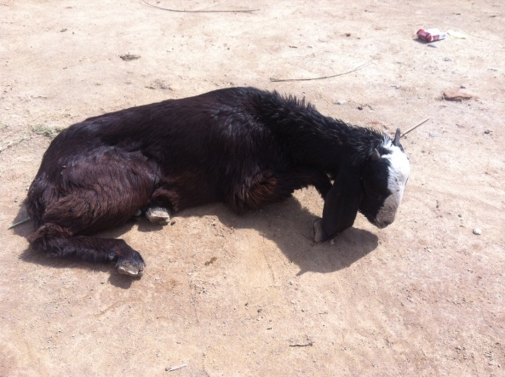
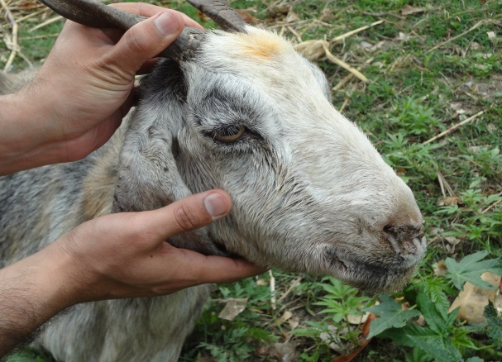

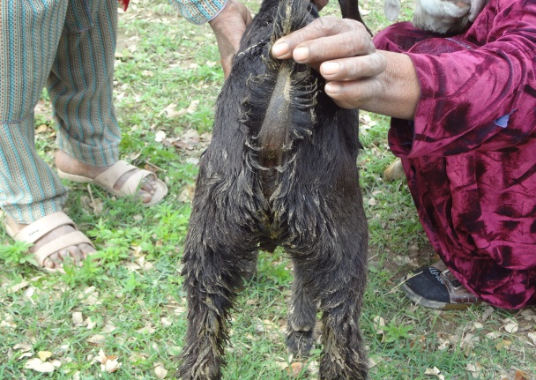
a) Isolated and depressed goat b) Nasal and ocular discharges
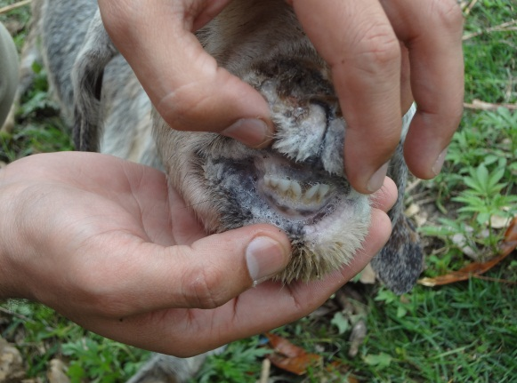

c) Cheesy material on gums d) severe diarrhoea
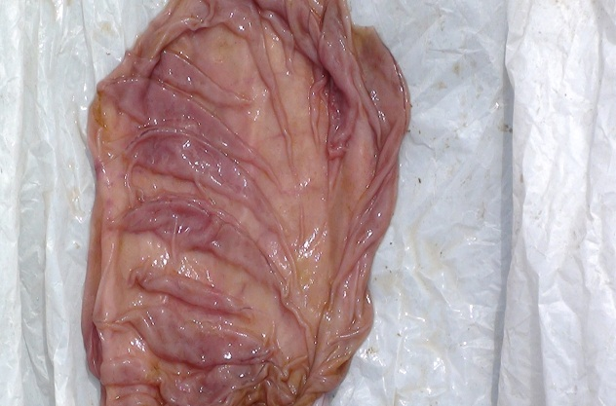
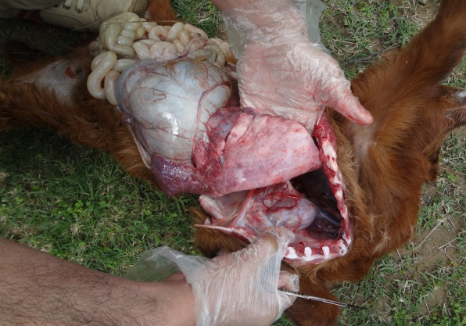

e) Congestion on Lungs f) Haemorrhages on abomasal mucosa

Figure 2: Clinical signs and necropsy findings of PPR virus infection in goats

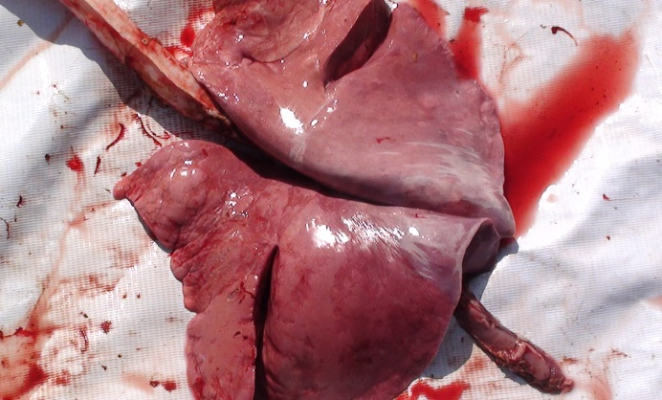
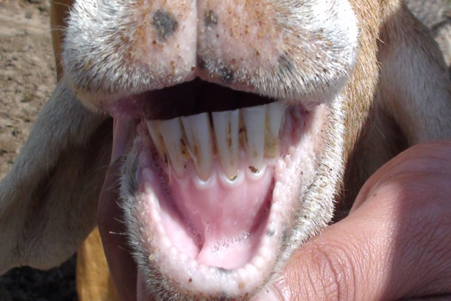

a) Mild congestion on lower gums b) congestion of lungs
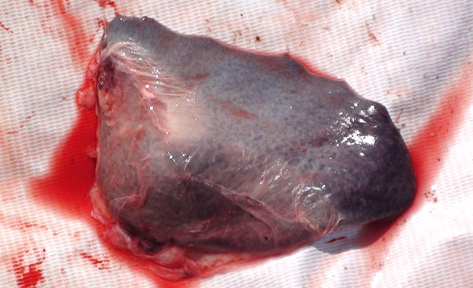
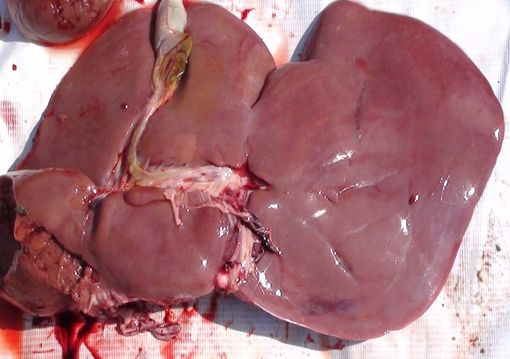

c) Haemorrhages on liver d) Splenomegaly
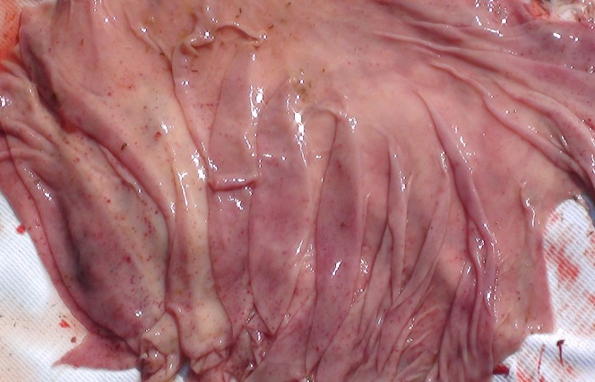
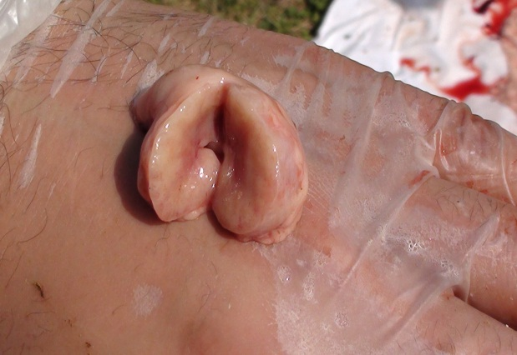

e) Inflamed Lymph Node f) Pinpoint Haemorrhages on abomasal mucosa

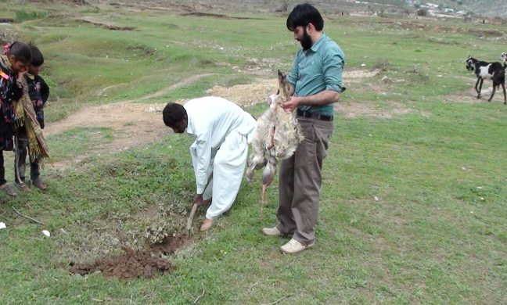
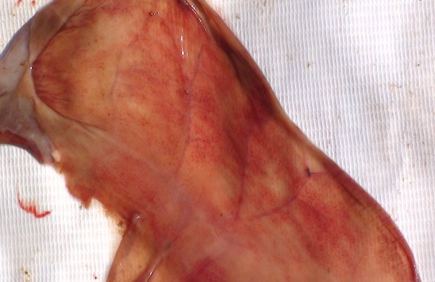

g) Haemorrhages on large intestinal mucosa h) proper disposal of dead carcass
Figure 3: Clinical signs and necropsy findings of PPR virus infection in sheep



Figure: 1 Penside Side Test
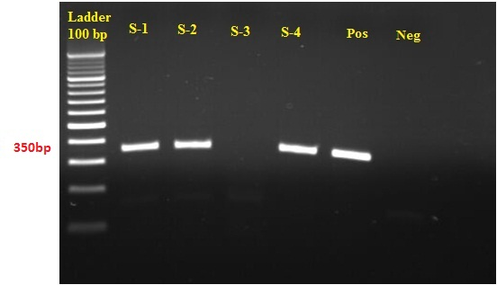

Figure 4: Gel electrophoresis picture showing positive results with band size of 350pb

Acknowledgement
Author’s wants to thanks FAO-UN project on Progressive control of PPR in Pakistan (GCP/PAK/127/USA) for logistic support.
References
- Abu-Elzein E , Hassanien M, Al-Afaleq A, Abd-Elhadi M, Housawi F (1990). Isolation of peste des petits ruminants from goats in Saudi Arabia. Veterinary Record 127, 309-310.

- Athar M, Muhammad G, Azim F, Shakoor A (1995). An outbreak of peste des petits ruminants-like disease among goats in Punjab (Pakistan). Pakistan Veterinary Journal 15, 140-140.

- Abubakar M, Ashiq S, Zahoor AB, Arshed MJ, Banyard AC (2011). Diagnosis and control strategies for peste des petits ruminants virus: Global and Pakistan perspectives. Pakistan Veterinary Journal 31, 267-274.

- Couacy-Hymann E, Roger F, Hurard C, Guillou J, Libeau G, Diallo A (2002). Rapid and sensitive detection of peste des petits ruminants virus by a polymerase chain reaction assay. Journal of virological methods 100, 17-25.

- Diallo A (2006). Control of peste des petits ruminants and poverty alleviation. Journal of Veterinary Medicine, Series B 53, 11-13.

- Gibbs E, Taylor W, Lawman M, Bryant J (1979). Classification of peste des petits ruminants virus as the fourth member of the genus Morbillivirus. Intervirology 11, 268-274.

- Hamdy F, Dardiri A (1976). Response of white-tailed deer to infection with peste des petits ruminants virus. Journal of Wildlife Diseases 12, 516-522.

- Hussain M, Muneer R, Jahangir M, Awan A, Khokhar M, Zahur A, Zulfiqar M, Hussain A (2003). Chromatographic strip technology: A pen-side test for the rapid diagnosis of pests des petits ruminants in sheep and goats. OnLine Journal of Biological Sciences 3.

- Kwiatek O, Minet C, Grillet C, Hurard C, Carlsson E, Karimov B, Albina E, Diallo A, Libeau G (2007). Peste des petits ruminants (PPR) outbreak in Tajikistan. Journal of comparative pathology 136, 111-119.

- Lefevre PC, Diallo A (1990). Peste des petits ruminants. Rev. Sci. Tech. Off. Int. Epiz. 9, 951-965.

- Nanda Y, Chatterjee A, Purohit A, Diallo A, Innui K, Sharma R, Libeau G, Thevasagayam J, Brüning A, Kitching R (1996). The isolation of peste des petits ruminants virus from northern India. Veterinary microbiology 51, 207-216.

- Roeder RL, G Abraham, G Kenfe, and T Barrett (1994). Peste des petits ruminants in Ethiopian goats. Trop. Anim. Hlth. Pro. 26: 69–73.
- Shaila M, Purushothaman V, Bhavasar D, Venugopal K, Venkatesan R (1989). Peste des petits ruminants of sheep in India. Veterinary Record 125, 602-602.

- Taylor W, Diallo A, Gopalakrishna S, Sreeramalu P, Wilsmore A, Nanda Y, Libeau G, Rajasekhar M, Mukhopadhyay A (2002). Peste des petits ruminants has been widely present in southern India since, if not before, the late 1980s. Preventive veterinary medicine 52, 305-312.
- Taylor WP, and T Barrett (2007). Diseases of sheep In: Blackwell publishing, Oxford, UK, 460-469.

