Detection of Trypanosoma evansi by different methods in bovines in Andhra Pradesh
*S.Sivajothi, V. C. Rayulu and B.Sudhakara Reddy
Department of Veterinary Parasitology,
College of Veterinary Science,
Sri Venkateswara Veterinary University,
Proddatur - 516360, Andhra Pradesh, India

ABSTRACT:
In the present study diagnosis of Trypanosoma evansi in bovines was conducted using the wet blood film method, giemsa stained smears and ELISA. Among 320 cattle and 382 buffaloes examined in different parts of Rayalaseema region of Andhra Pradesh 2.56, 10.68 and 34.18 per cent were found positive by wet blood film examination, stained smears examination and by indirect ELISA, respectively.
Keywords: Bovines, Trypanosoma evansi, diagnostic methods
INTRODUCTION:
Trypanosoma evansi is a widely distributed flagellate protozoa that causes a disease called surra in domestic animals and is transmitted mechanically by biting flies such as Tabanus and Stomoxys spp. The incidence and the severity of the disease vary with the strain of the parasite as well as the species of host affected (Sivajothi et al. 2013 a). Clinical signs in different animals vary based on the severity of the infection (Sivajothi et al. 2013b). There are several techniques for parasite detection, which include direct microscopy, concentration techniques and animal inoculation. The most useful of these tests, in view of their sensitivity and specificity, are the enzyme immunoassay (ELISA) which is used for the diagnosis of Trypanosoma evansi infections (Sivajothi et al. 2014a). Hence the present investigation was designed to detect Trypanosoma evansi in bovines by different methods (wet blood film method, giemsa stained smears and ELISA) in Andhra Pradesh.
MATERIALS AND METHODS:
The animals from the Rayalaseema region of Andhra Pradesh were screened for the infection by different methods such as wet blood film examination, Giemsa’s staining and Indirect ELISA. Blood was obtained from the peripheral ear vein and jugular vein from suspected animals. Blood samples collected in to separate vials without EDTA for serum collection. Serum samples were collected in sterile vials. Few drops of 1: 10,000 sodium azide solution was added to the serum samples and stored at -20 °C until use.
Wet blood films examination was done by placing a droplet of blood on a clean microscope slide and covering with a cover-slip (22 × 22 mm). The blood is examined microscopically at ×400 total magnification approximately 50–100 fields per slide. Trypanosomes was recognised by their movement among the red blood cells (RBCs). Stained smears were examined at a magnification of 400–1000× with oil immersion. Approximately 50–100 fields of the stained thin smear are examined, with a ×50 or ×100 oil-immersion objective lens, before the specimen is considered to be negative. Even after a trypanosome has been detected, approximately 20 extra fields are investigated to determine if more than one species is present. The sharp extremity of the smear must be extensively explored as, because of their capillary properties, trypanosomes may be concentrated at this place O.I.E. (2004 ). (Sivajothi et al. 2013c).
Isolate of T. evansi was maintained in the wistar rats for bulk harvest of parasites. At the high of parasitaemia, the rats were bled by heart puncture and the blood was used for separation and purification of Trypanosoma evansi by using DEAE (Diethyl amino-ethyl cellulose anion exchange column chromatography). Whole cell lysate (WCL) antigen was prepared from purified trypanosomes. Protein concentration of the WCL Ag of T. evansi prepared in the present study was estimated and it was adjusted to 1.0 mg /ml in PBS, pH 8.0 and stored at -20⁰c in 1.0 ml aliquots. The hyper immune sera (HIS) was raised in two healthy New Zealand white rabbits, raised against WCL Ag was confirmed by agar gel precipitation test and counter immune electrophoresis. Pre immunized serum of these experimental rabbits was also stored at -20ºc till use as negative control serum for standardization of Indirect ELISA (Sivajothi et al. 2014a).
RESULTS AND DISCUSSION
T. evansi was detected by using the different methods and results were presented in table-1. The results of different diagnostic tests adopted for the detection of T. evansi in bovines in Andhra Pradesh is presented in Table-1. Out of the 320 cattle screened by wet blood examination one 2.50% was positive wherein 2.61% buffaloes were positive by wet blood film examination out of 382 examined. In the blood smear staining methods, 33 (10.31%) cattle were positive out of 320 animals screened whereas 42 (10.99%) bufflaoes were positive out of 382 screened. The ELISA detected antibodies against T. evansi in 102 (31.87%) cattle out of 320 screened whereas 138 (36.12 %) buffaloes were positive out of 382 screened.
Prevalence of T. evansi can be correlated with the vector population and favorable conditions for vector breeding, species of the host, host immune status etc. The WBF method is simple, inexpensive and gives immediate results. Depending on the trypanosome size and movements a presumptive diagnosis can be made of the trypanosome species. The diagnostic sensitivity of the method is generally low but depends on the examiner’s experience and the level of parasitaemia. Blood smear examination is simple and relatively inexpensive, but results are delayed because of the staining process. Trypanosomes are easily recognised by their general morphology, but may be damaged during the staining process. This may make it difficult to identify the species.
One obvious reason for low number of positive samples by WBF was the inherent low sensitivity of the test. Similar observations have been made by numerous workers over past decades in India (Desquesnes et al., 2009). Sinha et al. (2006) reported T. evansi prevalence in 52.69 and 52.31 per cent of cattle and buffaloes in Patna. Rayulu et al. (2009) recorded an overall prevalence of T. evansi in 2.47, and 34.98 per cent of domestic animals in Haryana by WBF and Ag- ELISA, respectively. Molina et al. (2000) found 1.3% and 9.0% positive by WBF and Ab- ELISA, respectively.
The number of animals positive by ELISA in the region should be higher than those detected by WBF. Because, latent infections with low parasitemia are common in cattle, buffaloes and camels, it is likely that many samples were found negative by WBF and staining technique. Antigenaemia due to release of the antigens from the parasites hiding in some tissues has also been speculated. Another reason why WBF figures were low could be the indiscriminate treatment of suspected animals for trypanosomosis based only on signs and symptoms. Veterinary practice based on signs and symptoms is quite common in the field in India. In such a situation, the recently treated animals would be declared positive by immunological tests (Sivajothi et al. 2014b). Parasite antibodies may remain in blood circulation for about few weeks to months after treatment (Wernery et al., 2001). Therefore, this fact would necessitate getting reliable history of the animal that received anti-trypanosome treatment during past few weeks before sample collection to make indirect-ELISA more dependable.

Acknowledgements
The authors acknowledge the authorities of Sri Venkateswara Veterinary University, Tirupati for providing facilities to carry out this research. Authors are also thankful to the field veterinarians who assisted in collection of blood samples.
REFERENCES
Desquesnes M, Bossard G, Thevenon S, Patrel O, Lepetitcolin E, Hollzmuller P, Berthier D, Jacquiet P, Cuny G (2009) Development and application of an antibody-ELISA to follow up a Trypanosoma evansi outbreak in a dromedary camel herd in France. Veterinary Parasitology, 162, 214-220.
Molina JM, Ruiz A, Juste MC, Corbera JA, Amador R, Gutierrez C (2000) Seroprevalence of Trypanosoma evansi in dromedaries (Camelus dromedaarius) from the Canary Islands (Spain) using an antibody Ab-ELISA. Preventive Veterinary Medicine, 47,53-59.
O.I.E. (2004 ) Surra (Trypanosoma evansi) In: ‘Manual of standards for diagnostic tests and vaccines”. Office International des Epizooties World
Health Organization for Animal Health, Paris, 5th edition pp: 891-900.
Rayulu VC, Singh A, Chaudhri, SS (2009) Evaluation of parasitological and monoclonal antibody based assays in detection of Trypanosoma evansi in animals. Indian Journal of Animal Sciences, 79(10), 978-981.
Sinha BS, Verma SP, Mallik KP, Samantary S, Kumar B, Kumar RP (2006) Study on epidemiological aspects of bovine Trypanosomosis in some districts of Bihar. Journal of Veterinary Parasitology, 20(1),69-71.
Sivajothi S, Rayulu VC, Sujatha K, Sudhakara Reddy B, Amaravathi P (2013a) Histopathological Observations in Rabbits Experimentally Infected with Trypanosoma evansi, Journal of Advanced Veterinary Research Volume 3, 122-126.
Sivajothi S, Rayulu VC, Sudhakara Reddy B (2013b) Haematological and biochemical changes in experimental Trypanosoma evansi infection in rabbits. Journal of parasitic diseases, DOI 10.1007/s12639-013-0321-6.
Sivajothi S, Rayulu VC, Malakondaiah P, Sreenivasulu D (2013c) Colloidal Dye Immunobinding Assay for Detection of Trypanosoma evansi Antibodies in Animals, International Journal of Livestock Research. Vol 3(3), 48-56.
Sivajothi S, Rayulu VC, Malakondaiah P, Sreenivasulu D (2014a). Diagnosis of Trypanosoma evansi in bovines by indirect ELISA. J Parasit Dis. DOI 10.1007/s12639-014-0465-z.
Sivajothi S, Rayulu VC, Sujatha K, Sudhakara Reddy B (2014b). Study of Histopathological Changes in Experimental Trypanosoma evansi Infected Rats. Proc Zool Soc DOI 10.1007/s12595-014-0104-9.
Wernery U, Zachariah R, Mumford J A and Luckins T 2001 Preliminary evaluation of diagnostic tests using horses experimentally infected with Trypanosoma evansi. Veterinary Journal 161: 287-300.

Table-1: Table showing the diagnosis of Trypanosoma evansi by different methods
 | Number screened | Method of Examination
 | Number screened | Wet blood film |  | Staining Method |  | Indirect ELISA
 | Number screened | Number found positive | Percent found positive | Number found positive | Percent found positive | Number found positive | Percent found positive
Cattle | 320 | 8 | 2.50 | 33 | 10.31 | 102 | 31.87
Buffaloes | 382 | 10 | 2.61 | 42 | 10.99 | 138 | 36.12
Total | 702 | 18 | 2.56 | 75 | 10.68 | 240 | 34.18

Legends:
Figure-1: Buffalo suffering with Trypanosoma evansi
Figure-2: Trypanosoma evansi in wet blood smears (10 X with 2x camera magnification) (A-Live Trypanosoma evansi)
Figure-3: Trypanosoma evansi in stained smears (100 X with 4x camera magnification)

Figure-1:
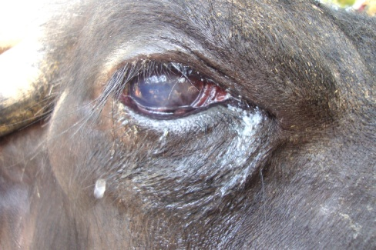

Figure-2:
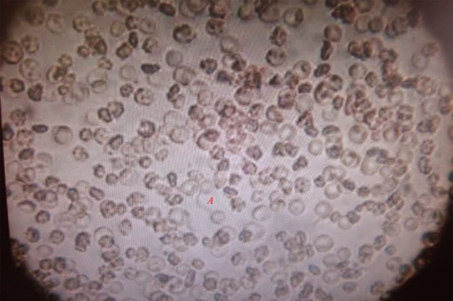

Figure-3:
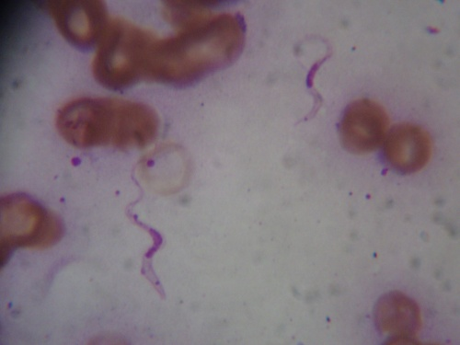

Assistant Professor
Professor and University Head
Assistant Professor (Veterinary Medicine), T.V.C.C *Corresponding author: bhavanamvet@gmail.com

