.
From |  | To
Dr.S.Sivajothi, |  | The Journal of advances in parasitology,
Assistant Professor, |  | Nexus publication.
Dept. of Parasitology,
College of Veterinary Science,
Proddatur,
Andhra Pradesh

Sir,

Sub: Submission of Research Article - regarding.

I submit to state that here I am attaching the research article for publication in our journal.

Thanking you sir,
Yours faithfully,

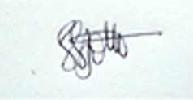
(Dr.S.Sivajothi)

