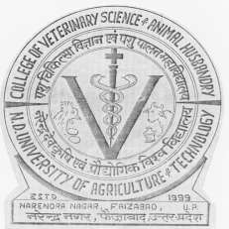 | Department of Veterinary Microbiology  College of Veterinary Science and Animal Husbandry  N. D. UNIVERSITY OF AGRICULTURE AND TECHNOLOGY  Kumarganj-224 229, Faizabad (U.P.), India  Phone: 05270-262847 (R)  09451663077 (M)  e-mail: rkjoshivet26@gmail.com |  |  |  | 
Dr. R. K. Joshi
M.V.Sc., Ph. D.
Professor
 |  |  |  | Dated: 04-05-2014

To
Chief Editor
Special Issue-2 of “Advances in Veterinary Research”

Dear Sir
Please find attached herewith, the research paper entitled “Infectivity titer and HA activity of canine parvo virus grown in CRFK cell culture” authored by B. Om. Preethi et al. It may kindly be considered for publication in Special issue II of “Advances in Veterinary Research”.
(R.K.Joshi)

