RARE CASE OF CRYPTOSPORIODIOSIS IN A NELLORE DOE ASSOCIATED WITH HYDROCEPHALOUS FOETUS
Y. V. Pridhvidhar Reddy, *S.Sivajothi, B.Sudhakara Reddy and R. Venkatasivakumar4
College of Veterinary Science,
Sri Venkateswara Veterinary University,
Proddatur, Andhra Pradesh- 516360, India.
*Corresponding author. E mail: sivajothi579@gmail.com

Abstract
Caesarean operation was performed to the goat with incomplete cervical dilatation. Up on caesarean two foetuses were recovered of which, a dead hydrocephalus foetus with enlarged head and one normal foetus. Hydrocephalous foetus had increased cerebrospinal fluid and enlarged skull and atrophied brain. Faecal sample examination of doe and both foetus showed cryptosporidium oocysts. This report is about the rare combination of Cryptosporidiosis associated with hydrocephalous foetus in a doe.
Key words: Hydrocephalus foetus, caesarean section, doe, cryptosporidium.
Introduction
Hydrocephalus is an excess cerebrospinal fluid accumulation in the cranial cavity. Several pathologies are encountered in the goat’s embryo and foetus that they occur due to infectious and non-infectious reasons at pre-implantation, embryonic and fetal periods (Semecan et al., 2012). Cryptosporidiosis is one of the zoonotic diseases caused by a protozoan parasite of the genus Cryptosporidium. Although the disease affects mainly the gastro-intestinal tract of a wide range of vertebrate hosts, significant effects of infections have been noted mainly in humans and calves. Cryptosporidiosis was recorded in calves as young as 4 days and in the gazella, the condition was observed among day-old neonates previously (Kanyari et al., 2002). The present communication reports a rare combination of Cryptosporidiosis associated with hydrocephalous foetus in a doe which was delivered by Caesarean operation.
Case History & Observations
A doe of 5 years age old was presented to the Veterinary Dispensary, Yerraguntla with history of severe abdominal straining, reduced intake of water and feed from previous night. Doe had the mating history of five months. Up on clinical examination it had restless, colic signs, raised rectal temperature (105.6ºF), pulse (115/min) and respiratory rate (68/min). Peripheral blood smears and faecal samples were collected from the doe for routine laboratory examination. Vaginal examination revealed incomplete cervical dilation. Complete cervical dilatation was not observed even 30 minutes after administration of Valathamide Bromide (20 mg/doe). Based on history and clinical presentation and response to the above therapy emergency caesarean was done.
Treatment and discussion
Caesarean was performed by ventral paramedian approach under xylazine sedation and local analgesia (2% Lignocaine). Up on caesarean one normal foetus and another with large cranium were recovered (Fig-1). In this normal foetus was live and abnormal foetus with enlarged head was dead at the time of Caesarean. Following caesarean the doe was treated with Ceftriaxone inj (500 mg IM x 5 days), 25 % Dextrose (250 ml, IV X 2 days), and Meloxicam inj (3 ml, IM X 3 days) and an herbal uterotonic. On examination, abnormal foetus had narrow facial part of skull which is disproportionately smaller. The skull was soft and prone for pressure. Cranial bones were thin with defects, filled with fibrous membrane. There is an abnormal increase in the amount of cerebrospinal fluid within the cranial cavity that is accompanied by expansion of cerebral ventricles, enlargement of the skull and especially forehead and atrophy of brain. Normal foetus had normal activities no other abnormalities were noticed after Caesarean. Faecal samples from the doe and two foetuses were collected into plastic containers directly from the rectum. The smears of faeces were made on glass slides and dried in room temperature and stained by modified Ziehl-Neelsen staining method, as described by Henriksen and Pohlenz, (1981). The stained smears were finally examined microscopically under oil immersion objective of compound microscope. Same procedure was used for diagnosis of Cryptosporiodiosis in neonatal dairy calves in Andhra Pradesh (Sivajothi et al., 2014). Samples collected from the two foetuses and doe revealed presence of cryptosporidiosis. The present case was diagnosed as hydrocephalous foetus associated with Cryptosporidiosis.
The incidence of dystocia in goats has been reported about (7%) from reproductive diseases (Abdul Rehman et al., 2000). The causes of dystocia have been reported either due to maternal or fetal in origin. Recent studies reveal that the fetal causes of dystocia were more common than the maternal causes (Hussain and Zaid 2010). Congenital hydrocephalous in domestic animals according to some authors is inherited through an autosomal recessive gene, although the role in its origin may be played by viral infections of foetus and dietary factors (Bester et al., 1976). In this study both foetuses had neonatal cryptosporidiosis to mean that infections may have been acquired transplacentally. The infective stages in this case would have to be the merozoites which systemically invade the maternal tissues including the circulatory system resulting in the fetal infection. The exact route of fetal infection may be oral by ingestion of merozoites possibly contained in amniotic fluids or via the blood (Kanyari et al., 2002).

References:
Abdul-Rahman LY, Al-Janabi AS, Asofi MK (2000). Study of some reproduction aspects of the mature local Iraqi goats. The Veterinarian, 10 (1): 47-60.
Bester RC, Cimprich RE, Evans LH (1976). Hydrocephalus in an 18-month old colt.J. Am.Vet. Med. Assoc. 168: 1041-1042.
Henriksen SA, Pohlenz JFL. (1981). Staining of cryptosporidia by a modified Ziehl-Neelsen technique. Acta Vet Scand; 22: 594-6.
Hussain SO and Zaid NW (2010). Dystocia in goats, causes and treatment. AL- Qadisiya Journal of Vet.Med.Sci. vol 9(1) 11-15.
Kanyari PWN , Oyejide AO, Alak JIB, Anderson DL, Wilson ST, Srivastava K (2002). Cryptosporidium Parvum: Experimental Transplacental Transmission In Murine Hosts. Israel journal of veterinary medicine. Vol. 57 (2)
Roberts SJ (1971). Veterinary Obstetrics and genital diseases, 2nd ed. CBS Publishers, New Delhi, India. Pp 69.
Sivajothi S, Reddy BS, Rayulu VC (2014). Cryptosporiodiosis in neonatal dairy calves. Advances in Applied Science Research, 5(1):74-76.
Semecan A, Kaymaz M, Fındık M, Rişvanlı A, Köker A. (2012) Çiftlik Hayvanlarında Doğum ve Jinekoloji. 589-590.

Legends:
Figure-1: Hydrocephalus foetus and normal foetus
Figure-2: cryptosporidiosis in faecal samples (100X)

Figure-1:
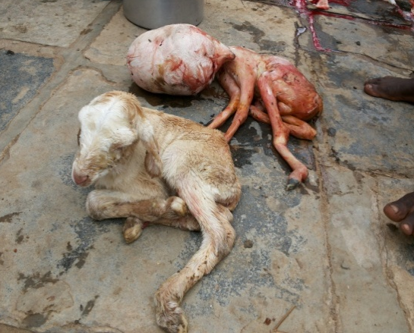

Figure-2:
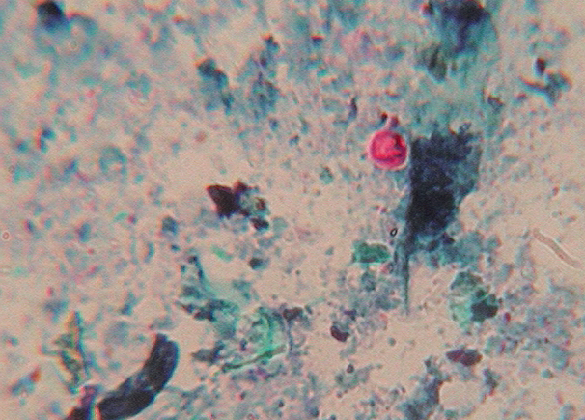

Assistant Professor, Dept. of Veterinary Gynaecology & Obstetrics
Assistant Professor, Dept. of Veterinary Parasitology
Assistant Professor (Veterinary Medicine), TVCC 4 Assistant Professor, Dept. of Veterinary Medicine

