Microscopic investigation of Beauveria bassiana infectivity in different life stages of Musca domestica (L.)

Sapna Mishra, Peeyush Kumar, Anushree Malik∗
Applied Microbiology laboratory, Centre for Rural Development & Technology, Indian Institute of Technology Delhi, New Delhi- 110 016, India

Abstract
Beauveria bassiana is a significant pathogen leading to growth reduction to mortality in different life stages of housefly (Musca domestica L). Investigation of B. bassiana infected M. domestica larvae showed sluggish movement, rigor, and failure of body to balance in water. Treated larvae also revealed varied level of cuticle shrinkage and extreme dehydration. Surface of the treated pupae showed varied stage of mycelial growth and few fungal spores, while the cadaver of adult fly was observed to be with extensive fungal growth covering the entire body surface. The observation of fungus mycelium on dead cadaver of different life stages of M. domestica establishes nature of fungal infection in this insect.

Keywords. Musca domestica; Beauveria bassiana; microscopy; life stages
Entomopathogenic fungi infect host insect through adhesion of the fungal conidia to insect cuticle, followed by penetration of hyphae through the cuticle. After penetration of hyphae, entomopathogenic fungi produce conidia within host insects using their nutrition and machinery to establish the infection. In the present study, attempts were made to study the effect of fungal infection on Musca domestica outer surface. Musca domestica L. (Diptera: Muscidae) or common housefly, is one of the most widely dispersed non biting insects in the world. It belongs to a group of domestic flies often called “filth flies”. Their association with more than 100 pathogens of medical and veterinary significance as well as proximity to human dwellings and animal farms has become a significant problem, requiring immediate attention for their control (Malik et al., 2007). In this regards, present study attempts to investigate the infection mechanism of entomopathogens to different life stages of M. domestica through microscopy.
The study was carried out through scanning electron microscopy (SEM) analysis of Beauveria bassiana infected M. domestica larvae and pupae. This was the first study evaluating fungal infection in M. domestica through SEM image analysis. Fungus treated dead larvae and live larva from control were prepared for SEM visualization through the method described earlier by Kumar et al. (2012a). For SEM analysis, larvae/pupae of M. domestica were primarily fixed in 2.5% glutaraldehyde in 0.1M phosphate buffer for 1-2 h. Thereafter, it was washed with distilled water for 10-20 min, followed by secondary fixation with 1-4% osmium tetroxide (OsO₄) in distilled water for 1-2 h. Secondary fixation was followed by washing with distilled water (10-20 min) and then serial dehydration with 45, 60, 75, 90, and 100% ethanol for 10 min each. After dehydration, samples were subjected to critical point drying (CPD) in hexamethylene disilazane (HMDS). All the processes were performed at room temperature. Samples were mounted on silver stub for SEM observation and gold-covered by cathodic spraying (Polaron gold). Observation was made on a scanning electronic microscope (ZEISS EVO 50) under the following analytical condition: EHT ¼ 20.00 kV, WD ¼ 9.5 mm, Signal A ¼ SE1 For adult flies of M. domestica , the image analysis of fungal infected dead cadaver was done through phase contrast microscopy (Leica microscope DM2500). The analysis was performed 5 days post exposure of fungal conidia to host insect.
SEM image of M. domestica larvae treated with B. bassiana and corresponding control is represented in Fig. 1. The visual analysis of M. domestica larvae treated with B. bassiana showed sluggish movement, rigor, and failure of body to balance in water. Image analysis of treated larvae revealed shrunken cuticle and extreme dehydration. The treated larvae also showed fungal growth on their body surface, which was present as mycelium or conidial aggregates. In variance to this, the control larvae had normal and intact cuticle, smooth and well formed body parts and showed normal body movement. Insun et al. (1999) investigated the effect of Kaempferia galenga on mosquito larvae through SEM. They reported convulsion, tremor, unnatural position, incoordination, rigor and sluggish movement in treated larvae, which was analogous to the present study. Shrinkage of treated larvae was accredited to the destruction of irregular ridge like reticulum present on larvae surface (Insun et al, 1999). Sukontason et al. (2004) reported deformation in the integument and intersegmental spines in the eucalyptol treated housefly larvae, while Kumar et al. (2012a) reported proliferation of spinose cells and bleb formation in the M. domestica larvae treated with Mentha × piperita essential oil. Further, M. domestica larvae treated with Eucalyptus globulus essential oil showed skin shrinkage especially at spinose rings with protruding intersegmental regions (Kumar et al, 2012b). The above literature reports with varied effect of control agents on treated insects, was in confirmatory with the results of present study. However, most of the above studies explored effect of plant extract, while the reports concerning SEM analysis of insect surface depicting fungal effect could not be retrieved. Nevertheless, these studies indicated surface aberration and cuticle damages, which were also observed in the present study.
SEM image analysis of M. domestica pupae treated with B. bassiana is depicted in Fig. 2. SEM micrograph of M. domestica pupae in longitudinal view showed intersegmental spines between different thorax segments (Fig 2a). Surface of the treated pupae showed varied stage of mycelial growth and few fungal spores. Mycelia growth was in dry condition due to treatment involving for SEM image analysis. Due to absence of relevant literature concerning image analysis of housefly pupae, the comparison with the present study could not be made. Figure 3 represents infection of B. bassiana in the adult flies of M. domestica. The figure revealed growth of fungal mycelia over different body parts of infected flies. The fungal growth on infected flies was shown to cover entire outer body surface of dead cadaver. The growth of fungal mycelium on surface of adult fly was extensive compared to fungal growth present on larvae or pupal surfaces. The observation of fungus mycelium on dead cadaver confirms with established route for fungal mechanism of action, where, infection of fungal conidia was said to be through establishment of hypahl contact with insects’ body surface.
Similar to the present study, Wakefield (2006) observed fungal conidia and germ tubes on the cuticle surface of storage beetle (Oryzaephilus surinamensis & Tribolium confusum) treated with B. bassiana. SEM observation of the cuticle surface showed higher number of adhered and germinating conidia on O. surinamensis than T. confusum. This was attributed to the presence of greater number of setae in O. surinamensis which may have assisted with adherence of conidia. Further, these setae were suggested to favour conidial germination by providing optimum moisture level. The importance of setae in fungal infection as suggested by Wakefield (2006) may explain high fungal infections to adult flies and low infection to larvae observed in this study. Larvae of M. domestica due to absence of any setae like structure would be less likely to support conidial adherence or germination, thus resulting in low B. bassiana infection. Similarly, abundance of setae on adult M. domestica supports and propagates any infection from entomopathogenic fungi. The results from present study was substantiated by high mortality of adult flies (72.7-100%) observed with fungal isolates in our earlier study, while larvae of M. domestica (36.7-72.3%) were found to be comparatively less susceptible (Mishra and Malik, 2012a). Similarly, abundance of setae on adult M. domestica supports and propagates any infection from entomopathogenic fungi. The low infection rate (10.1-20.2%) in M. domestica pupae (Mishra and Malik, 2012b) may be attributed to their protective covering. Thus, the current study establishes nature of fungal infection on outer surface of different life stages of M. domestica.

Acknowledgments
This work was supported by Indian Council of Medical Research (IRIS_ID No. 2010-07860), India. CSIR fellowship to one of the authors (SM) is gratefully acknowledged. The authors also acknowledge Mr. Sabal Singh (IIT Delhi, India) for his help in experimental work.
References
Insun D, Choochote W, Jitpakdi A, Chaithong U, Tippawangkosol P, Pitasawat B (1999). Possible site of action of Kaempferia galanga in killing Culex quinquefasciatus larvae. The Southeast Asian J. Trop. Med. Public Health 30: 195–199.
Kumar P, Mishra S, Malik A, Satya S (2012a). Insecticidal evaluation of essential oils of Citrus sinensis L. (Myrtales: Myrtaceae) against housefly, Musca domestica L. (Diptera: Muscidae). Parasitol. Res. 110: 1929-1936.
Kumar P, Mishra S, Malik A, Satya S (2012b). Comparative study of the Composition and Insecticidal Activity of Essential oils of Mentha × Piperita L. and Mentha Citrata Ehrh. Ind. crops Prod. 39: 106–112.
Kumar P, Mishra S, Malik A, Satya S (2012c). Compositional analysis and Insecticidal activity of Eucalyptus globulus (family: Myrtaceae) essential oil against housefly (Musca domestica). Acta Tropica 122: 212– 218.
Mishra S, Malik A (2012a). Comparative evaluation of five Beauveria isolates for housefly (Musca domestica L.) control and growth optimization of selected strain. Parasitol. Res. 111:1937–1945.
Mishra S, Malik A (2012b). Nutritional optimization of a native Beauveria bassiana isolate (HQ917687) pathogenic to housefly, Musca domestica L. J. Parasit. Dis. 37 (2): 199-207.
Sukontason KL, Boonchu N, Sukontason K, Choochote W (2004). Effects of eucalyptol on housefly (Diptera: Muscidae) and blow fly (Diptera: Calliphoridae). Revista do Instituto de Medicina Tropical de São Paulo 46: 97–101.
Wakefield ME (2006). Factors affecting storage insect susceptibility to the entomopathogenic fungus Beauveria bassiana. Scussel (Eds.), V.M. Proceedings of the 9th International Working Conference on Stored Product Protection, 15–18 October 2006, Sao Paulo, Brazil pp. 855–862.
Figure captions

Figure 1. SEM micrograph of housefly larvae (a) Entire larvae with no treatment, (b) Entire larvae after B. bassiana treatment, (c) intersegmental region with no treatment, (d) intersegmental region after B. bassiana treatment, (e) anterior region with no treatment, and (f) anterior region after B. bassiana treatment

Figure 2. SEM micrograph of B. bassiana treated housefly pupae (a) longitudinal view of housefly pupae, (b) magnified surface of pupae showing fungal growth, (c) fungal growth on pupal surface

Figure 3. B. bassiana infection in adult houseflies showing growth of fungal mycelium on cadaver, (a) leg, (b) joint between leg and abdomen, (c) leg joint between tibia and tarsus, (d) leg joint between femur and tibia, (e) antennae, and (f) lateral view of head
Figure 1
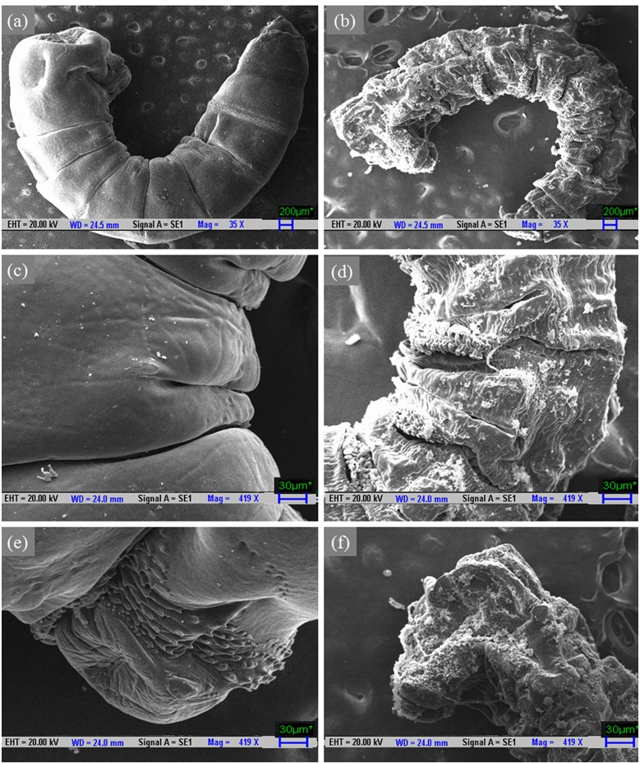
Figure 2
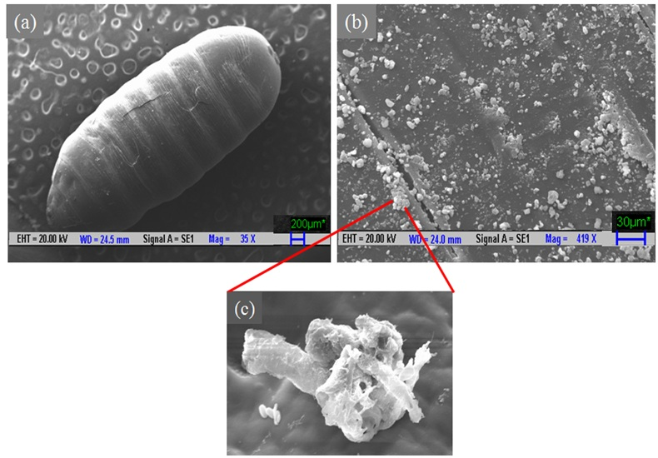

Figure 3
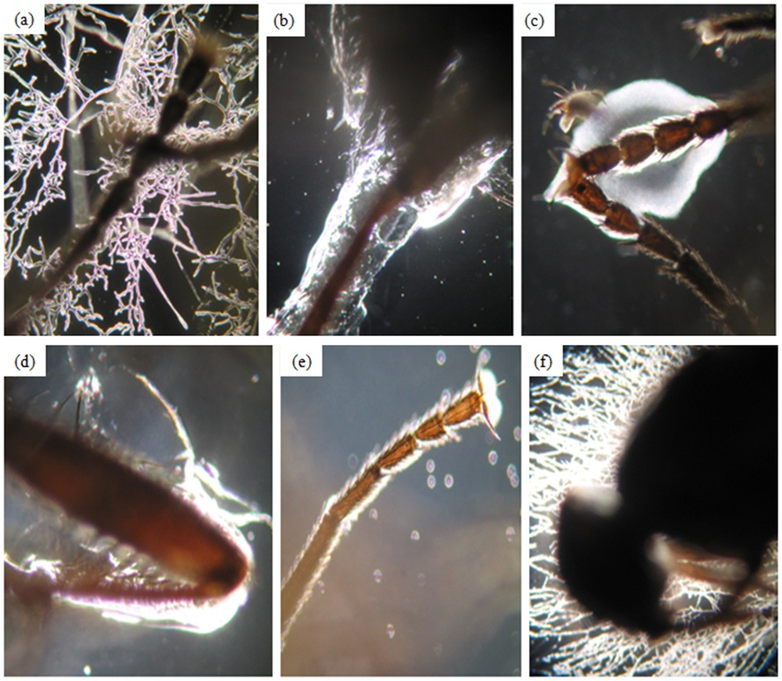

∗ Corresponding author. Tel.: +91-11-26591158; Fax: +91-11-26591121. E-mail address: anushree@rdat.iitd.ac.in (A. Malik).

