Dated: November 25, 2013
QOL No: 9750

TWAS Associateships
ICTP Campus
Strada Costiera 11
34151 Trieste, Italy

Subject: RECOMMENDATION LETTER FOR DR. MUHAMMAD ZUBAIR SHABBIR

This is to certify that Dr. Muhammad Zubair Shabbir has been working as Assistant Professor Quality Operations Laboratory at University of Veterinary and Animal science Lahore. He did join the University in Spetember 2006 and since then, he is known to me both academically and scientifically.

My assessment of his knowledge and background is based on his performance during that period. During his stay, Dr. Zubair has shown excellent skills in several experimental techniques and field/extension work including various PCR applications and sequence analysis methods. Furthermore, he has taken an active part in every day work and scientific lab and section meetings as well as social activities. He exhibited good knowledge of molecular biology techniques, capacity for teamwork, high motivation and commitment to the assigned tasks. He has also a very positive and outgoing personality. He showed genuine interest in scientific research and understanding of scientific problems. He is competent and well capable to write and defend both research projects and manuscripts as evidenced by his curriculum vitae.

I am very satisfied with his performance and give my best recommendations for TWAS-research associateship. If you have any questions, please don’t hesitate to call 00924299212506 and E. mail at tahiryaqub@uvas..edu.pk.

Sincerely

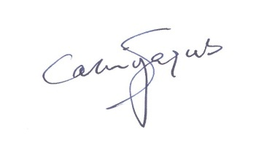
(PROF. DR. TAHIR YAQUB)
Director

