Figures
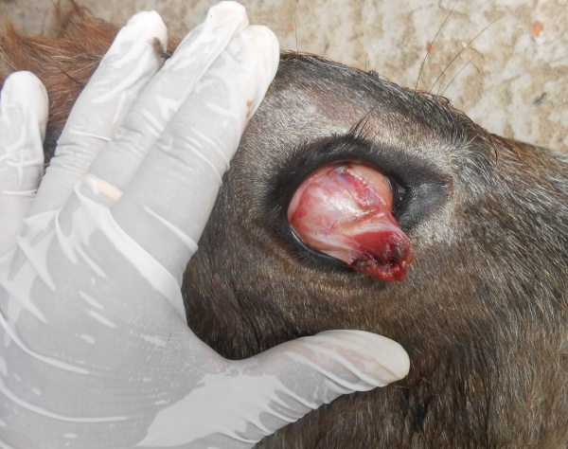  Fig.1: Rupture of eye muscles (1 day old) | 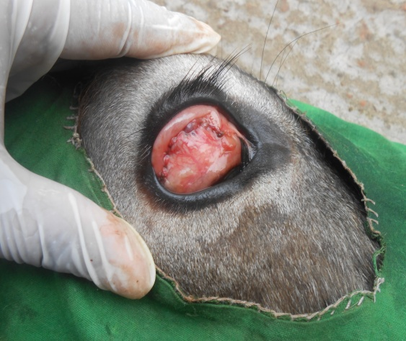  Fig.2: Suture of muscles by chromic catgut 1-0 (Continous pattern).
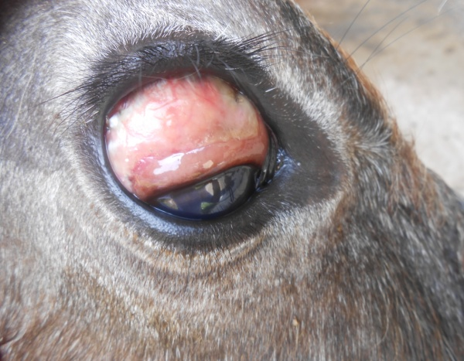  Fig.3: Healing of muscles (2nd week). | 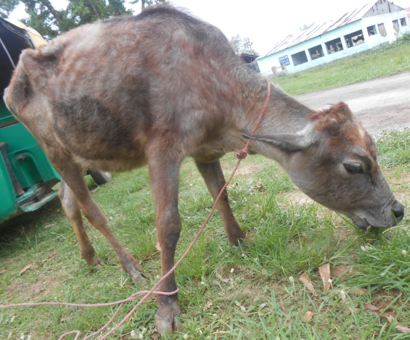  Fig.4: Animal after recovery (2nd week)

