
Division of Livestock & Fisheries Management
ICAR RESEARCH COMPLEX FOR EASTERN REGION
INDIAN COUNCIL OF AGRICULTUREAL RESEARCH
ICAR Parisar, P.O. B.V.College, PATNA – 800 014, BIHAR, INDIA

To Dated- 29/05/2014
The Editor- In - Chief
Journal of Animal Health and Production
Nexus Academic Publishers (NAP)
1-B Opposite School -4, Gate # 2,
Old Officer Colony, Zarar Shaheed Road, Sadar Lahore Cantt.
Lahore, Pakistan
Dear Sir
Greetings from ICAR RC ER, Patna. Herewith I am submitting an article entitled “PREVALENCE OF EYE DISEASES OF CATTLE IN BIHAR, INDIA” for publication in your esteemed journal. Kindly acknowledge the same at your earliest convenience.

Thanking you,
Yours faithfully,

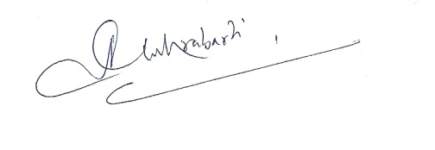
(Asit Chakrabarti)
Senior Scientist

