ABSTRACT
The aim of this study was to determine the prevalence of ecto and endoparasites in domestic pigeons in Hamedan, Iran. Study was done on 40 pigeons from September to March 2012 in Hamedan located in west of Iran. The Blood samples were obtained from wing vein and thin smears were prepared out of them. All smears were stained with Giemsa and the haemoparasites were identified. Then, the ectoparasites were collected as described by Soulsby (1986), briefly after killing the pigeons by decapitation, they were immediately placed in a polythene bag and the parasites collected after leaving the pigeons. The ectoparasites were preserved for identification purposes in 70% alcohol. At necropsy, each section of gastrointestinal tracts of the bird was opened, separately, then removed contents were examined under a stereo microscope for parasite helminthes. The respiratory tract was opened and the internal surface of the trachea was inspected. All worms collected were stored in 70% alcohol and 5% glycerine. Lungs, liver, kidneys and heart muscle were collected and fixed in 10% buffered neutral formalin for histopathological studies. Formalin fixed tissue samples were processed embedded in paraffin wax, sectioned and stained with hematoxylin and eosin as per standard method. Among 40 birds, 20 (50%) were infected with Haemoproteus columbae. All other helminth infection have been reported as follows : Raillietina achinobothridia (10 %) , Ascaridia colombae (12.5%), Ascaridia galli (82.5%) and Hartertia gallinarum (5%). 3 different species of ectoparasites identified were Pseudolynchia canariensis (25%), Columbicola columbae (62.5%) and Menopon gallinae (15%). Pathological lesions were also observed in liver of some cases which is reported as Coli-Granoloma. This is the first report on ectoparasites and endoparasites in domestic pigeon (Columba livia) in Hamedan,West of Iran. Also, present study is the first report on Hartertia gallinarum in domestic pigeons (Columba livia) in Iran .

Key Words: pigeons, Columba livia, Hippoboscidae, helminths, protozoa.

INTRODUCTION
Pigeons and doves are distributed everywhere on Earth and relationship between pigeons and human is very old. The pigeons have been domesticated for hundreds of years. Pigeons have been used for a long time as a food resource, pets or cultural and religious symbols. They also make good laboratory animals, as in the diagnosis of fowl cholera (Cooper, 1984). They can carry many parasites and pathogens to other poultry flocks such as coccidiosis, cryptococcosis, newcastle disease and histoplasmosis (Rehman, 1993; Opara et al., 2012). Also, they can serve as a source of zoonotic agents for human (Vucemilo et al., 2000; Karatepe et al., 2010). There are large number of pathogens related to hygiene and management of pigeons. The most important pathogens that threat pigeon’s life are ecto and endoparasites. Many species of parasites infect pigeons, resulting in reduced performance and mortality of the host (Rupiper, 1998; Dranzoa et al., 1999; Eckert, 2000) . The incidence of ectoparasite and endoparasite has been studied in world. In Iran, the infection was reported only in few reports (Ashrafihelan et al., 2010; Radfar et al., 2012; Khezerpour and Naem, 2013). Therefor the present study was undertaken to evaluate prevalence of ectoparasite and endoparasite in pigeons (Columba domestica) in Hamedan, west of Iran.

MATERIAL AND METHODS
This study was done on 40 pigeons from September to March 2012 in Hamedan located in west of Iran. Pigeons were caught from different parts of Hamedan and were transferred to the parasitology laboratory of the para veterinary faculty, Bu Ali Sina University. Appearance specifications of the birds were recorded in the forms. The Blood samples were obtained from wing vein and thin smears were prepared out of them. All smears were stained with Giemsa and the haemoparasites were identified by examining the blood smear under oil immersion (objective 100 × magnification) as described by Soulsby (1986) using a light microscope. It is notable that, all of infected birds have symptoms such as Anemia, loss of body weight, anorexia, diarrhea, and dehydration. Then, the ectoparasites were collected as described by Soulsby (1986), briefly after killing the pigeons by decapitation, they were immediately placed in a polythene bag and the parasites collected after leaving the pigeons. The ectoparasites were preserved for identification purposes in 70% alcohol. Then, ectoparasites were identified using a stereo microscope and taxonomic keys Graciolli and Carvalho 2003. At necropsy, each section of gastrointestinal tracts of the bird was opened, separately, then removed contents were examined under a stereo microscope for parasite helminthes. The respiratory tract was opened and the internal surface of the trachea was inspected. All nematodes removed from mentioned organs were placed in AFA solution (alcohol, formaldehyde, acetic acid, distilled water, and glycerine), and then cleared with lactophenol (25% glycerine, 25% lactic acid, 25% phenol and 25% distilled water). Cestodes removed from small intestine were stained with acidified alum/carmine. Identification of the species was confirmed on the basis of light microscopic examination with reference to keys (Soulsby, 1986). Postmortem examination was performed as described by Fowler (1990). Lungs, liver, kidneys and heart muscle were collected and fixed in 10% buffered neutral formalin for histopathological studies. Formalin fixed tissue samples were processed embedded in paraffin wax, sectioned and stained with hematoxylin and eosin as per standard method (Sol et al., 2003).

RESULTS:
The survey was undertaking from September to March 2012. Out of a total of 40 pigeons (18 mail and 22 femail) examined, 17 (42.5%) were infected with one or more species of helminthes, 32 (80%) had one or more ectoparasites and 20 (50%) were infected with Hemoparasites (Table 3). A total of 4 different worms’ species were identified in alimentary canal, 3 different ectoparasites and 1 haemoparasite species. The prevalence of endoparasite species identified in pigeons is shown in Table 1. In total 1 species of cestodes belonging to subfamily, Raillietinae: Raillietina achinobothridia (10 %) and 3 species of nematode belonging to subfamilies Ascaridae : Ascaridia colombae (12.5%), Ascaridia galli (18%) and Spiruridae: Hartertia gallinarum (5%) which this is the first report in domestic pigeons in Iran (Fig 1,2). No trematodes were found in the study and no endoparasite was found in gizzard and caeca. The 3 different species of ectoparasites identified were Pseudolynchia canariensis (25%), Columbicola columbae (62.5%) and Menopon gallinae (15%)(Table 2) . The haemoparasite species identified were Haemoproteus columbae (50%). Pathological lesions were also observed in liver of some cases which is reported as Coli-Granoloma. The lesions which closely resemble tuberculous tissue are found in the liver, but not in the other organs. Histologically the lesions consist of necrotic tissue surrounded by epitheloid and giant cells (Fig 3, 4).

DISCUSSION
The present investigation demonstrated that 12(30%) of all examined pigeons were infected with helminthes.The prevalence of helminthic infections recorded in this study is considered modestly Previous surveys on helminth parasites in pigeons in Iran and the world are partially comparable with the results in the current study. In our study highest infections was with Ascaridia galli which resemble to the study carried out by Ashrafihelan et al. (2010) on pigeons in Tabriz who were reported the same there species of cesetodes and two species of nematode. Borghare et al.(2009) displayed heavy infection with Capillaria spp, Ascaridia spp and Hetarakis spp in wild pigeons at Maharajbagh Zoo, Nagpur, while other findings from different parts of Iran revealed that cestodes were more common than nematode which were in contrast to our results. Shayeste (1996) reported that 70, 9, and 1 percent of examined birds were infected with R. echinobothrida, R. tetragona, and A. columbae, respectively.
The lowest infections was with Hartertia gallinarum, which this is the first report in domestic pigeons in Iran. Eslami and Mozafarinejad (1993) has been reported Hartertia gallinarum on fowl in southern part of Iran . Because of macroscopic similarities between the morphology of this nematode and that of Ascaridia galli, another small intestine nematode, it is much probable that poultry practitioners take one of these two species for the other.To prevent this in the present short note, in addition to the microscopic differences in the morphology of these two species, their life cycle, pathogenecity, and treatment were compared and discussed.
R.echinobothrida were the most common parasites which were nearly in agreement with our study (Naem et al., 2005; Nabavi et al., 2005; Khezerpour and Naem, 2013) . Before Hoseini et al. (2001) have already found heavy infection in gees population in Gilan province. Later, another investigation on in chikens in Golestan indicated that 96% of the examined fowl harbored at least one species of parasite (Eslami et al., 2009). Thus the results suggested that parasitic infection in other birds were higher than pigeons in different regions of Iran. The possible reason may be related to the type of host dietary habitat and immune mechanism.
Syngamus trachea together with other species (Raillietina spp, C. columbae, Tetramers spp, A. columbae, H. columbae, Menopen gallinae, Ceratophyllus columbae, Louse fly) were found in pigeons in Ilam (Bahrami et al., 2011), which was in contrast of the present study and other surveys (Radfar et al. 2011; Al-Barwari and Saeed 2012; Musa et al., 2011; Msoffe et al.,2010; Senlik et al., 2005; AdanG et al., 2009; Natal et al., 2009; Ashrafihelan et al., 2010).
Among the lice species observed, Columbicola columbae had the highest prevalence (62.5%) in and followed by Pseudolynchia canariensis (25%) and Menopon gallinae(10%) . According to Harlin (1994), Columbicola columbae is the most common malophagian parasite of pigeons. The rate of infestation with Columbicola columbae in this study was in agreement with their findings..
In present study, among 40 birds, 20 (50%) were infected with Haemoproteus columbae. Also, our results showed that the prevalence of Pseudolynchia canariensis were 25% , which are vector for Haemoproteus columbae. There was a noticeable relationship between the prevalence of Haemoproteus columbae and its vector Pseudolynchia canariensis. Difference among various reported prevalence rate in different regions of Iran, were probably due to geographical variations and different feeding habitat and abundance of vehicles of Haemoproteus. This findings are more or less in similar pattern of what was previously observed in Iran. Recently two studies were done about this parasite. Youssefi et al. (2010) reported 17.47% infestation rate in pigeons of north of Iran and Razmi and Andalibian (2006) found that 33% of pigeons in Mashhad (Northeast of Iran) were infected with H. columbae. Nematollahi et al. (2012) found that 57% H.colombae in pigeons in Isfahan. Marques (2007) showed that the prevalence of ectoparasites and endoparasites in 58 free-living pigeons (Columba livia) in urban areas of Lages, in the state of Santa Catarina, Brazil. The Quick Panoptic and Giemsa methods detected 62.24% and 46.55% of Haemoproteus spp, respectively, these results are in accordance with our findings.
Science, helminth infection in pigeon affected by food supply, geographic location and climatic conditions, the observed differences in the prevalence of helminths species within the months in present study could be due to the availability and distribution of their intermediate hosts or infective stages of larval nematode (Olsen and Braun, 1980). Pigeons have ability to transmission of some pathogenic agents to both human and birds. Toxoplasma gondi, an important zoonotic disease, have been detected in pigeons in some location of the world (Karatepe et al., 2011). Moreover, various bacterial and viral infections such as Salmonella, Campylabacter and Paramyxovirus can be transferred from these birds to human (Vucemilo et al., 2003). According to roll of pigeons as a risk factor for human and poultry health, more studies are need to investigate parasitic infection of pigeons in other parts of Iran. Neither of the referenced studies revealed the presence of ectoparasites or endoparasites that could be zoonotic to humans, nor did the present study.This is the first report on ectoparasites and endoparasites in domestic pigeon (Columba livia) in Hamedan,West of Iran. Also, present study is the first report on Hartertia gallinarum in domestic pigeons(Columba livia) in Iran .

ACKNOWLEDGMENT

Authors are thankful to Younes Rostami, Danial Yusefnia and Ebrahim Kargar for sample collection.

CONFLICT OF INTEREST

Author's declare that they do not have any conflict of interest.

REFERENCES
Adang KL, Oniye SJ, Ezealor AU, Abdu PA, Ajanusi OJ, and Yoriyo KP ( 2009).
Ectoparasites and intestinal helminths of speckled pigeon (Columba guinea
Hartlaub and Finsch 1870) in Zaria, Nigeria. Science World Journal. 4:1-5.

Al-Barwari1 S, and Saeed I (2012). The parasitic communities of the Rock pigeon
Columba liviafrom Iraq: Component and importance. Turkiye Parazitol Derg. 36: 232-239.

Ashrafihelan G, Norozi R, Seyed-Hosein N, and Mehpeikar H( 2010). An identification of helminth parasites and gastrointestinal infection domestic pigeon in Tabriz, Iran. Iranian Journal of Veterinary Research. 6(3): 52-57.

Bahrami A, Nasrolahi OA, Ahmady S, Doosti A, Bahrami A, and Monfared AL( 2012). Survey of egg per gram (EPG) parasite ovum in pigeon. International Journal of Molecular and Clinical Microbiology. 1:103,105,106.

Borghare AT, Bagde VP, Jaulkar AD, Katre DD, Jumde PD, Maske DK, and Bhangale GN( 2009). Incidence of gastrointestinal parasitism of captive wild pigeons at Nagpur. Veterinary World. 2: 343.

Cooper JE (1984). A veterinary approach to pigeons. J Small Anim Pract. 24: 505–516.
Dranzoa C, Ocardo M, Katete P (1999). The ecto-, gastrointestinal and haemo-parasites of live pigeons (Columba livia) in Kampala, Uganda. Avian Pathol. 28:119–124.
Eckert J (2000). Helminthosen des NutzgeflüUgels. In: Rommel M, Eckert J, Kutzer E, KöUrting W, editors. Schnieder, Vet Urmed Parasitol. Parey Buchverlag, Berlin.
Eslami A, Ghaemi P, and Rahbari S( 2009). Parasitic infections of free –range chickens from Golestan Province, Iran. Iranian Journal of Parasitology. 4: 10-14.

Eslami A and Mozaffari H(1993). The occurance of Hartertia gallinarum in the indigeous chiken of southern part of Iran. Journal of Veterinary Research. 47(1,2):123-124

Fowler NG (1990). How to carry out a field investigation In: Poultry Disease, F,T.W. (Ed.) Bailliere Tindall, London. 370-400.

Graciolli G, Carvalhoc J B(2003). Hippoboscidae (Diptera, Hippoboscoidea) no Estado do Paraná, Brasil:chaves de identificação, hospedeirose distribuição geográfica. Rev Bras Zool . 20: 667-74.

Harlin RW (1994). Pigeons. The veterinary clinics of North America. Small Anim Pract. 24:157–173.

Karatepe M, Kılıc S, KaratepeB, and Babur C ( 2011). Prevalence of Toxoplasma gondiiAntibodies in Domestic (Columba liviadomestica) and Wild (Columba livia livia) Pigeons in Niğde region, Turkey. Turkiye Parazitol Derg. 35: 23-26.

Khezerpour A and Naem. S (2013). Investigation on Parasitic Helminthes of Gastrointestinal, Liver and Lung of Domestic Pigeons (Columba livia) in Urmia, Iran. Int. J. Livest. Res. 3(3): 35-41.
Marques SMT,, RM Quadros CJ Silva and M Baldo( 2007). Parasites of pigeons in urban area of lages Southern Brazil. Parasitol. Latinoam. 62:183-87.

Msoffe PL, Muhairwa AP, Chiwanga GH, and Kassuku AA(2010). A study of ecto-and endo-parasites of domestic pigeons in MorogoroMunicipality,Tanzania. African Journal of Agricultural Research. 3: 264-267.

Musa S, Dil-Afroz S, and Khanum H ( 2011). Occurence of ecto-and endo parasites in pigeon (Columba livia Linn). University Journal of Zoology. 30:73-75.

Nabavi R, Manouchehre-NaiiniK,Yavari M, Zebardast M(2005). Study on the gastrointestinal helminthes of native fowls of Shahreh- Kord. Iranian J Vet Sci. 2 (4): 311- 316.

Naem S, Eskandari S (2005). Prevalence ofintestinal helminths of native chickens13in Urmia, Iran. Iranian J Vet Res Univ Shiraz. 3 (2): 200 – 203.

Natal AJ, Asemadahun ND, Okobanjo OO, and Ulyi BM (2009). A survey on prasaites of domestic pigeons(Columba livia domestica) in Zaria, Najeria. International Journal of Soft Computing. 4: 148-150.

Nematollahi A , Ebrahimi M and Mohammadpour H (2012). Prevalence of Haemoproteus columbae and Trichomonas gallinae in pigeons (Columba domestica) in Isfahan, Iran. J Parasit Dis. 38(1): 141-142.
Olsen OW, and Braun CE(1980). Helminths parasite of band tailed pigeons in Colorado. Journal of Wildlife Diseases.16: 65-66.

Opara MN, Ogbuewu IP, Iwuji CT, Njokua L, Ihesie EK, and Etuka IF( 2012). Blood characteristics, microbial and gastrointestinal parasites of street pigeons in Owerri Imo State, Nigeria. Journal of Animal Science. 1: 14-21.

Radfar MH, Fathi S, Asl EN, Dehaghi MM, Seghinsara HR( 2011). A Survery of parasites of Domestic Pigeon (Columba livia domestica) in South Khorasan, Iran. Iranian Journal of Veterinary Research. 4(1): 18-23.

Radfar MH, Norouzi Asl E, Rezaei Seghinsara H, Mirzaei Dehaghi M, Fathi S (2012). Biodiversity and prevalence of parasites odomestic pigeons (Columba livia domestica) in a selectedsemiarid zone of South Khorasan, Iran. Trop Anim Health. 44:225–229.
Razmi Gh and Andalibian E (2006). Survey on infestation to Haemoproteus columbae in pigeons of Mashhad. Pagh Saza .71: 95–96.

Rehman R( 1993). A study on the prevalence of Ascaridia galliand the effects of experimental infection on various blood parameters and body weight in the chicken. MSc. (Hons) Thesis, Univ. of Agric. (CVS), Faisalabad-Pakistan.
Rupiper DJ (1998). Diseases that affect race performance of homing pigeons. Part II: Bacterial, fungal and parasitic diseases. J Avian Med Surg.12: 81–86.
Senlik B, and Gulegen-EandAkyol V(2005). Effect of age, sex and season on the prevalence and intensity of helminth infections in domestic pigeons (Columba livia) from Bursa province, Turkey. Acta Veterinaria Hungarica. 53(4): 449-456.

Shayeste H( 1996). An investigation on parasitic helminthes of gastrointestinal domestic pigeons in Ahvaz. DVM thesis Veterinary,University of Shahid Chamran of Ahvaz. 235: 66-68.

Sol D, Jovni R and Torres J (2003). Parasitemediated Mortality and Host Immune Response Explain Age- related Differences in Blood Parasitism in Birds. Oecologia.135:542-547.

Soulsby EJL ( 1986). Helminths, Arthropods and Protozoa of Domesticated animals. 7th Edition, London.

Vucemilo M, Vlahovic K, Dovc A, Muzinic J, Pavlak M, Jercic J, and Zupancic Z( 2003). Prevalence of Campylobacter jejuni, Salmonella typhimurium, and avian Paramyxovirustype 1 (PMV-1) in pigeons from different regions in Croatia. Zeitschrift fur Jagdwissenschaft. 49(4): 303-313.
Youssefi MR, Sadeghian AG, Esfandiari B (2010). Prevalence of Haemoproteus columbae infection in Columba livia in North of Iran. World J Zool. 5:27.

Table1. Endoparasites recovered from 40 pigeons.
Parasite species Number infected prevalence(%) Range
Raillietina achinobothridia 4 10 % 1-5
Ascaridia galli 8 20 % 1-11
Ascaridia columbae 5 12.5 % 1-7
Hartertia gallinarum 2 5 % 1-2
Haemoproteus colombae 20 50 % 3-10

Table 2: Ectoparasites recovered from 40 pigeons.
Parasite species Number infected prevalence(%) Range
Menopon gallinae 4 15 % 1-3
Columbicola columbae 25 62.5 % 1-12
Pseudolynchia canariensis 10 25 % 1-3

Table 3: The frequency of mixed infection in examined pigeon

Mixed Parasites infection Prevalence(%), total=12
Ascaridia colombae + Ascaridia galli 3(7.5 %)
Ascaridia galli + Hartertia gallinarum 2(5 %)
Ascaridia galli + Raillietina achinobothridia 2(5%)
Menopon gallinae + Columbicola columbae 5(12.5%)

Fig. 1: Hartertia gallinarum(mail):anterior end

Fig. 2: Hartertia gallinarum (mail): posterior end
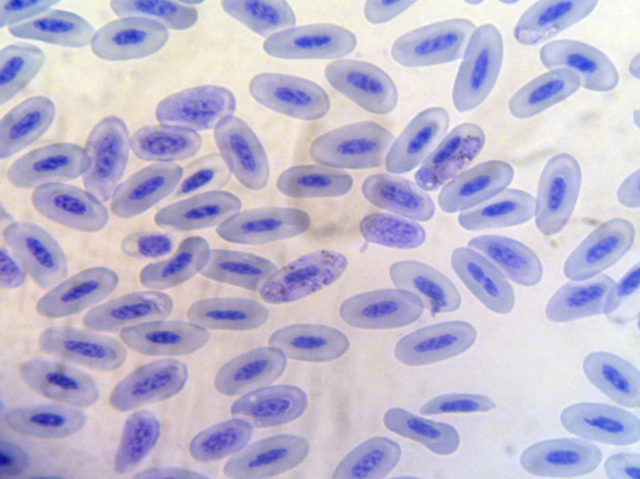
Fig.3: Macro and Microgametocytes of Haemoproteus columbae within RBC of pigeon, stained with Giemsa
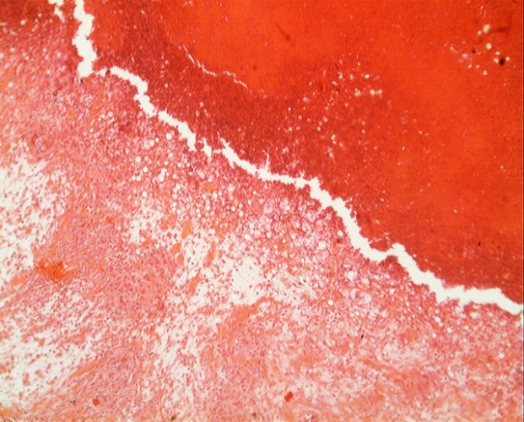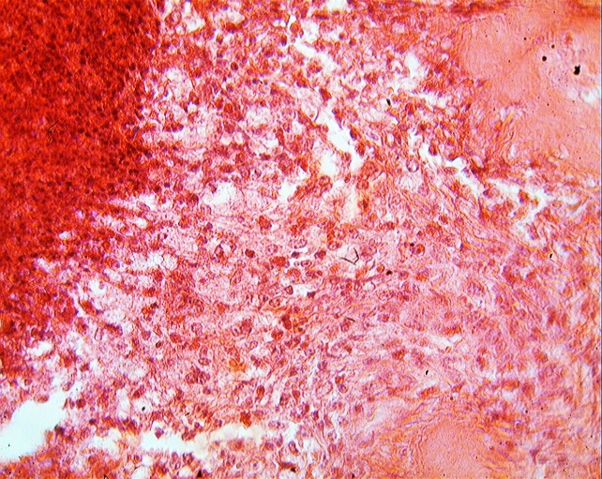
Fig. 4: Haemosidrin pigment and hyperplagia of bile duct also diffuse necrosis in hepatocyte.

