Hematobiochemical changes during fracture healing using
external skeletal fixation in goats**
Bini Joy^{1*}, Syam K Venugopal², S.Anoop³, N. Divakaran Nair⁴ and K.Rajankutty⁵
Department Of Veterinary Surgery and Radiology,
College of Veterinary and Animal Sciences, Mannuthy
Thrissur, Kerala, India. 680 651
Abstract
In the present study fracture in goats were treated with external skeletal fixation and hematological changes and biochemical changes during fracture healing in goats is studied. The variations in the level of markers of fracture healing were studied. There was a significant decrease in serum calcium concentration by the fourth week and it remained almost stationary during the subsequent observation. Serum phosphorus concentration was found lowered during the fourth and sixth weeks of observation. There was a significant difference of P<0.01 in calcium concentration during the second and fourth week of observation. A significant difference of P<0.05 noticed immediate postoperative and fourth week noticed. Statistical analysis using paired t- test showed significant difference.Variation in the level of Alkaline phosphatase indicated the increased osteoblastic activity during healing. The statistical analysis of each parameters showing significant difference is also studied.
Keywords: fracture healing, external skeletal fixation, hematobiochemical changes
Introduction
Fracture healing can be evaluated by physical and radiological examination. But to distinguish delayed union from nonunion more specific approaches are needed. Estimation of markers of bone healing such as Alkaline phosphatase, serum calcium, phosphorus etc may be useful in evaluating fracture healing (Komnenou.A, 2005).
** part of MVSc thesis submitted to Kerala Veterinary and Animal Sciences University by the first author
In the present study fracture in goats were treated with different configurations of external skeletal fixation depending on the type of fracture and bones affected. The study was conducted to evaluate the hematobiochemical changes in goats during the fracture management using external skeletal fixation and to statistically analyse the variations of parameters during healing.
Materials and methods
The study was conducted in six clinical cases of complete fracture of long bones in goats presented to the Surgery unit of University Veterinary Hospital, Mannuthy and Kokkalai during the period of December 2011 to February 2013. The goats selected for the study were subjected to detailed clinical and radiological investigation followed by hematological and serum biochemical evaluation. After confirming fitness of animal for surgical correction of fracture, all the goats were subjected to treatment with External Skeletal Fixation with Stainless Steel connecting bar in Type IA and Type II configurations depending on the bones affected. Periodic clinical, radiological, hematological and serum biochemical evaluations were conducted preoperatively and postoperatively immediately after the surgery. The follow up was done upto two months at two weeks interval. Clinical, radiological, hematological and serum biochemical observations were evaluated during second, fourth, sixth and eighth postoperative week, till the clinical healing of fracture was evident. Blood samples were collected preoperatively and on 2nd , 4th ,6th and 8th postoperative weeks in all animals for the evaluation of hematological parameters viz. hemoglobin concentration, volume of packed red cell (VPRC), erythrocyte sedimentation rate (ESR), total leukocyte count (TLC) , total erythrocyte count (RBC) and differential count (DLC) (Byers and Kramer, 2010).

Results and discussion
Hematological parameters were represented in Table I. Almost all the hematological parameters remained within the normal range during the observation period. There was a slight decrease in VPRC by the second week, which got normalised in the subsequent observation. There was a slight decrease in haemoglobin concentration during the initial two weeks, which got normalised in the subsequent observations. This variation may be due to trauma associated changes.
The serum biochemical parameters recorded were represented in Table II. Blood samples were collected preoperatively and on 2nd, 4th, 6th and 8th postoperative weeks in all animals for the evaluation of Serum biochemical parameters viz serum calcium, phosphorus and alkaline phosphatase (Kaneko,1998). The serum Calcium concentration (mg/dl) was 9.13±0.29 preoperatively. It was 8.88±0.39, 8.43±0.35, 8.48±0.91 and 8.48±0.71 in the second, fourth, sixth and eighth postoperative weeks respectively. There was a significant difference of P<0.01 in concentration during the second and fourth week of observation. A significant difference of P<0.05 noticed immediate postoperative and fourth week noticed. Statistical analysis using paired t- test showed significant difference. Graphical representation of variation is shown in Figure.1.The serum Phosphorus concentration (mg/dl) was 6±0.64 preoperatively. It was 5.37±0.46, 4.4±0.50, 5.26±0.23 and 5.11±0.20 in the second, fourth , sixth and eighth postoperative weeks. There was a significant decrease in concentration during the second and fourth week of observation and after that a slight increase noticed. Graphical representation of variation is shown in Figure.2. The serum Alkaline phosphatase enzyme concentration (U/L) was 155.17±10.70 preoperatively. It was 195.67±8,140±10.28 , 132±10.21and 128±9.4in the second, fourth , sixth and eighth postoperative weeks.
There was a significant decrease in serum calcium concentration by the fourth week and it remained almost stationary during the subsequent observation. Serum phosphorus concentration was found lowered during the fourth and sixth weeks of observation. Kumar et al. (1992) also observed a significant decrease in plasma calcium and inorganic phosphorus levels during the fracture healing period of three weeks. Increased osteoblastic activities accounts for the raised serum alkaline phosphatase (ALP) levels and a gradual and significant increase in enzyme a level from 0 to 30 days was reported following bone grafting in goats. (Aithal et al., 1995).
There was a significant increase in alkaline phosphatase concentration during the second and fourth week of observation and after that a slight decrease noticed. There was a significant difference of P<0.01 noticed in immediate postoperative and second week of observation. There was a significant diference of P<0.05 noticed in second and fourth week of observation. There was a significant diference of P<0.05 noticed in fourth and eighth week of observation. Graphical representation of variation is shown in Figure.3. There was a slight increase in alkaline phosphatase level by the second week of observation which got normalised in subsequent observations, may be due to the progress in fracture healing. Julie et al.(2005) noticed similar changes in alkaline phosphatase level during fracture healing.
Acknowledgement:
The authors would like to thank Kerala Veterinary and Animal Sciences University and University Veterinary Hospitals, Kokkalai and Mannuthy of the College of Veterinary and Animal Sciences, Mannuthy for the facilities offered for conducting the research work.
References
Aithal, H.P., Mogha, 1.V., Singh, G.R. and Swarup, D. 1995. Serum acid and alkaline phosphatase activities following bone grafting in goats. Indian J. Vet. Surg. 16: 47-49
Julie, B.2005. Acrylic external skeletal fixator for the treatment of long bone fracture in dogs. M.V.Sc. thesis, Kerala Veterinary and Animal Sciences University, Pookode, 94p
Kaneko,J.J., Harvey,W.J. and Bruss,M.L. 1998. Clinical Biochemistry Of Domestic Animals. (6th Ed.). Academic press. Elsevier. 904p
Kumar, R., Gill, P.S., Singh, R., Seifia,M.S. and Rattan, P.J.S. 1992. Plasma electrolyte changes during fracture healing in dogs. Indian Vet. J. 69: 476-477

Komnenou A, Karayannopoulou M, Polizopoulou ZS, Constantinidis TC, Dessiris A .2005. Correlation of serum alkaline phosphatase activity with the healing process of long bone fractures in dogs. Vet clin pathol. 34(1):35-8

Table.1- Serum hematological evaluation (Mean ± SE) of the cases under study
n= 6
PARAMETERS |  | Day of observations
 |  | 0th day | 2nd week | 4th week | 6th week | 8th week
Hemoglobin concentration (g/dl) |  | 8.77±0.50 | 8.43±0.48 | 9.21 ± 0.55 | 10.03±0.89 | 10. 01 ±0.43
VPRC (per cent) |  | 26.5±1.65 | 25.33±1.56 | 28.33±1.63 | 29.83±2.50 | 28.50± 2.47
Differential count | N (per cent) | 40 ± 1.78 | 44 ± 1.45 | 39 ± 2.64 | 43 ± 1.54 | 45 ± 3.78
Differential count | L(per cent) | 59 ± 0.28 | 55 ± 1.08 | 50 ± 1.38 | 56 ± 1.68 | 54 ± 1.78
Differential count | M(per cent) | 1± 0.34 | 1± 0.32 | 1± 0.14 | 1± 0.23 | 1± 0.75
RBC (10⁶ /cu mm ) |  | 11.05±2.70 | 6.33± 3.47 | 7.65 ±3.05 | 9.43± 2.10 | 11.277±1.21
ESR (mm/hr) |  | 2.165±0.91 | 2.33± 0.98 | 2.5 ± 0.56 | 1.83± 0.30 | 2.33± 0.98
Total leucocyte count (10³ /cu mm ) |  | 10.05±0.90 | 11.33±1.17 | 11.15±1.95 | 11.83±1.20 | 11.277± 1.21

Table .II Serum biochemical evaluation (mean±SE)

PARAMETERS | Day of observations
PARAMETERS | 0th day | 2nd week | 4th week | 6th week | 8th week
Serum Phosphorus (mg/dl) | 6±0.64 | 5.37±0.46 | 4.4±0.50 | 5.26±0.23 | 5.11±0.20
Serum Alkaline phosphatase (U/L) | 155.17±10.70* | 195.67±8.6* | 140±10.28** | 132±10.21** | 128±9.4**
Serum calcium ( mg/dl) | 9.13±0.29** | 8.883±0.39* | 8.433±0.35* | 8.483±0.91 | 8.487±0.71

*P<0.01 **P<0.05

Serum biochemistry variations during fracture healing( Fig.1, 2,3)
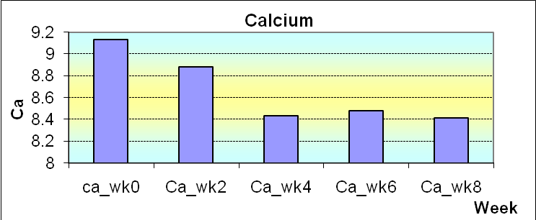Fig .1
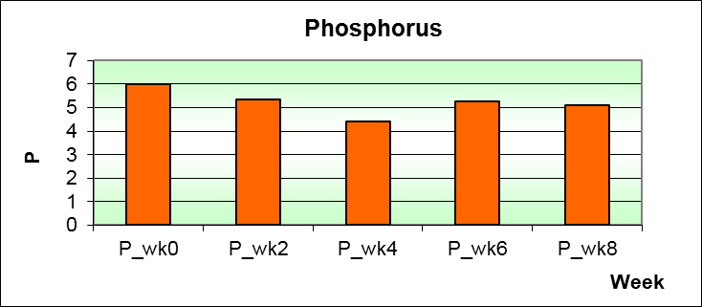Fig.2
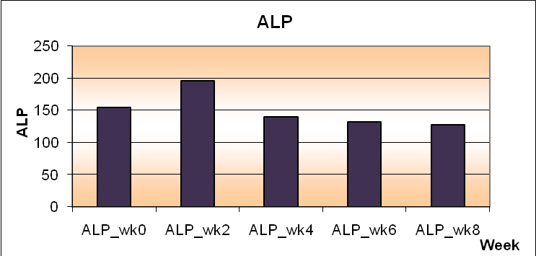Fig.3

