Figure 1: Percent prevalence of diseases (pathological affections) in lungs of slaughtered animal in CMP

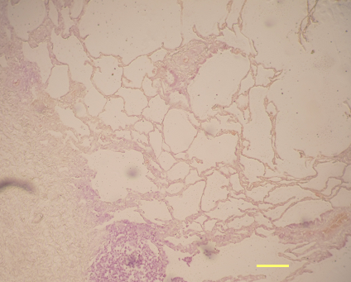
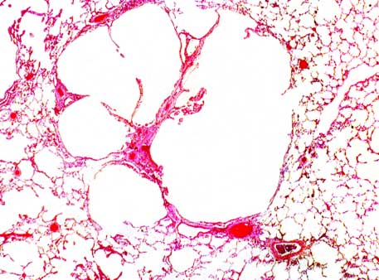
Figure 3

100
100
A
B
100
100

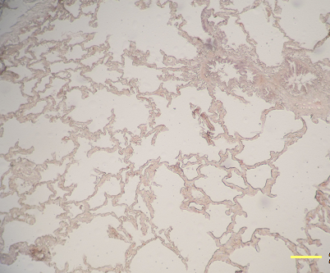
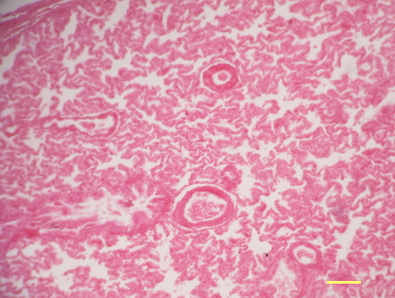

D
C

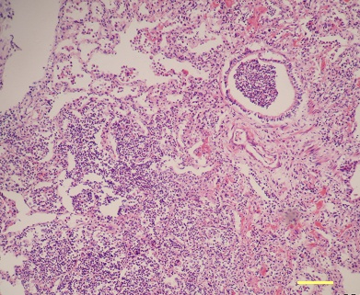
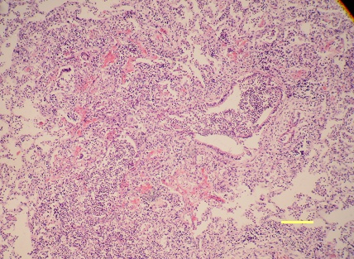

100
100
E
F
Fig: 3. Histopathology of lung lesions: A. Hydatid cyst in lung characterized by remnant of cyst wall with accumulation of reactive cells; B. Pulmonary congestion and alveolar emphysema; C. Pulmonary atelectasis; D. Interstitial emphysema in lung where alveolar septa are distended with gas as well as alveolar space; E. Purulent bronchopneumonia in lung, accumulation of neutrophils in bronchiolar airway; F. Pulmonary hepatization (pneumonic lung) where alveolar space is filled with copious exudates.

Figure 2
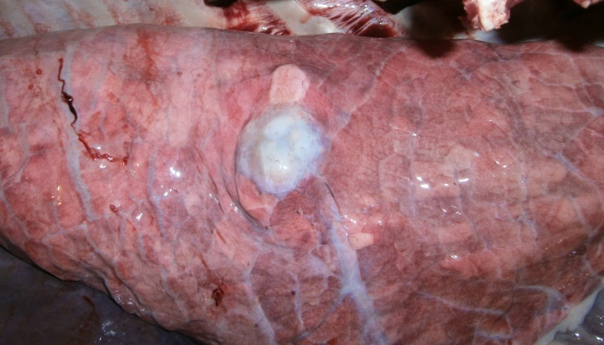
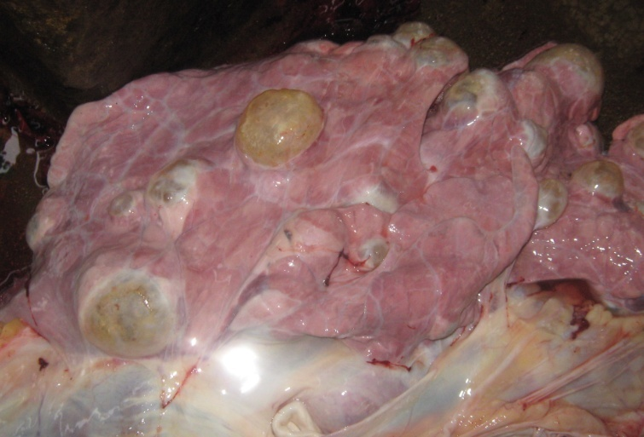
C

B
A

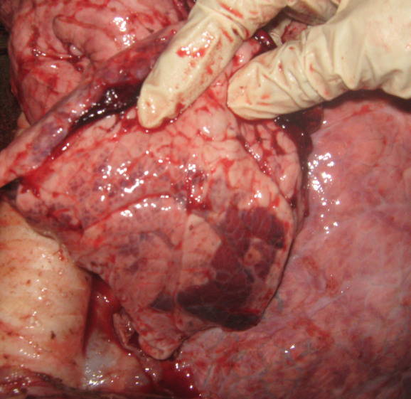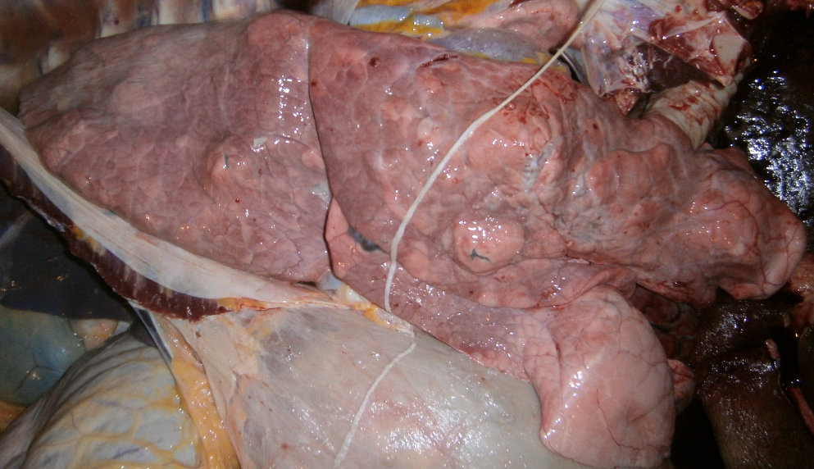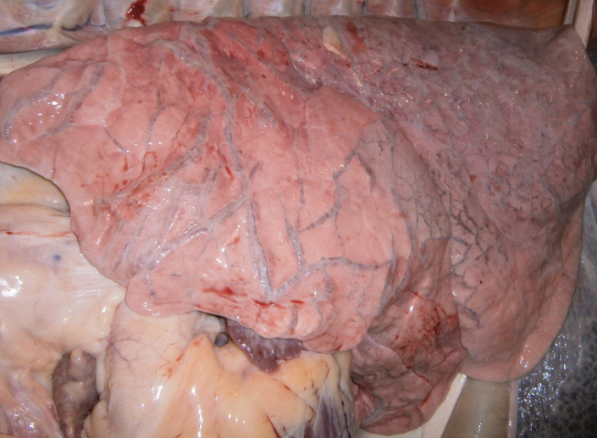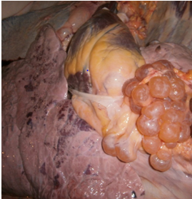
D

F
E
Fig: 2. Gross pathological changes caused by hydatidosis in lung: A. Polycystic lung containing large yellow fluid filled viable cyst and abscess; B. Old degenerated cyst and fibrosis in lung C. Viable cyst in the pleura and lung in clustered appearance; D. Severe interstitial emphysema and marked distention of the veins (blue color) in middle and caudal lobe; E. Red Hepatization (consolidation) indicating pneumonia; F. Abscess in all over the lung parenchyma.

Table- 1: Overall Pathological lesions in the different slaughterhouses
Name Abattoirs | No. of Carcass examined | Cattle | Buffaloes | Total | Overall %
FiringiBazzar | 498 | 50 | 18 | 68 | 13.65%
Bohodderhat | 152 | 35 | 3 | 38 | 25.00%
Pahartali | 232 | 20 | 2 | 22 | 9.4%
Total | 882 | 105 | 23 | 128 | 14.51%

Table- 2: Frequency of lung lesions in cattle and buffalo
Species | Slaughtered animal | Lung lesion | Percentage
Cattle | 660 | 105 | 15.90%
Buffalo | 222 | 23 | 10.36%
Total | 882 | 128 | 14.51%

Table 3: Comparative frequency of lung affections in cattle and buffalo
Pathological Affections | Cattle (N=105) |  |  | Buffalo (N=23) |  |  | P value
Pathological Affections | No | (%) | 95% CI | No | (%) | 95% CI | P value
Hydatid Cyst | 61 | 58.09 | 48.52-67.67 | 8 | 34.78 | 14.69-54.88 | 0.0211*
Atelectasis | 13 | 12.38 | 5.99-18.77 | 3 | 13.04 | 1.16-27.25 | 0.4653
Emphysema | 36 | 34.28 | 25.08-43.49 | 3 | 13.04 | 1.16-27.25 | 0.0225*
Nodule | 2 | 1.90 | 0.75-4.56 | 2 | 8.69 | 3.19-20.58 | 0.0450*
Congestion | 7 | 6.66 | 1.83-11.51 | 2 | 8.69 | 3.19-20.58 | 0.3652
Hemorrhage | 7 | 0.06 | 1.82-11.51 | 9 | 39.13 | 18.54-59.72 | 0.0001*
Abscess | - | - |  | 1 | 4.34 | 4.26-12.95 | 0.0160
*=Means p<0.05

F
E
D
C

